Kindergarten Supply List
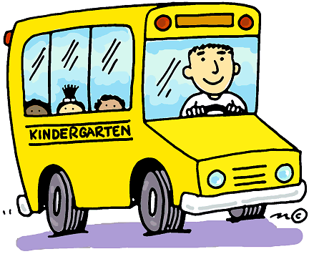
Carnesville Primary
2018-2019

2 boxes (16 or 24) of small CRAYOLA crayons
1 box of Expo Dry Erase markers (Black)
1 box/pack of pencils (#2 USA Gold last longer and sharpen)
(Other brands do not sharpen or erase well)
2-Pk of large pink erasers
1 pack of Elmer’s glue sticks
1 pair of blunt-tip Fiskar student scissors
1- 1 inch, 3 ring binder with inside pockets (for agenda, important
papers, student work, etc.
2 plastic folders with three prongs and pockets, NO RINGS
1 set of computer headphones (ear buds are not allowed)

Book bag that is large enough for notebook, coat, snack, etc.
(Rolling book bags are not allowed)

~3 canisters of Clorox wipes
~2 boxes of Kleenex
~2 rolls of paper towels
~1 box of quart Ziploc bags and 1 box of gallon Ziploc bags

