Franklin County Middle School
PBIS Handbook
2013-2014

FCMS Cubs show our P.R.I.D.E
by following a Preventative and Positive
Behavioral Interventions and Support model.

August, 2013
Dear Students, Parents, and Guardians,
Each year at FCMS we strive to improve every area of our school’s services to students. Last year, we implemented the Olweus Anti-Bullying Program to begin the process of teaching our students to be more empathetic to their peers and to not be bystanders in bullying or bully-like situations. Our work is not done in the area of anti-bullying and we will continue to work to prevent and deal with bullying/bully-like behaviors in our school.
In addition to Olweus, we are following a framework known as PBIS (Positive/Preventative Behavioral Interventions and Support). The purpose of PBIS is to help create an environment for learning that is positive and prevents undesired behaviors. School wide expectations will be taught so that all students understand what is expected in every area of the building. We want to see these P.R.I.D.E. behaviors in every student every day at FCMS. Our use of the framework will encourage, support and recognize the students’ appropriate behaviors.
Please support your student by making sure he/she understands that bully-like behaviors are not acceptable at home or at school, and that you expect the appropriate behaviors at school. This handbook will give you information about the behavior expectations.
We are looking forward to the best year ever at FCMS!

P…..Perseverance
R….Respect
I…..Integrity
D….Dependability
E….Excellence
Perseverance means to keep trying, even when things are hard; following through until the end even when we don’t want to.
Respect to be shown to others and self, including space, property and physical person.
Integrity means to do the right thing no matter where you are and whom you are with.
Dependability means doing what you say, doing what is asked of you, having materials and work, following through, completing work on time and to the best of one’s ability.
Excellence is striving for the best….helping others, not just settling or getting by, doing our best in every area.

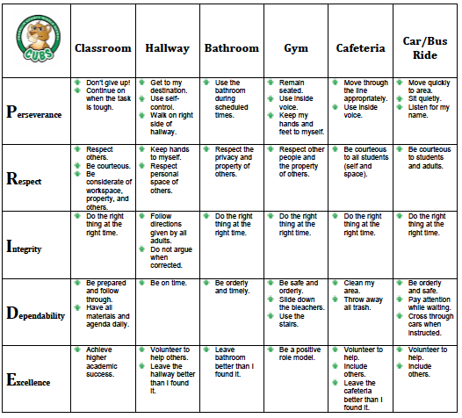

OVERVIEW:
What is school-wide PBIS?
PBIS is a systems approach to creating safer and more effective schools. PBIS focuses on improving a school’s ability to teach and support the positive behavior of all students. Each school’s PBIS Leadership Team designs, implements and evaluates specific school-wide practices that are for ALL students and staff. PBIS is not a program or curriculum. It is a team-based process for systemic problem-solving, planning and evaluation.
PBIS is an evidence-based practice that enhances the capacity of schools to educate all students, especially the students with challenging social behaviors. It is a proactive systems approach to school wide discipline that responds to the current social and/or educational challenges through three levels of intervention: universal, targeted group and individual. When students who struggle the most behaviorally are able to learn appropriate behaviors they are more able to behave appropriately and all students are given better opportunities to learn.
School-wide PBIS is being implemented today in schools across the United States and Canada.

How is PBIS proactive and educative?
A PBIS school focuses on the teaching of behavioral expectations directly like academic skills. PBIS allows a framework that supports looking at inappropriate behavior as a skill deficit just like a problem in reading or math. It does not eliminate consequences to poor choices, but skill deficits are remediated thorough instruction and the teaching of the appropriate skills. PBIS promotes the teaching of pro-social skills so all students can succeed even when confronted with potential conflicts and an ongoing acknowledgement system for students who meet expectations.

What does PBIS look like in a school?
A school implementing PBIS will use school-wide expectations in specific settings to teach students appropriate behavior, an acknowledgement system to encourage appropriate behavior, predetermined consequences to discourage inappropriate behavior, discipline referral procedures that are implemented consistently, outcome data to monitor progress, and a problem-solving process for making data-based decisions.

How long does it take to implement PBIS?
Full implementation of PBIS, which includes the targeted group and individual interventions for students needing more intensive support, generally takes from 3-5 years. We are at the beginning of the process. During the 2012-13 school term, FCMS staff members investigated different processes to begin supporting our students in a more positive way. We visited schools who use the PBIS framework and gathered information to begin our implementation. We have a team of committed staff members who are leading the rest of the staff to develop/publish the school-wide procedures, acknowledgement pieces and build the database for implementation. Members of our team will attend training provided by the Georgia Dept. of Education in the fall of 2013.

Successful PBIS frameworks are comprised of specific components:

- Behavioral Expectations are clearly defined. A matrix of the P.R.I.D.E behaviors will be posted all over the building. P.R.I.D.E… Perseverance, Respect, Integrity, Dependability, Excellence.
- Behavioral Expectations are taught. P.R.I.D.E. procedures/expectations will be taught to all students in all settings throughout the school. Behavioral expectations/procedures are best learned through positive examples, modeling, and opportunities to practice.
- Appropriate behaviors are acknowledged. Appropriate behaviors are acknowledged on a regular basis through praise and incentive programs to promote and reinforce behaviors demonstrated by individuals and classes. This does not mean that each and every time a student demonstrates appropriate behavior a tangible reward will be given.
- Negative behaviors are corrected proactively. Specific procedures are designed to address students who do not meet expectations. Students will be informed of unacceptable behavior and re-taught the expectation or rule. Positive practice and consistency are important to promote student success. This process of instruction does not eliminate consequences but supports students as they learn the procedures.

CONSEQUENCES:
While PBIS focuses on positive behaviors, we must be prepared to deal with negative behaviors when they happen. Each classroom teacher will follow the 4-step plan in dealing with inappropriate behaviors.
- Verbal Warning
- Note to parent (in the agenda or by email)
- Phone call to parent
- Office referral
**For returning FCMS parents, we are no longer using the RAC system. Therefore, we eliminated one of the steps in the “step plan”.
We are working to increase consistency across the building as we teach and re-teach our behavior expectations for all of our students.
**Please note that the 4-step plan will be utilized along with our PBIS procedures for re-teaching. However, on occasion, there are behaviors that must reported directly to the office and handled by an administrator.

PBIS Committee Members:
Amy Cheek, Liz Debban, Jenny Tollison, Mark Hamner, Andrea Antepenko, Tina Hart, Larry Printz, Amy Ginn, Chuck Holland, Elizabeth Faucher, Wendy Reddicks, Ronda Sullivan, CJ Wilder, Kelly Akin, Beth Pifer-Mills, Lucy Floyd,

