Bulldog Bulletin  Where we are  100% accountable!!!!! | January  2019  LES...where  Learning  Equals  Success!

Principal’s Page:  Safety is a big focus of our work this year and we take the safety of our students and staff seriously. We had 2 staff members almost get run over recently so please read carefully.  - If your child is dropped off as a car rider in the morning, you must use the car rider line. Do not park in the parking lot and let your child walk in on their own or park and walk your child to the front door. Our parking lot is a busy place and it isn’t safe to have students walking through the lot in the mornings.  - All transportation changes should be communicated through your child’s agenda. In the event of an emergency, you must call the school before 2:00 PM. When you call, the front office has to write a note for the student and get that note to the teacher before dismissal. We will not be able to make exceptions to this rule.  - In the mornings, if your child arrives after the bell rings, you must come into the office and sign them in as tardy. Please do not just let them out and have them sign in on their own. They are late after 7:50 AM.  - Breakfast ends at 7:50 AM. If your child arrives after that time, they will miss breakfast. Please be sure your child has already eaten if they arrive after 7:50 AM.  - When eating lunch with students, you may only eat with the child you have permission to visit. Other students cannot join you.Please eat on the stage and not at the student tables.  - We will also be checking your photo identification when you visit for any reason. Please have your photo ID ready when you sign-in. | Upcoming Events  January 18th-5th grade Idiom Day  January 21st-No school/MLK Holiday  January 28th-Access testing begins  February 4th- RI/MI testing begins  February 5th-Brian Buffington presentation on Digital Citizenship to grades 3-5  February 11th-Title I parent meeting  February 14th-Valentine’s Day  February 15th-Report cards go home  February 18th-22nd-Winter break  March 1st-Daddy & Daughter Dance  March 4th-NAEP testing for 4th grade

7 Mindsets  100% Accountable  This month, our Mindset lessons will focus on being accountable for your own success and happiness. Students will begin to apply the 100% Accountable Mindset. By analyzing the fears and limiting beliefs that they may have, they will understand the importance of standing up for what they believe in and how taking control of your life will allow you to grow and change from each opportunity you are given. They will explore how good and bad situations all allow us to learn and reach our goals.  Talk with your child about a goal they may want to set for themselves such as reading on a higher level or mastering their math facts. Setting goals can be very motivating for students and can help them focus their energy while avoiding excuses. | PBIS-Positive Behavior Intervention and Supports  Here are some snapshots of our current behavior data:  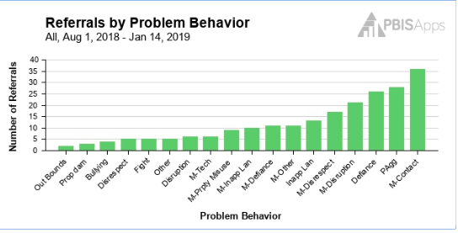  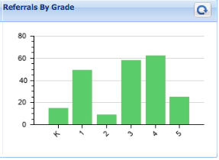

Bell to Bell Bulldogs Attendance Incentive
Our incentive program to target our bell to bell attendance is off to a slow start. Bell to bell means students arrive to school on time (by 7:50 AM) and they stay at school all day (until 3:20 PM). We have had 2 classes earn the incentive so far. Ms. Layton’s class and Ms. Blanton’s enjoyed ice cream parties!
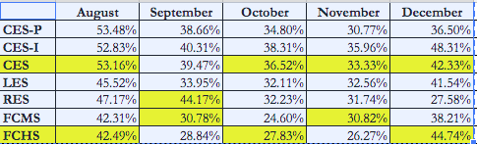
This picture shows you the percentage of bell to bell attendance across the county. As you can see, the numbers are low consistently. For example, in December, only 41.54% of LES students were at school all day, each day of the month. That means over half of our student body came in late or checked out early. The county gives a reward to the school with highest percentage each month, but LES has not won it yet.

Here are some ideas to help us improve this statistic at school:
- Be sure your child arrives to school on time. Students are late after 7:50 AM.
- Schedule appointments after school hours whenever possible.
- Being on time sets up lifelong habits that students will need when they begin careers of their own.
- If students are late because of the bus, they are not counted as tardy.

Our staff attendance continues to be among the highest in the county. LES has had the best staff attendance throughout the county every month this school year except for one. We are grateful to our teachers who show up everyday for your kids!
