Cell Transport Worksheet Name:________________________

**I. The Cell Membrane**

Write a title for the diagram and then label its parts. Use the choices:

Protein molecule lipid bilayer polar head fatty acid fluid mosaic model

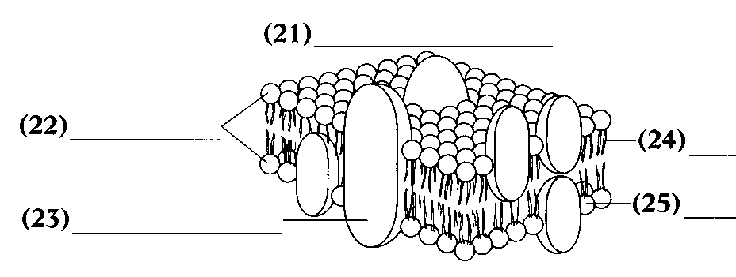

**2**

**5**

**4**

**3**

**1**

**II. Answer the questions below.**

1. What is a lipid bilayer? ___________________________________________________

_________________________________________________________________________

2. Why is the current model of the membrane structure called fluid mosaic? ___________

__________________________________________________________________________________________________________________________________________________

3. What is the function of the protein molecules in the cell membrane? ________________

_________________________________________________________________________

_________________________________________________________________________

4. What does it mean to be selectively permeable? __________________________________________________________________________________________________________________________________________________

5. What is facilitated diffusion? _______________________________________________

_________________________________________________________________________

_________________________________________________________________________

6. In reference to diffusion, “down the concentration gradient” means the molecules move from an area of ____________ concentration to an area of _____________ concentration.

7. Name three ways in which the rate of diffusion can be affected.

1.___________________________________________

2.___________________________________________

3. __________________________________________

8. What are the two major components of the cell membrane?

1. _________________________________________

2. _________________________________________

9. What is equilibrium? Do particles stop moving at this point? Explain. ______________

________________________________________________________________________

________________________________________________________________________

10. Why are some methods of transport considered active? _________________________

________________________________________________________________________

11. What is the difference between phagocytosis and pinocytosis? ___________________

________________________________________________________________________

________________________________________________________________________

**III. Fill in the blank.** Write the word(s) that best completes each statement. Use the choices:

osmosis shrink passive transport diffusion dynamic equilibrium

1. The diffusion of water into and out of cells across a selectively permeable membrane is called ___________________.

2. Osmotic balance occurs when ____________________ is established.

3. ____________________ is a freshwater plant that has evolved ways of maintaining osmotic balance.

4. Osmosis and ____________________ are processed by which water and lipids, and lipid-soluble particles permeate membranes.

5. Movement of particles across a membrane without the cell using energy is called ____________________.

**IV. True or False.** Answer true or false. If false, change the underlined word(s).

____________________ 1. A cell has no control over osmosis.

____________________ 2. Cells shrivel up in hypotonic solutions.

____________________ 3. Active transport requires energy.

____________________ 4. A cold bottle of perfume will diffuse faster than a hot

bottle of perfume.

____________________ 5. In isotonic solutions, molecules move in and out of

the cell at an equal rate.

____________________ 6. Molecules tend to move from areas of low

concentration to areas of high concentration.

____________________ 7. The part of the solution that is dissolved is the solvent.

____________________ 8. Some unicellular organisms contain contractile

vacuoles to pump water out.

**V. Understanding types of solutions**

1. A cell is placed in 100% water. The cell contains 60% water. What will happen to the cell? Is this cell in a hypotonic or hypertonic solution?

2. Complete the picture below to illustrate the cell and solution described above.

cell

3. Identify the following statements using these choices:

A= beaker A B= Beaker B C= Beaker C D= none of the above E= all of the above

cell

cell

cell

cell

Cell

70% H20

Solution 70% H2O

Cell

30% H20

Solution 90% H2O

Cell

80% H20

Solution 85% H2O

cell

________ 1. the cells will shrink

________ 2. exchange of water molecules at an equal rate

________ 3. the cells will swell

________ 4. the movement of water molecules requires the cells to expend energy

________ 5.does not change the shape of the cell

________ 6. exchange of water molecules

________ 7. equilibrium is established immediately

Draw arrows in the diagrams above to indicate the net movement of water molecules.

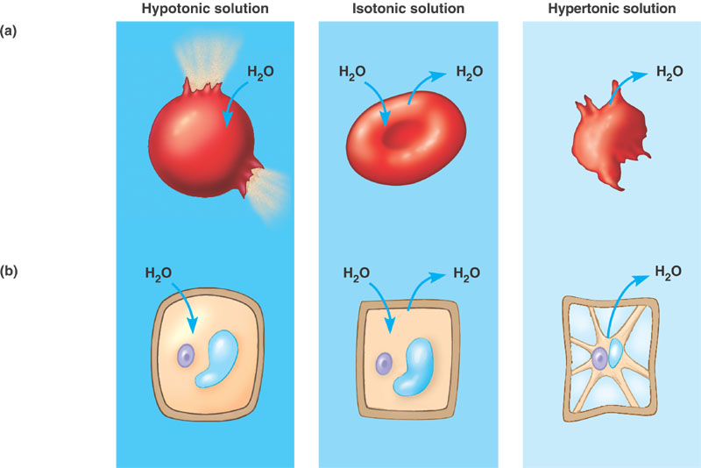

Explain what is happening to the animal cell (a) and plant cell (b) in the HYPOTONIC solution

Explain what is happening to the animal cell (a) and plant cell (b) in the HYPERTONIC solution

Explain what is happening to the animal cell (a) and plant cell (b) in the ISOTONIC solution