Africa After the Berlin Conference of 1884

Use the maps in your textbook to find the following information. Color the areas as indicated, listing the colors used in the legend below:

- British holdings
- French holdings
- German holdings
- Independent states
- Belgian holdings
- Portuguese holdings
- Italian holdings

  - Label the major natural resources Europeans sought in Africa (see handout provided). Be sure to add the symbols you use to the legend below.
  - Draw a STAR on each of the areas of conflict/resistance in Africa during the Age of Imperialism (see p. 783 in CP book).
  - Draw ARROWS showing the migration of peoples INTO and OUT OF Africa during this time (see p. 933 in AP book). Label each arrow with names of migrant groups.
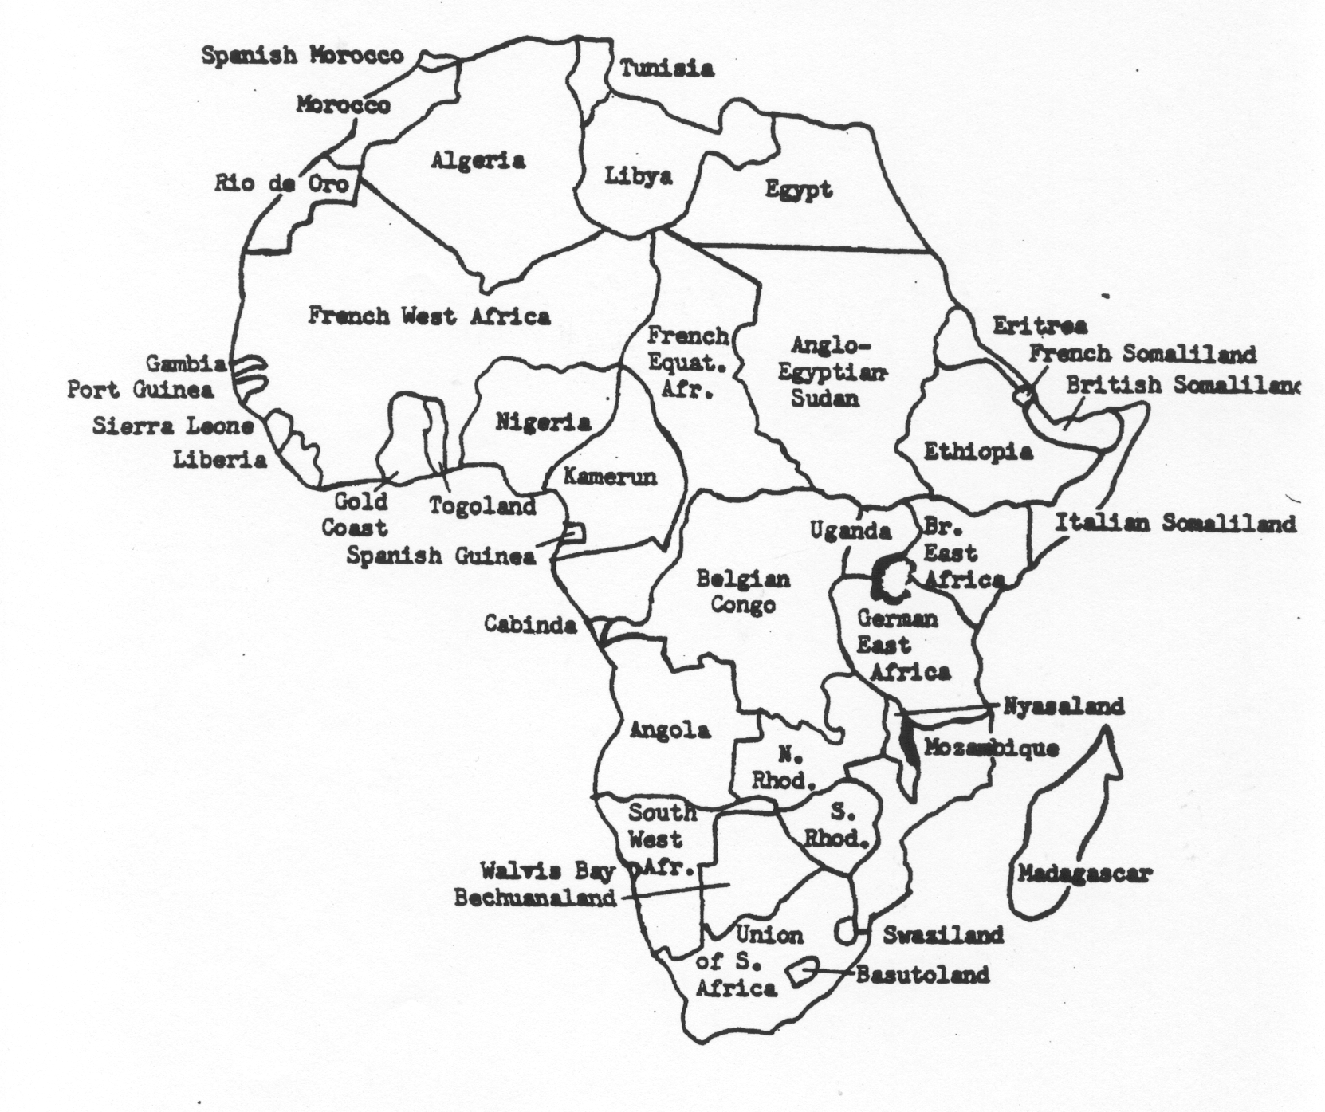
Legend

Physical map: AFRICA

Use the maps in your textbook to find and label the following physical features.
Color mountains/highlands BROWN, lakes & rivers BLUE, deserts YELLOW, savannas LIGHT GREEN, and rainforests DARK GREEN.

Bodies of Water:
Atlantic Ocean
Indian Ocean
Mediterranean Sea
Red Sea
Gulf of Guinea
Gulf of Aden
Gulf of Sidra
Strait of Gibraltar
Lake Victoria
Lake Tanganyika
Lake Turkana
Lake Nyasa
Lake Chad
Lake Tana
Mozambique Channel
Nile River (+ White & Blue)
Niger River
Senegal River
Zambezi River
Limpopo River
Orange River
Congo River
Victoria Falls

Deserts, Grasslands, & Rainforests:
Congo Basin
Sahara Desert
Sahel
Namib Desert
Kalahari

Islands:
Sicily
Crete
Cyprus
Canary Islands
Cape Verde Islands (draw in)
Reunion Island
Mauritius
Comoros Islands (draw in)
Seychelles (draw in)
Madagascar

Mountains & Highlands:
Atlas Mountains
Great Rift Valley
Ethiopian Highlands (Plateau)
Mt. Kilimanjaro
Drakensberg Escarpment

