**Student Packet**

**LCD MODULE:**

**Protein Synthesis and Genetic Mutations**

**Warm Up – complete the chart below**

|  |  |  |
| --- | --- | --- |
| **What is DNA:** | **Why is DNA important:** | **What might happen if your DNA was damaged:** |
|  |  |  |
|  |  |  |
|  |  |  |

**Part II –**

* **Watch the videos about genetic mutations like sickle cell and other genetic disorders.**
* **Write down 3 generalizations that can be made about the function of DNA and how mutations occur.**

**1.**

**2.**

**3.**

**Read the intro to the final project and complete the following notes:**

1. Summarize in your own words what protein synthesis is:

**You have been introduced to the task for this unit. In your own words, summarize what you are expected to do.**

**Use the teacher PowerPoint to fill in the notes for DNA history.**

**Section 1 - Griffith**

|  |
| --- |
| **Key Points:**  **\*Year-**  **\*Experiment-**  **\*Outcome­-** |

**Section 2 – Avery**

|  |
| --- |
| **Key Points:**  **\*Year-**  **\*Experiment-**  **\*Outcome­-** |

**Section 3 – Hershey-Chase**

|  |
| --- |
| **Key Points:**  **\*Year-**  **\*What question were they trying to answer? -**  **\*Outcome­-** |

**Section 4 – Chargaff**

|  |
| --- |
| **Key Points:**  **\*Year-**  **\*Discovery-**  **\*Conclusion-** |

**Section 5 – Watson/ Crick**

|  |
| --- |
| **Key Points:**  **\*Year-**  **\*Discovery-**  **\*How was Chargaff’s rule important to their discovery? -** |

**DNA/RNA Notes: Take turns reading the article about DNA or RNA and writing down the important ideas and vocabulary. You will then share the information your group collected with the rest of the class. Write down the information the other group collected as you listen.**

**DNA: Concept 11.2 Nucleic acids store information in their sequences of chemical units.**

|  |
| --- |
| **\*Building Blocks:**  Nitrogenous bases  DNA Strands  **\*DNA Structure:**  Double Helix  Complementary Base Pairs |

**DNA Summary questions:**

1. **What are the three parts of a nucleotide? Which parts make up the backbone of a DNA strand? _________________________________________________________**

**_____________________________________________________________________**

1. **List the two base pairs found in DNA? ___________________________________**
2. **If six bases on one strand of a DNA double helix are AGTCGG, what are the six bases on the complementary section of the other strand of DNA? ____________________________________________________________**

**RNA: What is RNA? Ribonucleic acid/ RNA**

|  |
| --- |
| **\*Building Blocks:**  Nitrogenous bases  RNA Strands  **\*RNA Structure:**  Function in the cell  3 Types |

**DNA Summary questions:**

1. **What is the name of the molecule that completes the flow of information from DNA to protein? _________________________________________________________**
2. **How are the nitrogen bases of RNA different from DNA? __________________**

**___________________________________________________________________**

1. **List two other ways in which RNA is different from DNA. __________________**

**____________________________________________________________________**

**When you finish your notes, complete this diagram comparing DNA and RNA.**

RNA

DNA

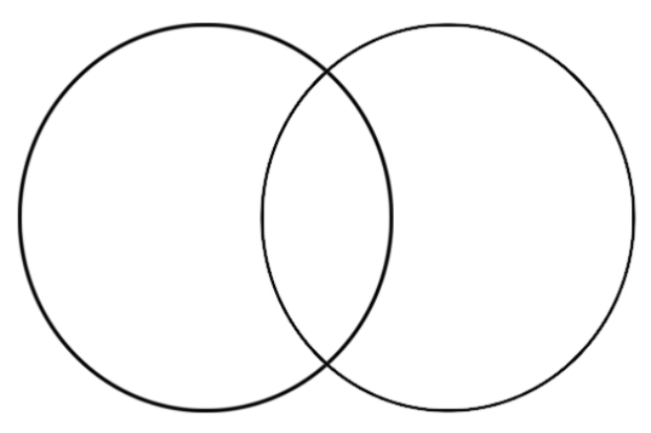

**DNA and RNA Structure Comparison**

Double Strand

Single Strand

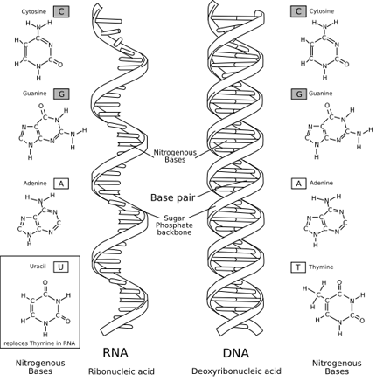

**Highlight three differences between DNA and RNA in the pictures above.**

**DNA Replication- Summarize the replication simulation that we just completed in the hall, in three short steps**

**\***

**\***

**\***

**Overall Summary for DNA Replication: Write a paragraph that will be reviewed and critiqued by a peer:**

Explain how DNA is replicated in the cell. Be sure to include the following vocabulary in your paragraph: **nucleotides, base pairing rule, template strand, sugars and phosphates, new strands and resulting product**. Use the picture below to guide your response.

**Peer suggestions**

**Central Dogma of Genetics**

|  |  |  |
| --- | --- | --- |
| **What is the main idea?** | **Who are the main players?** | **How would you draw it?** |
|  |  |  |

**What is another name for the central dogma idea? ­­­­­­­­­­­­­­­­______________________**

**HOMEWORK – VOCABULARY SHEET**

|  |  |  |
| --- | --- | --- |
| **Term** | **Definition in your words** | **Symbol or Visual** |
| **Gene** |  |  |
| **Triplet code** |  |  |
| **Transcription** |  |  |
| **Translation** |  |  |
| **Protein Synthesis** |  |  |

**Find a picture that helps you understand the process of protein synthesis and glue it below.**

|  |
| --- |
|  |

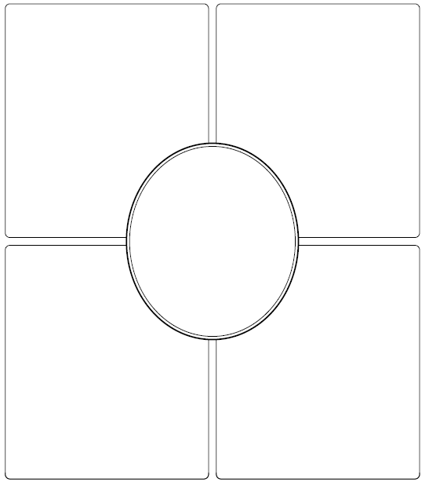

***DNA code***

**ATGCTTAGCTTGTAC**

**_______________________**

***mRNA code***

**RNA:**

**DNA:**

**Where does it occur**

**TRANSCRIPTION**

**Definition:**

**Example**

**Bases**

**Steps**

**Summary:**

Transcription Worksheet

1. What are the bases in DNA?

1. How do the bases pair up?
2. What are the bases in RNA?

What RNA nitrogen bases match with the following DNA nitrogen bases?

A T G C

1. If this is a sequence of one DNA strand, what is the complementary sequence of the other DNA strand?

A T T C A G C G A

1. What in RNA sequence would bond with DNA strand from question 5?

A T T C A G C G A

1. Three RNA bases make a
2. What does a codon code for?
3. If you have 1500 base pairs, how many amino acids are there?
4. The shape of a DNA molecule is
5. What do proteins do for us?
6. Where are proteins made in the cell (organelle)?

MCj04241160000[1]Activity I The Cat Message

Directions:

Each DNA triplet represents one letter of the alphabet.

Carefully follow the following steps to determine what the cat

is trying to tell you.

Step 1. Translate the DNA triplets into mRNA codons

Step 2. Use the chart of mRNA codons to find the correct amino acids

Step 3. Write the alphabet letter for that amino acid above the appropriate

DNA triplet to decode the message

I ‘ V E

TAT’ ATC CTT CCC CAG TGA TAT TGA—TGC GTG CTT

AUA UAG GAA

CCC CTT TTG CTT TGA TAT ACG ACG CAG CTA CTT!

ACC CGA TAT TGA CGA TAC TAT TTG ACT TGA CTT,

ACC GTG CAG CGA GAG GGG GTG CGA---

GTT CTT TGA TAT TTT CTT CTA TGA GTG TAT AGA?!

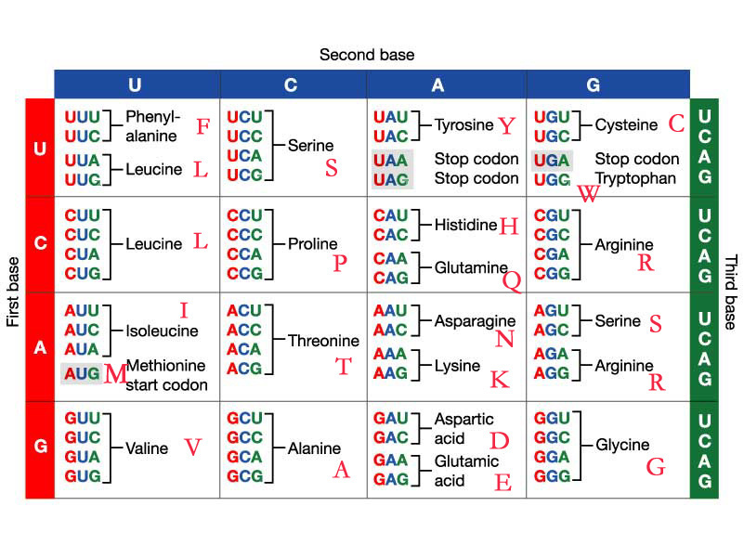

**RNA Warm Up**

Use the word banks next to each visual to label the correct parts of protein synthesis

**Visual 1**

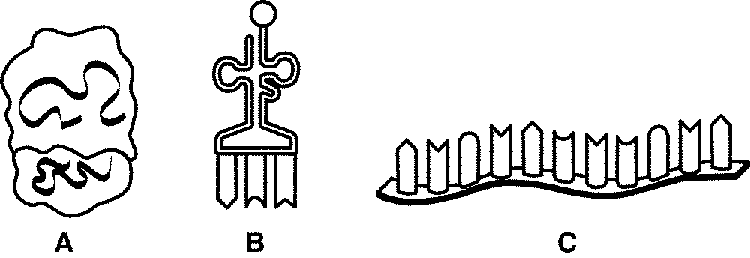

Label the:

m-RNA t-RNA r-RNA

**Visual 2**

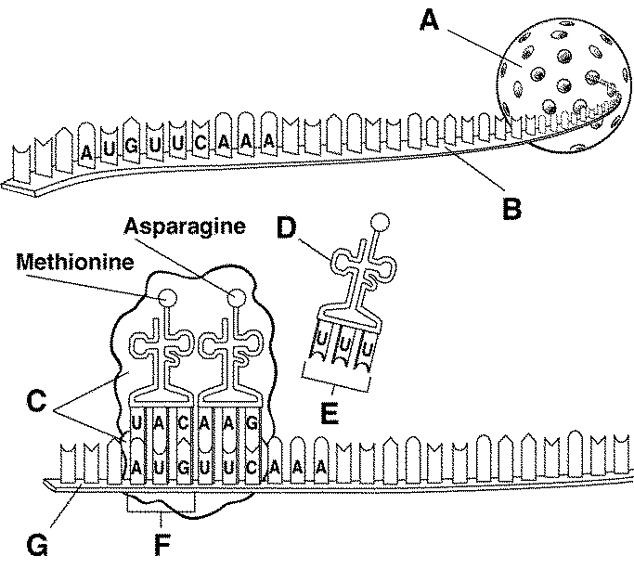

Label the:

anti-codon m-RNA codon

nucleus ribosome

amino acid t-RNA



**How is it used?**

**What is a codon chart?**

**What is an anticodon?**

***mRNA code***

**AUG CAG UAU GAU GUU UUA CCU UAG**

**___ ___ ___ ___ ___ ___ ___ ___**

***tRNA code***

**___ ___ ___ ___ ___ ___ ___ ___**

***amino acid sequence***

**What is it?**

**Where does it occur**

**TRANSLATION**

**Definition:**

**Example**

**Codons**

**Steps**

**Summary:**

**Protein Synthesis Homework**

**Visual 3**

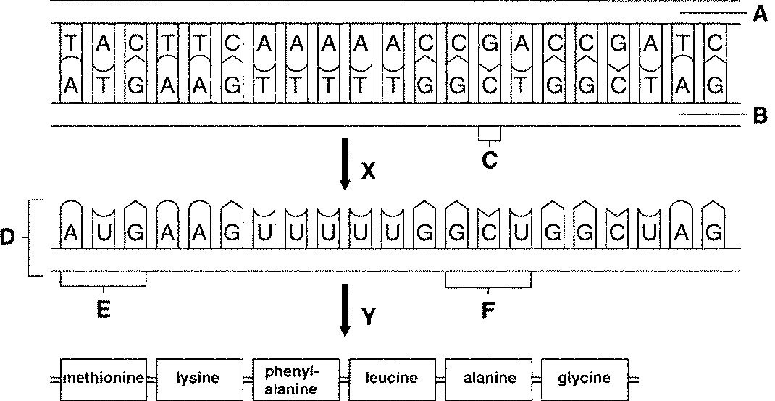

**______G______________**

__________________________

**Label the following:**

transcription DNA parent strand 1 m-RNA codon

nucleotide base DNA parent strand 2 translation protein

translation start codon

Visual Summary- Use the three visuals to write a summary of the process of protein synthesis. You must use a minimum to two of the visuals (refer to visuals in your summary) along with the words that you labeled to create your summary of protein synthesis. Your summary paragraph will be assessed based on applied scientific vocabulary, content, and depth of understanding the process. If you need more space than what is provided below, use a sheet of loose leaf.

In the process of protein synthesis…

**Mutation Notes**

|  |  |  |  |
| --- | --- | --- | --- |
| **Name** | **Definition** | **Example** | **Picture** |
|  |  |  |  |
|  |  |  |  |
|  |  |  |  |
|  |  |  |  |

**How Can A Mutation in DNA Affect an Organism?**

**Background Information**

Sometimes the DNA code that makes up a gene has an error in it. This error is called a mutation. When the DNA contains an error, the mRNA it makes will copy that error. When the mRNA contains an error, it will code for incorrect tRNAs and produce an incorrect protein. Sickle-cell anemia is a disorder that gets its name from the sickle shape of the red blood cells. The sicked red blood cells are caused by a mutation in the hemoglobin of the person with the disorder. Hemoglobin is the main protein in red blood cells. Each hemoglobin molecule carries oxygen from the lungs to all other parts of the body.

**Objectives**

In this exercise, you will:

1. examine the coding errors produced in mRNA and tRNA when there is a mutation in the DNA.
2. examine the effect of a mutation in the gene that codes for blood hemoglobin.

**Keywords**

Define the following keywords:

gene _________________________________________________________________________

hemoglobin ___________________________________________________________________

mutation _____________________________________________________________________

sickle-cell anemia ______________________________________________________________

**Procedures**

1. Examine Table 1. The two columns show a section of normal DNA and a section of DNA that has a mutation in it.
2. In Table 1, in the row marked *mRNA code*, write in the correct letters that will match with the nitrogen base letters of DNA given in the row above. Do this for both columns. Remember that A matches with U, T matches with A, C matches with G, and G matches with C.
3. Examine the codon chart provided with this lab. This chart shows which amino acids are coded for by specific sets of nitrogen bases (three per set; called a codon) of the mRNA molecule. For example, the mRNA sequence CCC codes for the amino acid "proline."
4. In Table 1, in the row marked *Order of Amino Acids*, write in the correct order of amino acids coded for by the mRNA. Do this for both normal and sickle hemoglobin.
5. In the row marked *Shape of blood cells*, **draw** in what you think will be the correct shape of blood cells for the kind of protein found in the row above. Use the diagrams in Figure 1 for reference.

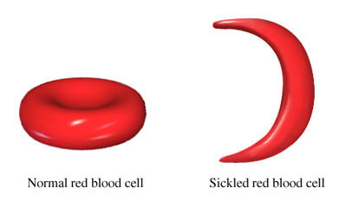**Normal hemoglobin (normal red blood cells) Sickled hemoglobin (normal red blood cells)**

**Figure 1. Shapes of blood cells**

1. In the column marked *This section codes for sickle hemoglobin*, locate the **one** nitrogen base that is different in DNA and mRNA from those in the column for normal hemoglobin. **Color** those bases that are mutations with the colored pencils.

**Table 1. Comparing Normal with Sickle Mutation DNA**

|  |  |  |
| --- | --- | --- |
|  | This section codes for normal hemoglobin. | This section codes for "sickle" hemoglobin. |
| DNA code | TGA GGA CTC CTC TTC AGA CGG | TGA GGA CAC CTC TTC AGA CGG |
| mRNA code |  |  |
| Order of amino acids |  |  |
| Shape of blood cells |  |  |

**Questions**

1. Look at the two DNA molecules in Table 1. What nitrogen base in the sickle mutation DNA is different from those of the normal DNA? _________________________________
2. If every three nitrogen bases on DNA represent a gene, how many genes are shown on
3. the section of normal DNA? _____________
4. the section of sickle hemoglobin DNA? ___________
5. List the DNA nitrogen bases (examined in Table 1) for
6. the normal genes of hemoglobin _____________________________________________
7. the sickle genes of hemoglobin ______________________________________________
8. How many bases are different in sickle hemoglobin DNA compared with normal hemoglobin DNA? ________________
9. How many genes are needed to code one amino acid into a protein such as hemoglobin? ____________
10. Define the word mutation
11. by using the word "gene" ____________________________________________________________
12. by using the phrase "DNA code" ________________________________________________________________________ ________________________________________________________________________
13. It is possible to move genes from one molecule of DNA to another. A normal gene could be put in the place of a gene with a mutation.
14. If the DNA with a mutation were corrected in this way, what would happen to the mRNA that DNA makes? ___________________________________________________________________________ ____________________________________________________________________________
15. What would happen to the protein formed by this mRNA? ________________________________________________________________________