Dehydration Synthesis:

What does the word dehydration mean?

If a reaction were called a dehydration reaction, what would you expect to be happening in that reaction?

As a ______________ is made, _____________ is released (Also known as a __________________ reaction).   
 If the forming of a polymer releases water, predict what the opposite reaction would be?

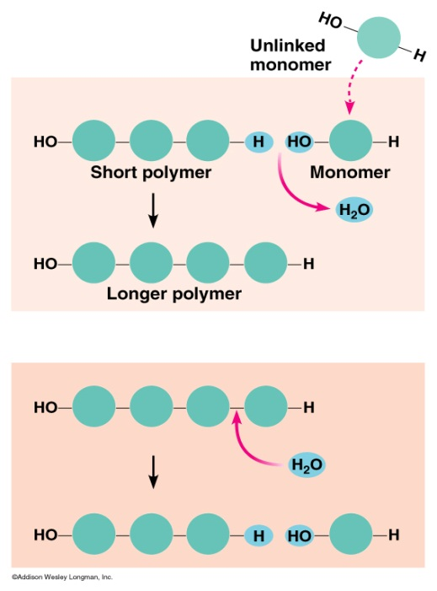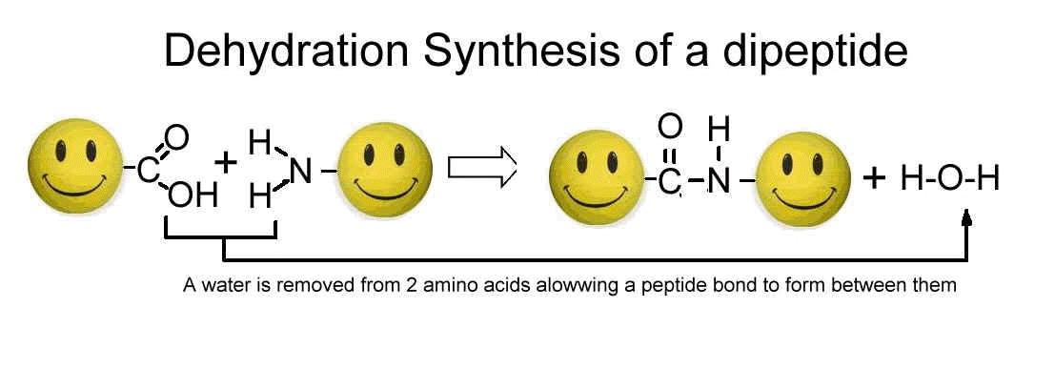

Hydrolysis:

Hydro – _________________– lysis - ___________________  
Hydrolysis =When ________________ is used to ____________ large molecules (polymers into smaller molecules).

Dehydration = Cells _________ monomers together to form a polymer accompanied by the ____________ of water, by a process known as _______________ or _____________________ synthesis. __________________________________________________________________________________________

Below is an example of dehydration synthesis. In dehydration synthesis, a hydrogen atom from one molecule joins with a hydroxyl group (-OH) from another molecule to form water, leaving two molecules bonded to the same oxygen atom. For example, when glucose and glucose combine by dehydration synthesis, they form maltose and water.

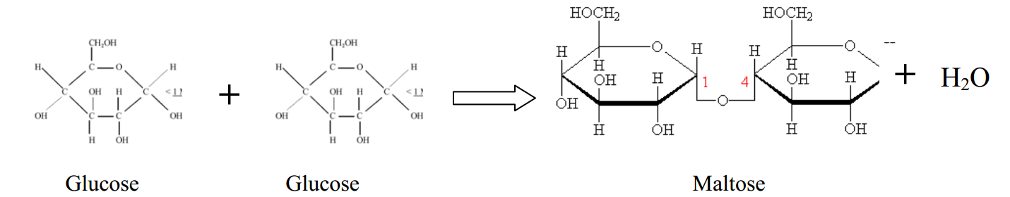

Below is an example of hydrolysis. Complex organic molecules are broken down by the addition of the components of water – H+ and OH-.

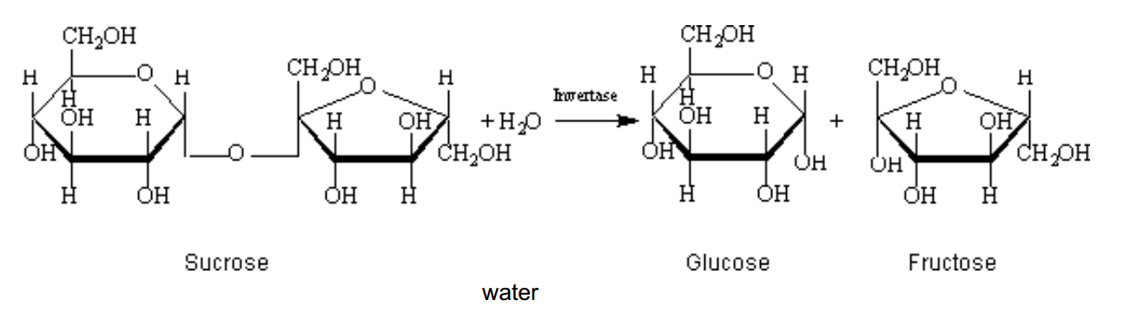

1) What are the products of the hydrolysis reaction? ____________________________________

2) What are the reactants of the dehydration synthesis reaction?________________________

3) How are the reactions in #5 and #6 related?_________________________________________

_________________________________________________________________________________

4) Look at the three reactions below. Which reaction or reaction(s) is hydrolysis taking place?______________

a. How do you know?

5) Look at the three reactions below. Which reaction(s) is dehydration synthesis taking place in? ________

1. How do you know?

6) Where is H2O located during a hydrolysis reaction? ________________________________________________

7) Where is H2O located during a condensation (dehydration) reaction? __________________________________

