Dear Parents,
We have had a great start to the school year! Fall benchmark testing for reading and math is beginning to wind down. Please schedule a conference with your child’s teacher or give them a call to discuss the results of their assessments. The results provide valuable information to parents and teachers on where students are and where they need to be academically. Let’s work together to ensure your child has all of the support they need to be successful. Do not wait until it is too late, stay involved in your child’s education throughout the year. Remember, Team Work Makes a Dream Work!
Clubs will be offered this year to students during the school day! The team is working out all of the logistics and will be sending out more information soon. This is an exciting new opportunity for our students.
Please refer to your handbook or call if you have questions. As always, our website is available and updated regularly with news and events for your convenience. We thank you in advance for your continued support.
Mrs. Robbin Temples, Principal

All classes in kindergarten had an awesome turnout at Open House. Parents, thanks for coming out and bringing your child to meet their teachers. Kindergarten teachers would also like to thank the parents for all the school supplies, and all you do! We have been working on rituals and routines in classrooms and throughout the school. We have started our reading program and will soon see many readers!
Our Super Heroes in Training will be performing on September 12th at our first PTO for 2016 school year. The kindergarten team invites all parents to come out and support their child. Let's see what our kindergartners can do. You won't be disappointed!
Let's work TOGETHER to make this school year a success!

From the Principal’s Desk
Robbin Temples, Principal
Elizabeth Knighton, Asst. Principal

Nahali Oliver, Counselor

Randolph County Elementary
School News
First grade is off to a SUPER START! The students have been learning about weather, nouns, place value, counting by tens from any number, and how to read and comprehend grade level text. Please continue to study the sight words provided for the first nine weeks. Students will be tested over these words. PTO will be held on September 12th. We are asking all parents to come show their support. TOGETHER WE can make this a successful year for OUR children.

2nd Grade

Second grade has had a great start to the 2016-17 school year!! We are all working very hard in Reading Mastery increasing our fluency, accuracy and comprehension skills. In math we are learning about place value. In language arts we have learned about compound words, using punctuation correctly and what types of words need capital letters. Narratives are what we are working on in writing. We have enjoyed learning about the different phases of the moon in science. We are looking forward to a great year of learning

Media Center
We are off to a super start in the Media Center! Please encourage your student to READ every day! Grandparents Day is coming up next month so watch for more information to come home with your student soon.
Be sure to check out our RCES web page at http://randolphcountyelem.ga.rce.schoolinsites.com where you will find the latest news, lunch menus, school calendars, and more!
Happy Reading
~Mrs. Crittenden: Media Specialist~

Mission Statement: RCES strives to be a happy place where students are inspired to excel.

Vision Statement: Everyone working together to improve student achievement.

1st Grade
Kindergarten News

RCES School News

Greetings,

I hope you had a wonderful summer and you are ready for a great school-year! I would like to welcome all of our students back to school and I look forward to getting to know all of our families.

I have worked in elementary education for the past 14 years in the Dougherty County School System as a teacher. As a guidance counselor, it is my goal to help every student be the best student they can be; this includes working directly with students as well as collaborating with families and staff. Please let me know if there’s anything I can do to help your child have a successful school year. I am excited to be a part of the RCES family and I am looking forward to having a wonderful year of teaching and learning.

Educationally Yours,

Ms. N. Oliver
Guidance Counselor

GRANDPARENTS are a
special blessing!

You are cordially invited to a Grandparent’s Day Celebration at RCES. Please see the list below for dates and times for each individual grade level.

Fourth and Fifth Grades: Tuesday, September 13, 2016 7:45-9:00
Second and Third Grades: Wednesday, September 14, 2016 7:45-9:00
Kindergarten and First Grades: Thursday, September 15, 2016 7:45-9:00

A light breakfast will be served to grandparents only beginning at 7:50 and then you will be released to visit your grandchild’s classroom until 9:00. At that time we will ask that you have a wonderful rest of your day so that the teachers and students can resume their instructional day.

Please RSVP by filling out and returning the attached form by Wednesday, September 7, 2016 so that will be able to prepare ample breakfast.

Grandparent’s Name(s):________________________________________________
Student(s) name(s) and Grade: ___________________________________________
_______Yes, I will be attending the 2016-2017 Grandparent's Day Celebration
Please check all appropriate dates:
_____Grades 4 and 5: Tuesday, 9-13-16
_____Grades 2 and 3: Wednesday, 9-14-16
_____Kindergarten and First: Thursday, 9-15-16
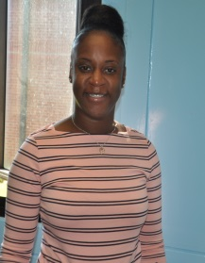

3rd Grade News
Music Returns to RCES!

Thanks to the generosity of Andrew College, each Thursday beginning September 8th, music classes will be offered at RCES. The class will meet during special area time in the teacher center. Any student interested in singing, performing, or simply learning more about the art of music is invited to participate. Mrs. Diana Boensel will be directing the music program at RCES. Mrs. Boensel is from Albany and has 16 years of experience as a children’s choir director and children’s music educator. We are extremely grateful to Andrew College for their partnership and willingness to provide this program for our students.

The third grade teachers are working very hard to prepare our students to be successful on the Georgia Milestones test in April. In math we have been using place value to round to the nearest 10 or 100 and fluently adding and subtracting within 1,000. In September, we will focus on learning our multiplication facts.
In ELA we are learning how to answer a constructed response question using the R.A.C.E. strategy. In Reading we are completing a lesson a day in Reading Mastery while focusing on reading for comprehension and answering constructed response questions that go along with our workbook pages. We are also learning how to close read in intervention/acceleration time.
In Science we are investigating the habitats of different organisms and the dependence of organisms on their habitat as well as science process skills. In Social Studies we are discussing the lives of Americans who expanded people’s rights and freedoms in a democracy.
We would like to remind you to please encourage your child to try their best in class and to come prepared for school each day. When homework is sent home, please assist them with it and continue initialing their homework folders. Thank you for your help.

5th Grade News

Math:

Students are being tested for the iLearn Math Intervention Program. Students are currently working on Place Value: Greater Than One up to the Billions - Numerical Expressions, Exponents and Powers of 10, Multiplying and Dividing 4 and 5 Digit Numbers.
ELA/Writing:
Narrative/Persuasive Writing
Writing to Text/Close Reads
Conjunctions, Prepositions, Interjections
Correlative Conjunctions
Science
5th Grade Science is learning about Plant and Animal Cells. We are also exploring the differences in unicellular and multicellular organisms and look forward to viewing samples under the microscopes.
Social Studies
5th Grade Historic Scholars will be studying government for the next couple of weeks. Effective Citizenship is the unit we are currently studying. We are excited to begin using electronic devices to enhance our learning experience and we are planning a mock election for November 2016. We encourage everyone who is an eligible to go vote November 1, 2016.
Reading
Students have just completed DIBELS Reading Test and SRI test to determine mastery of basic literacy skills & reading lexiles. We are currently working on starting a Reading Book Club in September 2016. Please encourage your child to join the Reading Book Club.

4th Grade

ELA: Students are continuing with Reading Mastery while also working on Author's Purpose and Text Structure. Students and parents remember to read 20 minutes every night.
Math: Students started off the year with Unit 1: Whole Numbers, Place Value and Rounding in Computation. As we get ready to wrap up this unit students will begin Unit 2 Multiplication and Division of Whole Numbers. Parents make sure your child is studying their basic multiplication facts so they will be well prepared for Unit 2.
Science: 4th Grade Scientists are identifying the temperatures at which water becomes a solid, liquid, and gas by using scientific inquiry skills.
Social Studies: Students kicked off the year learning about the early Native Americans. We are currently talking about the early Explorers that help shape the New World.

The fo

u

rth grade teachers are excited about this year. We are looking forward to teaching and making sure our students get what they need for the Georgia Milestones. We would like to welcome Mr. Marlon Gilbert to the fourth grade team.

RCES Welcomes New Staff Members!

Ms. Yvonne Bradley – 5th Grade Science
RCES New Faculty & Staff
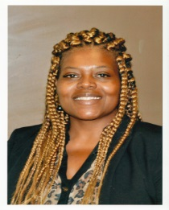
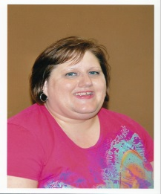
Ms. Nates Davis – 5th Grade Social Studies
Ms. Eugenia Collins – 3rd Grade
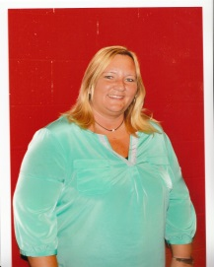
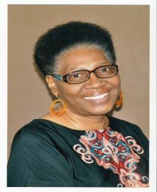
Ms. Pamela Dent – Paraprofessional
Mr. Jim Desantis- Speech/Language Pathologist
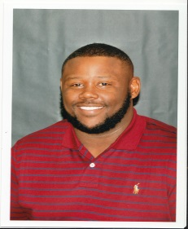
Mr. Marlon Gilbert – 4th Grade Math and Science
Mrs. Sarah Graddy - CEIS
Ms. Nahali Oliver – Counselor
Mrs. Jordan Scarborough – 2nd Grade
Mr. Tony Seymore – Custodian/Maintenance
Ms. Connie Wilson – 2nd Grade

Upcoming Events:
September 7th – Progress Reports

September 8th – Community Meeting
at J.B. Smith Complex Center 6:00

September 10th – Health Fair; RCES Cafeteria 9:00-2:00

September 12th – PTO Kindergarten and First Grade Presentation; Classroom Visitation K through 5

September 12-16 – Grandparents Week!

September 30th – Good Behavior Day (activities for students who have demonstrated good behavior)

October 1st – Andrew College Parade

October 6th – End of Nine Weeks Celebration

October 7 – Professional Learning Day for Teachers; NO school for students!

October 19th – Half-Day Conferences/Report Card Pick-up

(From left to right beginning with the 1st row)
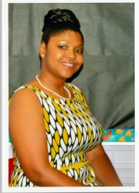

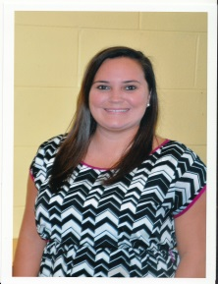
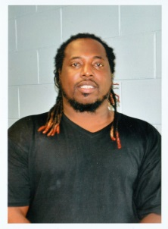

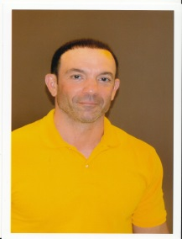
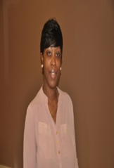

RCES Lifetouch school pictures will be taken on Thursday, September 15, 2016. The proof will be back for purchase October 5.

