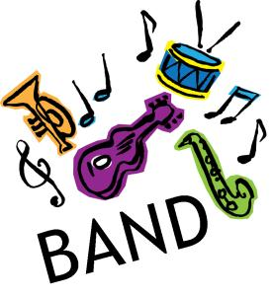
Clark County Advanced Band
Michelle Stewart
stewartm@mudlake.net
School 208-374-5215 Home 208-374-5817 cell 208-419-7881
Welcome to a new year in the Clark County Music Department. While this year may poise some personal health challenges, I am excited to see what the future holds! I have high expectations for each student & together we can accomplish much. Please feel free to contact me with any questions, concerns, comments and suggestions.

Course Description:
Advanced Band provides opportunities for students to further develop their musical potential, refine core concepts & fundamentals introduced in Beginning Band, & develop skills necessary to successfully play a woodwind, brass or percussion instrument. This band is made up of students with previous instrumental experience and who demonstrate dedication to a musical instrument.

Students in Advanced Band (along with Beginning Band) make up the District Pep Band which provides entertainment for high school sporting events.
**Please contact me if you do NOT want your student to participate in Pep Band**

Course Objective:
The objectives of this course is for students to be able to perform various “shows”, events and concerts at a level in which they meet the following high standards:

Students should be able to produce good tone, contrast in dynamics, appropriate style and articulations, and a display of enough technical ability in order to read and perform the selected ensemble music. Students should also be able to blend and balance with the rest of their ensemble.
In addition to developing musical skills, students in this course will learn to work together as a team. They will learn to rely on one another and to be reliable. The students will also develop work habits that are important both in and out of the musical environment and in life in general.

Music Philosophy:
Music is a common language that reaches across boundaries to bring cultures together and creates a global understanding. Music allows junior & senior high school students to explore the vast expanse of feeling and emotion beyond the limitations of words. These experiences inspire them to become lifelong learners who appreciate and value music.

Music Mission Statement:
Music Education is an important part of the school curriculum which provides an outlet for auditory creativity and self-expression. Our mission is to help all students, regardless of musical talent, establish a solid and permanent relationship with music, which will contribute to personal growth and satisfaction throughout life.
Course Expectations:
- Positive Attitude
- Be on time & prepared, participate & demonstrate appropriate behavior
- Show respect for yourself, others & property
- Have Materials needed every day:
- Instrument & Music/binder
- Pencil
- Notebook/Paper
- School Planner

GRADING:
- Attendance & Participation—class, concerts & other performances
- We work together as a team. When even one person is absent, the entire ensemble is affected and virtually incomplete.
- Please let me know of conflicts with performances as early as possible!
- Daily participation grade (10 points a day)
- Pep band will be counted as extra credit
- Weekly Practice—completed & SIGNED practice sheets due each Monday.
- Quizzes & Performance Tests

Duties & Expectations of the Clark County Band Member:
- Be on time to class and performances. (For performances: EARLY IS ON TIME – ON TIME IS LATE!)
- Leave every place cleaner than you found it!
- Upon entering the classroom setting, acquire your instrument and go directly to your seat.
- When the director or staff member steps on the podium or asks for your attention, all talking should cease.
- Come to class with a GOOD ATTITUDE
- Take care of your equipment at all times: before, during, and after class, rehearsals and performances.
- Play ONLY your instrument.
- Be considerate of those around you.
- Become responsible for and assume responsibility for your own actions. Admit when you are wrong.
- Display respect for yourself and those in authority
- Follow dress code requirements at all activities/competitions/performances
- Read and play music with insight – have musical expectations.
- Have fun making music!

SUPPLY REQUIREMENTS
Students will also need the following items according to their instruments (some items are in the instrument cases; otherwise, they are available at an additional charge):
Flutes Clarinets
• Cleaning rod • Reeds
• Cleaning swab • Cork grease
• Cloth (washcloth, old t-shirt, etc.) • Cleaning swab
Saxophones Trumpets, Horns, Baritones
• Reeds • Valve oil
• Cleaning swab • Cloth (washcloth, old t-shirt, etc)
• Cloth (washcloth, old t-shirt, etc.)
Trombones Percussion
• Slide cream/oil • Drum sticks
• Cloth (washcloth, old t-shirt, etc.) • Practice pad

CC Music Program’s Future:
It is my desire that students continue with the music program throughout their Jr. High & High School career. Festivals, competitions, and “fun” opportunities will be scheduled in the future. Music in the Park (at Lagoon) will only be scheduled if we have a few successful fundraisers. Currently, funds are tight and any competitions will not be possible without parents & students involvement and support. With the students & parents support, the CC Music Department can continue to take root and grow into a strong and enduring program.

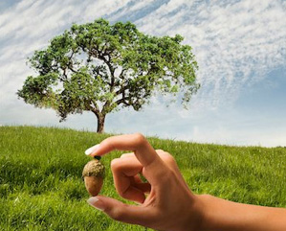

Please sign and return attached paper stating the student and parents have both read and understand the expectations of the course. Thank you.

