|  |  |  |  |  |  |
| --- | --- | --- | --- | --- | --- |
| Item  *Limited Sizes – please email for size availability  Spirit Spot Order Form | Color | Cost | Size | Quantity | Total |
| Embroidered Hoodie | Black | $35 |  |  |  |
| Glitter Pullover | Purple | $35 |  |  |  |
| Sweat Pants | *Grey / *Black | $20 |  |  |  |
| Crew Neck Sweatshirt | *Grey/ *Dark Grey/ Black | $20 |  |  |  |
| Female Athletic Shorts | Black | $20 |  |  |  |
| Long Sleeve T-Shirt | Grey/ Black | $15 |  |  |  |
| Vintage T-Shirt | Dark Grey | $15 |  |  |  |
| YOUTH Vintage T-Shirt | Dark Grey | $12 |  |  |  |
| YOUTH T-Shirt | *Grey | $10 |  |  |  |
| T-Shirt | *White | $10 |  |  |  |
| Winter Hat | Purple and White | $15 |  |  |  |
| Baseball Hat | Black/ White with Purple “M” | $15 |  |  |  |
| Ear Warmer | Black with Purple Embroidered “M” | $10 |  |  |  |
| Tumbler | Purple | $6 |  |  |  |
| Manteno Ornament in white box | Purple and White | $5 |  |  |  |
| Draw String Bag | Purple and Black | $5 |  |  |  |
| Window Decal | Purple | $5 |  |  |  |
| Seat Cushion | Purple and White | $5 |  |  |  |
| Pennant | Purple and White | $4 |  |  |  |
| Super Fan Pack | Purple and White | $12 | purple hair, bow tie, clown nose, face paint, paw tattoos, glow stick, #1 finger |  |  |
| Panther Pack | Purple and White | $5 | megaphone, paw tattoos, glow sticks, beads |  |  |
| Foam Paw | Purple and White | $3 |  |  |  |
| Glow Stick | Purple | $1 |  |  |  |
| Paw Tattoo | Purple | 25¢ |  |  |  |
| **TOTAL COST** |  |  |  |  |  |

Name: ____________________________________ Address: ____________________________________ Phone Number: _____________________________

Building (if applicable): PS ES MS HS *Make checks payable to MHS Student Council*

Please return spirit wear order form or email your order to Amy Younker (high school - ayounker@manteno5.org).

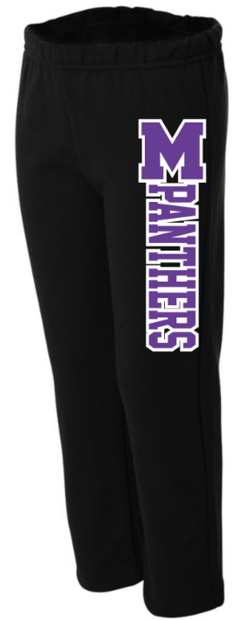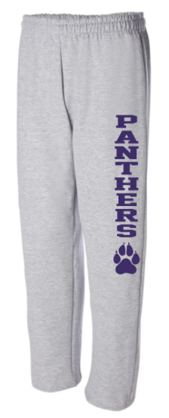Apparel

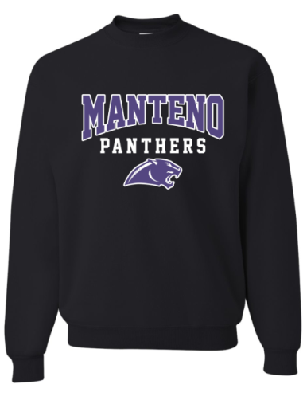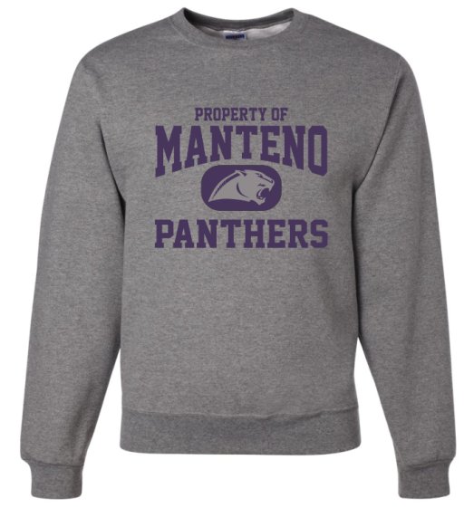

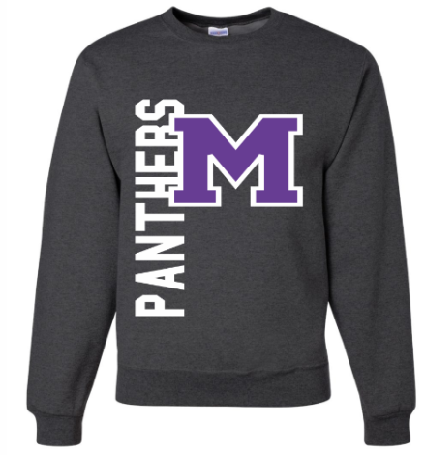

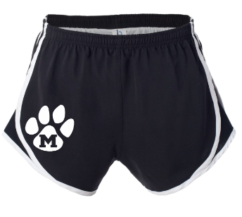

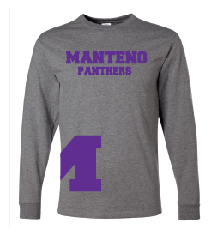

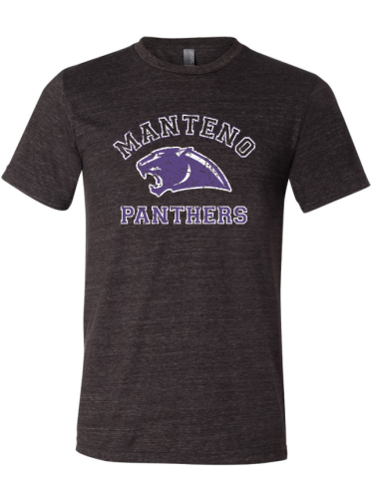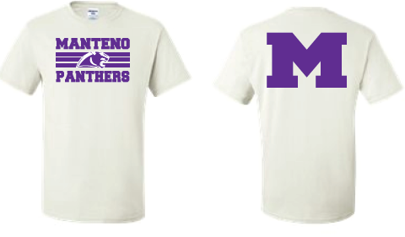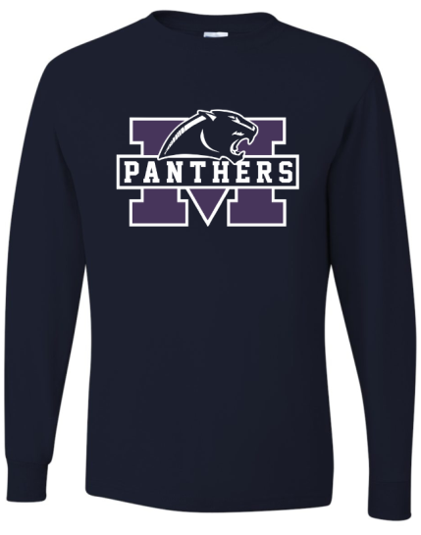

“M” wraps around the side

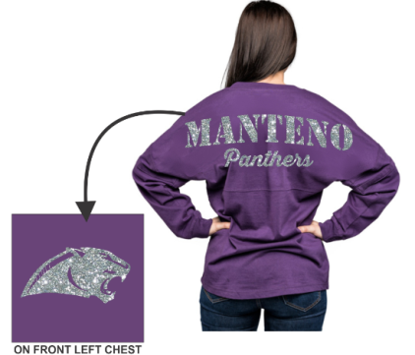

Front Back

*youth sized t-shirt is in grey*



Embroidered Hoodie

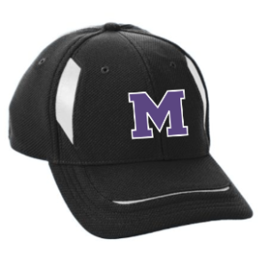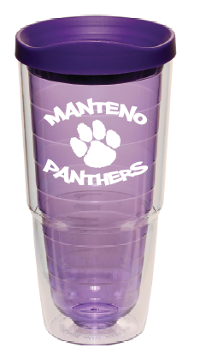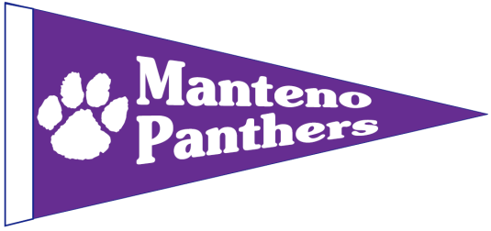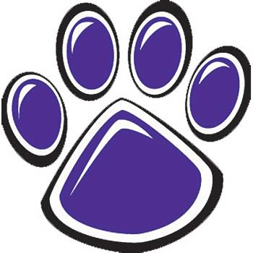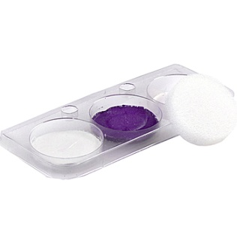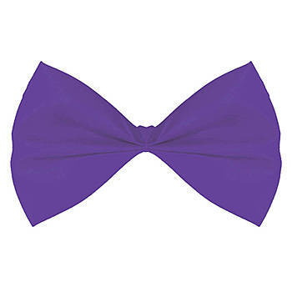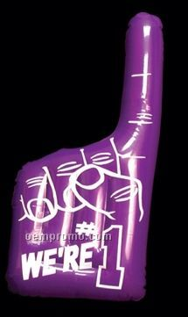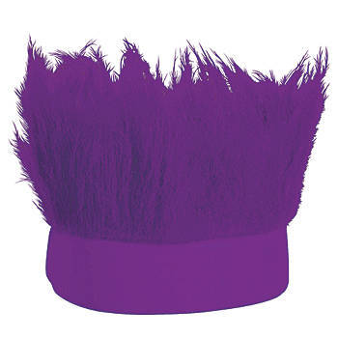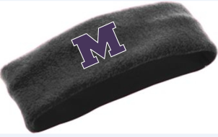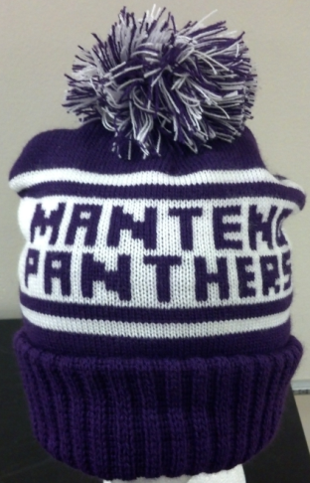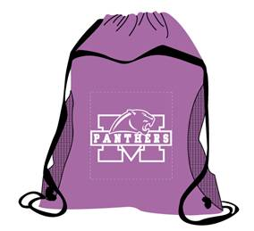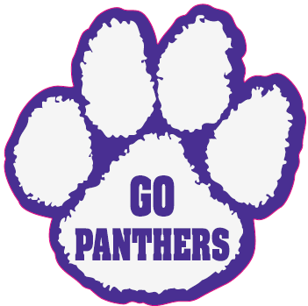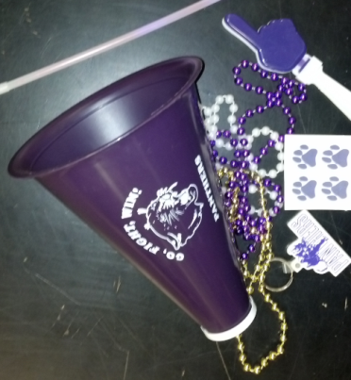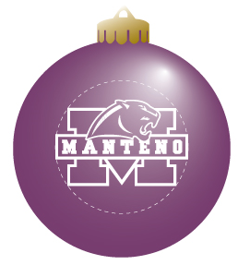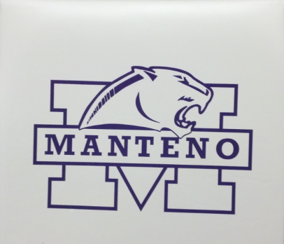

Baseball Hat

Winter Hat

Pennant

Super Fan Pack

Ear Warmer

Bag

Tumblers

Foam Paw

Panther Pack

Ornament

Seat Cushion

PANTHER PRIDE

Window Decal