Toddler/Youth Spirit Wear
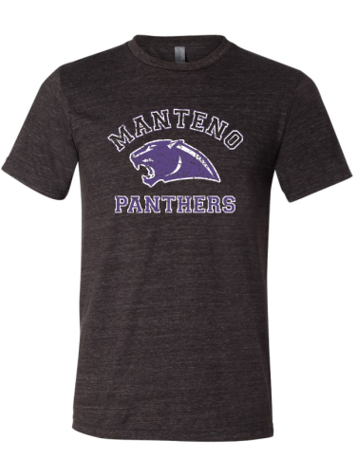
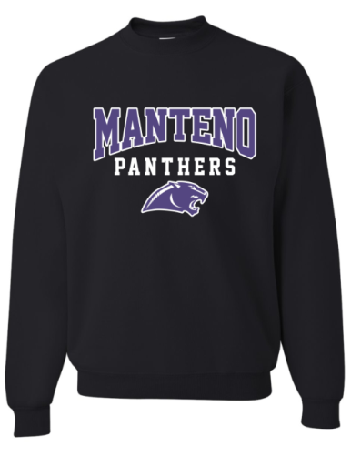

Name: ______________________________________________________

Phone Number: _____________________________________________

Grey Vintage T-shirt size ($15) 2T 3T 4T YS YM YL Total

Quantity ___ ___ ___ ___ ___ ___ _______

Black Crew Sweatshirt size ($20) 2T 3T 4T YS YM YL Total

Quantity ___ ___ ___ ___ ___ ___ _______

Due: Friday, September 18.

