STEM Project #1 – Community Garden / Landscape Plan
Launch Activities: Dr. Strietelmeier writes client letter to students asking them to investigate uses for 307 E. Valparaiso Street Property
Lessons Covered: | STEM Activity: | Other Activities/Resources:
Chapter 9  Area and Perimeter of Geometric Figures  (Area of simple 2D shapes, simple operations with positive numbers) | Students measure 307 E. Valparaiso Street Property  ↓  Students compile measurement data  ↓  Students create landscape plan in Excel to scale (1/2)  ↓  Students find amount of useable space on 307 E. Valparaiso property | 1. Students study one of the major constraints of the property, lack of running water to the site.  2. Students research various herbs  3. Students study self-watering systems  https://www.youtube.com/watch?v=rTXDQrAMWws and  https://www.youtube.com/watch?v=hIqssok6iXI&index=  9&list=PL86AC58B96094A73B&feature=iv&src_vid=  QRZt2YG1VaY&annotation_id=annotation_997226  4. Students create a 2 liter bottle self-watering herb garden with oversite from client (Dr. Strietelmeier) and Mrs. Schnick.
Chapter 7  Collecting, Displaying, and Analyzing Data  (Making line graphs, bar graphs, circle graphs, etc.) | Students track weather at home using weather.com  ↓  Students learn to create graphs in Excel  ↓  Students input their weather data in to Excel  ↓  Students create graphs of their weather data | 1. Students begin to research general growing data such as growing zones and crops they would and would not want to grow, citing specific reasons.  2. Students go on leaf exploration activity to identify a plant by its leaves – leaves belong to plants not native to our area so they are forced to see what things they cannot/should not grow in area (lemon, key lime, avocado)
Chapter 1 and 2  Integers and Rational Numbers and Algebraic Reasoning  (Adding, Subtracting, Multiplying, and Dividing with Positive and Negative Numbers, Order of Operations | Students study major constraints of property (trees and driveway)  ↓  Students research alternative growing methods – raised beds (thanks to Mr. William Smith, Agriculture teacher) and string gardening/kokedama  ↓  Students find costs of dealing with constraints. Students see value in alternative ways of dealing with constraints.  ↓  Students write order of operations problem that deals with removing/solving constraints | 1. Students experience “The Land” at Epcot to see alternative growing methods in action - https://www.youtube.com/watch?v=M6qcPkddT4I and see various videos on kokedama such as https://www.youtube.com/watch?v=LZdTFJjVSEg
Follow Up Activities:
1) Students write business letter to Dr. Strietelmeier as to why or why not we should grow a community garden using correct formatting. Students are also able to create a company letterhead for the company “Stem Projects Westville”
2) Students fill out report form that details first several steps of STEM process
[ Define >> Learn >> Plan >> Try >> Test >> Decide ]
3) Lowe’s comes out to speak to students to discuss suggestions for property (still to come)
4) Students write revision plan, as necessary (still to come)
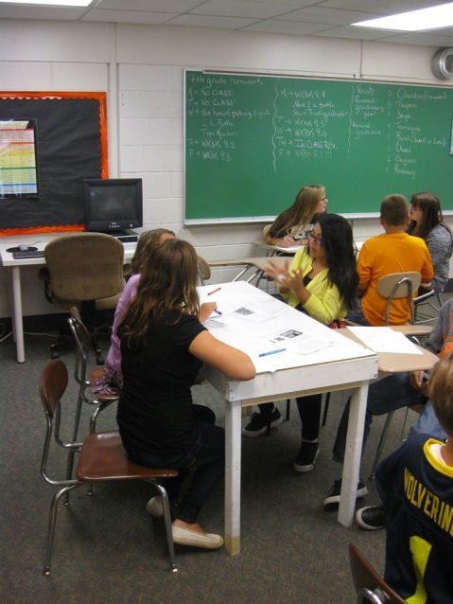 | 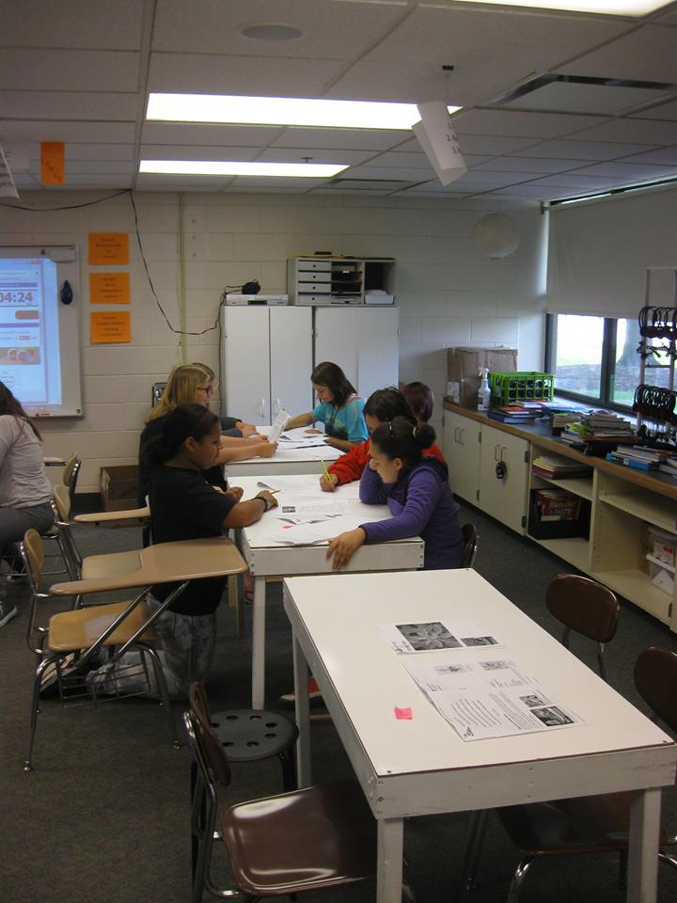
Students researching herbs in groups. Students read about all the herbs they could grow and then ranked them, based on their own analysis, from most likely to want to grow from least likely to want to grow. | More research…
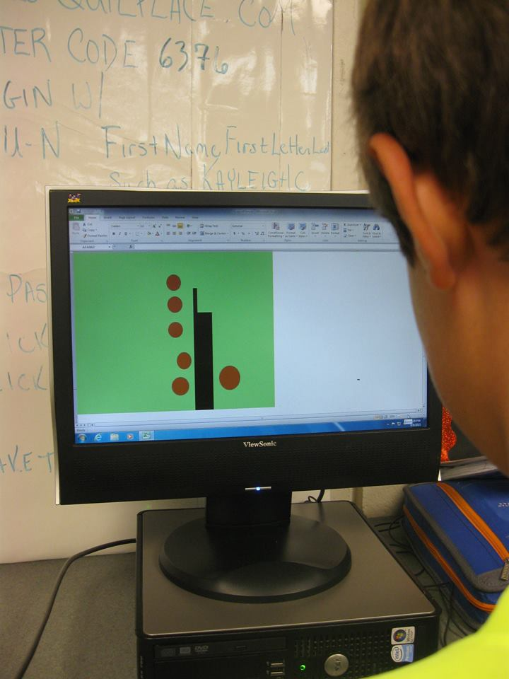 | 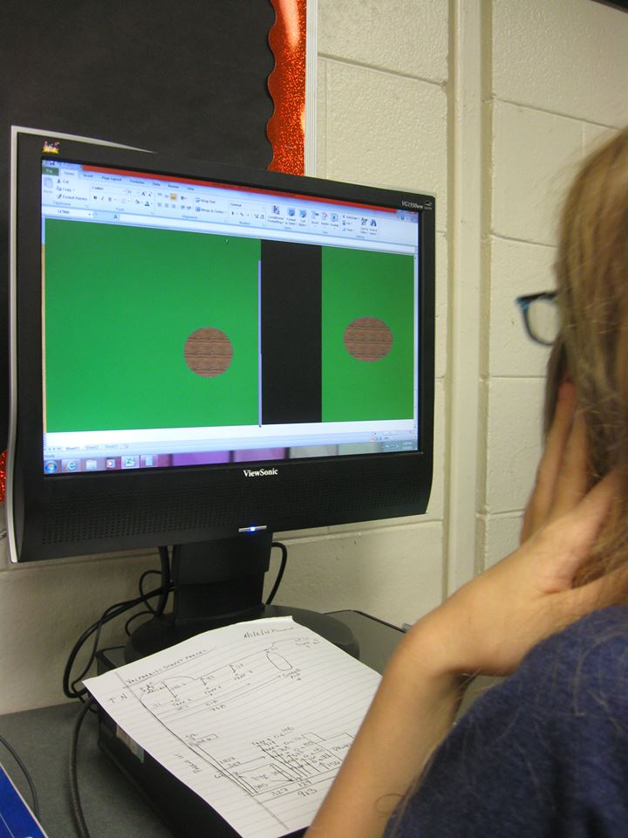
After measuring the 307 E. Valparaiso property, students created a scaled version of the property in Excel using a scale of ½. Pictured is student Trevor Henckel sketching the driveway and the trees around the driveway | More landscape planning. Picture is Emma Ton adding texture and gradient to her trees surrounding the driveway.

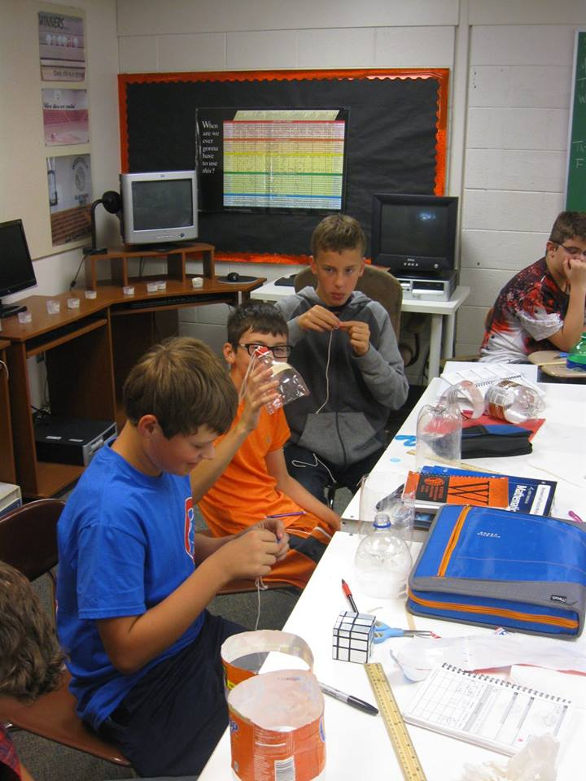 | 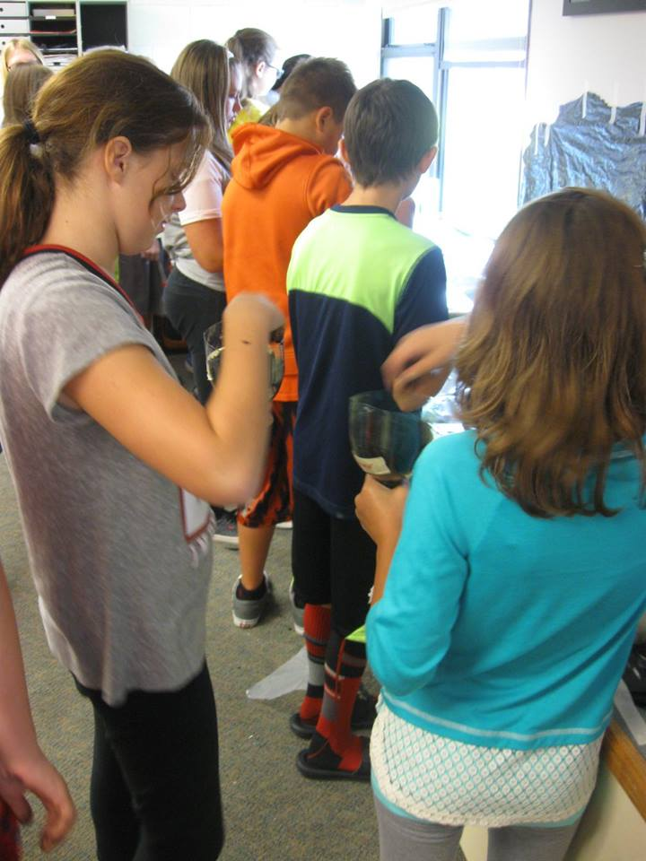
Students created 2 liter pop bottle gardens after their herbs research. Here are students in 6th and 7th hour in the creation phase. | Students in 2nd and 3rd hour taking care of planting their seeds.
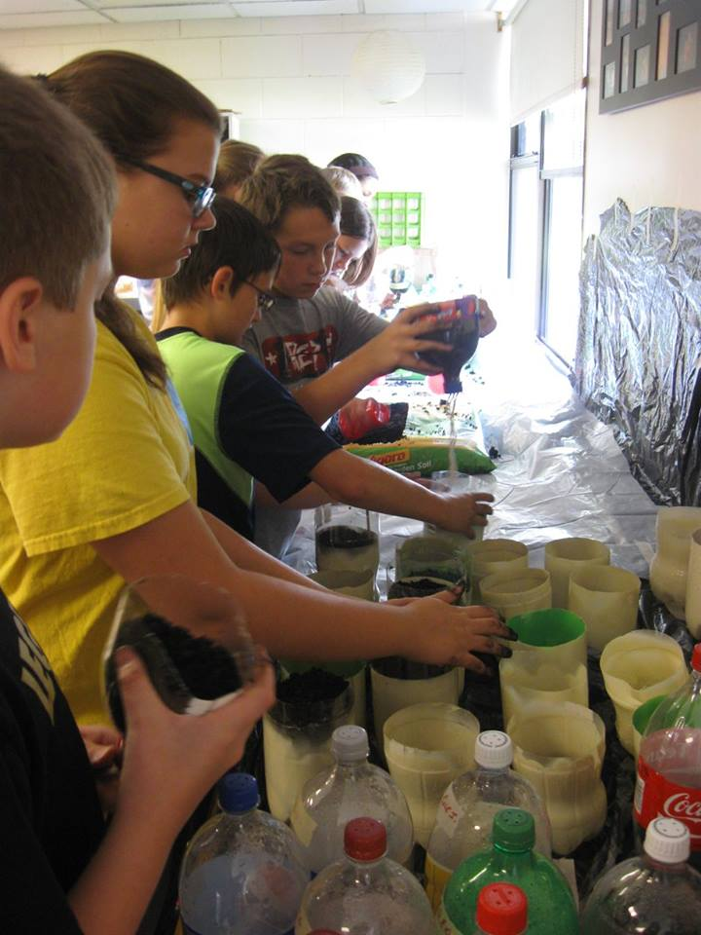 | 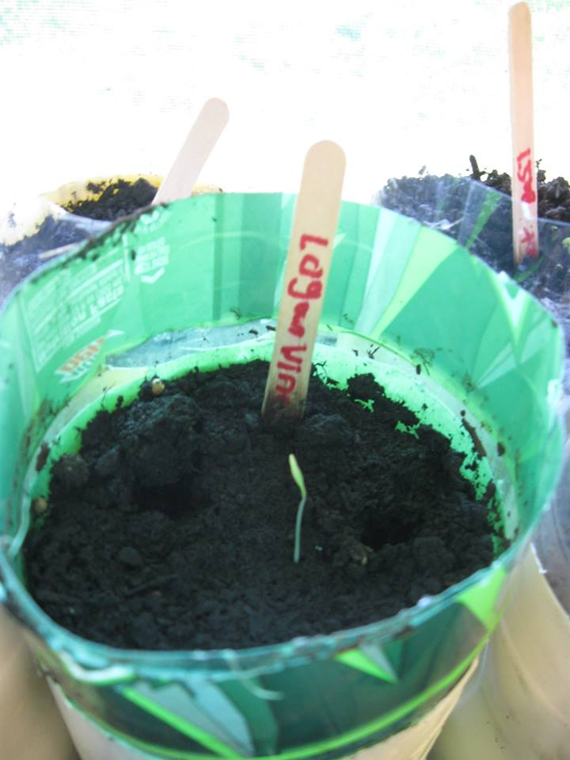
Students in 2nd and 3rd hour with their finished products. | Just about 10 days later, the herbs have sprouted!

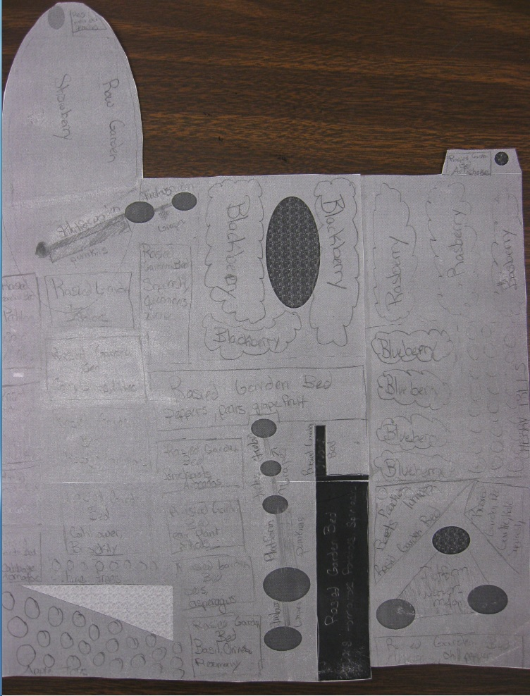 | 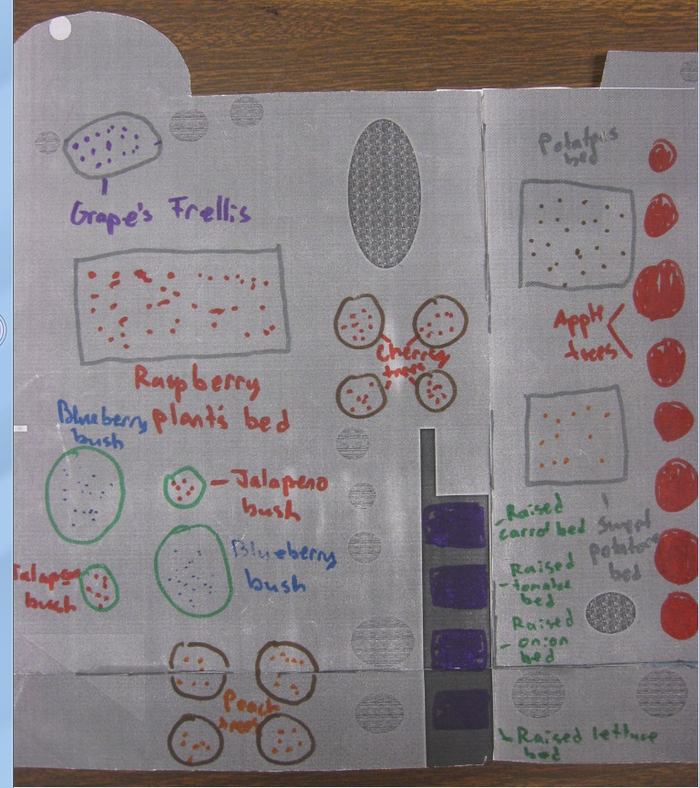
A landscape plan, labeled with garden ideas | Another landscape plan, labeled with garden ideas, this time in color.

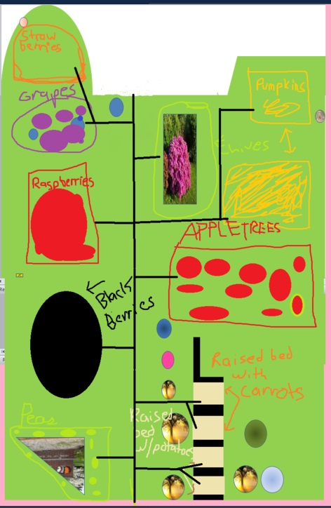 | 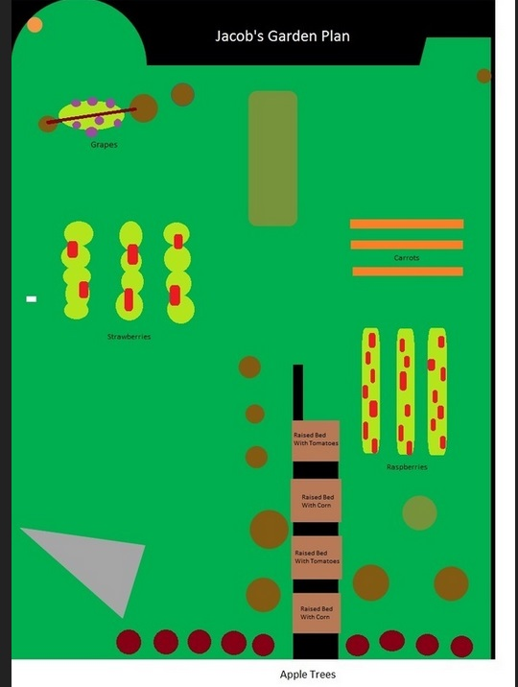
An entirely computer generated version of the landscape plan. Many students have never done any serious drawing in Microsoft Paint using the mouse, so this was quite a challenge for them. Students also learned how to take a snapshot of the screen and import that screen shot in to Paint in the process. | Another computer generated landscape plan with gardens labeled.

Several different letterheads for the company “Stem Projects Westville” created by our seventh grade students
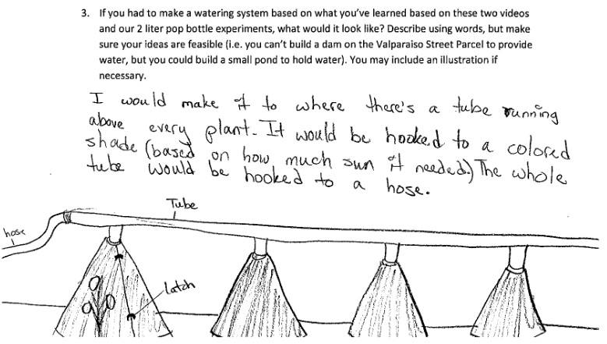 | 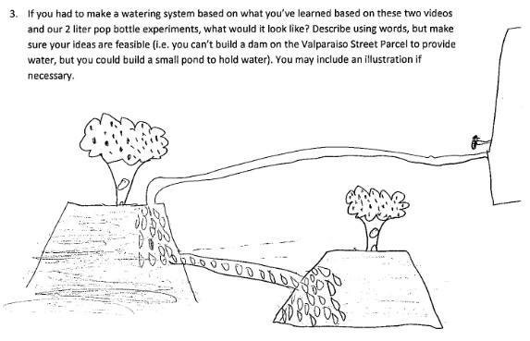
Student drawings of how to deal with the lack of running water on site.

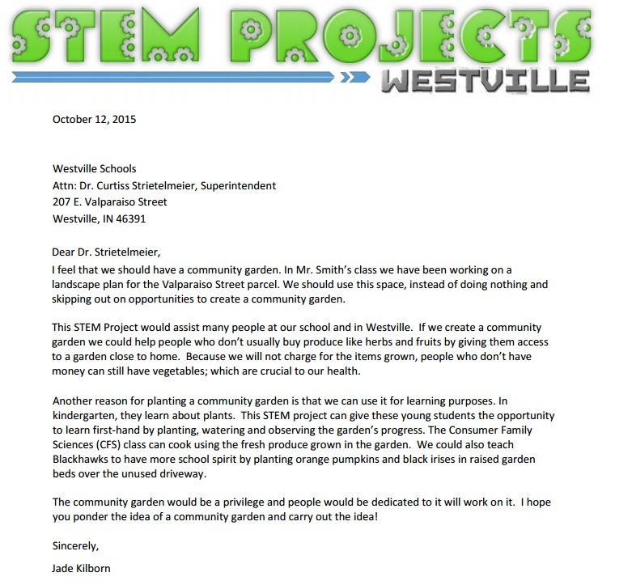 | JPEG version of Business Letter, including optional letterhead, written to Dr. Strietelmeier.  The task/objective was to write a letter to convince Dr. Strietelmeier as to why we should or should not use the parcel as a community garden.
Other Information:
Dr. Strietelmeier shared this article with me about the benefit of community gardens.
http://www.districtadministration.com/article/school-gardens-become-teaching-tools
Where Do We Go From Here?
The link to our next unit is the Excel piece. Now students will explore computer programming using the Hour of code program. Students will explore simple coding using the Hour of Code program which uses games the kids know like Angry Birds and Plants vs. Zombies to teach the basic programming in a step by step format.
https://studio.code.org/hoc/1
Then, with their basic programming knowledge, students will create simple Excel programs that add and subtract multi-digit numbers.
Later in the year we will continue studying the parcel, looking at it for other uses, specifically producing energy. What benefit would there be to placing solar panels there? How does a solar energy system work? What benefit would there be to placing windmills there? How do windmills produce energy? Which is the better option?

