Business Principles Name: _____________________________________________
10.5 Forecasting Demand
10.6 Breakeven Analysis
Using the information given in the text, select a product (any LEGAL product) that you want to sell. Answer the questions listed in the image.
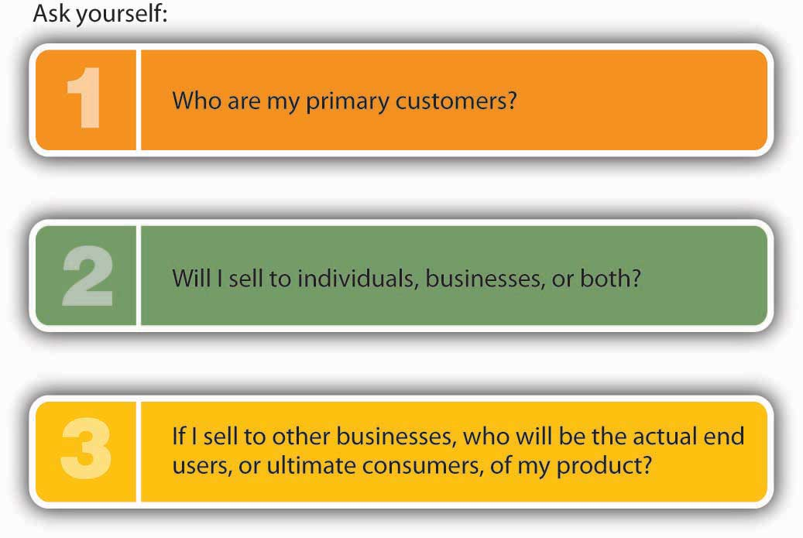
What product are you selling? _________________________________________________________
What are your answers? Write them below. ______________________________________________________________
______________________________________________________________________________________________________________________________________________________________________________________________________________________________________________________________________________________________________
Use these questions to create a questionnaire and survey 10 people in class. Use a piece of paper to create your survey.
1) What do you like about this product idea?
2) What don’t you like?
3) What improvements would you make?
4) What benefits would you get from it?
5) Would you buy it? Why, or why not?
6) What would it take for you to buy it?
Research a similar product and locate sales information. For instance, if you want to sell bass boats, you might Google Ranger Boat sales and find information on the number of boats sold or the dollar amount of income made from the sales. What information did you locate?
7) What is the product that is similar to your choice? _______________________________________________________
8) What information did you find? ______________________________________________________________________
__________________________________________________________________________________________________
9) Define: market share ______________________________________________________________________________
__________________________________________________________________________________________________
10.6 Breakeven Analysis
10) Define: Breakeven analysis _________________________________________________________________________
__________________________________________________________________________________________________
11) Define: fixed costs ________________________________________________________________________________
__________________________________________________________________________________________________
12) Give an example of a fixed cost for a business. _________________________________________________________
13) Define: variable costs _____________________________________________________________________________
__________________________________________________________________________________________________
14) Give an example of a variable cost for a business. _______________________________________________________
15) Write the formula to use when calculating contribution margin per unit ____________________________________
__________________________________________________________________________________________________
16) Write the formula to use when calculating breakeven point in units ________________________________________
__________________________________________________________________________________________________
17) (AACSB) Analysis
For the past ten years, you’ve worked at a PETCO Salon as a dog groomer. You’re thinking of starting your own dog grooming business. You found a place you could rent that’s right next to a popular shopping center, and two of your friends (who are also dog groomers) have agreed to work for you. The problem is that you need to borrow money to start the business and your banker has asked for a breakeven analysis. You have prepared the following cost estimates for your first year of operations:
Fixed Costs
Salaries | $105,000
Rent and utilities | $36,000
Advertising | $2,000
Equipment | $3,000
Variable Cost per Dog
Shampoo | $2.00
Coat conditioner | $1.50
Pet cologne | $0.75
Dog treats | $1.25
Hair ribbons | $0.50
You went online and researched grooming prices in your area. Based on your review, you have decided to charge $32 for each grooming.
Part 1:
1. What’s the breakeven point in units—how many dogs will you need to groom in the first year to break even?
2. If you and your two employees groomed dogs five days a week, seven hours a day, fifty weeks a year, how many dogs would each of you need to groom each day? Is this realistic given that it takes one hour to groom a dog?
Part 2:
3. If you raised your grooming fee to $38, how many dogs would you need to groom to break even?
4. At this new price, how many dogs will each of you have to groom each day (assuming, again, that the three of you groom dogs fifty weeks a year, five days a week, seven hours a day)?

