Business Principles Name: _____________________________________________________
12.3 Accrual Accounting
12.4 Financial Statement Analysis (skip)
12.5 The Profession: Ethics and Opportunities (skip)
13.1 The Functions of Money
13.2 Financial Institutions
1) Explain the difference between accounts PAYABLE and accounts RECEIVABLE _________________________________
____________________________________________________________________________________________________________________________________________________________________________________________________
2) Define: inventory _________________________________________________________________________________
__________________________________________________________________________________________________
3) Describe a long-term or fixed asset ___________________________________________________________________
__________________________________________________________________________________________________
4) Define: accrual accounting __________________________________________________________________________
__________________________________________________________________________________________________
5) Define: useful life _________________________________________________________________________________
__________________________________________________________________________________________________
6) Define: depreciation expense ________________________________________________________________________
__________________________________________________________________________________________________
7) Define: classified balance sheet ______________________________________________________________________
__________________________________________________________________________________________________
8) Define: liquidity ___________________________________________________________________________________
__________________________________________________________________________________________________
9) Compare current assets and long term assets – what is the difference? ______________________________________
__________________________________________________________________________________________________
10) Compare current liabilities and long term liabilities – what is the difference? _________________________________
__________________________________________________________________________________________________
11) Define: merchandiser _____________________________________________________________________________
__________________________________________________________________________________________________
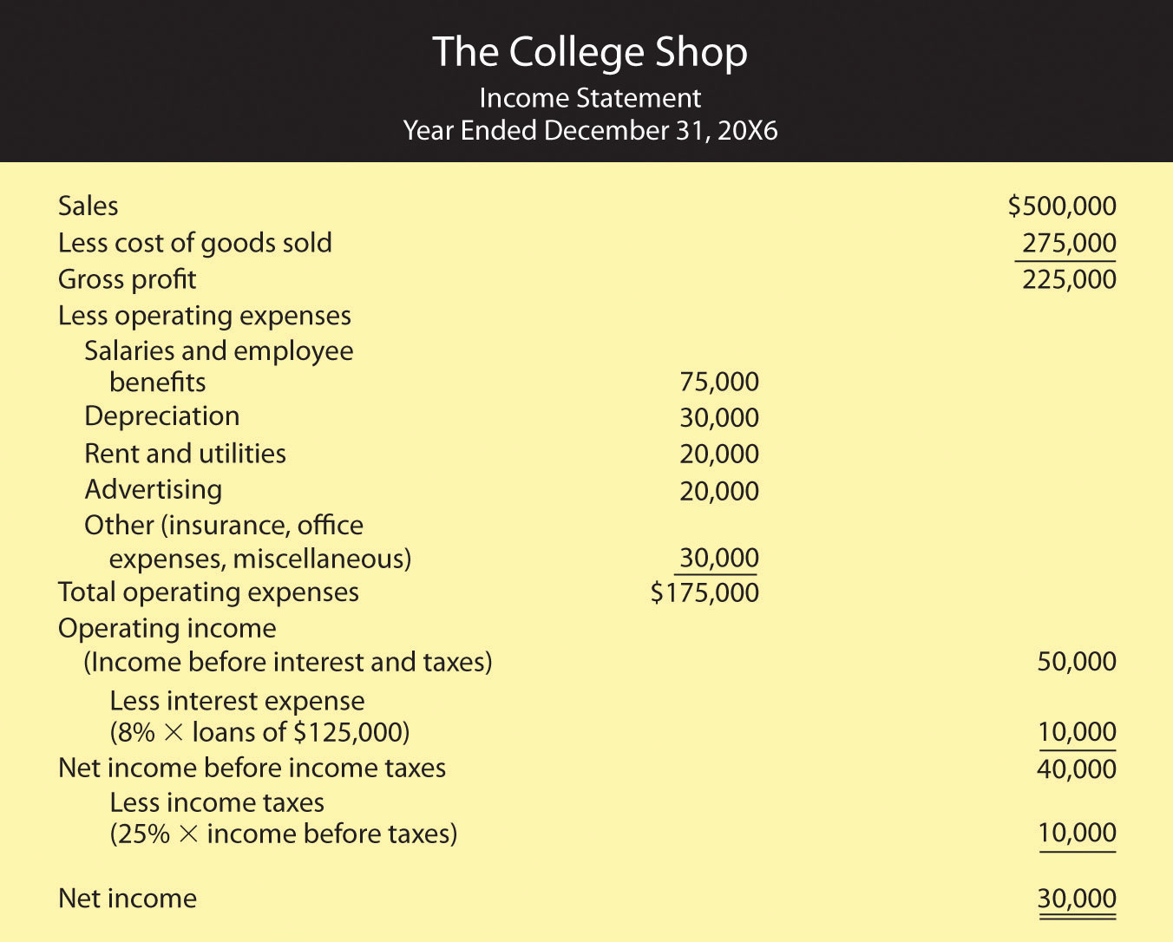
12) Define: cost of goods _____________________________________________________________________________
__________________________________________________________________________________________________
13) Define: cost of goods sold __________________________________________________________________________
__________________________________________________________________________________________________
14) Explain interest expense ___________________________________________________________________________
__________________________________________________________________________________________________
15) Define: statement of cash flows _____________________________________________________________________
__________________________________________________________________________________________________
16) Explain operating activities _________________________________________________________________________
__________________________________________________________________________________________________
17) Explain investing activities _________________________________________________________________________
__________________________________________________________________________________________________
18) Explain financing activities _________________________________________________________________________
__________________________________________________________________________________________________
19) (AACSB) Analysis
To earn money to pay some college expenses, you ran a lawn-mowing business during the summer. Before heading to college at the end of August, you wanted to find out how much money you earned for the summer. Fortunately, you kept good accounting records. During the summer, you charged customers a total of $5,000 for cutting lawns (which includes $500 still owed to you by one of your biggest customers). You paid out $1,000 for gasoline, lawn mower repairs, and other expenses, including $100 for a lawn mower tune-up that you haven’t paid for yet. You decided to prepare an income statement to see how you did. Because you couldn’t decide whether you should prepare a cash-basis statement or an accrual statement, you prepared both. What was your income under each approach? Which method (cash-basis or accrual) more accurately reflects the income that you earned during the summer? Why?
CREATE AN INCOME STATEMENT BELOW – YOU MAY USE GOOGLE IMAGES TO LOCATE AND DRAW THE TEMPLATE. THE ACCOUNTS AND DOLLAR AMOUNTS ARE IN THE PARAGRAPH ABOVE.

20) Three forms of money are:

21) Define: bartered _________________________________________________________________________________
__________________________________________________________________________________________________
22) For money to be used in this way, it must possess a few crucial properties:
23) What are demand deposits? _______________________________________________________________________
__________________________________________________________________________________________________
24) How do money market mutual funds pay interest? _____________________________________________________
__________________________________________________________________________________________________
25) Explain M1 and M2 (these are tricky so pay attention) ___________________________________________________
______________________________________________________________________________________________________________________________________________________________________________________________________________________________________________________________________________________________________
26) (AACSB) Analysis
Instead of coins jingling in your pocket, how would you like to have a pocketful of cowrie shells? These smooth, shiny snail shells, which are abundant in the Indian Ocean, have been used for currency for more than four thousand years. At one point, they were the most widely used currency in the world. Search “cowrie shells” on Google and learn as much as you can about them. Then answer the following questions:
1. How effectively did they serve as a medium of exchange in ancient times? __________________________________
______________________________________________________________________________________________________________________________________________________________________________________________________________________________________________________________________________________________________
__________________________________________________________________________________________________
2. What characteristics made them similar to today’s currencies? ____________________________________________
______________________________________________________________________________________________________________________________________________________________________________________________________________________________________________________________________________________________________
__________________________________________________________________________________________________
3. How effective would they be as a medium of exchange today? ____________________________________________
__________________________________________________________________________________________________________________________________________________________________________________________________________________________________________________________________________________________________________________________________________________________________________________________________________________________________________________________________________________________________________

27) What are the most common types of depository institutions?
28) Explain commercial banks _________________________________________________________________________
____________________________________________________________________________________________________________________________________________________________________________________________________
29) Explain savings bank ______________________________________________________________________________
____________________________________________________________________________________________________________________________________________________________________________________________________
30) Explain credit unions ______________________________________________________________________________
____________________________________________________________________________________________________________________________________________________________________________________________________
31) What is a finance company? ________________________________________________________________________
____________________________________________________________________________________________________________________________________________________________________________________________________
32) What is an insurance company? _____________________________________________________________________
__________________________________________________________________________________________________
33) Define: brokerage firm ____________________________________________________________________________
__________________________________________________________________________________________________
34) Define: mutual fund ______________________________________________________________________________
__________________________________________________________________________________________________
35) What is a money market fund? _____________________________________________________________________
__________________________________________________________________________________________________
36) IRA is the acronym for? ____________________________________________________________________________
37) Explain what an IRA is _____________________________________________________________________________
__________________________________________________________________________________________________
38) FDIC is the acronym for? __________________________________________________________________________
38) Explain what the FDIC does ________________________________________________________________________
__________________________________________________________________________________________________
39) Describe the money multiplier – what is the purpose? ___________________________________________________
__________________________________________________________________________________________________
Money multiplier = 1/Reserve requirement
40) (AACSB) Analysis
Congratulations! You just won $10 million in the lottery. But instead of squandering your newfound wealth on luxury goods and a life of ease, you’ve decided to stay in town and be a financial friend to your neighbors, who are hardworking but never seem to have enough money to fix up their homes or buy decent cars. The best way, you decide, is to start a bank that will make home and car loans at attractive rates. On the day that you open your doors, the reserve requirement set by the Federal Reserve System is 10 percent. What’s the maximum amount of money you can lend to residents of the town? What if the Fed raises the reserve requirement to 12 percent? Then how much could you lend? In changing the reserve requirement from 10 percent to 12 percent, what’s the Fed trying to do—curb inflation or lessen the likelihood of a recession? Explain how the Fed’s action will contribute to this goal. ______________________________________________________________________________________________________________________________________________________________________________________________________________________________________________________________________________________________________

