Business Principles Name: _________________________________________________
Ch 1 and
1.2 Getting Down to Business
1) Why do you believe Apple is used as the example to start off this textbook? __________________________________
__________________________________________________________________________________________________
Why is Apple significant? Why not Microsoft or another company? Research Apple to locate how the company was started and tell me about it. ___________________________________________________________________________
______________________________________________________________________________________________________________________________________________________________________________________________________________________________________________________________________________________________________
2) Watch “What Makes Apple So Successful?” https://www.google.com/url?sa=t&rct=j&q=&esrc=s&source=video&cd=1&cad=rja&uact=8&ved=0ahUKEwi-4JG3vNHTAhXJ5CYKHSMoBJQQtwIIITAA&url=https%3A%2F%2Fwww.youtube.com%2Fwatch%3Fv%3DrSwhu-Fc4T4&usg=AFQjCNFr7gIe7oUxe4pYoHQ1OzvndGvoGw – Summarize what the video states is the key to success. ______
________________________________________________________________________________________________________________________________________________________________________________________________________________________________________________________________________________________________________________________________________________________________________________________________________
3) Read Jon Hilsenrath, Serena Ng, and Damian Paletta, “Worst Crisis Since ’30s, With No End Yet in Sight,” Wall Street Journal, Markets, September 18, 2008, http://online.wsj.com/article/SB122169431617549947.html (accessed January 21, 2012). What crisis is referred to? _______________________________________________________
_______________________________________________________________________________
4) Economic turmoil that began in the _________________________ and _________________________ industries as a result of troubled subprime mortgages quickly spread to the rest of the economy. In 2008, credit markets froze up and banks stopped making loans. Lawmakers tried to get money flowing again by passing a $700 billion Wall Street bailout, yet businesses and individuals were still denied access to needed credit. Without money or credit, consumer confidence in the economy dropped and consumers cut back their spending. Businesses responded by producing fewer products, and their sales and profits dropped. Unemployment rose as troubled companies shed the most jobs in five years, and 760,000 Americans marched to the unemployment lines.
5) What is the difference between ‘housing’ and ‘mortgage’? ________________________________________________
__________________________________________________________________________________________________
5) Read “How the Economy Stole the Election,” CNN.com, http://money.cnn.com/galleries/2008/news/0810/gallery.economy_election/index.html (accessed January 21, 2012). What was the main concern of voters? __________________________________________________________________
What happened in July? ______________________________________________________________________________
__________________________________________________________________________________________________
What happened in August? ___________________________________________________________________________
__________________________________________________________________________________________________
6) The ______________________ market reacted to the financial _____________________ and its stock prices dropped by ______________________ percent while millions of Americans watched in shock as their ______________________ and __________________________ accounts took a nose dive. In fall 2008, even Apple, a company that had enjoyed strong sales ___________________________ over the past five years, began to cut production of its popular iPhone. Without ____________________ or ______________________, consumers would no longer flock to Apple’s fancy retail stores or buy a prized iPhone.
7) Define: consumer _________________________________________________________________________________
__________________________________________________________________________________________________
8) Define: retail _____________________________________________________________________________________
__________________________________________________________________________________________________
9) Read Dan Gallagher, “Analyst says Apple is cutting back production as economy weakens,” MarketWatch, November 3, 2008, http://www.marketwatch.com/news/story/apple-cutting-back-iphone-production/story.aspx?guid=%7B7F2B6F99-D063-4005-87AD-D8C36009F29B%7D&dist=msr_1 (accessed January 21, 2012). Summarize, IN YOUR OWN WORDS, this article. _____________________________________________________
____________________________________________________________________________________________________________________________________________________________________________________________________
__________________________________________________________________________________________________
10) You see the chart at the top of the article in #9? We are going to create a spreadsheet where you will track the price of stock during this year. At the end of the year, you will calculate to find if you made money or lost money. Directions:
1. Open MS Excel on your computer > Click the icon for Windows in the bottom left of your screen, > Select All Apps, > Select Excel. 2. SAVE AS ‘Stock Spreadsheet’ to your desktop. This will be your bellringer EVERY DAY. 3. Choose a company that you would like to track – practically any company you can think of sells stock. 4. Open Google Finance https://www.google.com/finance/portfolio?action=view&pid=1&ei=4KUIWeG5DKWwmgHek4DgCw 5. In the ‘Search Finance’ search box, type the name of any company you wish. Select a company and stock. 6. Go back to the Excel Spreadsheet and complete it similar to what I have below. You have $1,000 to spend on each stock. Choose FIVE companies – if a company is private, meaning they give their employees and owners stock, you will not be able to track the price. Your spreadsheet should look similar to this, except you will only have data for today, NOT nine days like I have. The stock price as of TODAY is where you will begin. Calculate: $1,000 / stock price. The stock price will change every day, therefore you will need to re-calculate the number of shares you own every day.
Ms. Ferguson
Stock: Home Depot
 | 2-May | 3-May | 4-May | 5-May | 6-May | 7-May | 8-May | 9-May |  | 10-May
$1,000 / $154.71 | 154.71 | 148.41 | 151.25 | 152 | 152.04 | 149.11 | 150.96 | 155.23 |  | 151.68
= 6.46 shares | 6.04 | 6.74 | 6.61 | 6.58 | 6.58 | 6.71 | 6.62 | 6.44 |  | 6.59
as of May 2, 2017
Stock: Stanley Black and Decker
 | 2-May | 3-May | 4-May | 5-May | 6-May | 7-May | 8-May | 9-May |  | 10-May
$1,000 / $137.15 | 137.15 | 143.54 | 143.01 | 139.64 | 136.99 | 137.28 | 141.72 | 141.36 |  | 145.62
= 7.29 shares | 7.29 | 6.97 | 6.99 | 7.16 | 7.30 | 7.28 | 7.06 | 7.07 |  | 6.87
as of May 2, 2017
Stock: Pepsi Co
 | 2-May | 3-May | 4-May | 5-May | 6-May | 7-May | 8-May | 9-May |  | 10-May
$1,000 / $112.28 | 112.28 | 112.98 | 110.11 | 98.98 | 99.04 | 110.25 | 112.46 | 111.65 |  | 112.79
= 8.91 shares | 8.91 | 8.85 | 9.08 | 10.10 | 10.10 | 9.07 | 8.89 | 8.96 |  | 8.87
as of May 2, 2017
Stock: L Brands (Bath & Body Works)
 | 2-May | 3-May | 4-May | 5-May | 6-May | 7-May | 8-May | 9-May |  | 10-May
$1,000 / $52.21 | 52.21 | 53.24 | 52.86 | 51.44 | 50.62 | 51.99 | 53.49 | 54.02 |  | 53.88
= 19.15 shares | 19.15 | 18.78 | 18.92 | 19.44 | 19.76 | 19.23 | 18.70 | 18.51 |  | 18.56
as of May 2, 2017
Stock: Ebay
 | 2-May | 3-May | 4-May | 5-May | 6-May | 7-May | 8-May | 9-May |  | 10-May
$1,000 / $33.49 | 33.49 | 34.79 | 34.65 | 33.97 | 32.11 | 35.81 | 36.5 | 36.52 |  | 37.26
= 29.86 shares | 29.86 | 28.74 | 28.86 | 29.44 | 31.14 | 27.93 | 27.40 | 27.38 |  | 26.84
as of May 2, 2017

11) As you go through the course with the aid of this text, you’ll explore the exciting world of business. We’ll introduce you to the various activities in which businesspeople engage—_______________________, ______________________, information technology, _____________________, ___________________________, and operations. We’ll help you understand the roles that these activities play in an organization, and we’ll show you how they work together.
12) Define: business ________________________________________________________________________________
13) Define: profit ___________________________________________________________________________________
14) Define: not-for-profit organization __________________________________________________________________
__________________________________________________________________________________________________
15) Define: management
16) How does a manager PLAN? ________________________________________________________________________
__________________________________________________________________________________________________17) How does a manager ORGANIZE? ___________________________________________________________________
__________________________________________________________________________________________________
18) How does a manager STAFF? _______________________________________________________________________
__________________________________________________________________________________________________
19) How does a manager DIRECT? ______________________________________________________________________
__________________________________________________________________________________________________
20) How does a manger CONTROL? _____________________________________________________________________
__________________________________________________________________________________________________
21) Put these in the correct order: CONTROL, ORGANIZE, PLAN, STAFF, DIRECT

22) Which are TANGIBLE products and which are INTANGIBLE?
_______________________ Electricity _________________________ McDonald’s French fries
_______________________ MediaCom _________________________ Sonic strawberry slush
_______________________ Levi jeans _________________________ Bath & Body Works lotion
_______________________ Hair brush _________________________ Television
_______________________ Postage stamp _________________________ Trademark
_______________________ Dollar Value of website _________________________ Internet service
23) Describe the role of an Operations Manager ___________________________________________________________
____________________________________________________________________________________________________________________________________________________________________________________________________
24) Think of a business in Hopkinsville. Which business might have an operations manager? _______________________
__________________________________________________________________________________________________
25) Describe the role of marketing ______________________________________________________________________
__________________________________________________________________________________________________
26) Go to Google and type “average salary of operations manager in Kentucky’. What salary is shown? _______________
27) Use the annual salary in #26 ____________________ / 52 weeks / 40 hours = ________________________________
(type the salary above) (hourly rate for full-time employment)
28) Explain the difference between a financial accountant and a managerial accountant __________________________
__________________________________________________________________________________________________
__________________________________________________________________________________________________
29) Finance involves >
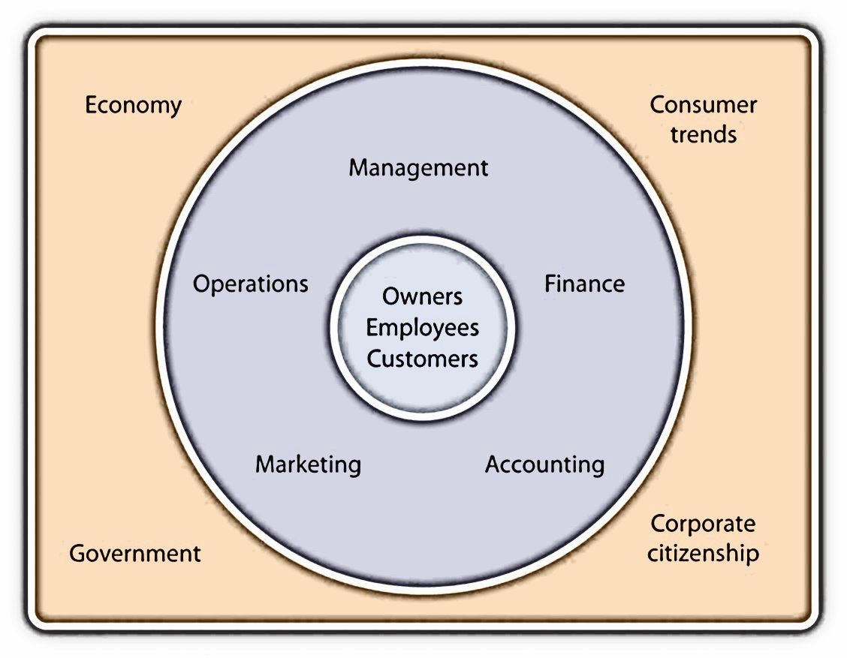
30) List the FOUR types of external pressure companies like Apple must deal with.

31) A strong ___________________________means people have more money to eat out at places where food standards are monitored by a ___________________________ agency, the Food and Drug Administration. Preferences for certain types of foods are influenced by ____________________________ (eating fried foods might be OK one year and out the next). Finally, a number of decisions made by the industry result from its _____________________________
________________________________________________________________.
32) Match the words – WORD BANK: Management, Profit, Operations, Marketing, Finance, Accounting
Involves planning, organizing, staffing, directing, and controlling resources to achieve organizational goals.
Involves planning for, obtaining, and managing company funds.
Works to identify and satisfy customers’ needs.
Transforms resources (labor, materials, money, and so on) into products.
Entails measuring, summarizing, and communicating financial and managerial information.
33) (AACSB) Analysis
The Martin family has been making guitars out of its factory in Nazareth, Pennsylvania, factory for more than 150 years. In 2004, Martin Guitar was proud to produce its millionth instrument. Go to https://www.martinguitar.com/about/ to link to the Martin Guitar Web site and read about the company’s long history. You’ll discover that, even though it’s a family-run company with a fairly unique product, it operates like any other company. Identify the main activities or functions of Martin Guitar’s business and explain how each activity benefits the company. BE THOROUGH!!!! _________
________________________________________________________________________________________________________________________________________________________________________________________________________________________________________________________________________________________________________________________________________________________________________________________________________________________________________________________________________________________________________________________________________________________________________________________________________________________________________________________________________________________________________________________________________________________________________________________________________________
34) Use the partially completed learning map and complete your own. Everyone’s answer will probably not be the same. Write down the tasks under each category that make the most sense to you.
_________________________ __________________________
_________________________ __________________________
_________________________ __________________________
_________________________ __________________________
_________________________ __________________________
_________________________ __________________________
_________________________ __________________________
_________________________ __________________________
Accounting
Marketing
Operations
Finance
Management

_______________________________ _________________________________
_______________________________ _________________________________
_______________________________ _________________________________
_______________________________ _________________________________
_______________________________ _________________________________
_______________________________ _________________________________
_______________________________ _________________________________
_______________________________ _________________________________
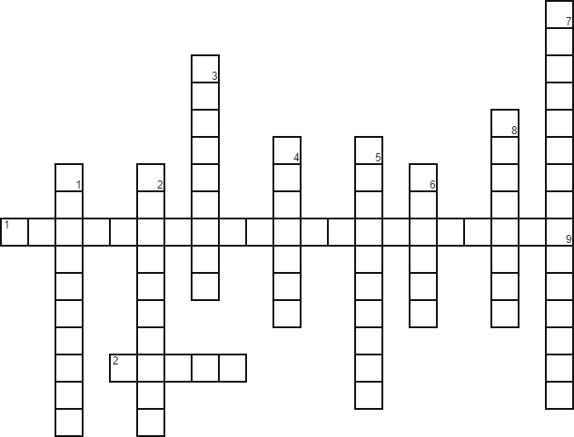

Across
- prepare information, such as reports on the cost of materials used in the production process, for internal use only
- products sold to consumers

Down
- involves planning, organizing, staffing, directing, and controlling resources to achieve organizational goals
- transforms resources (labor, materials, money, and so on) into products
- works to identify and satisfy customers’ needs
- involves planning for, obtaining, and managing company funds
- entails measuring, summarizing, and communicating financial and managerial information
- their primary role is to invest money in the business
- these people work for a business
- any activity that provides goods or services to consumers for the purpose of making a profit
- an activity sold to consumers

