Business Principles Name: ___________________________________________
Ch 6
6.4 Directing and 6.5 Controlling
6.5 Controlling
6.6 Managerial Skills
6.7 Cases and Problems
1) Define: directing __________________________________________________________________________________
2) Use F. John Reh, “Management 101,” About Management, http://management.about.com/cs/generalmanagement/a/Management101.htm(accessed October 8, 2011) to complete the following skills listed in the article. 1) List the name of the skill 2) Tell me what it means.
Skill #1 Skill #2 Skill #3 Skill #4
__________________ __________________ ___________________ __________________
Meaning: __________ Meaning: __________ Meaning: __________ Meaning: ___________
___________________ ____________________ ____________________ ____________________
____________________ ____________________ ____________________ ____________________
____________________ ____________________ ____________________ ____________________
____________________ ____________________ ____________________ ____________________
____________________ ____________________ ____________________ ____________________
________________ ________________ ________________ __________________
Skill #1 __________________________

3) Define: leadership style ____________________________________________________________________________
__________________________________________________________________________________________________
4) Name and Describe the THREE types of styles listed. 1) ___________________________________________________
__________________________________________________________________________________________________________________________________________________________________________________________________________ 2) __________________________________________________________________________________________
_________________________________________________________________________________________________________________________________________________________________ 3) _________________________________
____________________________________________________________________________________________________________________________________________________________________________________________________
5) Describe the differences between transactional leadership and transformational leaders. Be thorough!! ___________
______________________________________________________________________________________________________________________________________________________________________________________________________________________________________________________________________________________________________
____________________________________________________________________________________________________________________________________________________________________________________________________
6) Complete the diagram for the 5 Step Control Process

7) What are technical skills? ___________________________________________________________________________
__________________________________________________________________________________________________
8) What are interpersonal skills? _______________________________________________________________________
__________________________________________________________________________________________________
9) What are conceptual skills? _________________________________________________________________________
__________________________________________________________________________________________________
10) What are communication skills? ____________________________________________________________________
__________________________________________________________________________________________________
11) What are time management skills? __________________________________________________________________
__________________________________________________________________________________________________
12) What are decision making skills? ____________________________________________________________________
__________________________________________________________________________________________________
13) Label each as a(n) technical skill, interpersonal skill, or conceptual skill.
________________________ A. Making a formal presentation to a group on employees.
________________________ B. Using financial statements to explain income taxes to an accounting client.
________________________ C. Preparing ad campaigns for television commercials.
________________________ D. You are trying to motivate a group of investors to ‘buy-in’ to your product.
________________________ E. Managing a team of volunteers at summer camp.
________________________ F. You need to ‘think outside the box’.
________________________ G. For mid-level managers, this skill is important.
________________________ H. This is probably the last skill top-level executive acquire.
________________________ I. Entry level employees most likely learn this skill first.
________________________ J. If you are continuously late to work, you obviously need to improve this.
________________________ K. You are a manager who needs to solve a problem within the business.
________________________ L. Several friends are in an argument – which skill would you use to speak to everyone?
________________________ M. You are writing a cover letter for a job.
________________________ N. Your job in the Air Force is to assemble helicopter propellers.
________________________ O. You have sports practices, loads of homework, and a part-time job. How do you juggle?
________________________ P. It seems text messages and friends are always interrupting your homework..
________________________ Q. Your parents are upset with you because your chores are not completed daily.
________________________ R. The coach is upset with you, so you yell at him and then storm off the field.
________________________ S. You need to take a math test to qualify for a job.
14) Outline the 6 step approach to problem solving.
15) Define: controlling _______________________________________________________________________________
16) List the six steps for controlling:
17) What are technical skills? Where does a person learn technical skills? ______________________________________
____________________________________________________________________________________________________________________________________________________________________________________________________
18) Describe interpersonal skills. _______________________________________________________________________
_____________________________________________________________ How does a person show interpersonal skills?
____________________________________________________________________________________________________________________________________________________________________________________________________
19) Define: conceptual skills ___________________________________________________________________________
__________________________________________________________________________________________________
20) Define: time-management skills _____________________________________________________________________
__________________________________________________________________________________________________
21) List the six examples of time-management skills:
22) Define: delegate _________________________________________________________________________________
23) Of the six examples listed in #21, which do you feel are YOUR strengths and which are weaknesses?
STRENGTHS WEAKNESSES
24) Explain why decision-making skills are important at work ________________________________________________
_______________________________________________________________________________________________________________________________________________________________________________________________________________________ Why are decision-making skills important in life (think of ethical reasoning)?________________
______________________________________________________________________________________________________________________________________________________________________________________________________________________________________________________________________________________________________
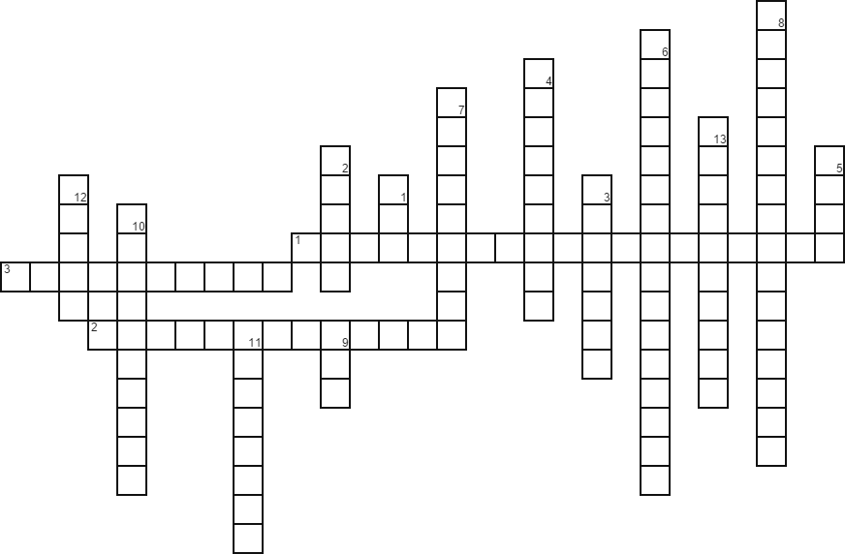
Across
1. Diagram listing all the people in the business from the top on down.
2.Ability to get along with and motivate people.
3. Process of entrusting work to subordinates.
Down
1. Small Business Administration
2. Nonprofit association dedicated to helping small businesses get off the ground.
3. Andrew Mason started this business.
4. Walmart's founder.
5. Strengths, weaknesses, opportunities, threats
6. Proactively dealing with catastrophe.
7. Skills needed to perform specific tasks
8. Ability to reason abstractly and analyze complex situations.
9. The number of steps to solve a problem.
10.Allocates resources (people, equipment, and money) to achieve a company’s plans.
11. Managers set goals and determine the best way to achieve them.
12. Major accomplishments that the company wants to achieve over a long period.
13. Short-term performance targets

6.7 Cases and Problems
1) To Manage or Not to Manage? (15 points)
Are you interested in a career that pays well and offers power, prestige, and a feeling of accomplishment? A career in management may be for you, but be forewarned that there’s a downside: you have to make tough decisions, other people will be after your job, and it can be lonely at the top. To find out more about the pros and cons of a management career, go to http://management.about.com/cs/yourself/a/ManagementForMe.htm to link to the About.com Web site and read the article “Is Management for Me?” Then, answer the following questions, being sure to provide an explanation for each of your answers:
1) Which of the pros of being a manager are important to you? 2) Which are not? 3) WHY? ________________________
________________________________________________________________________________________________________________________________________________________________________________________________________________________________________________________________________________________________________________________________________________________________________________________________________
4) Which of the cons might discourage you from pursuing a management career? ______________________________
____________________________________________________________________________________________________________________________________________________________________________________________________
Which might not? 5) _________________________________________________________________________________ __________________________________________________________________________________________________
__________________________________________________________________________________________________
6) Considering balance, does a career in management appeal to you? 6) Why, or why not? ________________________
______________________________________________________________________________________________________________________________________________________________________________________________________________________________________________________________________________________________________
2) Sugarcoating the News at Krispy Kreme (35 points)
According to Krispy Kreme’s “Code of Ethics for Chief Executive and Senior Financial Officers,” the company’s top executives are expected to practice and promote honest, ethical conduct. They’re also responsible for the health and overall performance of the company. Recently, however, things have gone wrong in the top echelons of the doughnut-shop chain.
First, a little background. Founded as one small doughnut shop in Winston-Salem, North Carolina, in 1937, the brand became increasingly popular over the next six decades, taking off in the 1980s and 1990s. By 2003, Krispy Kreme (which went public in 2000) was selling more than a billion doughnuts a year. That’s when things started to go stale. (For more details on the company’s ups and downs, go to http://jacksonville.com/tu-online/apnews/stories/012205/D87OTSIG0.shtml and read the article “Krispy Kreme: The Rise, Fall, Rise and Fall of a Southern Icon.”)
When sales first started to decline in the fall of 2003, CEO Scott Livengood offered a variety of creative explanations, mostly for the benefit of anxious investors: high gas prices discouraged people from driving to doughnut shops; supermarket sales were down because grocery stores were losing business to Wal-Mart; people were cutting back on carbohydrates because of the popular Atkins diet. Unfortunately, other (more plausible) explanations were beginning to surface. To complete this exercise, you’ll need to find out what they were. Go to http://www.usatoday.com/money/industries/food/2005-08-10-krispy-kreme_x.htm?POE=MONISVA to link to USA Today Web sites, and then read the article: “Krispy Kreme Must Restate Earnings by $25.6M.” Once you have a good grasp of the company’s problems and you’ve read about the people who are responsible, answer the following questions, being sure to provide explanations for your responses:
1) What factors contributed to the problems at Krispy Kreme? _______________________________________________ ______________________________________________________________________________________________________________________________________________________________________________________________________________________________________________________________________________________________________________________________________________________________________________________________________________________________________________________________________________________________________________________________________________________________________________________________________________________________________________________________________________________________________________

2) What happened to the company? 3) Who was hurt? _____________________________________________________
________________________________________________________________________________________________________________________________________________________________________________________________________________________________________________________________________________________________________________________________________________________________________________________________________
4) Should the firm’s problems be attributed to poor management, unethical behavior on the part of the executive team, or both? Why do you believe this? _____________________________________________________________________
__________________________________________________________________________________________________________________________________________________________________________________________________________________________________________________________________________________________________________________________________________________________________________________________________________________________________________________________________________________________________________
5) Judging from the lessons of the Krispy Kreme case, how important do you think it is for a firm to have strong top-down leadership? Why? ______________________________________________________________________________
________________________________________________________________________________________________________________________________________________________________________________________________________________________________________________________________________________________________________________________________________________________________________________________________________
6) If you’d been the CEO of Krispy Kreme, what things would you have done differently? __________________________
______________________________________________________________________________________________________________________________________________________________________________________________________________________________________________________________________________________________________________________________________________________________________________________________________________________________________________________________________________________________________________________________________________________________________________________________________________________________________________________________________________________________________________

3) What is SWOT? Do you remember the four corners?
1. _____________________________________________________________________________________
2. _____________________________________________________________________________________
3. _____________________________________________________________________________________
4. _____________________________________________________________________________________

