Business Principles Name: ____________________________________________________
9.3 Pricing a Product
9.4 Placing a Product
1) Why is pricing a product tricky? (answer is located in the first paragraph).____________________________________
______________________________________________________________________________________________________________________________________________________________________________________________________________________________________________________________________________________________________
2) What does it mean to skim prices? ___________________________________________________________________
__________________________________________________________________________________________________
3) What does penetration pricing mean? _________________________________________________________________
__________________________________________________________________________________________________
4) Explain cost based pricing ___________________________________________________________________________
____________________________________________________________________________________________________________________________________________________________________________________________________
5) Explain demand based pricing _______________________________________________________________________
____________________________________________________________________________________________________________________________________________________________________________________________________
6) Define: Target costing ______________________________________________________________________________
____________________________________________________________________________________________________________________________________________________________________________________________________
7) Define: Prestige pricing _____________________________________________________________________________
____________________________________________________________________________________________________________________________________________________________________________________________________
8) Define: Odd-even pricing ___________________________________________________________________________
__________________________________________________________________________________________________
9) Distribution entails … ______________________________________________________________________________
____________________________________________________________________________________________________________________________________________________________________________________________________
10) Define: intermediary _____________________________________________________________________________
__________________________________________________________________________________________________
11) Define: retailers _________________________________________________________________________________
__________________________________________________________________________________________________
12) Define: wholesalers ______________________________________________________________________________
__________________________________________________________________________________________________
13) What is a profit margin? ___________________________________________________________________________
__________________________________________________________________________________________________
14) How is a profit margin calculated? ___________________________________________________________________
__________________________________________________________________________________________________
Complete the following diagram:
Selling directly to consumers

Selling through retailers

Selling through wholesalers

15) What is physical distribution? ______________________________________________________________________
__________________________________________________________________________________________________
16) Explain the difference between a storage warehouse and a distribution center. ______________________________
______________________________________________________________________________________________________________________________________________________________________________________________________________________________________________________________________________________________________
17) How many regional distribution centers does Wal-mart have? _________________
18) What does materials handling mean? _______________________________________________________________
__________________________________________________________________________________________________
19) FULLY explain just in time production ________________________________________________________________
______________________________________________________________________________________________________________________________________________________________________________________________________________________________________________________________________________________________________
20) How does just in time production save a company money? _______________________________________________
________________________________________________________________________________________________________________________________________________________________________________________________________________________________________________________________________________________________________________________________________________________________________________________________________
21) Label the simplified supply chain
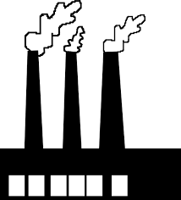 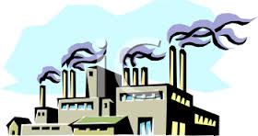 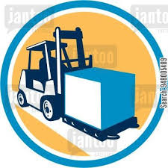 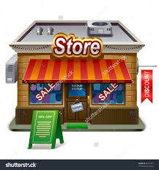
_________________ _________________ _______________ ________________ ___________________
22) What is the customer service triad? _______________________________________________________________
____________________________________________________________________________________________________________________________________________________________________________________________________
23) What is a value chain? ____________________________________________________________________________
__________________________________________________________________________________________________
24) Working in the school chemistry lab, you come up with a fantastic-tasting fruit drink. You’re confident that it can be a big seller, and you’ve found a local company that will manufacture it. Unfortunately, you have to handle the distribution yourself—a complex task because your product is made from natural ingredients and can easily spoil. What distribution channels would you use, and why? How would you handle the physical distribution of your product? ______
__________________________________________________________________________________________________________________________________________________________________________________________________________________________________________________________________________________________________________________________________________________________________________________________________________________________________________________________________________________________________________________________________________________________________________________________________________________________________________________________________________________________________________________________________________________________________________________________________________________________________________________________________________________________________________________
25)
(AACSB) Analysis
Students at Penn State University can take a break from their studies to visit an on-campus ice cream stand called the Creamery. Milk for the ice cream comes from cows that graze on university land as part of a program run by the agriculture school. Other ingredients, including sugar and chocolate syrup, are purchased from outside vendors, as are paper products and other supplies. Using your personal knowledge of ice cream stand operations (which probably comes from your experience as a customer), diagram the Creamery’s supply chain.
Use shapes (squares, triangles, circles, or rectangles) to create a diagram.
How would the supply chain change if the company decided to close its retail outlet and sell directly to supermarkets?
__________________________________________________________________________________________________________________________________________________________________________________________________________________________________________________________________________________________________________________________________________________________________________________________________________________________________________________________________________________________________________
9.5 Promoting a Product
26) Define: promotion mix ____________________________________________________________________________
____________________________________________________________________________________________________________________________________________________________________________________________________
27) What is advertising? ______________________________________________________________________________
__________________________________________________________________________________________________
__________________________________________________________________________________________________
28) Name TEN ways to advertise a product or service. (yes, TEN) 1) ___________________________________________
2) ___________________________________________ 3) ___________________________________________
4) ___________________________________________ 5) ___________________________________________
6) ___________________________________________ 7) ___________________________________________
8) ___________________________________________ 9) ___________________________________________
10) __________________________________________
29) Define: personal selling ___________________________________________________________________________
__________________________________________________________________________________________________
30) Define: sales promotion ___________________________________________________________________________
__________________________________________________________________________________________________
31) What is the example given for free publicity in the text? _________________________________________________
______________________________________________________________________________________________________________________________________________________________________________________________________________________________________________________________________________________________________
32) Companies encourage customers to buy their products by using a variety of promotion tools, including advertising, personal selling, sales promotion, and publicity. Your task is to develop a promotion strategy for two products—the Volkswagen Jetta and Red Bolt soda. For each product, answer the following questions:
What’s the purpose of the promotion? __________________________________________________________________
__________________________________________________________________________________________________
What’s your target market for each product? _____________________________________________________________
__________________________________________________________________________________________________
What’s the best way to reach each target market? _________________________________________________________
__________________________________________________________________________________________________
What product features should you emphasize? Use both products. ___________________________________________
______________________________________________________________________________________________________________________________________________________________________________________________________________________________________________________________________________________________________
How does each product differ from competitors’? (How does Red Bolt soda differ from Pepsi? How does the Volkswagon Jetta differ from the Cadillac CT6? ______________________________________________________________________
__________________________________________________________________________________________________________________________________________________________________________________________________________________________________________________________________________________________________________________________________________________________________________________________________________________________________________________________________________________________________________

