Business Principles Name: ________________________________________________
9.6 Interacting with Your Customers
9.7 The Product Life Cycle
1) What is customer-relationship management? ___________________________________________________________
__________________________________________________________________________________________________
2) Define permission marketing ________________________________________________________________________
__________________________________________________________________________________________________
3) Define: mass marketing ____________________________________________________________________________
__________________________________________________________________________________________________
4) Define: interruption marketing ______________________________________________________________________
__________________________________________________________________________________________________
5) Why do businesses use social media marketing? ________________________________________________________
__________________________________________________________________________________________________
6) List the 9 ways social media marketing is used according to Social Network Marketing Definition https://www.thebalance.com/social-media-marketing-definition-2948527
1) _________________________________________________________________________________________
2) _________________________________________________________________________________________
3) _________________________________________________________________________________________
4) _________________________________________________________________________________________
5) _________________________________________________________________________________________
6) _________________________________________________________________________________________
7) _________________________________________________________________________________________
8) _________________________________________________________________________________________
9) _________________________________________________________________________________________
7) Within the article, Advantages of Social Media Marketing http://ezinearticles.com/?Advantages-of-Social-Media-Marketing&id=6111206, it states:
Because of its many __________________, social media ____________________ has become an almost __________________ part of any business's attempt to establish a firm footing in today's __________________ market. When considering the ________________ and _________________ of different marketing ___________________, think of all the ______________________ and ____________________ that was traditionally spent on marketing your ___________________ or services, and compare it to what it now costs to market your ____________________ on social sites.
Originally, businesses _____________________ out of pocket for advertisements on ____________________, billboards, or in ___________________. Eventually, these strategies came to the point where they were not __________________ _____________________ in the least. Of all viewers of advertisements, only one to __________________ percent actually contacted the distributor and was ____________________ in their product. Why was this? One of the most interesting ____________________ of social media marketing is that when viewing __________________________, advertisements often ___________________ and interrupt viewers, causing most of them to be ______________________ in the advertised product. With social media, the ______________________ audience not only watches the advertisement, but also ________________________ in it.
Participation is a ______________________ ____________________ of social media __________________. Online, people _______________________ participate in ______________________ and blogs that market your company for you. When the ______________________ become ________________________ with your business or company, they not only ________________________ about your ______________________, the come to care about your __________________________. Social involvement with customers usually leads to an _______________________ in clientele and customer ____________________________.
___________________ ______________________ that comes with ______________________ media marketing is that ________________________ advertising with sites like Facebook is one hundred percent __________________. You no longer have to _____________________ a billboard or air time on the _____________________ or ________________. You do not have to _____________________ for ink and paper and distribute fliers about your business. You can do it all _______________________ and be much more _________________________. Almost every human being, in the United States at least, has heard of Facebook, MySpace, and Twitter. Most of them have profiles. By ________________ your business __________________, a completely ________________ ____________________ of advertising opens up.
Article Source: http://EzineArticles.com/6111206
8) List the seven advantages of using social media to promote products. I will give you the first one.
1) create brand awareness
2) _________________________________________________________________________________________
3) _________________________________________________________________________________________
4) _________________________________________________________________________________________
5) _________________________________________________________________________________________
6) _________________________________________________________________________________________
7) _________________________________________________________________________________________
9) Go to 5 Winning Social Media Campaigns to Learn From http://mashable.com/2010/09/14/social-media-campaigns/#PkE5s.ldlkqI and choose the best campaign (in your opinion). 1) Which campaign did you choose?
_____________________________________________ 2) Why did you choose this one? _________________________
______________________________________________________________________________________________________________________________________________________________________________________________________________________________________________________________________________________________________________________________________________ 3) What worked in this campaign? _____________________________
_______________________________________________________________________________________________________________________________________________________________________________________________________________________________________________________________________ 4) What flopped? ________________
__________________________________________________________________________________________________________________________________________________________________________________________________________________________________________________________________________________________________________________________________ 5) What would YOU have done differently? __________________________________
________________________________________________________________________________________________________________________________________________________________________________________________________________________________________________________________________________________________________________________________________________________________________________________________________
10) (AACSB) Analysis
If you ran an airline, how would you practice CRM? How would you get permission to market your product to customers? What information would you collect on them? What incentives would you offer them to continue flying with you? What advantages can you gain through effective CRM? BE THOROUGH WITH YOUR ANSWER! _________________
________________________________________________________________________________________________________________________________________________________________________________________________________________________________________________________________________________________________________________________________________________________________________________________________________
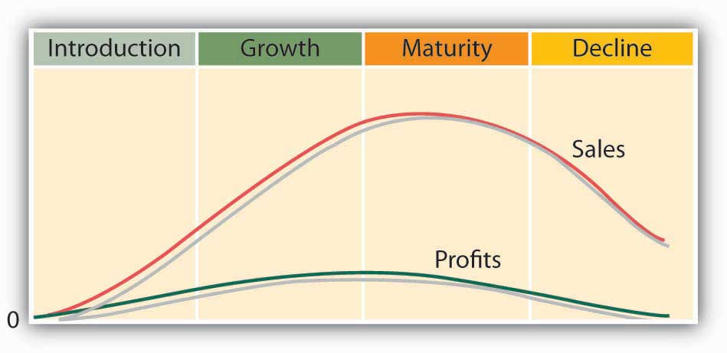
1) Explain the introduction stage of the product life cycle. ___________________________________________________
____________________________________________________________________________________________________________________________________________________________________________________________________
2) Explain the growth stage of the product life cycle ________________________________________________________
____________________________________________________________________________________________________________________________________________________________________________________________________
3) Explain the maturity stage of the product life cycle ______________________________________________________
____________________________________________________________________________________________________________________________________________________________________________________________________
4) Explain the decline stage of the product life cycle ________________________________________________________
__________________________________________________________________________________________________
(AACSB) Analysis
Did you ever have a Nintendo Game Boy? Is the product still popular? Like all products, Game Boy has a product life cycle. Your job is to describe that product life cycle. To learn something about the product, go to the Web, log on to your favorite search engine (Google, Yahoo!), and enter the phrase “Game Boy history.” Identify each of the product life stages that Game Boy has gone through, and speculate on the marketing actions that Nintendo would have taken during each stage. Where do you think Game Boy is now in its product life cycle? Where do you think it will be in five years? JUSTIFY YOUR ANSWERS – this means, don’t just write down an answer, give an explanation to show me you understood the information you wrote down. ______________________________________________________________________
______________________________________________________________________________________________________________________________________________________________________________________________________________________________________________________________________________________________________________________________________________________________________________________________________________________________________________________________________________________________________________________________________________________________________________________________________________________________________________________________________________________________________________________________________________________________________________________________________________________________________________________________________________________________________________________________________________________________________________________________________________________________________________________________________________________________________________________
____________________________________________________________________________________________________________________________________________________________________________________________________________________________________________________________________________________________________________________________________________________________________________________________________________________________________________________________________________________________________________________________________________________________________________________________________________
______________________________________________________________________________________________________________________________________________________________________________________________________________________________________________________________________________________________________
VOCABULARY BINGO

DIRECTIONS: CHOOSE ANY OF THE WORDS BELOW AND WRITE THEM IN ANY BOX ABOVE. ONE WORD PER BOX. THESE ALL CAME FROM PREVIOUS ASSIGNMENTS.
PROMOTION MIX DEMAND BASED PRICING PACKAGING
ADVERTISING MARKETING MIX LABELING
PUBLICITY SECONDARY DATA DOWNWARD
DISTRIBUTION PRIMARY DATA UPWARD
RETAILERS SURVEYS COMMUNICATE
WHOLESALERS FOCUS GROUPS TEAM
PROFIT MARGIN BRAND GROUPTHINK
COST BASED PRICING TRADEMARK MEDIATION
TARGET MARKET CONSUMER MARKET ARBITRATION
MARKETING CONCEPT PSYCHOGRAPHICS STRIKE
PICKETING BOYCOTTING LOCKOUT
VIRTUAL TEAM JOB ROTATION MOTIVATION
EFFORT PERFORMANCE REWARD
JOB DESCRIPTION JOB SPECIFICATION

