Business Principles Name: ____________________________________________________
9.8 The Marketing Environment
1) The external marketing environment can be divided into five sections, list them below. Divide the circle into the appropriate sections and label each.

2) Explain the Political and Regulatory Environment – why is it important? ______________________________________
____________________________________________________________________________________________________________________________________________________________________________________________________
3) Explain the Economic Environment ___________________________________________________________________
____________________________________________________________________________________________________________________________________________________________________________________________________
4) Explain the Competitive Environment _________________________________________________________________
__________________________________________________________________________________________________
5) Explain the Technological Environment ________________________________________________________________
__________________________________________________________________________________________________
6) Explain the Social and Cultural Environment ____________________________________________________________
__________________________________________________________________________________________________
7) Who are people that are considered the “baby boom generation” __________________________________________
__________________________________________________________________________________________________
8) Who are people that are considered “generation x”? _____________________________________________________
__________________________________________________________________________________________________
9) Who are people that are considered “generation y”? _____________________________________________________
__________________________________________________________________________________________________
10) Why is it important to know the ages of these people? Does it change the way you might market to each group? How? _____________________________________________________________________________________________
____________________________________________________________________________________________________________________________________________________________________________________________________
11) Define: consumer behavior ________________________________________________________________________
__________________________________________________________________________________________________
12) Explain each of these sections in the areas below.
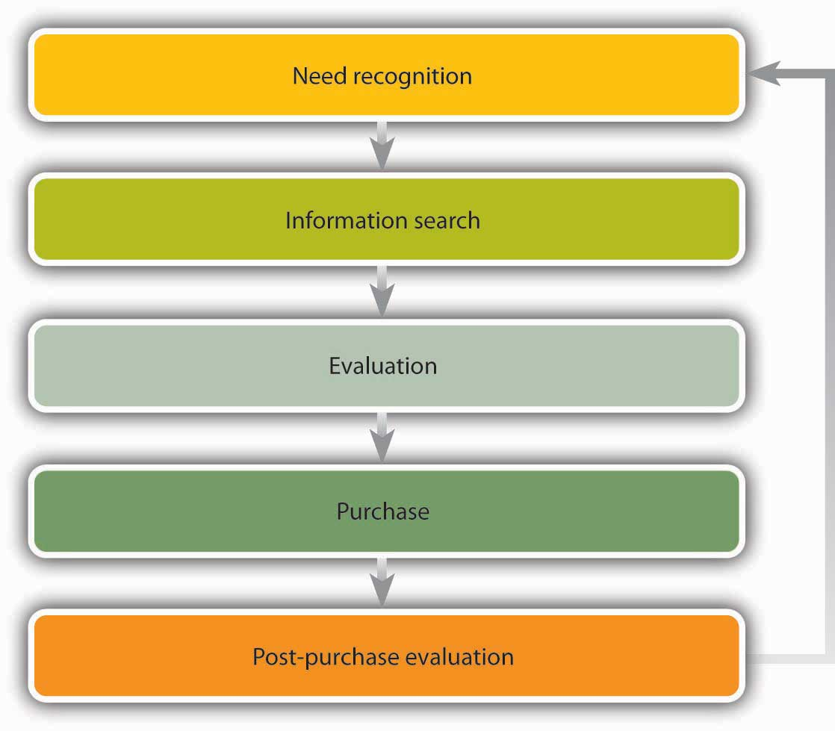
Need recognition _____________________________________________________________________________
__________________________________________________________________________________________________
__________________________________________________________________________________________________
Information search ___________________________________________________________________________
____________________________________________________________________________________________________________________________________________________________________________________________________
Evaluation __________________________________________________________________________________
____________________________________________________________________________________________________________________________________________________________________________________________________
Purchase ____________________________________________________________________________________
____________________________________________________________________________________________________________________________________________________________________________________________________
Post-purchase evaluation ______________________________________________________________________
____________________________________________________________________________________________________________________________________________________________________________________________________
13) What is buyer’s remorse? (this is not in the textbook) ___________________________________________________
__________________________________________________________________________________________________

