**PBIS Newsletter**

**March Edition**

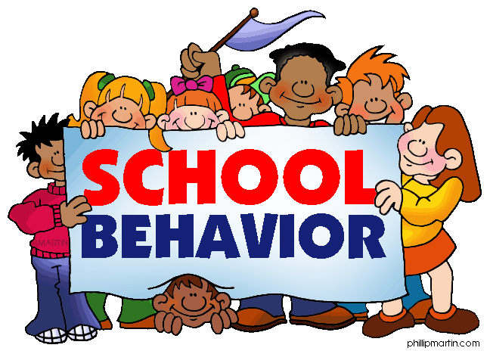

***School-wide Expectations***

Christian County High School ROCKS

**R**esponsible

**O**n-task

**C**ompliant

**K**nowledgeable

**S**hows Respect



**Discipline Data Update**

Discipline Referrals in **January** = 174

Discipline Referrals in **February** = 184

Discipline Referrals in **March** = 201

**27%** of discipline referrals are assigned on Fridays!

9th grade = 50% discipline referrals

10th grade = 19% discipline referrals

11th grade = 20% discipline referrals

12th grade = 11% discipline referrals

Aside from classroom referrals, HALLWAYS are the area in which the highest number of referrals are assigned.

**HOW CAN WE IMPROVE?**

* Utilize the Colonel Cash system
* Contact parents when writing referrals
* Maintain a 3 positives to 1 negative ratio
* Send Good News Cards
* Be present in the hallways between classes
* Review school-wide ROCKS expectations with students regularly

**Video of the Month**

What Students Really Need to Hear

<https://www.youtube.com/watch?v=-O7v4EJjx-g>

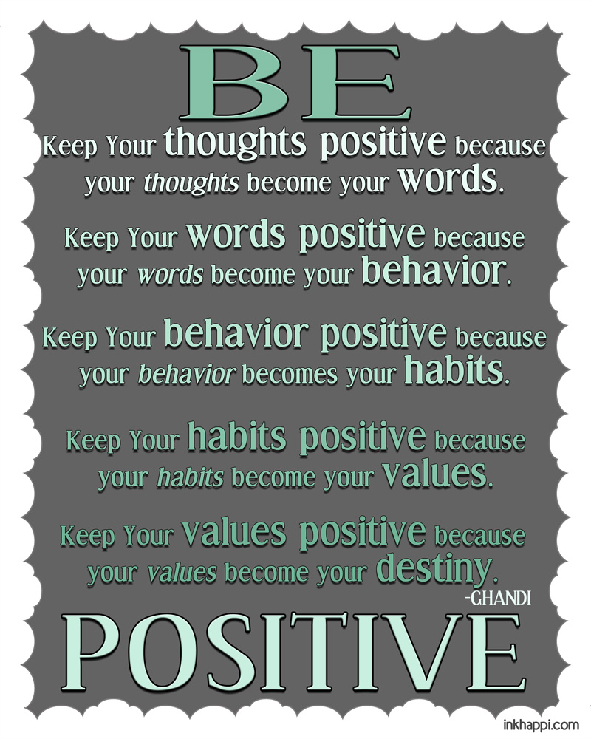



***Don’t count the days – make the days count***

* ***Muhammad Ali***

**Breaking News:**

**Colonel Cash Rewards**

Please encourage students to use Colonel Cash to purchase rewards! The following rewards are available for purchase – See Ms. Crick!

**\*Test/Quiz Retake Ticket**

**\*Hot Rods Baseball Game (April 26)**

**\*Snack Cart Items**

**\*Movie of the Month @ PAC (April 18)**

**\*Sweet Treats (April 12)**

**\*Designated Parking Space**

**\*Get Out of Detention Free Pass**



Congratulations to our

March WINNERS!

Ms. Sarah Brooks and Mr. Steven Brown for sending the most Good News Cards and awarding the most Colonel Cash! Ms. Brooks sent 76 Good News cards and Mr. Brown’s students deposited 42 checks in their Colonel Cash accounts! Thank you for promoting positive behavior in our building! These teachers will receive lunch from Davo’s next week!

**Good News Cards –**

Our goal is for every CCHS student to receive a Good News Card before the end of the year. PLEASE take time to complete Good News Cards and return them to Ms. Holloway in the FRYSC for postage. Following GFE rewards would be a great time to share some Good News about our students!