Scribe accommodations:
- Use of Technology (computer, mobile device, or tablet) if accessible to student.

Reader Accommodations:
Windows 10 computers
Accessibility Narrator
- Hold down the button with the windows icon on it and the U key at the same time and release
- Select Narrator
- Then close the window and highlight any text to start reading.
To turn Narrator off : Press Caps locks key and ESC at the same time.

Windows Tablet :
- To activate the Narrator push the window button and the volume up button together.
To turn Narrator off : Press Caps locks key and ESC at the same time.

Accessibility Instructions on Iphone/Ipad to read the screen:
- Settings
- General
- Accessibility
- Voice over ON
- Tap once to select an item
- Double tap to activate the selected item
- Swipe 3 fingers to scroll
Android Phone/Tablet
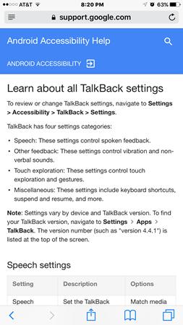
Email: Amy.day@christian.kyschools.us
Remind: enter 81010
@NTIMSD

