Solving Multiplication Problems

- Use any of the following strategies:
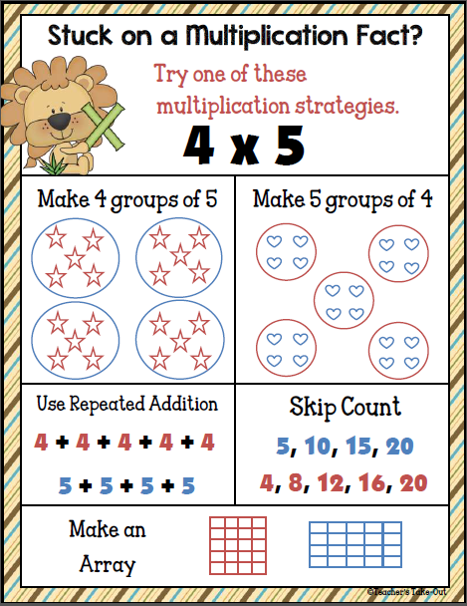
- On the 9’s multiplication facts use your fingers
- Here is how:
