**STUDY GUIDE: Access – Creating and Using a Database**

**TRUE/FALSE**

1. In Access, the columns in a table are called records.

2. A unique identifier also is called a primary key.

3. Replication is the storing of a piece of data in more than one place.

4. Database Design Language (DBDL) is a programming language.

5. In Access, table names can be up to 128 characters in length.

6. In a one-to-many relationship, each row in the first table may be associated with many rows in the second table.

7. The maximum number of characters allowed in a field whose data type is Text is 1024.

8. Fields that contain numbers but will not be used for arithmetic operations usually are assigned a data type of Text.

9. The Monetary data type is used for fields that contain only monetary data.

10. The URL Address data type can store text that can be used as a hyperlink address.

11. File names can be a maximum of 260 characters including the file extension.

12. A folder is a specific location on a storage medium.

13. To delete the ID field that Access creates automatically for a new table, the table must appear in Layout view rather than Datasheet view.

14. In Datasheet view, a table is represented as a collection of rows and columns called a datasheet.

15. One way to undo changes to a field is to click the Undo button on the Table Tools tab.

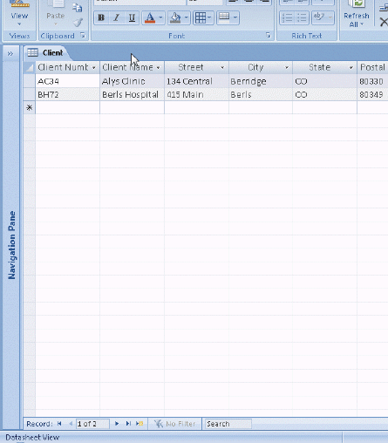

**Figure 1-1**

16. As shown in the accompanying figure, you can move to the end of a table to a position for entering a new record by clicking the Insert Record Navigation button.

17. As shown in the accompanying figure, you can use the Last record button to move to the last record in the table.

18. As shown in the accompanying figure, you can move to the first record in a table by clicking the First record Navigation button.

19. To print a wide database table, a table whose contents do not fit on the screen, you will need portrait orientation.

20. Landscape orientation means the printout is across the length (height) of the page.

21. Grouping means creating separate collections of records sharing some common characteristic.

22. Form view displays a single record at a time.

23. A DataForm combines both a datasheet and a form.

24. Standard properties are associated with all Microsoft Office documents and include author, title, and subject.

25. The Tools submenu on the Office menu provides commands to compact and repair a database.

**MODIFIED TRUE/FALSE**

1. The term database management system describes a collection of data organized in a manner that allows access, retrieval, and use of that data. ____________________

2. To create a new database, use either the Blank Database option or a template. ____________________

3. To delete a field, right-click the column heading for the field, and then click Delete Column on the shortcut menu. ____________________

4. To insert a field between existing fields, right-click the column heading for the field that will follow the new field, and then click Insert Field on the shortcut menu. ____________________

5. To use a template to create a table, click Create on the Ribbon and then click the Table Wizards button on the Create tab. ____________________

**MULTIPLE CHOICE**

1. Access is a ____.

|  |  |  |  |
| --- | --- | --- | --- |
| a. | word processing software tool | c. | workbook management system |
| b. | file management system | d. | database management system |

2. In Access, a(n) ____ consists of a collection of tables, each of which contains information on a specific subject.

|  |  |  |  |
| --- | --- | --- | --- |
| a. | object | c. | database |
| b. | relation | d. | tuple |

3. A(n) ____ contains information about a given person, product, or event.

|  |  |  |  |
| --- | --- | --- | --- |
| a. | attribute | c. | field |
| b. | record | d. | column |

4. ____ words are words that have a special meaning to Access and cannot be used for the names of fields or tables.

|  |  |  |  |
| --- | --- | --- | --- |
| a. | Special | c. | Significant |
| b. | Reserved | d. | Restricted |

5. In Access, table and field names can be up to ____ characters in length.

|  |  |  |  |
| --- | --- | --- | --- |
| a. | 32 | c. | 128 |
| b. | 64 | d. | 255 |

6. A field whose data type is ____ can contain any characters.

|  |  |  |  |
| --- | --- | --- | --- |
| a. | Alpha | c. | Normal |
| b. | Text | d. | Lookup |

7. A(n) ____ data type can store a variable amount of text or combination of text and numbers where the total number of characters may exceed 255.

|  |  |  |  |
| --- | --- | --- | --- |
| a. | Unlimited | c. | Memo |
| b. | Variable | d. | Character |

8. A field with the ____ data type can store a unique sequential number that Access assigns to a record. Access will increment the number by 1 as each new record is added.

|  |  |  |  |
| --- | --- | --- | --- |
| a. | Sequential | c. | Incremental |
| b. | AutoNumber | d. | AutoSequence |

9. A field with the ____ data type can contain an attached file, such as an image, document, chart, or spreadsheet.

|  |  |  |  |
| --- | --- | --- | --- |
| a. | Attachment | c. | Document |
| b. | File | d. | Extend |

10. A field whose data type is ____ can store an OLE object, which is an object linked to or embedded in the table.

|  |  |  |  |
| --- | --- | --- | --- |
| a. | Picture | c. | OLE Object |
| b. | Image | d. | Bitmap |

11. When you maximize a window, the Maximize button changes to a(n) ____ button.

|  |  |  |  |
| --- | --- | --- | --- |
| a. | Minimize | c. | Original |
| b. | Return | d. | Restore Down |

12. A saved database is referred to as a ____.

|  |  |  |  |
| --- | --- | --- | --- |
| a. | file | c. | DBMS |
| b. | databook | d. | template |

13. To change the save location for a database, click ____ in the Favorite Links section.

|  |  |  |  |
| --- | --- | --- | --- |
| a. | Save in | c. | Desktop |
| b. | Searches | d. | Computer |

14. When you create a new database, the name of the database appears on the ____ bar.

|  |  |  |  |
| --- | --- | --- | --- |
| a. | title | c. | menu |
| b. | Windows | d. | scroll |

15. In addition to the top-level tabs, Access displays other tabs called ____ tabs that display when you perform certain tasks or work with certain objects such as datasheets.

|  |  |  |  |
| --- | --- | --- | --- |
| a. | subtype | c. | contextual |
| b. | tiered | d. | sublevel |

16. One way to create a table, is to click ____ on the Ribbon and then click the Table button.

|  |  |  |  |
| --- | --- | --- | --- |
| a. | New | c. | Add |
| b. | Create | d. | Insert Table |

17. When you create a table in Datasheet view, Access automatically adds a field called ____ as the first field in the table.

|  |  |  |  |
| --- | --- | --- | --- |
| a. | Field1 | c. | AutoCode |
| b. | ID | d. | TableCode |

18. You only can delete a primary key in ____ view.

|  |  |  |  |
| --- | --- | --- | --- |
| a. | Datasheet | c. | Print Preview |
| b. | Layout | d. | Design |

19. To undo the most recent change to a table structure, click the ____ button on the Quick Access Toolbar.

|  |  |  |  |
| --- | --- | --- | --- |
| a. | Cancel | c. | Back |
| b. | Escape | d. | Undo |

20. To delete a field in a table, right-click the column heading for the field, and then click ____ on the shortcut menu.

|  |  |  |  |
| --- | --- | --- | --- |
| a. | Delete Field | c. | Delete Column |
| b. | Remove Field | d. | Remove Column |

21. To change the name of a field, right-click the column heading for the field, click ____ on the shortcut menu, and then type the desired field name.

|  |  |  |  |
| --- | --- | --- | --- |
| a. | Rename Field | c. | Change Field |
| b. | Rename Column | d. | Change Column |

22. To insert a field as the last field in a table, right-click the Add New Field column heading, click ____ on the shortcut menu, type the desired field name, click the down arrow, and then ensure the correct data type is already selected.

|  |  |  |  |
| --- | --- | --- | --- |
| a. | Add Column | c. | Rename Column |
| b. | Add Field | d. | Rename New Field |

23. To insert a field between existing fields, right-click the column heading for the field that will follow the new field, and then click ____ on the shortcut menu.

|  |  |  |  |
| --- | --- | --- | --- |
| a. | Insert Field | c. | Add Field |
| b. | Insert Column | d. | Add column |

24. In the accompanying figure, the small box or bar to left of each field is called the ____.

|  |  |  |  |
| --- | --- | --- | --- |
| a. | row selector | c. | field bar |
| b. | field selector | d. | current field bar |

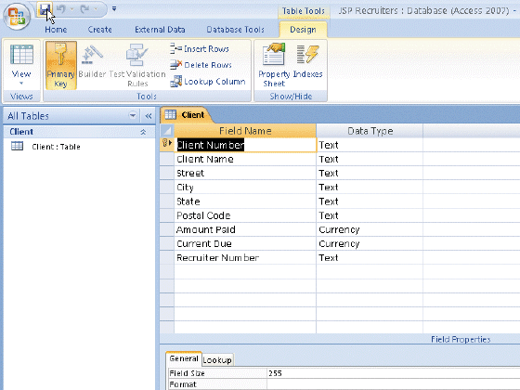

**Figure 1-2**

25. In the accompanying figure, the key symbol that appears in the row selector for the Client Number field indicates that Client Number is the ____ for the table.

|  |  |  |  |
| --- | --- | --- | --- |
| a. | principal key | c. | primary key |
| b. | foreign key | d. | main key |

26. In the accompanying figure, you would save the changes to the structure of the table by clicking the Save button on the ____.

|  |  |  |  |
| --- | --- | --- | --- |
| a. | title bar | c. | Quick Access Toolbar |
| b. | status bar | d. | Home tab |

27. To open a table in Design view, right-click the table in the Navigation Pane and then click ____ on the shortcut menu

|  |  |  |  |
| --- | --- | --- | --- |
| a. | Table Design | c. | Structure View |
| b. | Design View | d. | Layout View |

28. To specify AutoCorrect rules and exceptions to the rules, click ____ on the Office Button menu and then click Proofing in the dialog box that displays.

|  |  |  |  |
| --- | --- | --- | --- |
| a. | Customize | c. | Access Options |
| b. | Manage | d. | Grammar |

29. You can place an insertion point by clicking in the field or by pressing ____.

|  |  |  |  |
| --- | --- | --- | --- |
| a. | F2 | c. | F4 |
| b. | F3 | d. | F5 |

30. To delete a record, click the Record selector for the record, and then press the ____ key(s).

|  |  |  |  |
| --- | --- | --- | --- |
| a. | CTRL+DELETE | c. | DELETE |
| b. | CTRL+Y | d. | CTRL+K |

31. To add a record to a table, click the ____ record button.

|  |  |  |  |
| --- | --- | --- | --- |
| a. | Add New | c. | Last |
| b. | New (blank) | d. | Insert |

32. To quit Access, click the ____ button on the right side of the Access title bar.

|  |  |  |  |
| --- | --- | --- | --- |
| a. | Quit | c. | Quit Access |
| b. | End | d. | Close |

33. To hide the Navigation Pane, click the ____ Button.

|  |  |  |  |
| --- | --- | --- | --- |
| a. | Hide Navigation Pane | c. | Close Pane |
| b. | Shutter Bar Open/Close | d. | Navigation Bar Show/Hide |

34. To preview and then print a table, select the table, click the Office Button, point to the Print command arrow to display the Print submenu, and then click ____ on the Print submenu.

|  |  |  |  |
| --- | --- | --- | --- |
| a. | Preview/Print | c. | Preview View |
| b. | Report View | d. | Print Preview |

35. To change the print orientation from portrait to landscape, click the ____ button on the Print Preview tab.

|  |  |  |  |
| --- | --- | --- | --- |
| a. | Portrait/Landscape | c. | Landscape |
| b. | Orientation | d. | Switch Orientation |

36. If a field has a Number data type, you can change the ____ property to Fixed to set a fixed number of decimal places.

|  |  |  |  |
| --- | --- | --- | --- |
| a. | Field Size | c. | Decimal |
| b. | Format | d. | Caption |

37. If the Field Size for a field whose data type is Number is set to ____, the field size will be an integer value in the range of 0 to 255.

|  |  |  |  |
| --- | --- | --- | --- |
| a. | Byte | c. | Least |
| b. | Smallint | d. | Integer |

38. To create a report using the Report Wizard, click ____ on the Ribbon and then click the Report Wizard button.

|  |  |  |  |
| --- | --- | --- | --- |
| a. | Insert | c. | Create |
| b. | New Object | d. | Report |

39. A(n) ___ combines both a datasheet and a form.

|  |  |  |  |
| --- | --- | --- | --- |
| a. | DataForm | c. | AutoForm |
| b. | simple form | d. | split form |

40. To back up a database, use the ____ command on the Office Button menu.

|  |  |  |  |
| --- | --- | --- | --- |
| a. | Manage | c. | Backup |
| b. | Data Tools | d. | Options |

**MULTIPLE RESPONSE**

**Modified Multiple Choice**

1. Table names cannot contain ____

|  |  |  |  |
| --- | --- | --- | --- |
| a. | periods (.) | c. | spaces |
| b. | square brackets [ ] | d. | underscores (_) |

2. A field with a Yes/No data type can store only one of two values. The choices are ____.

|  |  |  |  |
| --- | --- | --- | --- |
| a. | True/False | c. | Yes/No |
| b. | One/Zero | d. | On/Off |

3. You can save a database on a variety of storage media including a ____.

|  |  |  |  |
| --- | --- | --- | --- |
| a. | USB flash drive | c. | hard disk |
| b. | CD | d. | Web site |

ANS: A, B, C PTS: 1 REF: AC 13

4. The Access window consists of a variety of components. These include the ____.

|  |  |  |  |
| --- | --- | --- | --- |
| a. | Navigation Pane | c. | Ribbon |
| b. | Content pane | d. | Quick Access Toolbar |

ANS: A, C, D PTS: 1 REF: AC 17

5. File names cannot contain _____.

|  |  |  |  |
| --- | --- | --- | --- |
| a. | backslashes (\) | c. | hyphens (-) |
| b. | question marks (?) | d. | asterisks (*) |

ANS: A, B, D PTS: 1 REF: AC 15

**COMPLETION**

1. A unique identifier also is called a(n) ____________________.

ANS: primary key

PTS: 1 REF: AC 4

2. To show the symbol for the Euro instead of the dollar sign, change the ____________________ property for the field whose data type is Currency.

ANS: Format

PTS: 1 REF: AC 9

3. Fields that contain numbers but will not be used for arithmetic operations usually are assigned a data type of ____________________.

ANS: Text

PTS: 1 REF: AC 9

4. ____________________ means storing the same fact in more than one place.

ANS: Redundancy

PTS: 1 REF: AC 10

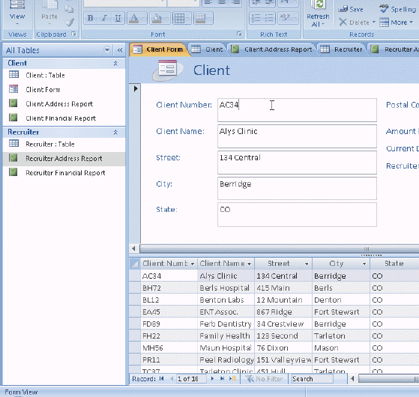

**Figure 1-3**

5. In the accompanying figure, the ____________________ Pane contains a list of all the objects in the database.

ANS: Navigation

PTS: 1 REF: AC 18

6. In the accompanying figure, the words Form View at the lower left of the screen appear on the ____________________.

ANS: status bar

PTS: 1 REF: AC 18

7. In the accompanying figure, the entire area that displays on the screen is called the ____________________ work area.

ANS: Access

PTS: 1 REF: AC 18

8. In the accompanying figure, ____________________ for the open objects appear at the top of the work area.

ANS: Object tabs

PTS: 1 REF: AC 18

9. In the accompanying figure, the ____________________ is a blinking vertical bar that indicates where text, graphics, and other items will be inserted.

ANS: insertion point

PTS: 1 REF: AC 18

10. In the accompanying figure, the buttons at the bottom-right edge of the screen are **____________________** buttons, which you use to change the view that is currently displayed.

ANS: View

PTS: 1 REF: AC 19

11. On the Ribbon, the **____________________** tab, called the primary tab, contains the more frequently used commands.

ANS: Home

PTS: 1 REF: AC 19

12. **____________________** is a feature that allows you to point to a gallery choice and see its effect in the database object — without actually selecting the choice.

ANS: Live preview

PTS: 1 REF: AC 20

13. Initially, the Quick Access Toolbar contains the **____________________**, Undo, and Redo commands.

ANS: Save

PTS: 1 REF: AC 22

14. To remove Key Tip badges from the screen, press the ALT key or the **____________________** key until all Key Tip badges disappear.

ANS:

ESC

Escape

PTS: 1 REF: AC 23

15. In **____________________**, the table is represented as a collection of rows and columns called a datasheet.

ANS: Datasheet view

PTS: 1 REF: AC 30

16. The **____________________** feature of Access corrects common mistakes when you complete a text entry in a cell.

ANS: AutoCorrect

PTS: 1 REF: AC 34

17. A(n)____________________ is a software tool that can be used to create a database; add, change, and delete data in the database; sort and retrieve data; and create forms and reports using the data in the database.

ANS:

database management system

dbms

PTS: 1 REF: AC 2

18. The rows in the tables are called ____________________.

ANS: records

PTS: 1 REF: AC 4

19. A(n) ____________________ contains a specific piece of information within a record.

ANS: field

PTS: 1 REF: AC 4

20. Table names can be from 1 to ____________________ characters in length and can contain letters, digits, and spaces.

ANS: 64

PTS: 1 REF: AC 8

**MATCHING**

Identify the letter of the choice that best matches the phrase or definition.

|  |  |  |  |
| --- | --- | --- | --- |
| a. | Mini toolbar | f. | gallery |
| b. | menu | g. | key Tip Badge |
| c. | shortcut menu | h. | Quick Access Toolbar |
| d. | Office Button | i. | Ribbon |
| e. | Enhanced ScreenTip | j. | status bar |

1. On-screen note that provides the name of command, the available keyboard shortcut(s), and the description of the command.

2. Presents information about the database object, the progress of current tasks, and the status of certain commands and keys.

3. Provides easy, central access to the tasks you perform while creating a database.

4. Set of choices, often graphical, arranged in a grid or in a list.

5. Appears automatically based on tasks you perform such as changing the appearance of text in a database object.

6. Appears when you right-click an object.

7. Provides easy access to frequently used commands; located by default above the Ribbon.

8. Contains a list of commands.

9. Central location for managing and sharing database objects.

10. Press the ALT key to display this keyboard code icon for certain commands.

1. ANS: E PTS: 1 REF: AC 20

2. ANS: J PTS: 1 REF: AC 19

3. ANS: I PTS: 1 REF: AC 19

4. ANS: F PTS: 1 REF: AC 20

5. ANS: A PTS: 1 REF: AC 21

6. ANS: C PTS: 1 REF: AC 21

7. ANS: H PTS: 1 REF: AC 22

8. ANS: B PTS: 1 REF: AC 22

9. ANS: D PTS: 1 REF: AC 22

10. ANS: G PTS: 1 REF: AC 23

**ESSAY**

1. When you create a database, you should follow some general guidelines for database design. What are these seven guidelines?

ANS:

*The seven guidelines are:*

*1. Identify the tables.*

*2. Determine the primary keys.*

*3. Determine the additional fields.*

*4. Determine relationships among the tables.*

*5. Determine data types for the fields.*

*6. Identify and remove any unwanted redundancy.*

*7. Determine a location for the database.*

PTS: 1 TOP: Critical Thinking

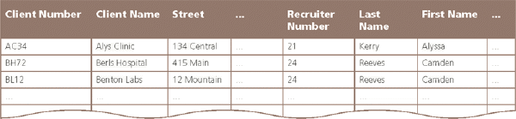

**Figure 1-4**

2. In the accompanying figure, recruiter names appear more than once in the table. Storing this data on multiple records is an example of redundancy which can cause several problems.

What are these problems? What is the solution to the problem?

ANS:

*Redundancy causes the following problems:*

*1. Wasted storage space. The same name is stored more than once. It should be stored only once.*

*2. More difficult database updates. If the same name is stored more than once and the individual’s name changes, then the name would need to be changed in several different places.*

*3. A possibility of inconsistent data. There is nothing to prohibit a name being changed on one record and not on another.*

*The solution to the problem is to place the redundant data in a separate table.*

PTS: 1 TOP: Critical Thinking

3. Discuss the difference between the way Access saves a record and the way Excel saves a row in a worksheet.

ANS:

*In Access, as soon as you move to another record, the record is saved. No separate save step exists. In Excel, data entered into rows is not saved until the entire worksheet is saved.*

PTS: 1 TOP: Critical Thinking

**CASE**

**Critical Thinking Questions**

**Case 1**

Mary has been asked to create a database for her company. The database is to track employees and the departments for which the employees work. A department can have between 5 and 15 employees. She has determined that she needs the following tables:

Employee (Social Security Number, Employee Name, Street Address, City, State, Postal Code, Date Hired, Salary, Department Code)

Department (Department Code, Department Name)

1.

Which field in the Employee table should be the primary key and why?

ANS:

*Social Security Number should be the primary key because the values in the field will be unique for each record.*

PTS: 1 REF: AC 8 TOP: Critical Thinking

2. Which field in the Department table should be the primary key and why?

ANS:

*Department Code should be the primary key because you can assign unique values to the field.*

PTS: 1 REF: AC 5 TOP: Critical Thinking

**Critical Thinking Questions**

**Case 2**

Now that Mary has created the tables and determined the primary and foreign keys, she needs to determine the data types for the fields in each table.

3. What data type should Mary use for the Salary field? Why?

ANS:

*Mary should use the Currency data type because monetary values will be stored in the field.*

PTS: 1 REF: AC 9 TOP: Critical Thinking

4. What data type should Mary use for the Social Security Number field? Why?

ANS:

*Mary should use the Text data type. Even though the field contains numbers, the field will not be used for arithmetic operations.*

PTS: 1 REF: AC 9 TOP: Critical Thinking