Advanced Algebra II 2nd Nine Weeks Exam Study Guide
On your own paper complete the following problems. If you turn in the study guide when you take your 9 weeks exam you will receive 5 bonus points on the exam.

1. There are 1,332 people under the age 20 in Pierce City. This represents 14% of the total population. Write and solve an equation to find the total population in Pierce City.

2. Find the slope of the line containing the points and .

3. Simplify

4. You start with $15 and save $8 each week. What algebraic expression models the total amount you save?

5. Evaluate the following for h. 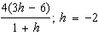
6. Combine like terms to simplify the following expression.

7. Solve

8. Solve the formula/equation for the indicated variable. , for t

9. Solve and graph the solution. 2r – 9 ≥ –6

10. Solve the absolute value equation and graph the solution.

11. Is the following relation a function? {(14, 15), (5, 7), (3, 10), (11, 1), (5, 8)}

12. What is the output of the function for the given input? For , .

13. Find the domain and range of the relation.

14. What is an equation of the line in slope-intercept form?

15. Solve and graph the solution.

16. Write the equation in slope-intercept form. State the slope and y-intercept.

17. Does y vary directly with x? If so find the constant of variation k and write the equation.
x | y
7 | 14
10 | 20
13 | 26
16 | 32

18. What is the slope of the line that passes through the points (–12, 12) and (2, 4)?

19. What is an equation of the line, in point-slope form that passes through the points: ,

20. What is the equation of the line in standard form? Use integer coefficients.

21. If y = 2.52 when x = 8.4, what is y when x = 2.7?

22. A 7-mi cab ride costs $5.80. A 10-mi cab ride costs $7.30. Find a linear equation that models a relationship between cost c and distance d.

23. How are the functions and related? How are their graphs related?

24. Let be the reflection of in the y-axis. What is a function rule for ?

25. The function . The graph of is vertically compressed by a factor of and reflected in the x-axis. What is the function rule for ?

26. What is the graph of the ?

27. What transformation change the graph of f(x) to the graph of g(x)? If and

28. What is the graph of –2x + 2y ≤ –4

29. What is the graph of

30. What is the graph of y ≥ |x + 3| – 2

31. Solve by graphing. 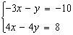

32. Solve by graphing. 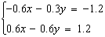

33. Solve by using a table. 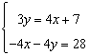

34. A rental car agency charges a flat fee of $139.00 plus $30.00 per day to rent a certain car. Another agency charges a fee of $13.00 plus $51.00 per day to rent the same car. Using a graphing calculator, find the number of days for which the costs are the same. Round your answer to the nearest whole day.

35. Without graphing is the system independent, dependent, or inconsistent?
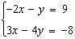

36. Without graphing is the system independent, dependent, or inconsistent?
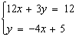

37. Solve by substitution. 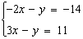

38. Solve by substitution. 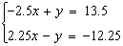

39. Solve by elimination. 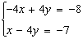

40. Solve by elimination. 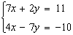

41. A group of 52 people attended a ball game. There were three times as many children as adults in the group. Set up a system of equations that represents the numbers of adults and children who attended the game and solve the system to find the number of children who were in the group.

42. Solve by graphing. 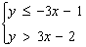

43. Solve by graphing. 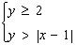

44. Solve by graphing. 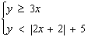

45. What point in the feasible region maximizes the objective function?
Constraints 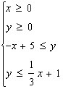 Objective function:

46. Solve by elimination. 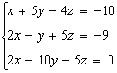

47. Solve by substitution. 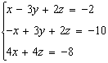

48. Your furniture store sells two types of dining room tables. The first, type A, costs $213 and you make a $23 profit on each one. The second, type B, costs $109 and you make a $16 profit on each one. You can order no more than 90 tables this month, and you need to make at least $1720 profit on them. If you must order at least one of each type of table, how many of each type of table should you order if you want to minimize your cost? Write a system of inequalities using your constraints and an objective function. (you will use linear programming.)

49. Solve. (You choose which method) 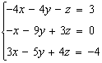

50. A food store makes a 11-lb mixture of oatmeal, crispies, and chocolate chips. The cost of oatmeal is $1.50 per pound, crispies cost $2.00 per pound, and chocolate chips cost $1.00 per pound. The mixture calls for twice as much oatmeal as crispies. The total cost of the mixture is $17.00. How much of each ingredient did the store use? Write a system of equations and solve.

