This Is Why You Need to Wear Special Glasses Before You Stare at a Solar Eclipse

July 28, 2017 by Philip Perry
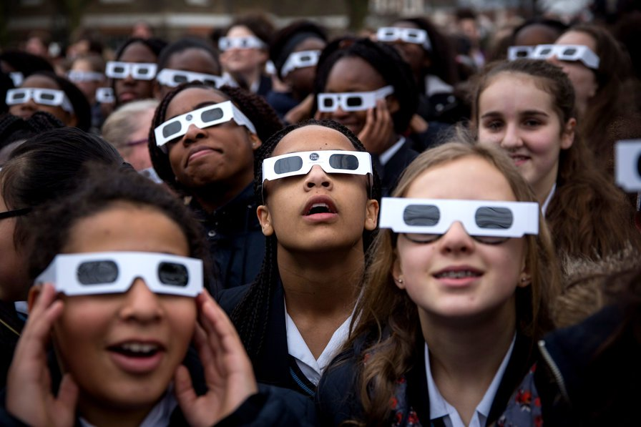
On Monday, August 21 there will be a continent-wide solar eclipse, the first to be visible only in the US since 1776. It’ll also be the first to cross the entire continent in the last 99 years, moving east from Oregon to South Carolina. A solar eclipse is when the moon passes between the Earth and the sun, while a lunar eclipse is when the Earth passes between the moon and the sun.
So with a solar eclipse, the sun blocks out the moon. With a lunar eclipse the moon simply disappears for a short while. According to NASA, an easy way to remember is, “In a solar eclipse, the sun gets darker. In a lunar eclipse, the moon gets darker.”
What we see is actually the shadow of the moon being cast onto the Earth. For a time you get that ethereal corona around Earth’s oldest satellite, or its shadow. It’s hauntingly beautiful and symbolic of tremendous change. But be warned, the “path of totality” when the moon completely envelops the sun, will last a couple of minutes total. Be prepared or else you'll miss it.
The schedule and how much of it you can see varies from where you live. There are partial eclipses and total ones. Although it happens somewhere on Earth once every year, witnessing a total solar eclipse is exceedingly rare. It only occurs once every 375 years, on any one place on the planet, on average.
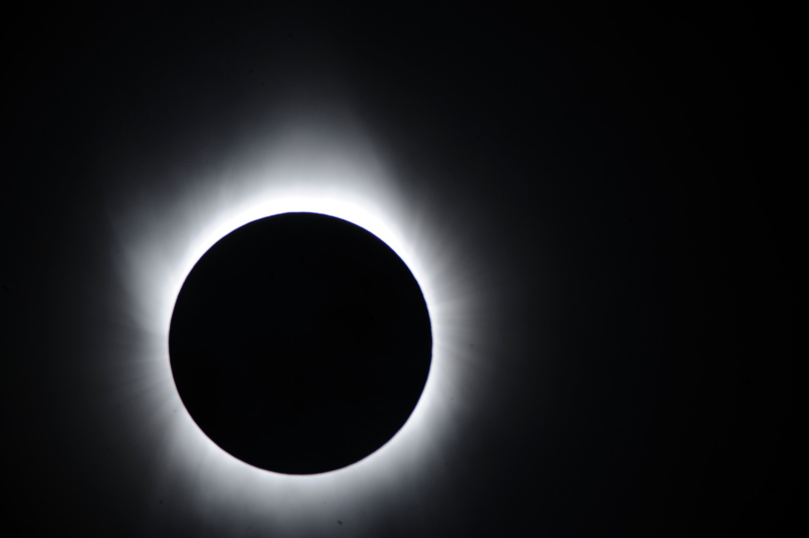
A total solar eclipse at the moment of totality. Getty Images.
While it’s a fantastic opportunity to observe one of the most dramatic astronomical events you can witness from Earth, it’s important that one do so safely. Wearing sunglasses or cupping your hands around your face isn’t good enough. And sunglasses aren’t strong enough filters.
Dr. Thomas Hwang is a retina expert at the Oregon Health & Science University (OHSU) Casey Eye Institute. He’s also an associate professor of ophthalmology in the OHSU School of Medicine. He says that when it’s occurring, it may seem dark, but this is one of the most dangerous times to look at the sun, because the energy reaching your eye is concentrated into the center of your vision. The results can be disastrous.
“If you look directly at the eclipse,” Dr. Hwang said, “it can burn your retina in mere seconds and can cause permanent damage.” The result, solar retinopathy—a blind spot in your vision. The longer the exposure, the more likely damage will occur. What’s Dr. Hwang’s solution? Wear solar eclipse safety glasses or use a pinhole projector. Even with special glasses, you shouldn’t stare directly at the eclipse for a prolonged period. But it gets even more complicated.
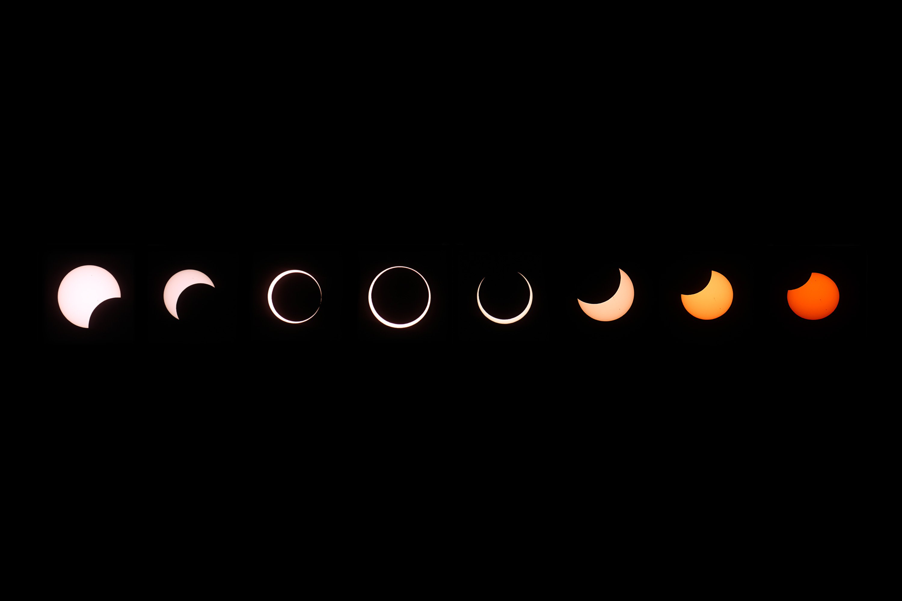
Phases of a solar eclipse. Getty Images.
Technically, when the sun is fully encased in the moon’s shadow, you can view it with the naked eye safely. Beyond totality, at any point in the partial eclipse stage, coming or going, you need to wear special glasses and observe the event sparingly. Keep in mind that totality is only about two minutes.
Also be warned that there are hundreds of vendors selling eclipse viewing glasses on Amazon right now, but many aren’t backed by any reputable organization. If you’re considering purchasing a pair, these brands are recommended by the American Astronomical Society (AAS), part of the American Institute of Physics (AIP).
Some other important safety tips according to the AAS:
- Always inspect your solar filter before use; if scratched, punctured, torn, or otherwise damaged, discard it. Read and follow any instructions printed on or packaged with the filter.
- Always supervise children using solar filters.
- If you normally wear eyeglasses, keep them on. Put your eclipse glasses on over them, or hold your handheld viewer in front of them.
- Stand still and cover your eyes with your eclipse glasses or solar viewer before looking up at the bright Sun. After looking at the Sun, turn away and remove your filter — do not remove it while looking at the Sun.
- Do not look at the Sun through a camera, a telescope, binoculars, or any other optical device while using your eclipse glasses or handheld solar viewer — the concentrated solar rays will damage the filter and enter your eye(s), causing serious injury.
- Seek expert advice from an astronomer before using a solar filter with a camera, a telescope, binoculars, or any other optical device.
- If you are within the path of totality, remove your solar filter only when the Moon completely covers the Sun’s bright face and it suddenly gets quite dark. Experience totality, then, as soon as the bright Sun begins to reappear, replace your solar viewer to look at the remaining partial phases.

PART 1: Annotate this article. This means ask questions where something does not make sense to you, note when you find something interesting, highlight a sentence you like, etc.
PART 2: Answer these questions using COMPLETE sentences.
- Are we experiencing a solar or lunar eclipse?

- This is the first year that the United States will experience a continent-wide eclipse since 1776. What other major United States event occurred during the year 1776?

- What is happening during a solar eclipse?

- During a solar eclipse what object in space gets darker?

- When is the most dangerous time to look at the sun?

- Why is this the most dangerous time to look with your eyes?

- What part of your eye will be affected if you look at the sun and what damaged could be caused to your eyesight?

- What is Dr. Hwang’s solution for not causing damage to your eye?

- If you normally wear sunglasses, should you take them off to wear the safety glasses or keep them on?

- Is it okay to look through a camera or telescope to view the eclipse?

- Is it okay to remove your glasses during totality?

