How does a solar eclipse affect animals?

Birds may go quiet, bats may fly around and pets may become uneasy, but it's difficult to predict exactly how non-human animals will react.

Russell McLendon August 3, 2017, 8:25 a.m.
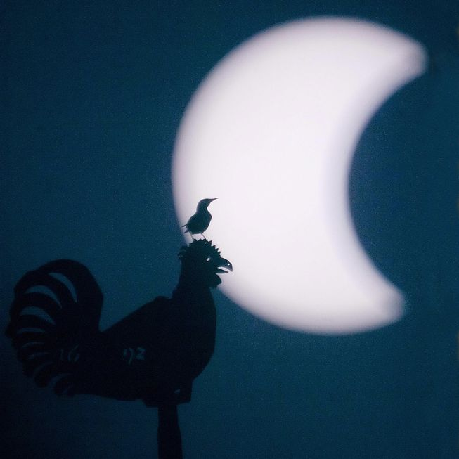A solar eclipse can throw off the daily patterns of wildlife like songbirds. (Photo: Henning Kaiser/AFP/Getty Images)
A total solar eclipse will soon sweep across the United States for the first time in 99 years, providing a rare spectacle for millions of people. Among the many human onlookers in the path of totality, however, will also be countless wild animals, pets and other creatures with a much looser grasp of what's happening.
Seeing the moon block the sun should be amazing even if you're expecting it. It's presumably a little disorienting if you're in the dark about why you're in the dark.
Our own species was long confused about the nature of eclipses, but the experience must still be very weird for other animals, especially within the path of totality. This is likely a once-in-a-lifetime event for them, too, and while few scientific studies have thoroughly examined their reactions, there are many anecdotal reports of wildlife, farm animals and pets seemingly duped or bewildered by a solar eclipse.
If you're planning to watch the Great American Eclipse this month, here are some things to look for from any non-human animals who might be watching with you — including a new effort to help you share your observations with scientists.

Wildlife
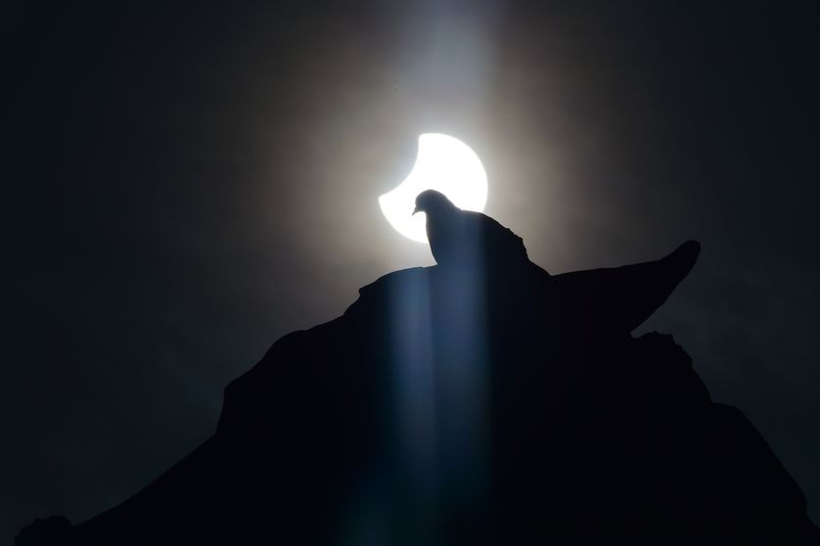A pigeon ponders a solar eclipse from Milan, Italy, in March 2015. (Photo: Giuseppe Cacace/AFP/Getty Images)
Many wild animals have been known to treat a total solar eclipse like an abrupt midday night. "The birds behave as if the disappearance of the sun means evening, and the return of the sun means morning — in time-lapse, of course," Max Planck Institute ornithologist Wolfgang Fiedler tells German news outlet Deutsche Welle.
That means many songbirds retire to wherever they normally sleep, perform their typical dusk serenade and then quiet down for the "night." When the eclipse ends a few seconds or minutes later, they interpret it as morning and respond with a dawn chorus. This disruption is brief, though, and reportedly doesn't throw off the birds' internal clocks or the broader patterns that dictate things like migration.
Although most reports of eclipse-confused animals are informal observations, there have been some scientific studies on the subject. During a total solar eclipse in June 2001, for example, astronomer Paul Murdin observed how various wildlife reacted at Mana Pools National Park in Zimbabwe. He saw doves and other songbirds act out bedtime routines, briefly going silent before singing when the sun reappeared.
"Egrets, oxpeckers, ibis, trumpeter hornbill and geese stopped feeding and set off for roosts," he wrote, noting that only some returned to feed after the eclipse. A pod of hippos dispersed into the water during totality, as they do at dusk, but then "showed nervousness for the rest of the afternoon" and took a day to get back to normal.
A sun squirrel stayed in his hole on the eclipse day, Murdin wrote, "apparently having concluded from the eclipse that he had overslept into nightfall." Bees withdrew to their hive in the late stages of the eclipse, he added, then tried reconnaissance: "Two scout bees left the hive after the eclipse and returned later, but whatever they reported, the swarm of bees did not leave the hive again that afternoon."
During a total solar eclipse in July 1991, researchers studied responses of orb-weaving spiders in Mexico. The spiders acted normally until totality, when many took down their webs — only to rebuild them when the sun reappeared.
Crepuscular animals often mistake solar eclipses for twilight, too. Crickets and frogs may jump into a dusk chorus, and mosquitoes and midges may start their evening swarms. And in the midst of a total solar eclipse, it can be dark enough not only to quiet down diurnal animals, but also to lure out the night shift. There are many reports of nocturnal animals being active during totality, including bats and owls.
Reactions vary widely by species, though. Baboons recovered quickly from the 2001 eclipse, Murdin wrote, and he saw little effect on crocodiles, lions or zebras. Solitary male elephants "appeared sanguine about the eclipse," he added, "although two did join up and stand passively side by side for the period of greatest darkness."

Pets
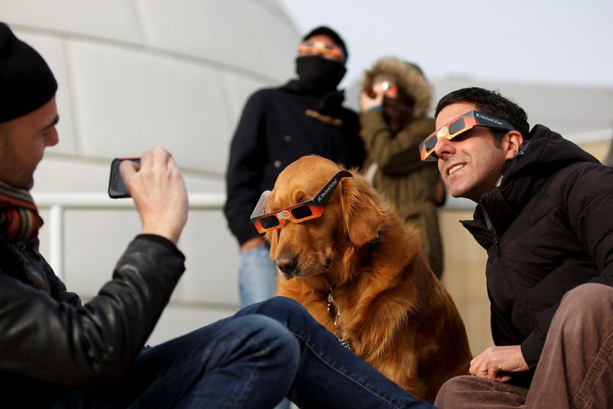A dog wears protective glasses during a solar eclipse over Spain in 2015. (Photo: Pablo Blazquez Dominguez/Getty Images)
With daily routines influenced by human schedules as well as sunlight levels, pets and other non-wild animals often have relatively mild reactions to an eclipse.
Dogs and cats may be confused by a total solar eclipse, or in some cases even frightened, but probably less so than with fireworks or thunder. Totality only lasts a few minutes at most, and an eclipse itself is silent, causing none of the noise that typically scares pets during storms and fireworks. Still, it's generally a good idea to keep pets leashed if they're outdoors with you during the eclipse.
As one Illinois animal-control officer recently told the Southern Illinoisan, pets are more likely to be spooked by crowds of people than the eclipse itself, so their reactions could depend largely on your surroundings. "It's sort of like the Fourth of July, but tripled," he said. "We are going to have concerts, people shooting off fireworks in the dark of the midday sun, loud noises and strangers."
Humans should definitely wear eye protection to watch the eclipse (except during the brief period of totality, when the moon is fully blocking the sun). There are mixed opinions, however, about whether we also need put eclipse glasses on pets.
"On a normal day, your pets don't try to look at the sun, and therefore don't damage their eyes. On this day they're not going to do it, either," said Angela Speck, director of astronomy at the University of Missouri, at a recent news conference with NASA about the August 2017 eclipse. "I'm not going to worry about my cat."
Still, it is possible that some pets could harm their eyes by looking at the eclipse. Cats may be more aloof, but since dogs can follow a human gaze and pointing, it's conceivable that people looking and pointing at the eclipse might tempt dogs to do the same. And thus many people do equip their dogs with eclipse glasses.

Other animals
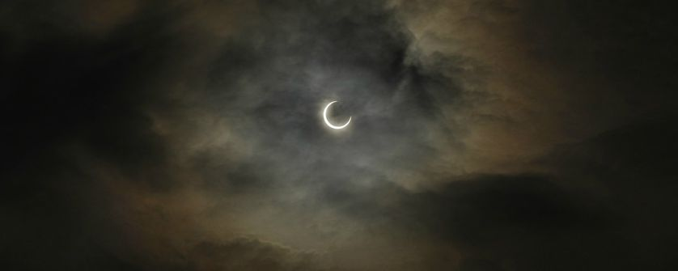As in the wild, zoo animals show a wide range of reactions to solar eclipses. (Photo: NECI/NOAA)
Animals on farms and in zoos have been known to act strangely during a total solar eclipse, or to retire as if night has fallen. And when a partial eclipse occurred over Germany in 1999, zoologist Lydia Kolter also noticed a different response from some animals at the Cologne Zoo. "Even if there is no solar eclipse, it can get very dark, very suddenly — for example just before a thunderstorm," Kolter tells Deutsche Welle. "Then, the animals hide in protected areas, because they expect it to rain."
A group of captive chimpanzees showed an eerily relatable response to an annular solar eclipse in 1984. "[W]hen the sky began to darken and the temperature began to decrease, solitary females and females with infants moved to the top of a climbing structure," wrote researchers who studied the chimps' behavior. "As the eclipse progressed, additional chimpanzees began to congregate on the climbing structure and to orient their bodies in the direction of the sun and moon."
"[D]uring the period of maximum eclipse, the animals continued to orient their bodies toward the sun and moon and to turn their faces upward," they added. "One juvenile stood upright and gestured in the direction of the sun and moon."

'Life Responds'
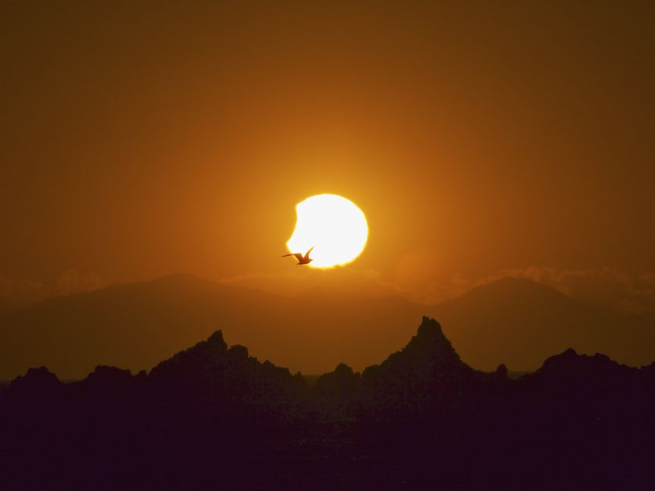A seagull flies in front of a partial solar eclipse over New Zealand in 2011. (Photo: Morgan Loomis/flickr)
For anyone lucky enough to see the Aug. 21 eclipse, the stars of the show are obviously the sun and moon. But without distracting from the main event, some scientists hope the public will help with a little data collection. Because total solar eclipses are so rare, most of what we know about animals' reactions is still anecdotal.
The California Academy of Sciences (CAS) is organizing a citizen-science project, called Life Responds, to document how North American wildlife reacts to the eclipse. Once the eclipse is over, anyone can submit data using the iNaturalist app.
"We're just hoping that people who are watching the eclipse, in places of differing levels of totality, will take some time and observe the animals around them and see how they respond to the eclipse," says Rebecca Johnson, citizen-science lead for the CAS. "A lot of people are interested in studying how animals respond to an eclipse, but as you can imagine it's not a super easy way to set up a research project."
So rather than chasing eclipses around the world to study wildlife, scientists can crowdsource data from hordes of people who will be out observing anyway. If possible, Johnson suggests scoping out your viewing site in advance. "We're asking people to be curious and pay attention, and ideally get out before the eclipse and figure out what animals you might watch and what might be around," she says.
Even if you don't take your eyes off the eclipse, you could keep an ear out for which animals are (or aren't) singing, like songbirds, insects and owls. And beyond animals, Johnson notes that some plants may curl up or unfurl during totality.
As much as humans may understand what's happening during a solar eclipse, we shouldn't feel too smug about the confusion seen in other species. As Johnson points out, we still have plenty to learn about the natural world around us. "There's a lot we probably don't know," she says. "There's a lot we know we don't know."

PART 1: Annotate this article. This means ask questions where something does not make sense to you, note when you find something interesting, highlight a sentence you like, etc. All four pages of the article should be full of writing, underlining, and highlighting.
PART 2: Observe FOUR different animal behaviors during the total eclipse. Explain these different behaviors that you observed during this time.

