Saint Mary Catholic School
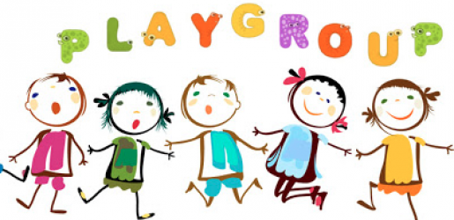

Open to all Moms, Dads, Grandparents and Caregivers
ALL children ages 0-5 are welcome!
(Even if your child is not enrolled at Saint Mary Catholic School)
Tuesdays at 9:30 AM
September 18, 2018-May 21, 2019

Come and Enjoy Socializing, Music, Dancing, Stories
Snacks and Crafts!
www.saintmarypawpaw.org
Find us on
Call (269)657-3750 for more information
Visit us at 508 Paw Paw Street, Paw Paw, MI 49079

