KNHS Color 5K Run/Walk
All proceeds will go to the Johnson County Cancer Society
Registration Form
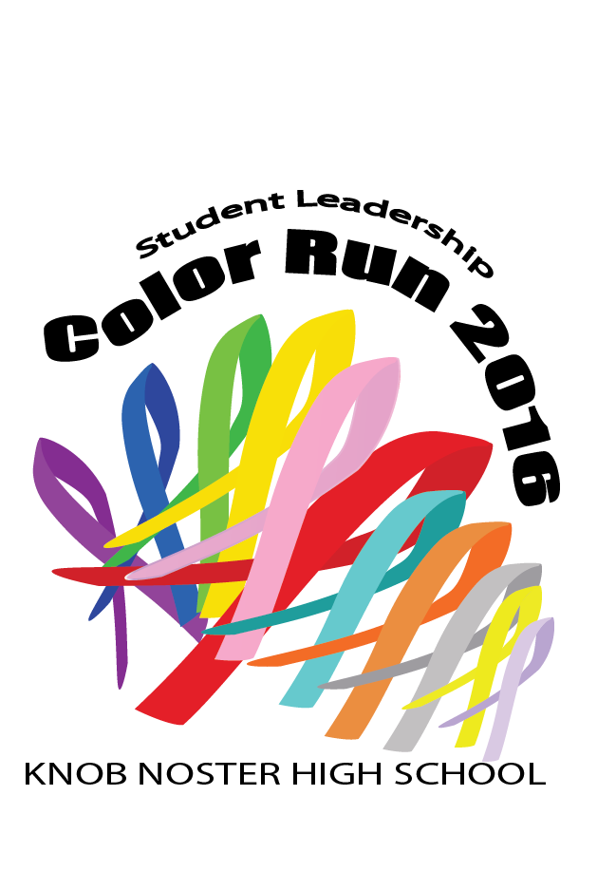
When: 19 November 2016 | Fees: $20 5K
Where: Meet at Knob Noster High School | Optional: $5 per sponsorship in memory or honor of someone affected by cancer. (Names will be listed on back of shirt if received by October 26)
Pre-Race day registration – 26 October 2016 3:45 – 5:00 KNHS,
Knob Noster Middle School, Knob Noster Elementary & Whiteman Elementary

Race Day registration & T-Shirt Pick up begins at 8:00 AM
5K starts at 9:00 AM - Color Blast ~ 9:30

Name ____________________________________________________
Address __________________________________________________
City___________________________State_________ Zip__________
Telephone Number ( ) _______________________
Age on Race Day __________Date of Birth ______/_____/ _________
Sex: Male ____ Female ____

T-Shirt Size:
Youth S ____ M ____ L ____ Adult S ____ M ____ L ____ XL ____ XXL ____
Sponsorship Name(s): ____________________________, ____________________________, ____________________

Make Checks Payable to: Knob Noster High School
Send signed release, completed entry form, and race fee to:
Veronica Chan, Knob Noster High School, 504 S Washington, Knob Noster, MO 65336
------------------------------------------------------------------------------------------------------------------
KNHS Color Run - 5K Liability Waiver:
I know that running a road race is a potentially hazardous activity. I understand that participating in the Knob Noster High School “COLOR RUN - 5K Run/Walk" is a potentially hazardous activity where powdered color will be thrown at and around me during the course of the event. I understand that some of the course I, the participant, may go through colored corn starch, which has not been tested for chemicals or disease. I should not enter unless I am medically able and properly trained. I assume all risks associated with participating in this event including, but not limited to: falls, contact with other participants, the effects of the weather, traffic and the conditions of the road, all such risks being known and appreciated by me. Having read this waiver and knowing these facts and in consideration of your accepting my entry to participate in the event I hereby agree that the hosts of the event and the race director are not legally liable in any manner for any injury or accident that may occur during this event. I agree to the following:

1. I do waive and forever release any and all rights and claims for any damages and liabilities of any kind arising out of my participation in the Event against all persons, entities and agencies involved with promoting and holding the Event, including Knob Noster School District, City of Knob Noster and the event race director.
2. I assume the risk of all bodily injuries, including death, resulting there from, and personal injuries to me and damage to and loss of my property, including loss of use thereof and any other indirect or consequential damages, resulting directly or indirectly, wholly or in part, from my participation in the Event and while traveling to and from the Event.
3. I hereby agree, for myself and/or for a minor under the age of eighteen for whom I am signing, to indemnify, defend, and hold the entities named above harmless from and against any and all claims, liabilities, losses and damages, costs, expenses (including attorney’s fees) judgments and penalties arising out of any of my, and or
said minors, acts or omissions to act.

______________________________________________________________ _____________________
Participant Signature Date

______________________________________________________________ _____________________
Parent or Guardian of Participant under the age of 18 Relationship to minor

