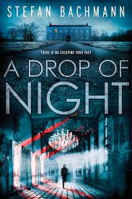 A Drop of Night by Stefan Bachmann
Modern-day teenagers meet a palace of terrors locked up since the French Revolution in this haunting, genre-bending thriller from Stefan Bachmann, the internationally bestselling author of The Peculiar and The Whatnot. A Drop of Night will thrill fans of Neal Shusterman and Jessica Khoury.

