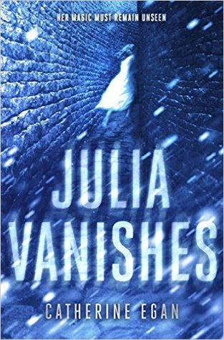 Julia Vanishes by Catherine Egan
"An exciting novel with magic and serial killers.... One of the hottest books coming out."—Hypable.com
Fans of Marie Lu, Leigh Bardugo, and Kristin Cashore will be captivated by this stunning first book in a must-have new fantasy trilogy about a spy who can vanish at will and who discovers that monsters, mystery, and magic are also lurking—just out of sight. Per Amazon.com

