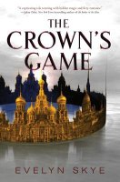 The Crown’s Game by Evelyn Skye
Perfect for fans of Shadow and Bone and Red Queen, The Crown’s Game is a thrilling and atmospheric historical fantasy set in Imperial Russia about two teenagers who must compete for the right to become the Imperial Enchanter—or die in the process—from debut author Evelyn Skye.
"Gorgeous and richly imagined."—Sara Raasch, New York Times bestselling author of the Snow Like Ashes series
"Teeming with hidden magic and fiery romance."—Sabaa Tahir, New York Times bestselling author of An Ember in the Ashes

