Holly Springs High School
Research Manual
2015-2016

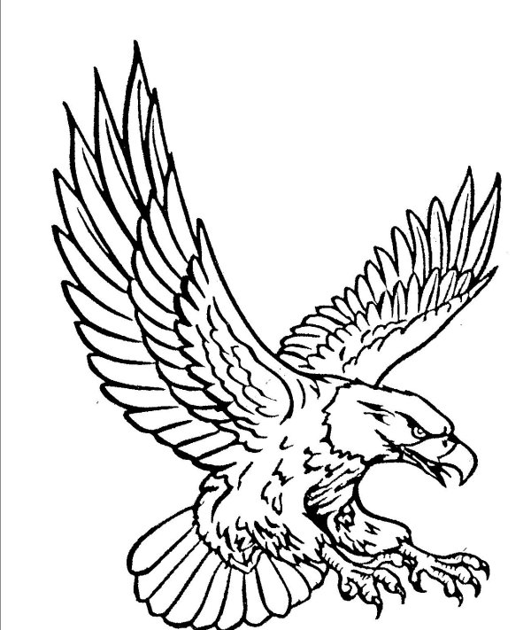Where Hawks Fly High

Senior Research Paper Checklist
Student Name: _________________________________________________
Title _______________ Catchy phrase: Title, Name and School Name
Header _______________ (On each page with page number on every page except the first page)
Introduction _______________ (Short narrative- no dialogue- to catch the reader’s attention to problem, no longer than 1 page)
*****Don’t Forget your Thesis Statement******
Problem _______________ (2 paragraphs to 1 page)
Idea _______________ (Solution to the problem- 2 paragraphs to 1 page) Details _______________ (2 pages, may include charts and graphs with an explanation of what the chart and graph means)
Related works _____________ (Can be incorporated in details, this should be references to other works that supports or opposes the student’s idea)
Conclusion _______________ (Minimum 1 paragraph)
Reference Page ____________ 5 sources, Students should use scholarly sources in APA format or MLA format ; all sources should NOT be internet only sources
Comments: ___________________________________________________________________________________________________________________________________________________________________________________________________________________________________________________________________________________________________________________________________________________________________________________________________________________________________________________________________________________________________________________________________________________________________________________________________________________________
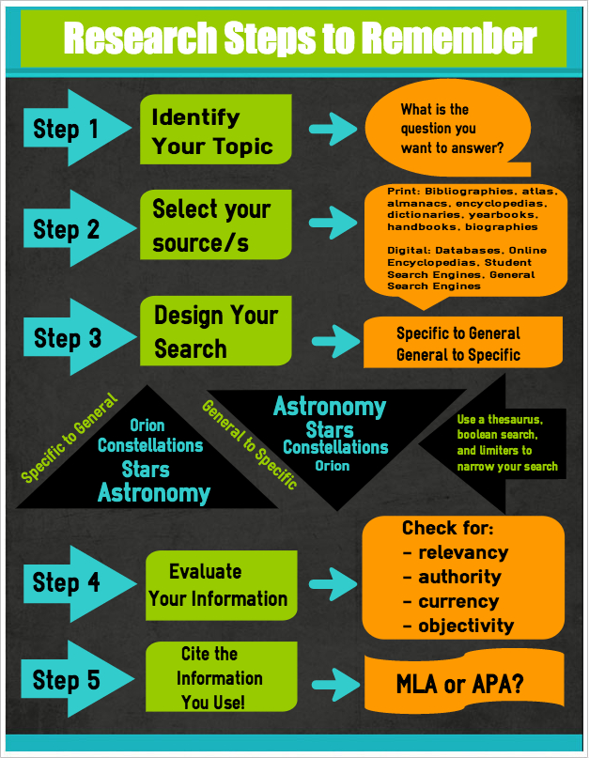

How to Avoid Plagiarism?

KidsHealth.org

What Is Plagiarism?

Chris just found some good stuff on the Web for his science report about sharks. He highlights a paragraph that explains that most sharks grow to be only 3 to 4 feet long and can't hurt people. Chris copies it and pastes it into his report. He quickly changes the font so it matches the rest of the report and continues his research.
Uh-oh. Chris just made a big mistake. Do you know what he did? He committed plagiarism (say: PLAY-juh-rih-zem). Plagiarism is when you use someone else's words or ideas and pass them off as your own. It's not allowed in school, college, or beyond, so it's a good idea to learn the proper way to use resources, such as websites, books, and magazines.
Plagiarism is a form of cheating, but it's a little complicated so a kid might do it without understanding that it's wrong. Chris should have given the author and the website credit for the information. Why? Because Chris didn't know this information before he came to the website. These aren't his thoughts or ideas.

Plagiarism Steals Ideas
The word plagiarism comes from a Latin word for kidnapping. You know that kidnapping is stealing a person. Well, plagiarism is stealing a person's ideas or writing. You wouldn't take someone's lunch money or bike, right? Well, someone's words and thoughts are personal property, too.
What should Chris have done? He should have written down the name of the website and the name of the person who wrote the article. Then he could have added it and given credit to the source.
Teachers have different rules on how you list sources. Sometimes, you provide a list at the end of a report. Other times, a teacher might want you to list the source immediately after the information you took from that source. Or you might just make it part of the sentence (for example: "According to the National Institutes of Health, breathing secondhand smoke can cause problems for kids with asthma.").
All this shouldn't make you nervous to use websites, books, and other sources. It's great that you can get information from experts on stuff you don't know much about. You just have to make sure to show where the information came from. If you do that, you're in the clear.
It's not always easy to tell what's plagiarism and what's not. Sometimes, it's accidental — you really intended to do your own work, but instead ended up with some sentences that sound just like something you've read. You might not be doing it intentionally, but if you don't identify the original source, you're risking a lot of trouble.
So even if you put the information into your own words, you still should list the source. Ask yourself, "Would I know this if I hadn't read it on that website or in that book?" If the answer is no, list the source.

Plagiarism Is Lazy
Though plagiarism can be accidental, it's sometimes done on purpose and that's just being lazy. By copying whole paragraphs from different places, a kid doesn't have to spend the time thinking about the subject, gathering his or her own thoughts about it, and then putting it into original words. Cut, paste, and you're done.
But this is a shortcut that will probably catch up with a kid, even if he or she doesn't get caught for plagiarism. It's important for kids to be able to research a subject, think about it, and then come up with something interesting to say. This skill is important in elementary school, middle school, high school, college, and beyond. A kid who just lifts an entire report won't get the practice needed to become good at this.
Ask yourself, "Am I using this to avoid doing my own work? Is it easier just to copy this?" If the answer is yes, beware. You just might be plagiarizing.

What Happens if I Plagiarize?
Most schools are pretty strict about plagiarism. If you're caught, you can wind up suspended or worse. At the very least, you're probably going to fail the assignment. When you're older and in college, some schools will expel students who plagiarize. To be expelled means to be kicked out. And when you're kicked out of one college, it can be hard to get into another.
Also, when you apply for a job someday you want to be able to say, "I graduated from Supersmart University in 2020." You don't want to have to explain how Supersmart University kicked you out!

Avoiding Plagiarism
To be on the safe side, always make it clear where the information comes from. Your teacher will tell you how to do this. Sometimes, teachers ask kids to write a bibliography (say: bih-blee-OG-ruh-fee). That's a list of the sources you used for a project or report. To do that, you'll need to know the author, the title, and the date it was published. For instance, if you did a report on giraffes, you could give credit to an author this way:
Smith, Hazel B. "All About Giraffes." 2005.
But your most important guide on sourcing is your teacher. Different teachers will have different rules. If you're confused, ask questions to make sure you understand what your teacher expects. And if you write something really great about sharks or any other topic, maybe someday someone will be quoting you in a report!
How to cite credible information?
Check out these valuable webistes.

Purdue OWL: MLA Formatting and Style Guide
https://owl.english.purdue.edu/owl/resource/747/01

Purdue OWL: APA Formatting and Style Guide
https://owl.english.purdue.edu/owl/resource/560/01

