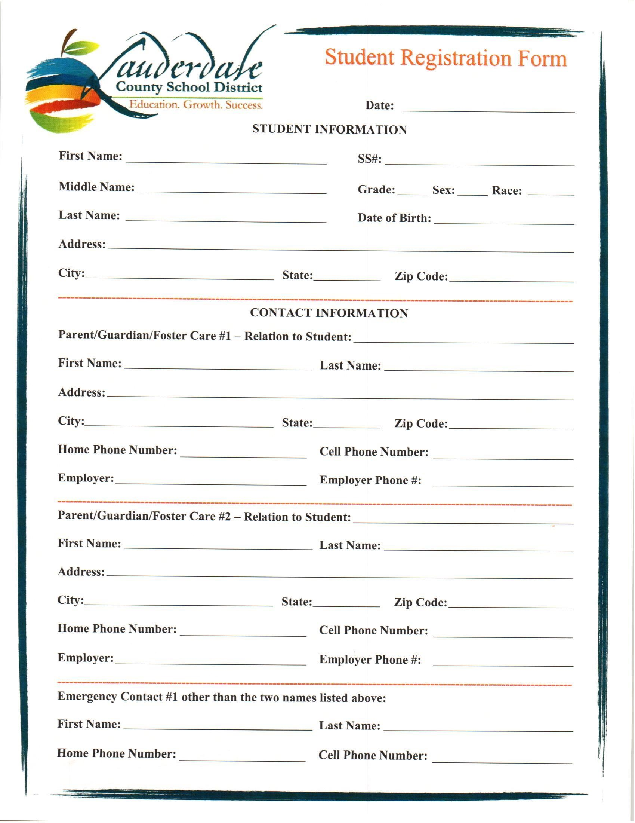
Emergency Contact #2 other than the three names listed above:
First Name: Last Name:
Home Phone Number:
Cell
Phone
Number:

MILITARY INFORMATION
Check all that apply:
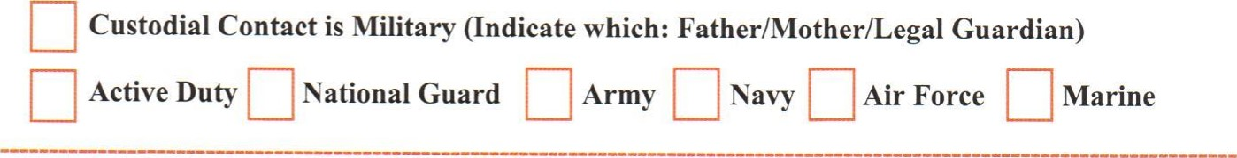
ENROLLMENT INFORMATION
Name of School the Student is transferring from:

Address:

City: State: Zip Code:
School Phone Number: School Fax Number:

If your child is enrolling in Kindergarten, please indicate services received prior to today:
Family Care Pre-K Public Pre-K Private
Name of Provider/Business:

Address:

Is your child in any special classes?(Art, SpEd, Gifted, etc...)

5th and 6th Grade Students: Please check two of the following electives you are interested in:
Physical Education Music
7th and 8th Grade Students: Please check activites you are interested in:
Is there any medical information we need to know about? Please explain.

