Year 10 Astronomy
Life Cycle of a Star – Worksheet Name: ________________

A STAR IS BORN – STAGES COMMON TO ALL STARS
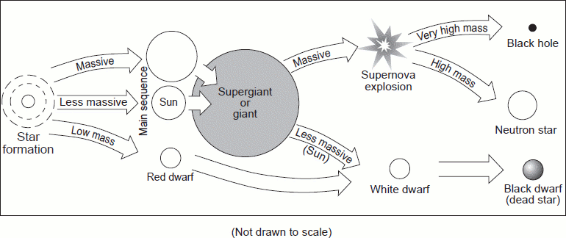
All stars start as a nebula. A nebula is a large cloud of gas and dust. Gravity can pull some of the gas and dust in a nebula together. The contracting cloud is then called a protostar. A protostar is the earliest stage of a star’s life. A star is born when the gas and dust from a nebula become so hot that nuclear fusion starts. Once a star has “turned on” it is known as a main sequence star. When a main sequence star begins to run out of hydrogen fuel, the star becomes a red giant o red super giant.

THE DEATH OF A LOW OR MEDIUM MASS STAR
After a low or medium mass or star has become a red giant the outer parts grow bigger and drift into space, forming a cloud of gas called a planetary nebula. The blue-white hot core of the star that is left behind cools and becomes a white dwarf. The white dwarf eventually runs out of fuel and dies as a black dwarf.

THE DEATH OF A HIGH MASS STAR
A dying red super giant star can suddenly explode. The explosion is called a supernova. After the star explodes, some of the materials from the star are left behind. This material may form a neutron star. Neutron stars are the remains of high-mass stars. The most massive stars become black holes when they die. After a large mass star explodes, a large amount of mass may remain. The gravity of the mass is so strong that gas is pulled inward, pulling more gas into a smaller and smaller space. Eventually, the gravity becomes so strong that nothing can escape, not even light.

Question Sheet
Just like living things and humans, stars have a life cycle, which consists of birth, growth, development, middle age, old age, and death. The life cycle of a star spans over billions of years.

Section One - Sequencing
The stages below are not in the right order. Number the stages in the correct order.

_____ The star begins to run out of fuel and expands into a red giant or red super
giant.

_____ Stars start out as diffused clouds of gas and dust drifting through space. A single
one of these clouds is called a nebula

_____ What happens next depends on the mass of the star.

_____ Heat and pressure build in the core of the protostar until nuclear fusion takes place.

_____ The force of gravity pulls a nebula together forming clumps called protostars.

_____ Hydrogen atoms are fused together generating an enormous amount of energy igniting the star causing it to shine.

Section Two - Vocabulary
Match the word on the left with the definition on the right.

____ black dwarf e. star left at the core of a planetary nebula

____ white dwarf g. a red super giant star explodes

____ nebula c. what a medium-mass star becomes at the end of its life

____ protostar b. a large cloud of gas or dust in space

____ supernova a. exerts such a strong gravitational pull that no light escapes

____ neutron star d. the earliest stage of a star ’s life

____ black hole f. the remains of a high mass star

Section Three – Understanding Main Ideas - Low Mass Star

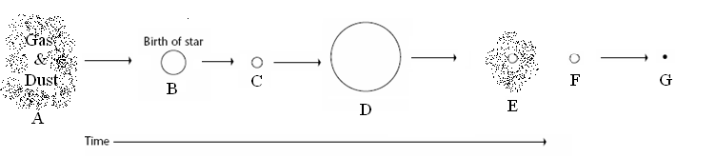

____ 1. Red giant
Label the diagram with all the words given as well as write down the Letter that matches each object.
____ 2. Where fusion begins
____ 3. Nebula
____ 4. Black hole
____ 5. The stage the sun is in
____ 6. White dwarf
____ 7. Planetary Nebula

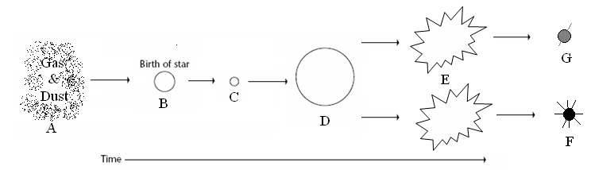
Section Four – Understanding Main Ideas - High Mass Star

____ 1. Black Hole
____ 2. Supernova
Label the diagram with all the words given as well as write down the Letter that matches each object.
____ 3. Protostar
____ 4. Gravity causes this to condense into a protostar
____ 5. Main sequence star
____ 6. When a star begins to run out of fuel and grows larger
____ 7. Neutron star
Section Five – Graphic Organizer – Putting it all Together
Black hole Supernova White dwarf Planetary nebula
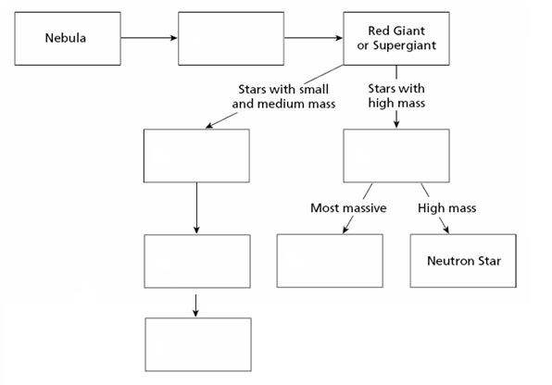
Protostar Neutron stars Black dwarf

Section Six – Use the following words to fill in the blanks

Black hole Massive White dwarf Supernova
Average Nebulae Super-giant Planetary Nebula
Neutron star

1. ___________ are clouds of dust and gas from which a star first forms. They are pulled together by gravity into a spinning disc. The center of the disc becomes a star while the rest can become a system of planets.
2. ___________ come from giant or massive stars. They grow to as much as three times the mass of our sun as they lose the nuclear fuel at their core. The outer layer of this red star expands as the core contracts.
3. Nebula can form either an _________ star that is about the size of our Sun or a
___________ star which can be over three times as big as our Sun! These stars stay in this period for most of their lives and they convert hydrogen to helium while generating lots of heat and light.
4. At the end of the life of a giant star, a _______________ is resulted when a red supergiant’s core collapses in on itself. The electrical forces at the center of the star overcome the gravitational pull and create a massive explosion that scatters the outer layers of the red supergiant.
5. The outer layers of a red giant keep expanding until they eventually drift off and form a __________ _________.
6. Eventually the outer layers of an average star drift away and the star becomes a much smaller __________ _______. It has now run out of nuclear fuel to burn off.
7. This star is very small and tremendously dense and marks the end of the
supergiant’s life cycle. It has a strong magnetic field, a very fast spin and is about 1.4 times the mass of the sun – it is called a ___________ __________.
8. If the star is very massive or big enough, a _________ _______ is formed, which is so dense that not even light can escape its gravitational pull!

Section 7 Crossword Puzzle on the Life Cycle of Stars
Across | Down
  3 | a white dwarf that has cooled down in temperature; is invisible because it no longer emits light
  5 | one of the endings of a star that has a mass 4-8 times greater than our Sun; are very dense
  6 | this is what a low or medium life star will become later in its life; typically have the same mass as our Sun, but only a bit larger than the Earth
  7 | the explosion of a star when it has reached the end of its lifetime; are no longer stars, and are seen as bright points of light in the sky
  8 | the dying stage of a star; they become larger and this color due to the decrease in temperature
  9 | burn up their fuel more quickly than regular stars; soon all fuels will run out and the core will collapse
  10 | places in space so strong that not even light can escape; may occur when a star is dying
  1 | this may be the beginning or the end of a star's life; a cloud that is made up of dust, helium and hydrogen, and plasma
  2 | this is what 90% of stars in the sky are; they fall out of balance when all the fuel has been used up
  4 | this is the starting point of a star's birth, lasting about 100,000 years; mainly made of helium and hydrogen particles, with a relatively low temperature
