Background Information for Political Cartoon Assignment
The Crucible
In the aftermath of World War II, Americans reacted with dismay as relations between the United States and the Soviet Union deteriorated, the Russians imposed communist control over much of Eastern Europe, and China was on the verge of going communist. People worried that communists might try to subvert schools, labor unions, and other institutions. Government agencies and private groups began to look for evidence of subversive activity. In this climate of fear and suspicion, the House Committee on Un-American Activities, which Herb Block had opposed since its inception in the 1930s, became active. And in 1950, a young senator from Wisconsin, Joseph McCarthy, seeking political gain, began a well-publicized campaign using smear tactics, bullying and innuendo to identify and purge communists and "fellow travelers" in government. Herb Block recognized the danger to civil liberties posed by such activities and warned of them in his work.

He coined the phrase "McCarthyism" in his cartoon for March 29, 1950, naming the era just weeks after Senator McCarthy's spectacular pronouncement that he had in his hand a list of communists in the State Department. His accusations became headline news, vaulting him into the national political spotlight. For four years McCarthy attacked communism, while in his cartoons Herb Block relentlessly attacked his heavy-handed tactics. In June 1954, McCarthy was censured and in December condemned by the Senate.
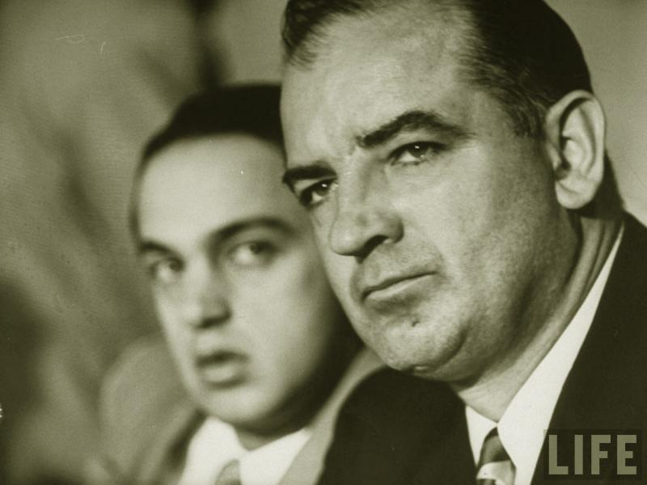

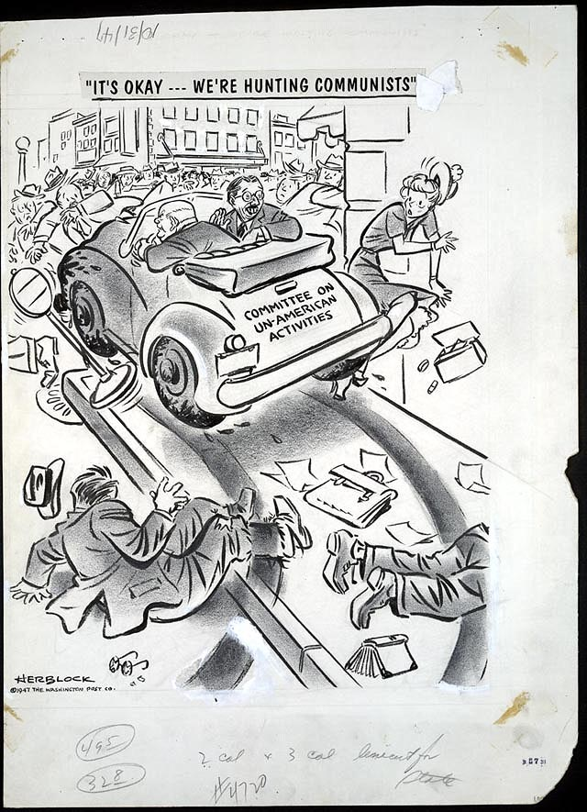

"It's okay – We're hunting Communists"
The Cold War revived the anti-communist hysteria that had gripped the United States after World War I. In 1947 Congress revived the House Committee on Un-American Activities (HUAC), opposed by Herb Block since its inception in the 1930s and declared by President Truman to be itself the most un-American activity. Herb Block comments: "The FBI, under J. Edgar Hoover, helped provide the committee with material from its aptly named ‘raw files'. Some producers, directors and screen writers refused to testify or to play the ‘name game' in which the committee demanded the names of associates, who could then be called on to name others thus providing an ever-expanding list of suspects to be summoned."
"It's okay – We're hunting Communists," October 31, 1947
Ink, graphite, and opaque white over graphite underdrawing on layered paper
Published in the Washington Post (18)

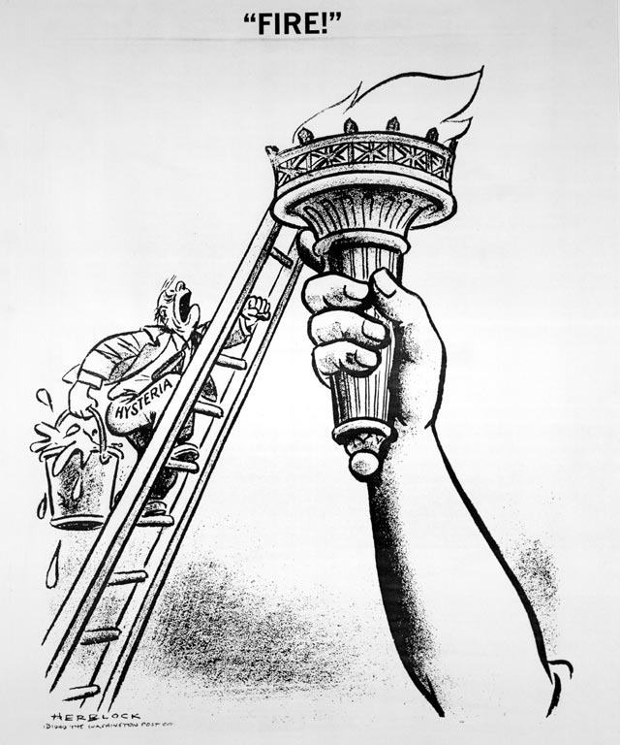

"Fire!"
By 1949, the Soviets had expanded their control to cover most of Eastern Europe, and it appeared that China would soon fall to the communists as well. "The fear-filled forties and fifties were a dark period when the spread of communism abroad increased anxieties and frustration at home," wrote Herb Block. In their zeal to stamp out all signs of subversion in the United States, professional and amateur anti-communists threatened to suppress American liberties as well.
"Fire!" June 17, 1949
Reproduction from original drawing
Published in the Washington Post (25)

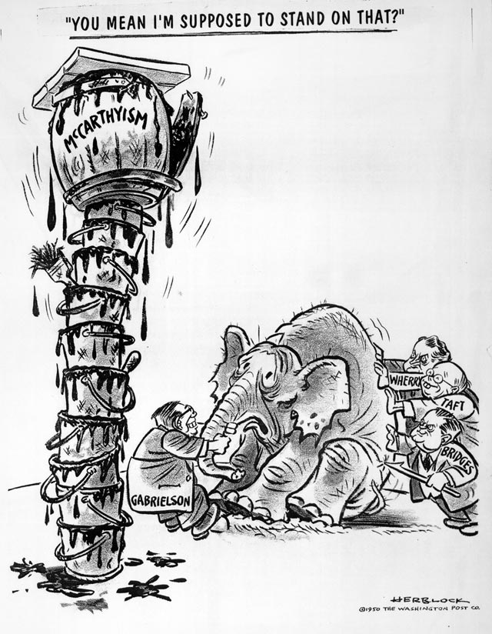

"You mean I'm supposed to stand on that?"
In February 1950, Senator Joseph McCarthy captured headlines by his claims that he held in his hand, a list of names of some 205 communists in the State Department which he did not reveal. Many members of Congress, influenced by his success, began to support his heavy-handed and abusive tactics for political purposes. Here conservative Republican senators, Kenneth S. Wherry, Robert A. Taft, and Styles Bridges and Republican National Chairman Guy Gabrielson push a reluctant GOP elephant to mount the unsavory platform. This was the first use of the word "McCarthyism."

"You read books, eh?"
During the postwar anti-communist campaign hundreds of elementary and high school teachers were investigated and lost their jobs, sometimes as a result of being named by proliferating "anti-subversive" groups and individuals. Some individuals compiled and circulated their own blacklists, which were accepted by frightened employers and casting directors who feared being blacklisted themselves if they sought facts and fair play. The motives of some self-serving or vindictive accusers were summed up by Herb Block in a phrase: "If you can't crush the commies, you can nail a neighbor."
"You read books, eh?" April 24, 1949
Ink, graphite, and opaque white over graphite underdrawing on layered paper
Published in the Washington Post (24)
LC-USZ62-127202

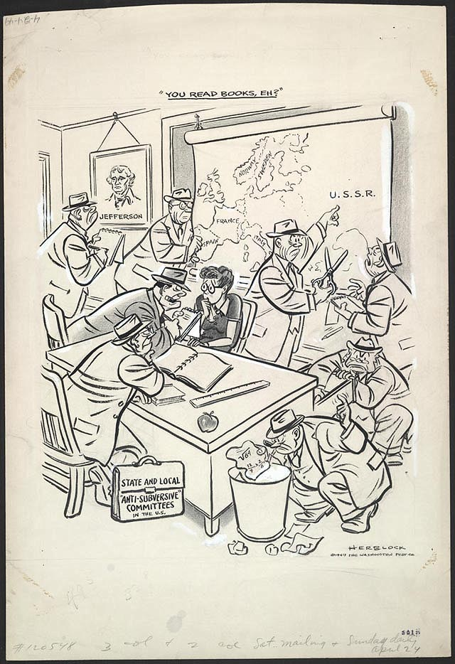

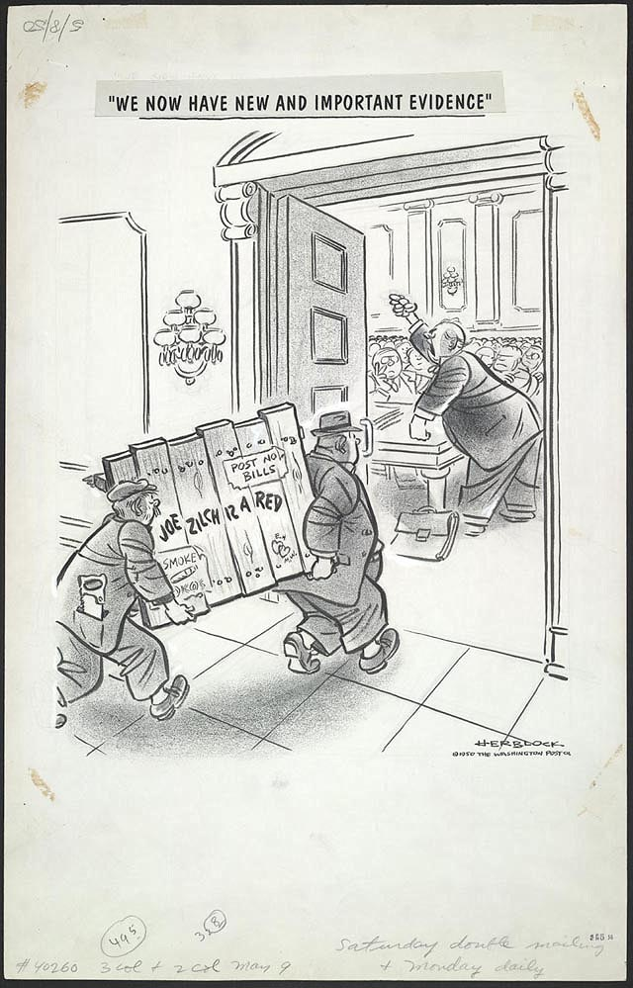

"We now have new and important evidence"
Senator Joseph McCarthy's continued string of reckless charges of communism in government created such a sensation that the Senate appointed a special committee under Millard E. Tydings to investigate his "evidence." McCarthy managed to turn the hearings into a circus, each new charge obscuring the fact that earlier accusations weren't backed up. Despite a final report by the committee discrediting McCarthy's tactics and evidence, he emerged with more general support than ever. And "anti-subversive" hearings by other committees of Congress, particularly the Senate Internal Security Committee headed by Senator Pat McCarran (D-Nevada), continued treating rumors and unsupported charges as "evidence."
"We now have new and important evidence," May 8, 1950
Ink, graphite, and opaque white over graphite underdrawing on layered paper
Published in the Washington Post (28)
LC-USZ62-126908

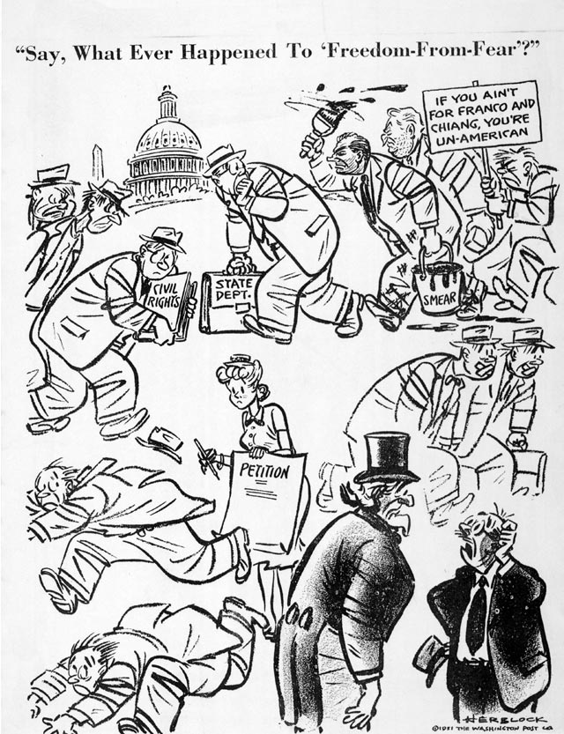

"Say, what ever happened to 'freedom-from-fear'?"
As Senator Joseph McCarthy's campaign against State Department and Justice Department officials continued, President Harry Truman spoke against "scaremongers and hatemongers" who "are trying to create fear and suspicion among us by the use of slander, unproved accusations, and just plain lies."
"Say, what ever happened to 'freedom-from-fear'?"August 13, 1951
Reproduction from original drawing
Published in the Washington Post (31)

Nothing exceeds like excess
Senator Joseph McCarthy's irresponsible tactics were endorsed by many voters who felt that the communist threat was such that the means justified the ends. A non-combat veteran, he had used the nickname "Tail-gunner Joe" to win a Senate seat after the war. He then latched on to anti-communism as a winning tactic for re-election. Other politicians, recognizing pay dirt when they saw it, jumped on his tar-barrel bandwagon. The attacks on the Truman Administration continued even as President Harry Truman was fighting a war against communist aggression in Korea. At the State Department's request, Herb Block contributed a booklet of his anticommunist cartoons for distribution abroad. McCarthy used this to charge that he was in the pay of the administration. When confronted by a reporter, McCarthy backed down.
Nothing exceeds like excess, September 12, 1952
Ink, graphite, and opaque white over graphite underdrawing on layered paper
Published in the Washington Post (32)
LC-USZ62-126909

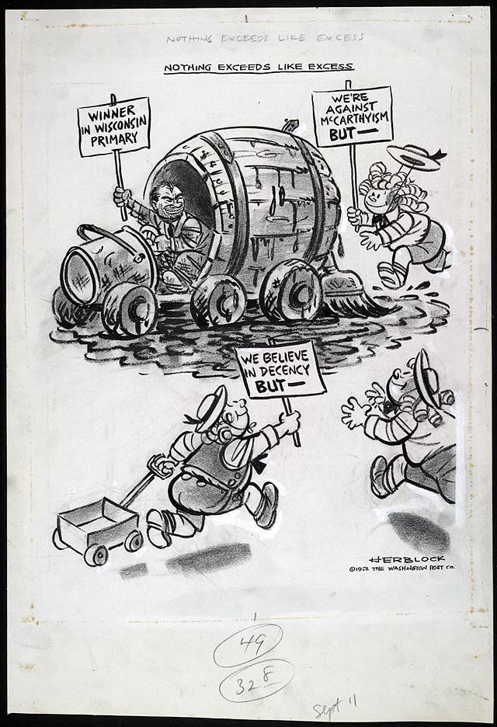

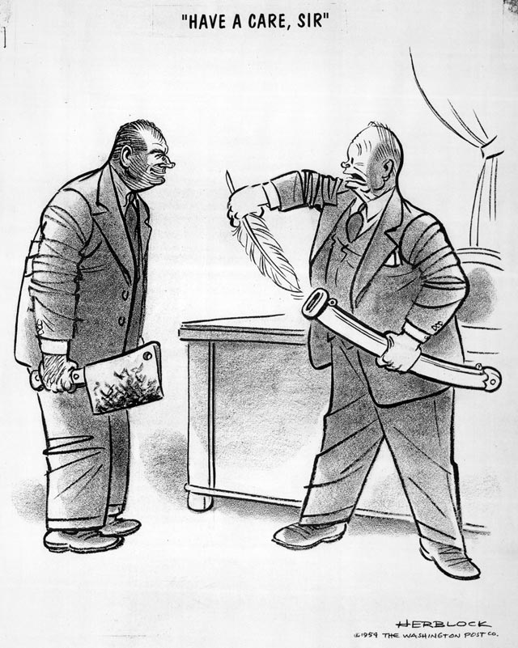

"Have a care, sir"
Throughout his political career, Dwight Eisenhower refused to take a public stand against Senator Joseph McCarthy's aggressive anti-communist campaign. Eisenhower even struck from a 1952 campaign speech in Wisconsin a defense of his mentor, George C. Marshall, a McCarthy target. Half a dozen Republican senators, including Ralph Flanders, joined Margaret Chase Smith in a "declaration of conscience" against McCarthy. Eisenhower, however, continued to speak of "justice and fair play" in fighting communism, and it was a long time before they prevailed.
"Have a care, sir," March 4, 1954
Reproduction from original drawing
Published in the Washington Post (33)

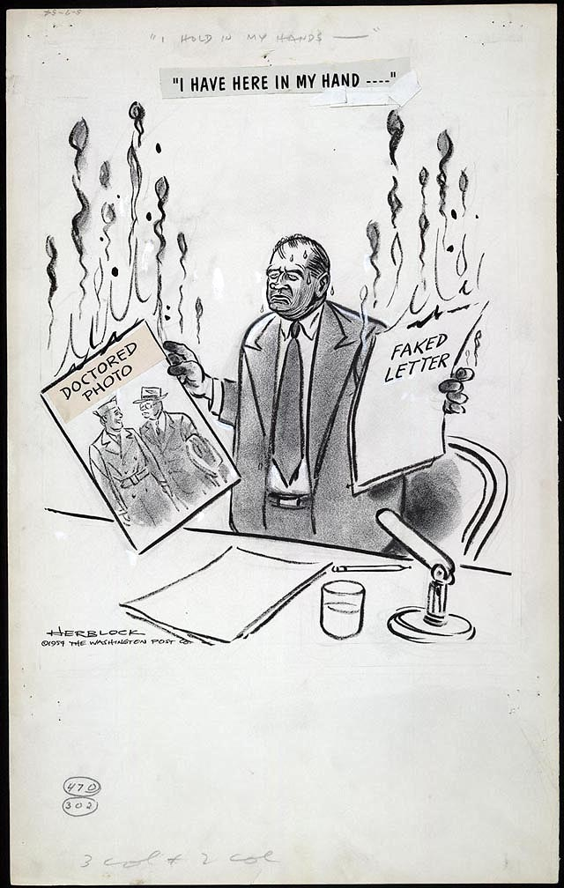

"I have here in my hand . . ."
In 1954, Senator Joseph McCarthy went too far when he took on the United States Army, accusing it of promoting communists. The Senate held special hearings, known as the Army-McCarthy hearings, which were among the first to be televised nationally. In the course of testimony McCarthy submitted evidence that was identified as fraudulent. As both public and politicians watched the bullying antics of the Senator, they became increasingly disenchanted. Before the year was out McCarthy, whose charges had first hit the headlines in February 1950, was censured by his colleagues for "conduct unbecoming a senator."
"I have here in my hand . . .," May 7, 1954
Ink, graphite, opaque white, and overlay over graphite underdrawing on layered paper
Published in the Washington Post (34)
LC-USZ62-126910

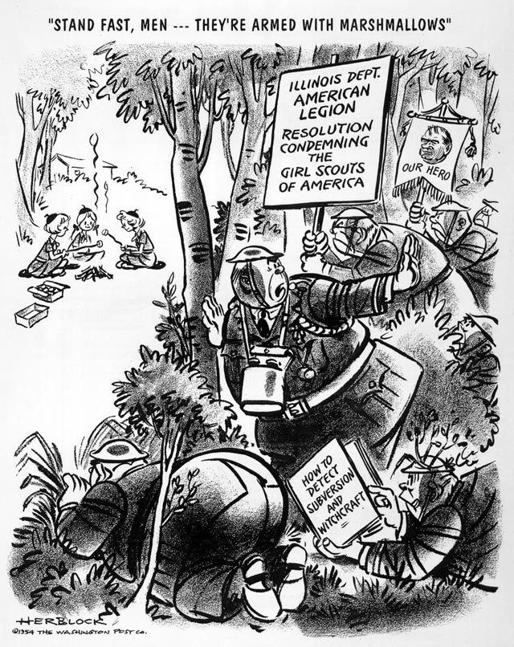

"Stand fast, men -- They're armed with marshmallows"
Even with Senator Joseph McCarthy on the wane, the general hysteria continued in many forms by assorted super patriots. In the summer of 1954, a branch of the American Legion denounced the Girl Scouts, calling the "one world" ideas advocated in their publications "un-American."
"Stand fast, men--They're armed with marshmallows," August 11, 1954
Reproduction from original drawing
Published in the Washington Post (35)

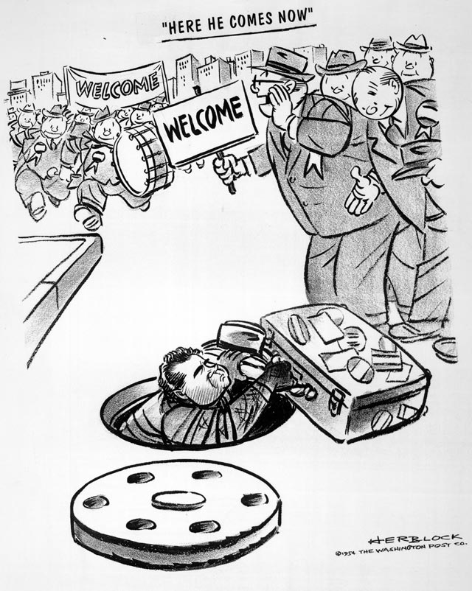

"Here he comes now"
Richard Nixon had discovered the power of smear attacks in his early campaigns for the House of Representatives and Senate years before Senator McCarthy began to use them. In 1954, during his vice-presidential campaign for re-election, Nixon traveled the country to charging previous Democratic administrations and current Democratic members of Congress with being soft on communism. His targets included some of the most respected members of the Senate. Herb Block's 1954 depiction of the emerging campaigner would stick with Nixon throughout his career.
"Here he comes now," October 29, 1954
Reproduction from original drawing
Published in the Washington Post (36)

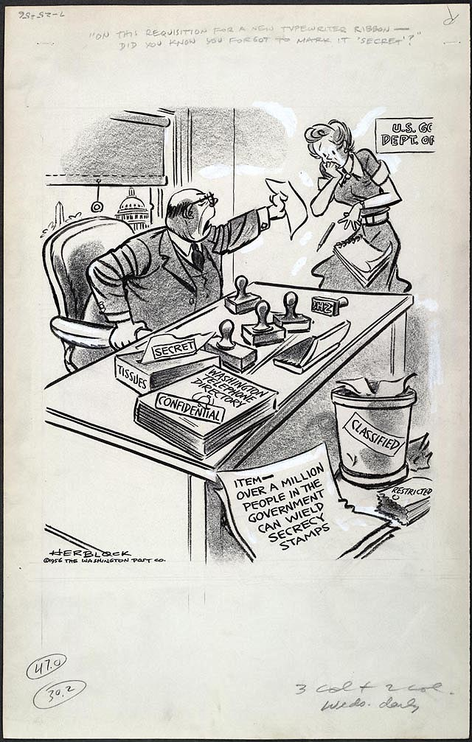

"On this order for a new typewriter
ribbon -- did you know you forgot to
stamp ‘Secret'?"
The least secret fact about the federal government is that it keeps too many secrets. In 1956, a congressional committee reported that a million people in government—military and civilian—were authorized to wield secrecy stamps. A Defense Department official summed up: "I have never known a man to be court-martialed for overclassifying anything." And a Herb Block cartoon had one official saying to another, "Well, we certainly botched this job. What'll we stamp it—‘secret' or ‘top secret'?" In March 1957, The Washington Post reported that the Pentagon had recently stamped more documents secret than they had during World War II. Much of the "secret" information consist of speeches and other public records.

