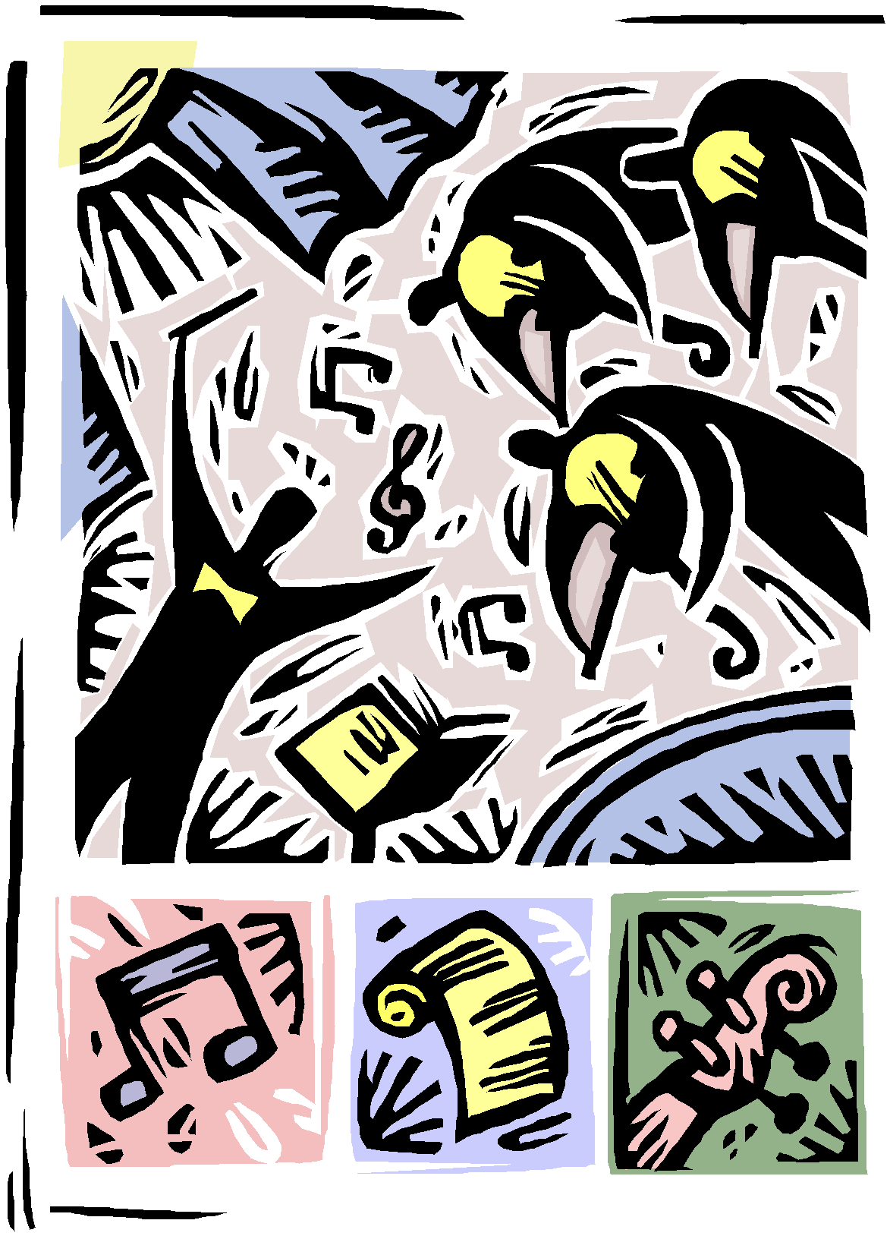

Springfield Middle School
Vocal/Choir Handbook
2017-2018

Be the change you wish to see in the World!
-Mahatma Gandhi

Mr. Aaron Edmundson: Director of Choral Activities

SPRINGFIELD MIDDLE SCHOOL MUSIC OBJECTIVES

The overall objective of the SFMS Music Department is to cultivate, educate and nurture the musical talent and creativity of our students. We will accomplish this through performance excellence, music literacy, history and exposure to a variety of musical styles and genres. Our goal is to make music a lifelong passion in each of our students’ lives.

SPRINGFIELD MIDDLE SCHOOL MISSION STATEMENT

Springfield Middle School will provide a safe and orderly environment, which recognizes cultural diversity and develops academic and social abilities while promoting life-long learning for a global community. Springfield Middle School believes every student can learn and should experience success and recognition. Our school environment will have a profound effect on student achievement. Our staff will create a sensitive, caring environment which will encourage students to be lifelong learners. Students need to practice respect for others and themselves and should be held responsible for their own actions. Student success is enhanced when families, schools and the community are engaged in an ongoing partnership.

WELCOME TO SFMS MIDDLE SCHOOL CHOIR!

Dear Choir Parent(s),

Greetings from your new choral director at Springfield Middle School! My name is Mr. Aaron Edmundson and I am very excited about this school year and the opportunities that await your student. The school year will be filled with wonderful music making, engaged learning about music, and excellence in creating the music we will perform.

Choral music is an incredible avenue toward building better musicians and better people. Through teamwork, performance, music literacy and creativity, students are able to develop their self-esteem and ability to express themselves. Through exposure to many different musical styles and periods, they are more aware of history and the world cultures. They also begin to understand the impact that music can have in their lives and in the lives of others.

I believe that the most successful outcomes for everyone are derived from excellent communication. It is my goal to have good communication with parents. If you have any questions regarding classes, or the program, please don’t hesitate to contact me. E mail is probably the quickest way to get in touch with me rather than calling. My e-mail address is aaron.edmundson@wilsonschoolsnc.net. The phone number at the school office is (252) 237-4250 and they can forward your call to my extension.

Please read carefully through the choir schedule and mark your calendars accordingly. Also, please sign the student agreement form with signatures of both parent and student to Mr. Edmundson. This form will serve as the 1st grade of the year for your student.
THE PURPOSE OF THE SFMS VOCAL PROGRAM

As a member of any singing ensemble you will further develop your musicianship and total understanding of music in such a way that you can continue to enjoy, learn and perform music as an independent musician. Your SFMS choral experience will not only prepare you to perform in high school but will prepare you so that you can enjoy music throughout your life as a performer, creator or consumer of music.

Your Objectives For This Year Include:
VOCAL DEVELOPMENT (Choir) - tone, breath, care of the voice, pitch and intonation. DEVELOPMENT OF MUSICALITY (all music areas) - expressing the written music through
performance of varied styles and listening.

MUSIC APPRECIATION AND HISTORY (MUTECH) - understanding of periods, composers, styles, genres and instruments.
SIGHT READING (all music areas) - reading music through the use of the solfege system. MUSIC LITERACY (all music areas) –following a vocal score with all pertinent markings,
symbols and directions.

MUSIC THEORY (all music areas) – understanding all notes, rest values as well as all musical symbology.

MOVEMENT - expressing music through choreography if the music calls for it

PERFORMANCE AND CONCERT ETIQUETTE ( all performing music areas)- presenting oneself in a formal and informal concert setting as well as showing the kind of demeanor and courtesy one should have as an audience member.
CHORAL STUDENT EXPECTATIONS/GRADING POLICY

PARTICIPATION
What is expected from you as a participant of the choral classroom? These are the things you are graded on when you earn points for participation every week in choir. Sometimes there is a crossover into other grading areas. Participation is 45% of your overall grade.

• Sitting in your seat at the beginning of class with all materials.

• Attempting to sing, move and follow all directions at the best of your ability.

• Raising your hand to answer questions or ask questions.

• Assisting the teacher when needed.

• Assisting fellow students when needed.

• Taking part in all classroom activities, singing or otherwise.

• Completing or attempting to complete worksheets or homework.

• Giving your best in all tests and quizzes.

• Being attentive in all vocal rehearsals.

• Marking your music when appropriate.
• Behaving in such a manner to support the learning environment. TEST & QUIZ GRADES
Concerts, rehearsals, worksheets, and written tests are assigned as test grades.

• Test grades are 50% of your overall grade.

• Stay for the entire concert.

• Perform to the best of your ability.

• Sit quietly while your peers are performing with no disruptive behavior.

• Attend all required rehearsals and give your best.

• Prepare yourself to take singing tests with your friends so that you earn the best grade possible.

• Study for written theory quizzes and tests.

• Display proper concert etiquette.

• Attend Concerts on time dressed in the proper performance attire.

HOMEWORK/CLASSWORK
Occasionally, I will have worksheets that go home, but most of the time we complete all written assignments in class. These sheets will contribute to your knowledge of music symbology and theory and will directly affect your musical literacy (reading and understanding). I assign homework grades to these types of assignments.

Homework and classwork assignments are (5%) of your overall grade.

Here is what I look for when you earn your homework grades:

• Completion or the attempt at completing any music theory or fun worksheet.

• Bringing back homework completed the next day or finishing it in class.

• Keeping your materials organized and bringing your music with you when you are allowed to take it home to study it. Having materials with you all the time.
SFMS MIDDLE SCHOOL CHOIR RULES

1. Be on time and in your seat with required materials at the start of class and be prepared for a wonderful class experience. Do not be tardy!
Music is based on time and what you do with that time.

2. Be respectful of all materials given to you (pencils, paper, & books). Make sure you are very careful with any music that you are given. Music is your textbook. Students will be responsible for damaged textbooks or damaged print music. Never vandalize any equipment in the music rooms.
Music needs to be nurtured.

3. There is No gum or cell phones allowed in the choral classroom.
Music does not involve choking or texting.

4. Display a positive attitude. We all have bad days from time to time, but leave the luggage of the day outside the classroom if at all possible. Always speak positive things, never negative things.
Music heals.

5. Be respectful of your teacher and fellow students by raising your hand to speak and not speaking over your teacher or fellow choir members. Never argue with your teacher. Problems can be handled in a fair and calm way. Your teacher is always in control of the class. You only talk when you have permission to do so.
Music unifies.

6. Show a positive contribution every day. Vocal music is a participation class. Each member is expected to uphold his/her responsibility of participation in all activities. If you have a day where you feel you cannot positively contribute, please let the teacher know. Disruption of the learning environment will have consequences. All I ask is that you do your best to participate. “Try” is the magic word!
Music is all about people.

7. Be a team player. Choir is about many voices joining into one voice to create beauty. We are only as good as our weakest member. Cooperating and working together will make us successful.
Music brings us together.

8. Maintain the appropriate posture and understand the term “set.” Learn to take care of your voice. We will learn this together.
Music rehearsal is organized.

9. Dress appropriately when you are to perform in front of any audience.
Music can be formal and informal.
10. Audition and experience as much as you can. Auditioning is a part of life-lessons. There are other opportunities for you at SLMS and more than one year to audition for things if you do not make it the first time around.
Music requires much tenacity.

11. Come prepared to have the very best year ever! Never settle for anything but your very best. Being EXCELLENT is hard work, but very worth the time and effort involved.
Music is about discipline.

12. Have FUN! Choir ROCKS! Singing is a wonderful way to stir the soul and create well balanced, compassionate and creative human beings. It is also an incredible way to express yourself and experience more about the world around us.

Music is about expression and enjoyment of life!

*Note that rules can change based off the needs of the choir.

CHORAL MAKE-UP POLICY

As a teacher in the Fine Arts, I am always looking for ways to assist students to earn grades that encourage and inspire them to be the best they can be. I would rather find ways to give students points rather than taking them away. I firmly believe that I am teaching students life skills as well as musical skills, since music is such an incredibly powerful tool. Music inspires, molds, and helps create wonderful, responsible and passionate human beings.

It is important that every student understand that Choir is a performance and participation class and that the major exams ARE the concerts. All the weeks we spend preparing are leading up to these golden opportunities to show off your skills in front of peers and family. They are required and graded.

If your student is ill, we do not want them at a concert to make the choir sick. If your student stayed home from school, do not come to the concert unless you have permission from me to do so. However, any absence that is not based on illness (with a parent or doctor’s note) or due to a death in the family will be deemed an unexcused absence.

Unexcused absences are zeroes in the gradebook. However, there is good news for students who are absent from a concert for any reason:

An alternate assignment will be made to students who miss a concert. To get full credit, these alternate assignments are due no later than one week after the concert. One week later will result in 80% credit; Two weeks later will result in 70% credit; Three weeks later will be 60% credit. No grades lower than 60% will be given for late work as long as it is complete and is quality work. However, if the student fails to complete and submit the alternate assignment within the trimester the concert occurred, the grade will remain a zero.

***Transportation or attire is not an excuse to miss a concert.

CHOIR PERFORMANCE ATTIRE

Choral attire for all performing groups will be as follows:

Green Springfield Middle School Music Department Shirt, khaki pants, tennis shoes
No flip flops! All shirts MUST be tucked in.

My priority is that every student gets to perform at a SFMS Choir concert with appropriate attire.

Please do not let money be a reason for not being dressed properly for concerts. Waiting till the day of the concert to ask for proper attire is unacceptable. Those students who do not wear the proper attire (or we can’t find the proper attire to fit at the last minute) or refuse to do so may watch the concert from the audience, write a short review and receive partial credit for attire. They will receive full credit for attending. Doing this is discouraged since students are robbing themselves of the experience of performing which is why you take the course to begin with.

CHOIR FIELD TRIPS Competitions/Events/Performances: ELIGIBILITY

From time to time, vocal students may leave the SFMS campus to perform or to attend performances after the school day or during the school day. These are deemed field trips.

It is the policy of SFMS Middle School that in order to participate in these special outings (which are extra-curricular) a student must have passing grades in all of their classes. In other words, in order to participate, a student must have no grade lower than a D in any one class.

I check e mails from our administration about students’ eligibility as it pertains to their classes. I check the grade list a week before any extra-curricular event. Doing this enables the students to contact the teacher well in advance and raise their grade in order to participate. Students who are unable to raise their grade by the day of the event or competition will not be allowed to participate.

If the field trip occurs during the school day, students are expected to know the homework assignments for classes missed and be current in any earlier homework assigned. Should a student have too many missing assignments, he/she may have to stay at school rather than taking part in that particular field trip. The goal of this policy is to promote success in all areas of academic development.

***IT IS VERY IMPORTANT THAT HIGH ACADEMIC STANDARDS BE MAINTAINED IN ORDER TO PARTICIPATE FULLY IN ALL EVENTS ASSOCIATED WITH THE SFMS CHOIR AND THE MUSICAL IN PARTICULAR.

VOCAL MUSIC – GRADES 6-8
STUDENT LEARNING GOALS & EXPECTATIONS
For
Springfield Middle School

The middle school vocal music student can…

Performance
1. Demonstrate healthy use and care of the voice.
2. Sing with good tone and correct posture and breathing.
3. Sing in tune and in rhythm.
4. Sing in balance with the choir.
5. Follow conductor and music markings.
6. Show appropriate rehearsal and performance skills.

Expression and Creativity
1. Move appropriately to a variety of musical styles, tempos, meters and dynamics.
2. Demonstrate musicianship by responding to stylistic elements.
3. Arrange music by making choices, including part selection, form, dynamics, etc.
4. Create rhythmic and melodic patterns through improvisation and/or
composition.
Music Literacy
1. Recognize various musical patterns, forms and styles.
2. Identify musical elements including melody/harmony, major/minor tonalities and voice parts.
3. Evaluate own and others’ performances.
4. Read, write and perform basic music notation.
5. Sight-read simple melodies using solfege.
6. Follow voice part in choral music.

Connections
1. Identify and perform choral literature of various styles, cultures and time periods.
2. Identify and describe roles of composers and musicians in various
settings and cultures.
3. Show understanding of how other subjects (academics and life- skills) relate to music.
4. Demonstrate appropriate behavior as a performer and audience
member.

SFMS CHORAL SYLLABUS:
Go to following link and select the respected grade level of your child to view the county syllabus for chorus.

https://sites.google.com/a/ccs.k12.nc.us/arts-education-k-12/choral-music-MS?pli=1

CHOIR VOLUNTEERS

A great vocal program involves the staff, the students, the administration and yes…our
PARENTS!

We cannot do this without you parents. There are so many areas in which you could assist this year. Please review the items listed below. If you are available, just send me an email and I will give you all the pertinent information
Please let us know if you have a special interest in helping in any of the following areas:

• Assisting the director in the concerts
• Providing transportation to concerts
• Artists for posters, programs & drawings
• Photographers and Videographers for concerts and other events
• Chaperoning field trips during the school day
• Are you a certified teacher? What subject?
• Can you drive a commercial vehicle?
• Are you a musician? What do you play? How many years? Do you still play?

* Any area that is not listed that you feel like you could benefit the chorus please let Mr. Edmundson know.

I’ll need your name, your student’s name and grade level, your address, the phone number where I can readily reach you and your e-mail address. Thank you!!!!!!!

CONCERT ETIQUETTE

Formal Concert Etiquette

It is a goal of the SFMS Fine Arts Program to instill in every student a set of values which stress proper manners associated with concert performances. Concert etiquette should be practiced at all SFMS concerts as well as those outside of our school. Concert etiquette is a part of your grade at SFMS and what you learn about etiquette will be an important part of your life long support of the performing arts. We want to make sure that everyone's performances at SFMS are respected by the audience and that we show proper appreciation based on the particular venue.

Examples of Formal Concert Etiquette are as follows:

If you bring small children with you, we understand that from time to time, little listeners can become restless. Should your child begin crying or suddenly become noisy, we would please ask that you exit the auditorium (gym) with your child as quickly as possible until they become calmer. Our concerts may be recorded and so we like to keep distractions to a minimum.

Please do not carrying on loud conversations during performances.

Often, people dress up to go to the opera, symphony, ballet or choral concert etc. This shows respect for the performers and for the venue.

Clap appropriately after a piece is finished.

If you need to leave the auditorium (gym) for any reason, please leave between selections as quietly as possible.

Please leave all electronic devices on the off or silent mode.

Please do not bring food or drink of any kind into the auditorium (gym).

When a piece has ended, always wait for the conductor's arms to come down to his/her side before applauding, thereby allowing a moment of silence for the audience savor the moment after the conclusion of the piece.

Someone once said “music is an exquisite soundscape, superimposed on a background of silence, and its existence is fragile". Please help us to make every performance at SFMS the most enjoyable experience for performers and fellow audience members alike.
Informal Concert Etiquette

Much of what has been written above pertains to Informal Concerts as well. However, show choir performances, talent shows and pop concerts are considered to be informal concert experiences. There are differences that are worth mentioning:

At show choir performances, talent shows, jazz or pop concerts, it is perfectly fine to clap after someone has finished a solo vocally or instrumentally within the piece before the piece has concluded. However, keep the clapping short as to not mar the rest of the piece.

Many times, audience members are excited about the energy coming from the stage and they may shout encouraging words such as "BRAVO" or "GREAT JOB" or whoop and holler since many of these show events are competitive and considered informal.

It is never okay to interrupt a performance with inappropriate gestures or language. It is also never acceptable to boo a performer or disrupt someone else’s enjoyment of a performance formal or informal.
Special Note:

By signing the choral contract, you are also giving your consent in letting Springfield Middle School Performing and Fine Arts Department to take pictures or video of your child at various event as it pertains to musical functions. If you think this would be a problem, please let Mr. Edmundson know as soon as possible. Thank you!

