Resources in White Pine County for Families

Clubs/Schools/Recreation:
- Aquatic Center
  - 1111 Veterans Blvd, Ely NV 89301 775-289-7700
- Boys and Girls Club
  - 844 Aultman St. Ely NV (White Pine Middle School) 775-360-2453 (Mark Jacoby)
- Boy Scouts
- Cooperative Extension Services
  - 1000 Crampton St., Ely NV 89301 775-289-4459
- Ely Shoshone Tribe
  - 250 Heritage Dr., Ely NV 89301 775-289-6907
- Girl Scouts of Sierra Nevada
  - Reno NV 898503-4328 775-322-0642 email info@gssn.org
- Little People’s Head Start
  - 435 S 13th St. Ely NV 89301 775-289-6113
- Make-a-Wish Foundation
  - 775-826-8000
- Magic Carpet Preschool
  - 108 W. Mineral Dr., Ely NV 89301 775-289-3731
- McGill Swimming Pool
- Nevada Bureau of Vocational Rehab
  - 480 Campton St., Ely NV 89301 775-289-1675
- Parents Encouraging Parents
  - 800-216-5188
- Project ASSIST (for families with handicapped children & young adults)
  - 800-552-0066
- White Pine County School District
  - District Office - 1135 Ave C, Ely NV 89301 775-289-4851
  - Baker School – Baker, NV 775-234-7333
  - David E. Norman Elementary K-5 – 1101 N 11th St. Ely NV 89301 775-289-4846
  - Great Basin College – 2115 Bobcat Dr., ELY 89301 775-289-3589
  - Lund Grade K-12 School – 301 E. 2nd N, Lund NV 775-238-5200
  - McGill Pre-5th Grade – 25 Ave F, McGill NV 89315 775-235-7722
  - Steptoe Valley High School – 700 Aultman St., Ely NV 89301 775-289-2999
  - White Pine Middle School (6-8th Grade) – 844 Aultman St., Ely NV 89301 775-289-4841
  - White Pine High School (9-12th Grade)– 1800 Bobcat Dr., Ely NV 89301 775-289-4811
- White Pine County Community Training Center
  - 1501 Park Ave, Ely NV 89301 775-289-6713
- White Pine County Library
  - 950 Crampton St. Ely NV 89301 775-289-3737
- 4-H Club
  - White Pine County Office 995 Campton St., Ely NV 775-289-4459

Emergency Services:
- Ambulance Services
  - 1785 Great Basin Blvd., Ely NV 89301 775-289-4833
- Ely Volunteer Fire Department
  - 1780 Great Basin Blvd, Ely NV 89301 775-289-6633
- McGill/Ruth Fire Department
  - 911
- National Runaway Safe-line
  - Serving Ely Area 800-786-2929
- Nevada Highway Patrol
  - 775-289-1600 or 911
- Nevada Division of Investigation (NDI)
  - 775-289-1660
- Poison Control
  - 800-446-6179
- Poison Hot Line
  - 800-229-1222
- Shoshone Tribal Police
  - 775-289-4888
- White Pine County Sheriff
  - 1785 Great Basin Blvd, Ely NV 89301 775-289-8808 or 911

Health/Social/Emotional:
- Bureau of Indian Affairs
  - 775-738-5165
- Certified Nutritional Consulting Services
  - Ely NV 89301 775-289-4658
- Crisis Line in NV
  - 800-992-5757
- Division of Child and Family Services
  - 740 Park Ave. Ely NV 89301 775-289-1640
- Dr. Kent Robertson (Ophthalmologist)
  - Great Basin Blvd, Ely NV 89301 775-289-2580
- Dr. Todd Wilkin (Dentist)
  - 1475 Ave G, Ely NV 89301 775-289-4000
- Dr. Van Tassel & Dr. Goodrich (Dentist)
  - 1304 E Aultman St. Ely NV 89301 775-289-6166
- Dr. Shannon Sena (Dentist)
  - 1500 AveF, Ely NV 89301 775-289-3375
- Dr. Jeffry Willis (Chiropractor)
  - 664 14th St. E, Ely NV 775-289-6800
- Economy Drug
  - 696 Aultman, Ely NV 89301 775-289-4929
- Ely Mental Health Clinic (Individual and Family counseling)
  - 1675 Ave F, Ely NV 89301 775-289-1671
- Home Health Services
  - 685 Lyons Ave, Ely NV 89301 775-289-2611
- I CAN Program
- Lion’s Sight Programs
  - Runnolo DiCianno 775-289-2844
- Mountain Vista Chapel (Mortuary)
  - 450 Mill St., Ely NV 89301, 775-289-2651
- Newe Indian Health Clinic
  - 775-289-2134
- Physical Therapy
- Professional Pharmacy
  - 6 Steptoe Circle, Ely NV 89301 775-289-3420
- RX Help
  - 800-33-1597
- Senior RX Help
  - 866-303-6323
- Services at White Pine County School District
  - Irlen Syndrome Testing
  - Dyslexia Screening
  - Basic Vision/Hearing/Scoliosis Screenings
  - Special Education Services
  - OT Evals
  - PT Evals
- Servcies for the Blind
  - 775-738-9573
- Services for the Deaf
  - 775-687-4452
- Social Services General Services
  - 297 11th St. East Ste #7, Ely NV 89301 775-293-6528
- Talking Books
  - 800-992-9334
- White Pine County Care Center
  - 1500 Ave G, 775-289-8801
- White Pine County Health Nurse – shots
  - 297 11th St. East. Ely NV 89301 775-289-6558
- William B. Ririe Clinic and Hospital with After Hours Clinic
  - 1500 Ave H, Ely NV 89301 775-289-3001, 775-289-3612

Housing/Real Estate:
- Desert Mountain Realty
  - 1060 E. Aultman, Ely NV 89301 775-289-3038
- HUD (Housing and Urban Development)
  - 775-887-1795
- Ely Mobile Home Sales
  - HWY 93, Ely NV 89301 775-289-3413
- Klaas Realty
  - 643 Aultman, Ely NV 89301 775-289-5300
- Farmer’s Home Administration
  - 1170 Ave E, Ely NV 89301 775-289-8100
- Nevada Rural Housing Authority
  - 775-289-1795
- Shoshone Joint Housing Authority
  - 210 Heritage Dr., Ely NV 89301 775-289- 2319
- VS & T Realty
  - 775-289-3555

Food:
- ABD Food Bank White Pine County
  - 341 Clark St. Ely NV 89301 775-235-7292
- Cache Program (Weekend Packets for students)
  - For information on this program ask at your school
- Food Bank of Northern Nevada
  - First Baptist church, 7001 Ave N, Ely NV 89301 775-289-6323
- NV Welfare Division
  - 725 Ave K, Ely NV 89301 775-289-1650
- WIC
  - 435 S 13th St. Ely NV 89301 775-289-1688

Legal Services
- Attorney General
  - 775-289-1630
- Adult Parole/Probation
  - 775-289-1636
- District Court
  - 775-293-6550, 775-293-6560
- Justice Law Center
  - 775-289-4422
- Justice of the Peace
  - 775-289-2678
- Juvenile Probation and Parole
  - 297 11th St East Ste #6 Ely NV 89301 775-293-6587
- NV Disability Advocates
  - 800-922-5715
- Social Security Disability Advocates
  - 775-359-6990
- White Pine county District Attorney
  - 775-293-6565
- White Pine County Public Defender
  - 775-289-1680

Additional Services from DCFS Resource List:
Social Services:
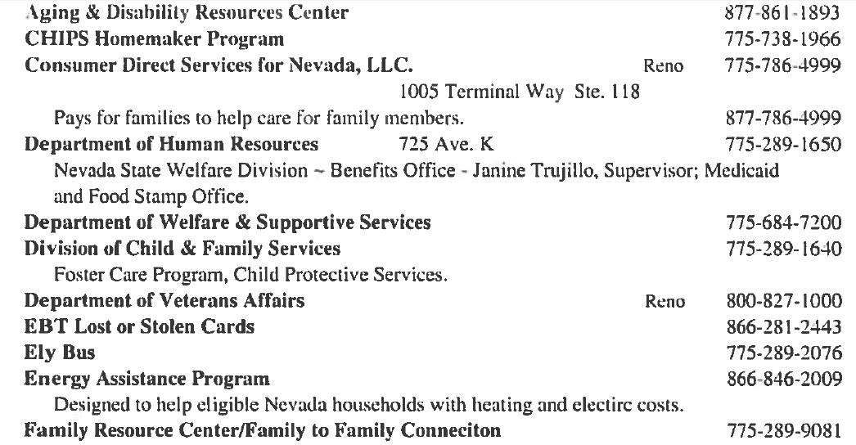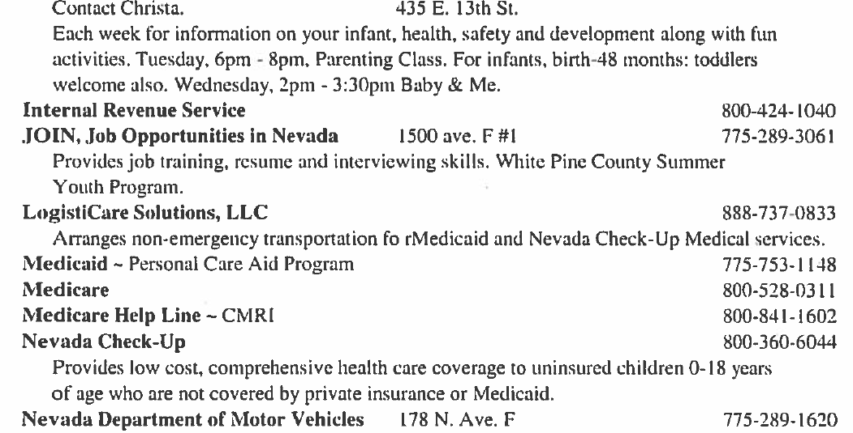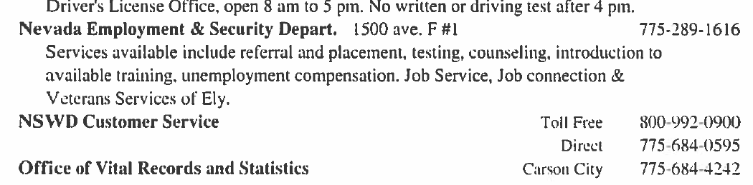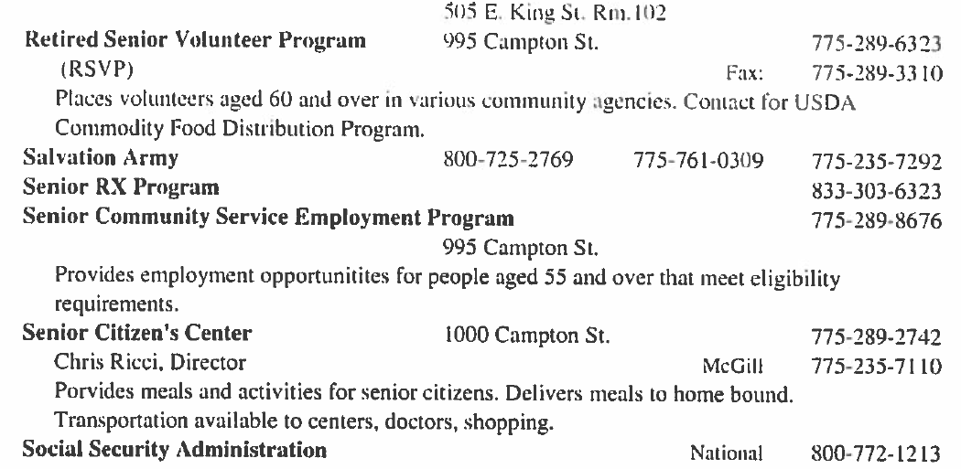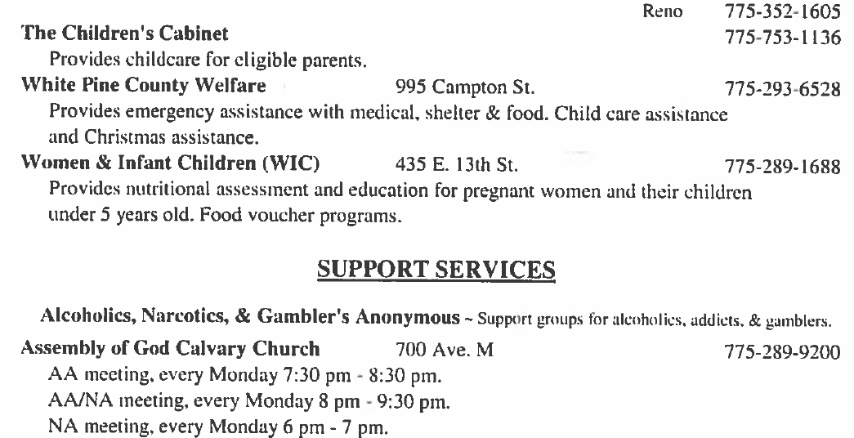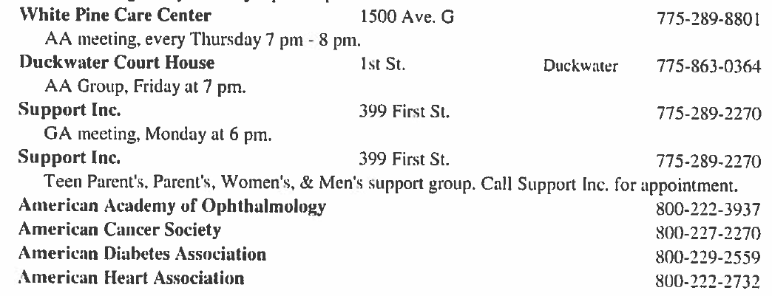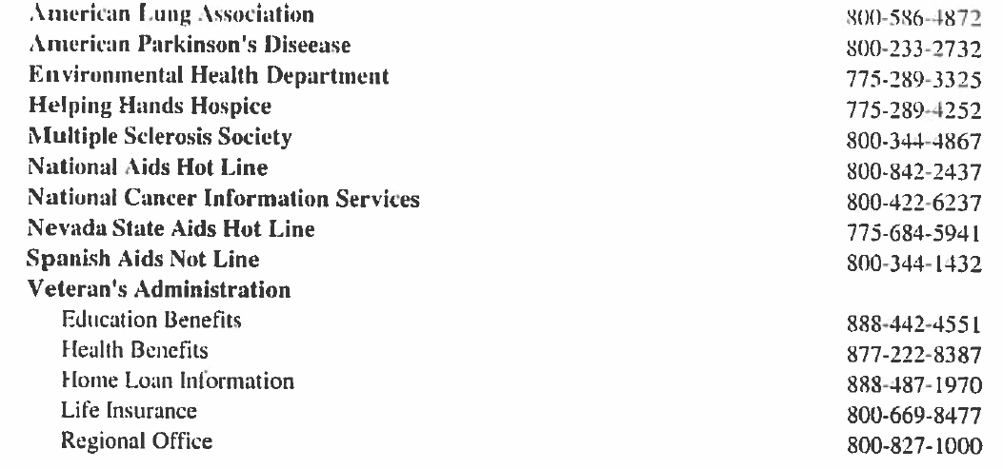
Support Services:

