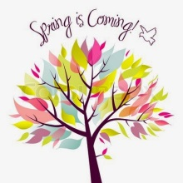Spring into Reading and Writing and Win a Prize
Complete 5 reading activities. Each activity should last for at least 20 minutes.
Initial your reading selection & complete at least 3 writing activities to hand in with this log thank you.
NAME : _______________________________________ LMS Reading Challenge Begins on Feb 16th
Read your favorite book | Go to the public library & take out a book | Read a book with a number in the title | Make a list of ten new words from your readings & write their definitions | Read a book with more than 500 pages
Write a book review | Read a poem | Write a song about a main character | Read a book published this year | Read a nonfiction book
Read a book by a female author | Make a movie poster for a book | Read a graphic novel | Write a letter to the author | Read a magazine
Read a new genre | Write a letter to a character | Read to a family member | Write an original poem | Write a journal entry
Create a playlist for a book | Read a book a recommended by a friend | Design a new book cover | Illustrate a scene /the setting for a book | Write an original poem
LMS Reading ChallengeEnds on March 26th Look on the LMS website for extra copies

