S.T.E.A.M. Research Paper Requirements
Before completing your projects and creating your presentations, it is important to be fully educated about your chosen topic. The purpose of this research paper is to learn the background of your topic and educate the reader on important information before completing your project.
The research paper should be in a standard size-12 font (Times New Roman), be double-spaced with 1-inch margins, and have the following format:
Cover Page: Must include…
- A Title
- Your Name
- The School’s Name
- Date Submitted
- The name of your social studies teacher
Introduction: This portion of a paper should capture the attention of the reader and define the direction your paper will take. An ideal introduction should include
- An opening sentence that is interesting
- Very general information about your topic
- A thesis statement that summarizes what will be discussed throughout the paper
Body Paragraph(s): This portion of a paper includes all important information that you have researched. Be sure to include
- Specific details and supporting ideas
- Information from your sources
- Transitional words and phrases
Conclusion: This is your chance to tie everything together and make a final, lasting statement. Your closing should be meaningful and possibly look to the future.
References/ Works Cited: Cite sources using MLA format
Rubric: Must be attached to the end of the paper for grading

On every single page of the paper, the following items must be clearly visible:
- Your name
- Date Submitted
- Page Number (optional)

See the attached rubric for more specific information
S.T.E.A.M. Fair Project Research Paper Rubric

Student Name ___________________________ Graded By ____________________

Social Studies Teacher ____________________

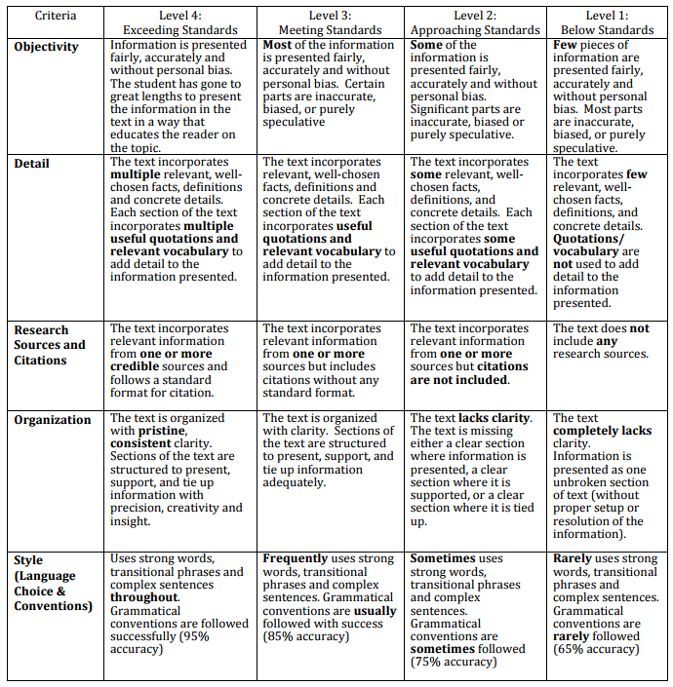

Final Grade: ________ / 20

