50
Days
of

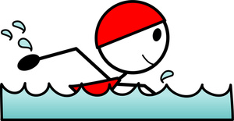

We don’t want all that you’ve learned this year to sink to the bottom of your brain!

Complete these 50 activities over the summer, and turn it in to your new teacher in September during the first week for a special treat!

Have a great summer!!!

Day 1

Write about one thing you really want to do this summer.

- Five Sentences

- Capital Letters

- Punctuation (Commas, Periods, Exclamation Marks, and Question Marks)

- Indent the Paragraph
________________________________________________________________________________________________________________________
_______________

Day 2

Volunteer to do something nice for someone else today. Write about what you did.

Examples:

- Do the dishes for your mom.

- Help your neighbor mow their lawn.

- Give the mailman a cold bottle of water.
______________________________________________________________________________________________________________________________

Day 3

Go on a nature scavenger hunt.
Find the following items on this list.
Record them on the next page.

- Something bumpy
- Something wet
- Something green
- Something smooth
- A bug
- Something pointy
- A flower
- A seed
- Something slimy
- Something sticky

- ________
- ________
- ________
- ________
- ________
- ________
- ________
- ________
- ________
- _______

Day 4

Practice your addition facts, so you can be a mathematician when you get back to school in August!!

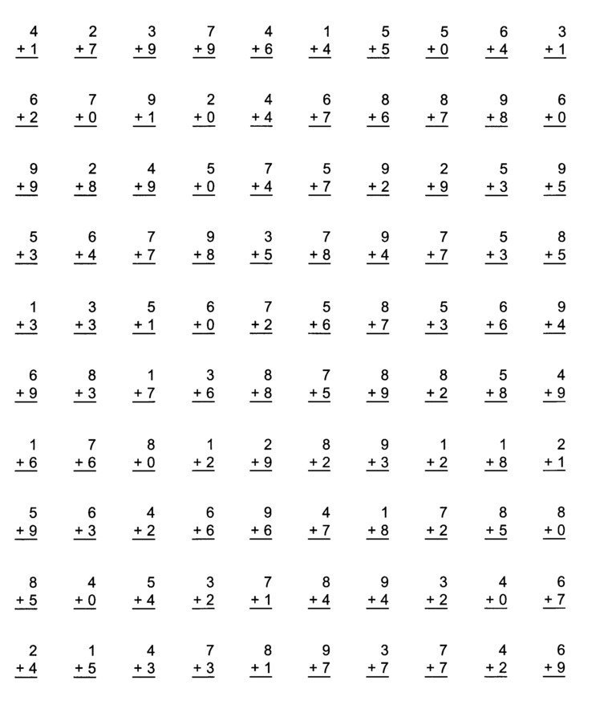

Day 5

Play a game with your siblings or a friend! Tell me about what game you played.

- What is it called?

- How do you play it?

- How do you know who wins?

- Why is it fun?

______________________________________________________________________________________________________________________________

Day 6

Imagine you are at the carnival. You want to buy an ice cream cone that costs $1. 59. You paid with a five dollar bill.

How much change will you get back?

Show your work on the back of this page!

Show your work here.

I would get $ _____ back.

Day 7

Write down your favorite recipe!

Name of Food: _________________

Ingredients:

Directions:
- ______________________________________________________
- ______________________________________________________
- ______________________________________________________
- ______________________________________________________
- ______________________________________________________
Day 8

Draw an array for these multiplication problems.

Remember to be neat and draw them in straight lines!

4 x 7

6 x 3

8 x 5

4 x 7

6 x 3

8 x 5

Day 9

Practice your subtraction facts so that you can be a math wizard when you get back to school in August!!

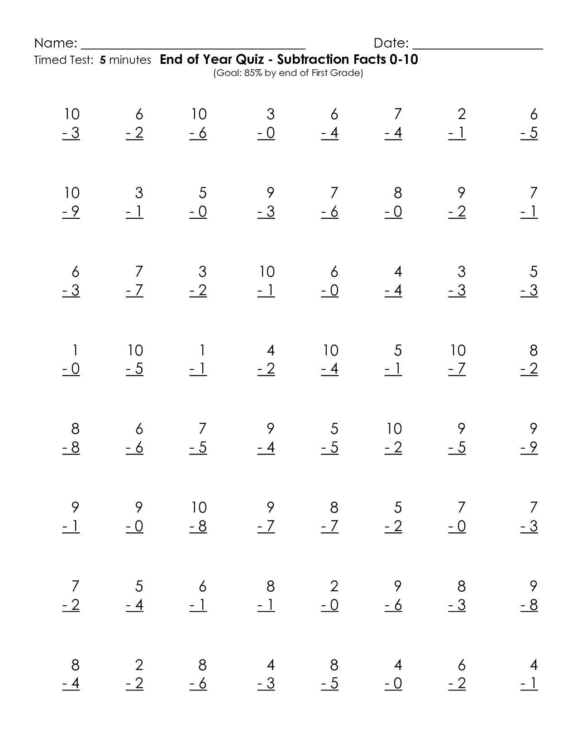

Day 10

Write a summer acrostic poem.

Each word you pick must describe summertime!

S ___________
U ___________
M ___________
M ___________
E ___________
R ___________
T ___________
I ___________
M ___________
E ___________
Day 11

Draw an advertisement for a new invention (that you created)!

Remember - an advertisement should convince someone to buy your product!

Day 12

Imagine you had 15 flowers. You want to divide them evenly between 4 people.

Use pictures to figure out how many flowers each person will get and how many will be left over.

Each person would get ____ flowers.

There would be ____ flowers left over.

Day 13

Watch the news tonight and look for the weather forecast.

Record the weather forecast of the temperature on the next page.

Weather Forecast

Monday: ___ degrees

Tuesday: ___ degrees

Wednesday: ___ degrees

Thursday: ___ degrees

Friday: ___ degrees

Day 14

You go on a vacation on July 6th. You return two weeks later.

On what date do you return?

Use the calendar on the next page to find the answer.

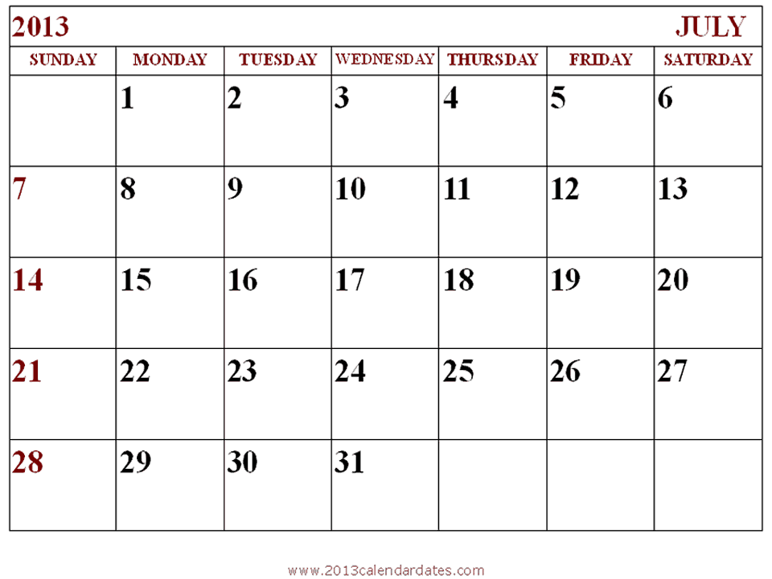

I would return on ___________.

Day 15

Complete the fact family on the next page!

11, 7, 4

__ + __ = __

__ + __ = __

__ - __ = __

__ - __ = __

Day 16

Think of what it means to be a good citizen. Do something today that shows good citizenship.

Write 5 sentences about what you did and what you learned.

______________________________________________________________________________________________________________________________
Day 17

On the next page is a table where we recorded the times that the sun set each day. The sun sets 6 minutes later each night.

Complete the table.

Monday | 7:05 PM
Tuesday | 7:11 PM
Wednesday
Thursday
Friday

Day 18

Find 3 things in your house that you can recycle.

Things I Could Recycle:

- _______________

- _______________

- _______________

Day 19

What are you most looking forward to learning in 4th grade?

- Five Sentences

- Capital Letters

- Punctuation (Commas, Periods, Exclamation Marks, and Question Marks)

- Indent the Paragraph
______________________________________________________________________________________________________________________________

Day 20

Draw a picture of your dream summer day.

Day 21

Practice your multiplication facts so that you can be a math superhero when you get back to school in August!!

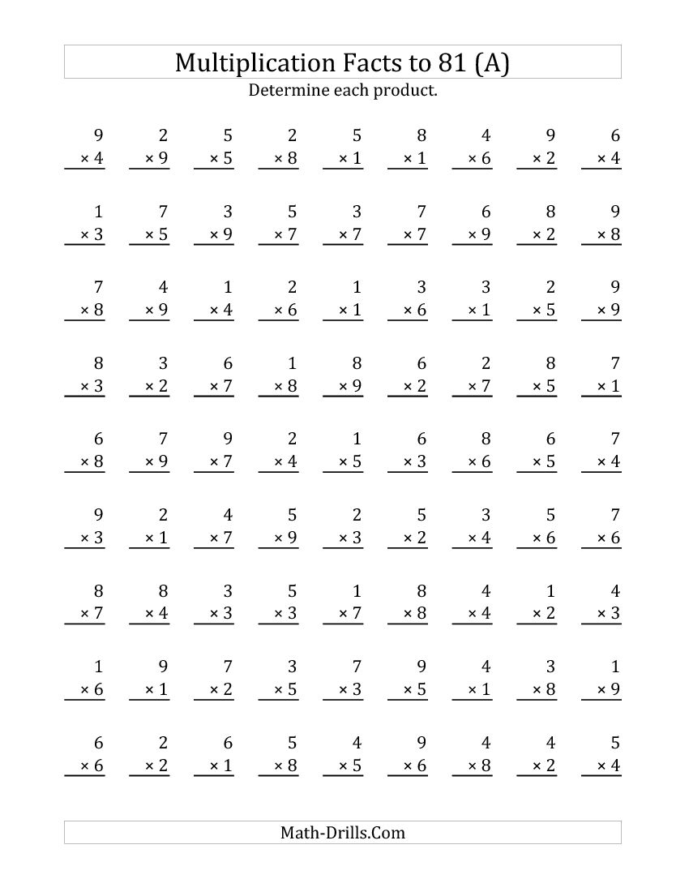

Day 22

Give someone a compliment. It cannot be about the way they look. Say something nice about the person that they are!

Write about who you complimented, what you said, how you felt, and how they felt.
______________________________________________________________________________________________________________________________

Day 23

Make a list of 10 verbs that you have done this summer.

Remember – verbs are action words, things you can do.

Summer Verbs

- _________
- _________
- _________
- _________
- _________
- _________
- _________
- _________
- _________
- ________
Day 24

Complete the fact family on the next page!

6, 48, 8

__ x __ = __

__ x __ = __

__ ÷ __ = __

__ ÷ __ = __

Day 25

Create 5 goals that you want to achieve in 4th grade.
4th Grade Goals

- I would like to __________
_____________________.

- I would like to __________
_____________________.

- I would like to __________
_____________________.

- I would like to __________
_____________________.

- I would like to __________
_____________________.
Day 26

Make a list of 10 adjectives that describe summer!

Summer Adjectives

- _________
- _________
- _________
- _________
- _________
- _________
- _________
- _________
- _________
- ________
Day 27

Have a family member or friend help you label as many states on the map as you can!
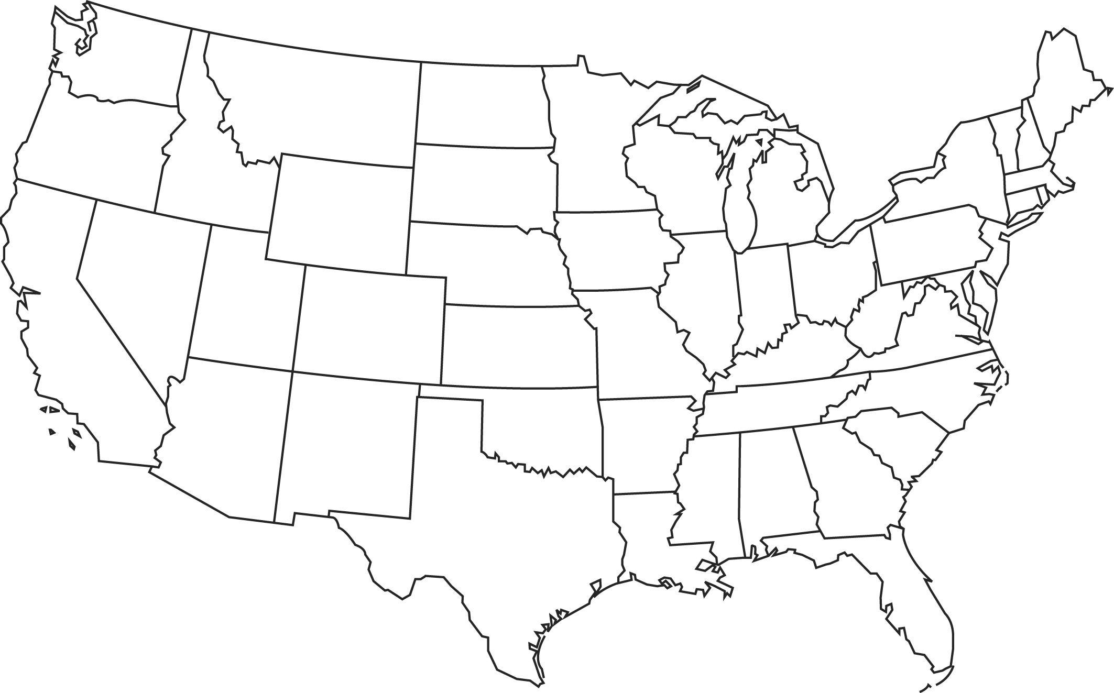
Day 28

Complete the Summer Mad Lib!

Day 29

Draw a comic strip depicting an event that happened in 3rd grade.

Day 30

Read a book today!

Write about the story elements.

Title: _________________________

Author: _______________________

Setting: ______________________
_____________________________

Characters: ____________________
_____________________________

Problem: ______________________
__________________________________________________________

Solution: ______________________
__________________________________________________________

Day 31

Write a letter to your teacher!

Date: ____

Dear __________,

____________________________________________________________________________________________________________________________________________

Sincerely,
__________
Day 32

Practice your math facts by painting with water on the sidewalk or driveway!

All you need is a cup of water and a paintbrush. Paint, and watch it disappear!

Day 33

Think about an animal that you see outside in the summertime.

Write three adaptations that the animal has. (Hint: Adaptations are things that help an animal survive in its environment.)

Adaptations of a(n)
__________

- _______

- _______

- _______

Day 34

Practice your division facts so that you can be a math whiz when you get back to school in August!!

Day 35

Write down the time you went to bed last night. Then write what time you woke up. How much sleep did you get?

Time I Woke Up: ______

Time I Went to Bed: _____

I slept for ____ hours
and ____ minutes.
Day 36

Go for a walk. Write down all the things you see that are COMPOUND words.
Compound Words

_____ _____ _____
_____ _____ _____
_____ _____ _____
_____ _____ _____
_____ _____ _____
_____ _____ _____
_____ _____ _____
_____ _____ _____
_____ _____ _____

Day 37

Read a book out loud to someone at home today.

Have them sign their name on this line to verify that you read to them.

Sign Here: ________________

Day 38

Use your time-telling skills to write down a schedule of what you did today.

Make sure that you include what time you woke up, ate breakfast, ate lunch, played outside, ate dinner, went to bed, and all the other fun things you did!
Time Activity

_______ __________
_______ __________
_______ __________
_______ __________
_______ __________
_______ __________
_______ __________
_______ __________
_______ __________
_______ __________

Day 39

Complete this summer word search!

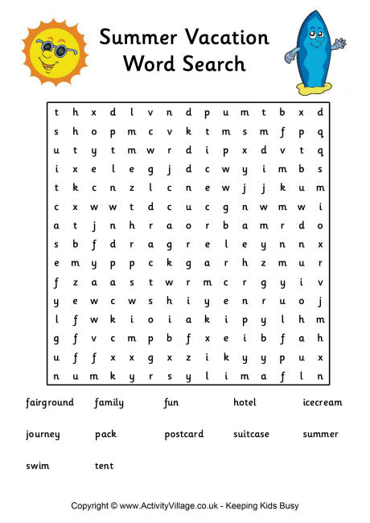
Day 40

Create your own rollercoaster!

After you draw it, fill the page with adjectives that describe it.

Examples: fast, high, scary

My Rollercoaster

Day 41

Roll a set of dice. Multiply the two numbers together.

Record your problems on the next page!
Roll Those Dice!

___ x ___ = ___

___ x ___ = ___

___ x ___ = ___

___ x ___ = ___

___ x ___ = ___

___ x ___ = ___

___ x ___ = ___
Day 42

Get a bag of colored candies (M&M’s are yummy!).

Sort them by colors, and write the fraction for each.

Tasty Fractions!

Red: _____
Blue: _____

Green: _____

Brown: _____

Orange: _____

Yellow: _____

Day 43

Draw a map of your neighborhood.

Label important places and roads.

Remember to include a map key!

Day 44

Look at a clock in your house – a real clock, not a digital clock!

Write down the time, and draw it on the clock.

When I looked at the clock, it was
_____:_____.
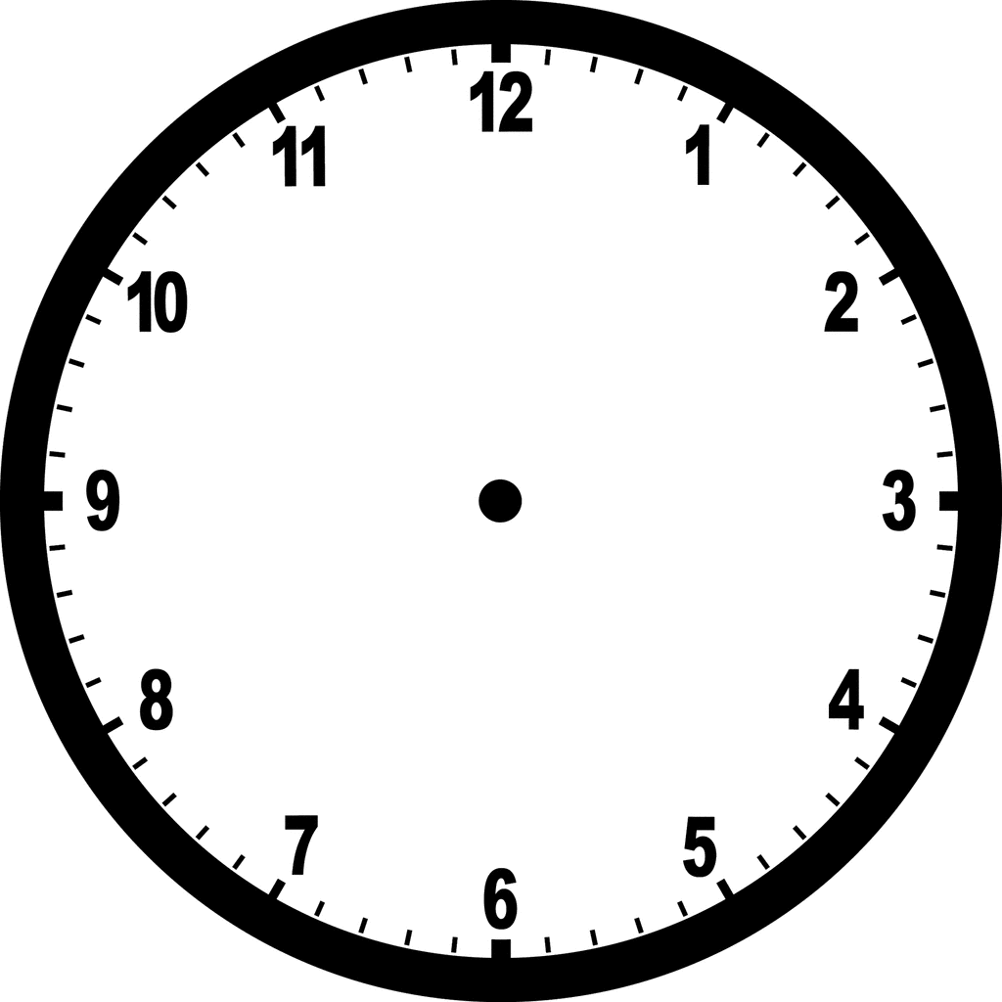

Day 45

Look at all your t-shirts.
Sort them by color.

Create a bar graph that shows your data.

Red Shirts: ____

Blue Shirts: ____

Green Shirts: ____

Purple Shirts: ____

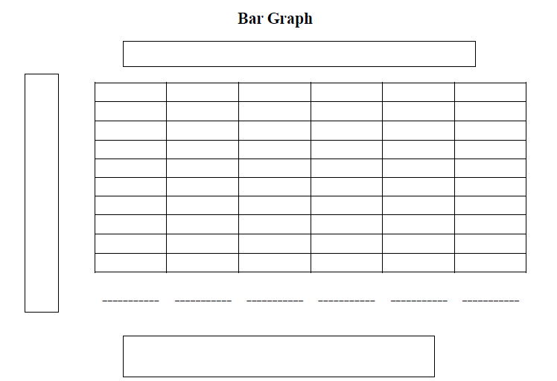

Day 46

Read a newspaper or magazine today.

Find a picture with a caption, cut it out, and glue it to this page.

Day 47

Find something around your house or neighborhood that look like these shapes.

List them on the next page!
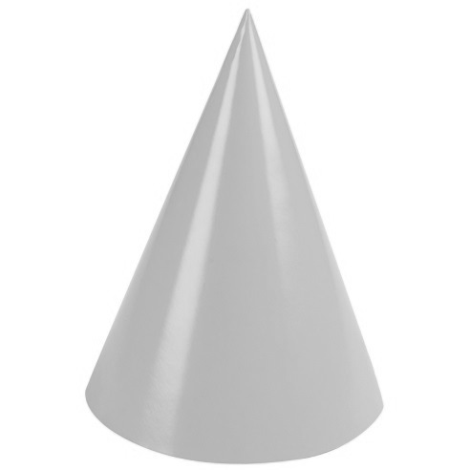

Things that look like a cylinder:

- ________________
- ________________
- ________________

Things that look like a cone:

- ________________
- ________________
- ________________

Things that look like a rectangular prism:

- ________________
- ________________
- ________________
Day 48

Look for a flower outside. Draw it, and label the parts of the flower.

Be sure to label the roots, stems, and leaves.

Day 49

Summer is almost over.

Complete this summer crossword!

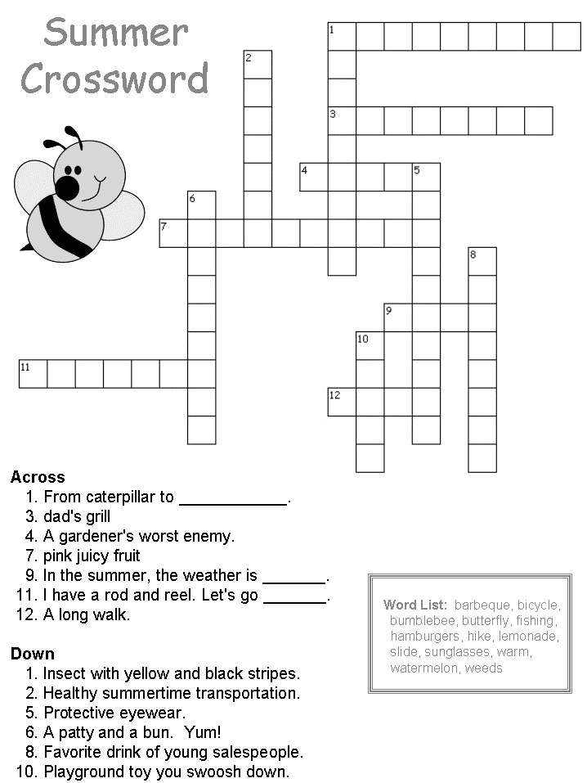
Day 50

What is your favorite thing that you did this summer?

Write about it, and make sure it is detailed so that I feel like I was right there with you!

______________________________________________________________________________________________________________________________
Congratulations on finishing the

50

Days

of

See you soon!!!

