Name_____________________________________ Summer Assignments for College Biology 101

Summer Assignment #1– due FIRST CLASS DAY
Many people see learning Biology as learning another language due to the high volume of vocabulary we cover. This next assignment will help you with all of the terminology by learning the root words that make up your vocab words. Write the definition of each word root/prefix/suffix in the following table. *You may save as an attachment and email if completed sooner. Use any resources you have available to you. 84 points
Prefix/Suffix | Definition | Prefix/Suffix | Definition | Prefix/Suffix | Definition
A-, an- |  | Dis- |  | Mort-
Ab- |  | Du-,duo- |  | Morph-
Ac- |  | Ect- |  | Multi-
Ad- |  | En- |  | Neo-
-al |  | -en |  | Non-
Alb |  | End-,ent- |  | -oid
Allo |  | -eous |  | Pan-
Amph-, amb- |  | Eu- |  | Permea-
An- |  | Extra- |  | Phag-
Ante- |  | Ex- |  | Pheno-
Anti- |  | -gen, -gine |  | -phile
Aqu- |  | -gene,gene- |  | -phobe
Archaeo- |  | -gony |  | Photo-
-ase |  | Herb- |  | Poly-
Auto- |  | Hetero- |  | Por-
Bene- |  | Homo- |  | Pre-
Bi- |  | Hydr- |  | Pro-
Bio- |  | Hypo- |  | Proto-
Carb- |  | Hyper- |  | Pseud-
Chem- |  | -ine |  | Saccharo-
Chlor- |  | Inter- |  | Semi-
Chrom-,-chrome |  | Iso- |  | Strat-
-cide |  | -itis |  | Sub-
Co- |  | -less |  | Super-
Con- |  | Lip- |  | Sym-, syn-
Contra- |  | -logy |  | -taxis
-cycle, cyci- |  | Macr- |  | Therm-
di- |  | Micro- |  | Trans-
Dia- |  | Mono- |  | Troph-

Summer Assignment #2: Biology Scavenger Hunt and Photo Album– due FIRST DAY OF CLASS
For this assignment, you are going to create a photo album containing 25 photographic examples of biological terms/concepts. This can either be a virtual photo album in the form of a blog, a google doc or a power point (saved to google drive and shared with dli@wajc.org, or a physical photo album that you bring into class. This photo album will not only introduce you to the language of biology, but it will also emphasize the importance that biology is something that’s done, not just memorized.
To create your photo album:

1. Choose 25 terms from the list on the next page. You are welcome to work with other members of our College Biology class, but each person’s list should be unique. With 75 terms to choose from, having unique photo lists should not be an issue.

2. Collect your photos by taking a picture in nature either of the term itself or something that represents that term. For example eubacteria are microscopic organism found everywhere so it would be hard to take a picture of the eubacterium itself, but you could take a picture of a snotty kleenex and explain how it represents eubacterium (you cannot use this example in your album now, sorry ☺).

3. If making a physical album, print out your pictures. If making a virtual album, upload them for your presentation.

4. For each picture, you must include a definition of the term and a statement explaining how the picture represents the term or concept.

5. Must use original photos – no photos from the internet. To ensure this happens, you need to include something of yours in every photo-this could be a keychain, a ring a stuffed animal, etc…

6. You are to use natural items. Take a walk in your neighborhood, go to the zoo, go to a park, hit up a nature trail, etc… Be creative in your collection – have fun obtaining your picture collection-have fun obtaining your picture collection.

7. Be careful – never touch plants or animals you are not familiar with. Don’t kill or harm any organisms. Don’t remove any organisms from their natural environment. Photograph animals from a distance with you in the foreground if the situation will not be in your best interest to get to close to large/dangerous animals.

8. See the example on the next page if you are having trouble getting started.

9. This project is out of 75 points – 3 points for each entry (1 each for the photo, the definition and your explanation) – and will be your first test grade for the class. I will use the rubric on the last page to grade you on this assignment.
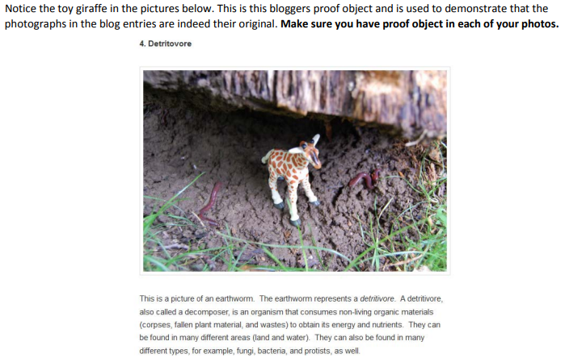

Biology Scavenger Hunt Term/concept list – choose only 25
- Adaptation of an animal | 26. Endosymbiosis | 51. mycelium
- Adaptation of a plant | 27. endotherm | 52. mycorrhizae
- Altruistic behavior | 28. enzyme | 53. mutualism
- Amniotic egg | 29. epithelial tissue | 54. niche
- Analogous structures | 30. Ethylene | 55. parasitism
- Animal with a segmented body | 31. eukaryote | 56. parenchyma cells
- Anther & filament of stamen | 32. exoskeleton | 57. phloem
- Asexual behavior | 33. fermentation | 58. pollen
- ATP | 34. gametophyte | 59. population
- Autotroph | 35. genetic variation within a population | 60. predation
- Auxin producing area of plant | 36. genetically modified organism | 61. prokaryote
- Batesian mimicry | 37. Giberellins | 62. R-strategist
- Bilateral symmetry | 38. glycogen | 63. radial symmetry (animal)
- Biological magnification | 39. hermaphrodite | 64. redox reaction
- C3 plant | 40. homeostasis | 65. seed dispersal (animal, wind, etc.)
- C4 plant | 41. homologous structures | 66. spore
- CAM plant | 42. hydrophilic | 67. sporophyte
- Calvin Cycle | 43. hydrophobic | 68. stigma and style of carpel
- Cellular Respiration | 44. introduced/invasive species | 69. succession
- Coevolution | 45. keystone species | 70. taxis
- Commensalism | 46. Krebs cycle | 71. territorial behavior
- Connective tissue | 47. Lichen | 72. tropism
- Cuticle layer of plant | 48. Lipid used for energy storage | 73. unicellular organism
- Detrivore | 49. Mating behavior (be careful-make it appropriate!!) | 74. vestigial structure
- ectotherm | 50. Mutualism | 75. xylem

