`Football Homecoming 2012
KHS held its football homecoming on Friday, October 5, 2012. Queen candidates were Christina Meyer, Melissa Wallace, and Allison Woodall. King candidates were Mike Austin, Aaron Butler, Tanner Rogers, and Tanner Sweetwood. Kindergarten attendants were Kaelin Rainey and Cason Purdy. Tanner Rogers and Melissa Wallace were named as Homecoming Royalty.
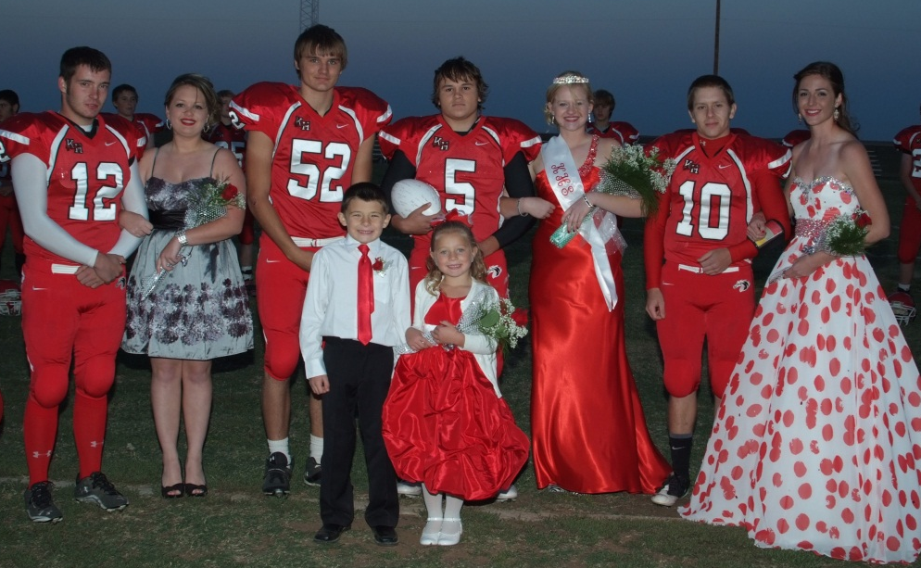
Congratualtions King Tanner and Queen Melissa!

WildHorse Gang celebrates 20 years of service!
by Gini Zaloudek
What a great way to kick off 2012! Our 20th year! It started with the Gang presenting checks to the pool and KHAEF and their 20th year as the Cherokee Strip Clean-up Crew, wearing their new T’s sponsored by the Bank of Kremlin. We enjoyed having breakfast and lunch by our generous businesses in Enid – Schieber’s Donuts, McDonalds, Jumbo Foods, and Golden Chick. We are very fortunate to have the honor of being the guest ushers for all the Enid Symphony concerts, learning to appreciate the opportunity to learn about the guest performers and practice what they learned at Miss Fawn’s Etiquette School. Recently the Gang members were guest waiters for the 50th anniversary for Memorial/St. Joseph school reunion. The Gang earned tips and were served dinner following the event. We are growing in numbers this year and are so grateful to all parents who also volunteer their time.
[More about WildHorse Gang on page 2!]
New Sign Installed!!!!

New Staff at KHS in 12-13
There are a lot of new faces around the KHS campus this year. In this issue of THE BRONC we have included bios of several. The rest will be featured in future issues. The KHS community gives a big Bronc welcome to:
Brad Hawkins (elementary principal and boys basketball coach; also teaches high school social studies); Jenny Smithson (counselor); Tana Turney (math/computer teacher and girls basketball coach); Kelsey Smith (junior high social studies and softball coach); Diane Highfill (special ed); Janel Powell (special ed); Pamela Tucker (fifth grade teacher); Ginger Patton (payroll officer); Laura Streck (custodian); Chuck Dickason (custodian); Tracie Rhodes (cafeteria); Vicki Odle (first grade teacher aide).

KHAEF passes out Grant money to KHS faculty
Read all about it inside this issue of THE BRONC!

WildHorse Gang (continued)
November and December are proving to be very busy, starting with an invitation to participate in the Veterans Day parade in Enid on November 18; the annual Integris Christmas dinner on November 30; and the annual Christmas Dillard’s Style Show on December 1. The annual Dillard’s Christmas Gala follows on December 2. We are looking forward to celebrating a great year and making a big difference in our school and our community. A big thank you to Jim Holt and his family to help make our Annual Aluminum Can Round-Up a huge success! Thanks to all of you for your unselfish support of the WildHorse Gang in accomplishing their projects.
Mr. Brad Hawkins
by Justin Lippard
Mr. Hawkins graduated high school at Maud High School. He also graduated college at Oklahoma Baptist University (OBU). The reason why Mr. Hawkins wanted to be a principal is because he has a great desire to impact kids and he enjoys the organizational side of administration. The reason why he wanted to be a basketball coach is because he is able to prepare young athletes for life that is farther down the road. The last school that he was at was OBA. He coached basketball and taught History and Social Studies. At KHS he coaches junior high and high school boys basketball, is elementary principal, and teaches high school Economics and World History.
Ms. Kelsey Smith
by Rebekah Gannon
Ms. Smith graduated from Oilton High School in 2008. She studied at Oklahoma State for four years. She studied Secondary Education and graduated with a Bachelor’s Degree in Secondary Education. Her sophomore year of college she decided that she wanted to become a teacher/coach. Ms. Smith started teaching at Kremlin-Hillsdale School in 2012. She teaches middle school geography and coaches Jr. High and High School fast and slow pitch softball, and 5th and 6th girls’ basketball. Ms. Smith loves her job teaching and coaching at Kremlin-Hillsdale.
Mrs. Diane Highfill
by Gabrielle Morris
Mrs. Highfill was born on July 4. She grew up and is currently living in Cherokee. She has three girls named Shayla, Jacklyn, and Taylor. Mrs. Highfill has been married to Boyde Highfill for 28 years.
Mrs. Highfill has been teaching special ed for 10 years. She went to college at OSU first and then to Northwestern. The first school that Mrs. Highfill ever taught at was Cherokee HS. Before Mrs. Highfill came to Kremlin she taught at Wakita.
When Mrs. Highfill was asked what made her want to teach she said it was because she enjoyed working with kids and she wants to help them. Also when asked if she had any goals for her students she replied “For them to meet new challenges and to excel in their academic areas and that they learn to enjoy school. “

More bios and pics on following pages!
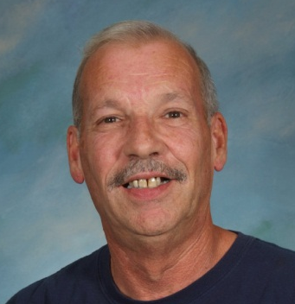
Chuck Dickason
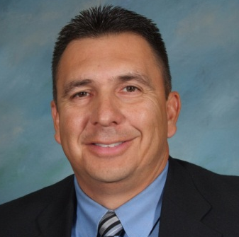
Brad Hawkins
Kelsey Smith
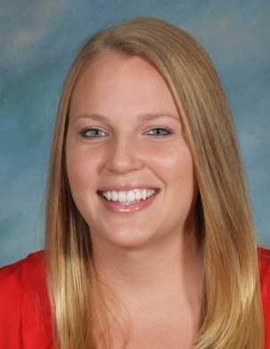
Tana Turney
Mrs. Highfill’s picture
was unavailable
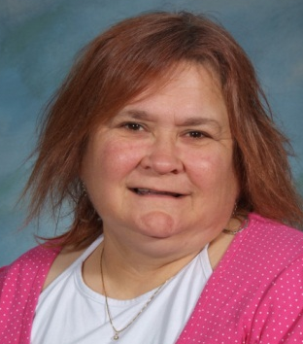
Laura Streck

Girls basketball
by Baylee Smith
The lineup for the Lady Broncs this year is, Karlee Bittle, Kristin Burris, Braley Bench, Jordan Presley, Hannah Wuerflein, Elizabeth Elliot, Ryan Voth, Lakan Light, Katie Davis, Shay Regier, Masa Carter, Maddy Blythe, Siera Carter, Cheyenne Roche, Mary Mitchell, Rebekah Gannon, Olivia Felber, and Billie Jo Gabriel. This should be a good season for the Lady Broncs!

Boys basketball
by Baylee Smith
The line-up for the Broncs this year is, Tanner Sweetwood, Connor McCollough, Andre Lizar, Antwon Lizar, Rustin Pearce, Zac Webber, Hayden Bonine, Justin Lippard, Elijah Voth, Kass Bittle, Lee Olmsted, J.J Stubblefield, Eugene Brooks, Blake Bower, Jacob Perkul, Noah Garvin, and Connor Snapp. This should be a good season for the Broncs!

Softball news
by Justin Lippard
Ms. Smith is very excited about next year. Even though they did pretty well last year she thinks that the softball team will get farther next year. Their record last year was eight wins and nine loses. She said that they are going to work very hard next year and that they are going to improve. She thinks that they have a chance to make the playoffs for softball.

High school football
by Kass Bittle
The high school football team finished the season with a 2-8 record. It wasn’t what they were hoping for but it was a lot better than previous years. There were four seniors on the team: Mike Austin, Tanner Rogers, Tanner Sweetwood, and Aaron Butler. The team hopes to be a lot better next year and to improve more and more as time goes on.

Junior high football
by Kass Bittle
The junior high football team finished the season with a record of 4-4. They faced some hard times just like any team but pushed through the adversity. There were six eighth who will be playing high school football next year. There is a lot of potential and hopefully they will be successful.

5th/6th grade football
by Kass Bittle
The fifth and sixth grade football team ended the season with a 3-4 record this year. The team played hard and learned a lot and had lots of fun. The team had a very talented set of players this year that will be making lots of noise in future years.
Bronc Boosters
by Connor Snapp
The Bronc Boosters have been very active this year, even though it is so early. They supplied food for the high school football team at long road games, such as Wesleyan Christian in Bartlesville, Claremore Christian, and Bluejacket. Several times, they have showed their support for the Broncs, like raising the money for the charter buses for the players and the fans that could go to the long drive to the corner of the state. They have done things such as the before mentioned food and money donations and also moral support.
If you want to join the Bronc Booster Club, contact any officer. President: Dennis and Pam Schoenhals; Vice Presidents: Jacque Voth and Tracy Bittle. Show your support for KHS teams by joining the Bronc Boosters!

FFA News
by Ciarra Creel
Many members attended County, Oklahoma City, and Tulsa State Fairs and ended the show season with various winners in many categories. The Officer Team recently went to National FFA Convention and had a blast. The Keynote Speakers were Walter Bond and Scott Hamilton. The Officer Team that attended includes; Hayden Bonine, Ciarra Creel, Lakan Light, and Elizabeth Elliot. We are looking forward to MFE/ALD in December. Thanks to everyone who attended and supported the FFA Booster Club at the Chili and Soup Cook-Off and Pie Auction.

Senior news
by Lana Reid
Several weeks ago we had senior night where Mike Austin, Tanner Rogers, Tanner Sweetwood, Aaron Butler, Melissa Wallace, Christina Meyer, Morgan Stevens and Alison Woodall were recognized. We had a good football season where the senior class has shown a lot of support by attending each game. Yearbook pictures and the other stuff required for a senior page is due by December 21. If you don’t know what these are, contact Mr. Schultz.

Junior news
by Karlee Bittle
Homecoming mums were a huge success for the Junior class! Thank you everyone who participated in making the mums! Basketball mum order forms will be sent out soon so keep an eye out for those! All proceeds go towards Junior/Senior Prom 2013!

Sophomore news
by Hayden Bonine
Several sophomores played football this year, and they include Austyn Creel, Andre Lizar, Antwon Lizar, Austin Brewer, Blake Bower, James Olmstead, John Schrader, Zane Maner, Jacob Pekrul, and Hayden Bonine. The softball team also included a few sophomores as well: Ashleigh Brewer and Katie Davis. Cheerleaders from the sophomore class are Ashleigh Brewer and Keeley Horning. Also Jessey Martin, Lakan Light, Megan Courtney, and D.J. Toelle run Cross Country. Sophomores on the academic team are Jacob Pekrul, Hayden Bonine, and John Schrader.

Ninth grade news
By Connor Snapp
This year has gone very well so far. The class participated in the Homecoming Parade with the theme as “Up”, which is the Disney movie. The float had a dog house on a green lawn with balloons on top of the house. The class got 3rd in parade judging. Many students participated in sports such as football, softball, and basketball, with the new basketball season soon to be underway. The high school football team went 2-8 this season and the softball team going 8-9.
Eighth grade news
by Paul Courtney
The 8th grade class has finally received their Explorer test results. They took these tests during the beginning of the first nine weeks, and the results proved to be good. The tests showed a bright future for the class, and they are looking forward to that future.
The eighth grade class is slowly growing. At the beginning of the year they received two more classmates, and just recently, another classmate. Casper Ramirez, who came to Kremlin last year, came back again. Hopefully the class might grow even larger by the end of the school year!

Seventh grade news
by Alice Keithly
Cheers erupted from the stands as Mr. Gossen, the voice of the Broncs, announced that the 7th grade class won the float contest at football homecoming 2012. The theme for the 7th grader’s float was A Bug’s Life. The class worked on their float at Hannah Carson’s grandparents with their sponsor, Ms. Smith. They built a tree and a boot to depict scenes from the movie, and the theme was Crush the Bobcats. They worked hard, but also had a great time hanging out together. When asked what the best part about winning was Sydney Winters said, “We worked really hard on our float, and our work paid off.”
****************************
J.H. band news
by Alice Keithly
The Kremlin Hillsdale Pep Band rang out from the stands at the football game Friday night against Cherokee. The KHS Pep Band, made up mostly of 7th and 8th grade band members helped keep the crowd fired up at five home games this year. Because most of the High School band members are on the football team or cheerleading squad, the 7th and 8th grade band was pressed into duty. When asked how he thinks the Pep band contributes Kent Keithly says: “It helps get the crowd fired up.” Joe Keithly agreed saying: “It helps players get motivated and the crowd going.” Joe says he can even hear the band when he is filming and is sure the players can hear it, too. When asked what the best part about being in Pep Band was, Kaitlyn Woods says: “We have an amazing teacher”.
High school principal
by Steven Shook
This year Kremlin-Hillsdale has experienced a new leader for our high school. His name is Mr. Jeremy Brashears. He is married to his wife whom he loves with every ounce of his heart. Her name is Laura.. He also has two beautiful daughters, Katy and Sarah. Katy is 10 years old and is in Mrs. Russell’s 4th grade class. Sarah is 7 years old and a 1st grader in Mrs. Riddle’s class. Coach Brashears loves his job as high school principal here at Kremlin-Hillsdale even though it may be hectic at times. He loves coaching the high school football team and looks forward to getting the high school basketball team ready for a great year. Even though we didn’t win every game he knows that the experience and hard work has paid off to make our team better than ever. We’ve kept up with some hard teams and pushed them to their limit and he would agree when I say that we gave it our all. He would just like encourage everyone to come out and support the high school basketball and share in their hard work and effort out there on the court. Academics is one of his highest priorities and being the high school physical science teacher helps him to not forget about how important it is to do well in school before sports. You can’t succeed in life without a well-earned education!
The PRIDE of KHS
by Faith Matthews
The PRIDE of KHS is 54 members strong this year and is under the field direction of Senior Sarah Stein, Soph. Katie Davis, and Soph. D.J. Toelle.
After stellar ratings at Tri-State marching contest, the PRIDE just barely missed out on going to state. One week after marching season ended, the PRIDE was busy working on the carnival. With so many more students in band we had just over 30 booths of games and food. We raised $1700 towards our band trip in 2014.
After the carnival, the Felber family hosted the band a bonfire and Mr. Carson and Mr. Streck took us on a hayride. We had a great evening. Thanks to those parents- and so many others- for making so many great things happen for the PRIDE!!
Two weeks after the carnival we have the Veteran’s Day assembly and then just a few more weeks and you’ll us at the All-School Christmas program, Monday, Dec. 17 at 6:30. It’s been a busy semester but we’ve had a lot of fun as well. In between our major contests, fundraisers and performances, we also played at 4 home football games. Whew!
Trash bag sales will begin after Christmas break….and don’t forget to buy Jumbos Band Bucks!! Huge congratulations to Sophomore Drum Major, Tuba, and Trumpet player D.J. Toelle!! D.J. is our first All-State band member!! D.J. competed in Tecumseh against students from 2A, 3A, and 4A schools, Over 100 trumpet players from all over the state auditioned and only 12 were selected. D.J. earned 9th chair. This means he’ll go to a 2 day clinic at UCO and put on a concert with the top players in the state. Way to go, D.J.!

Buy Band Bucks at Jumbo’s!
Ginger Patton
Tracie Rhodes
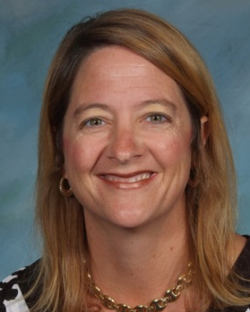
Jenny Smithson
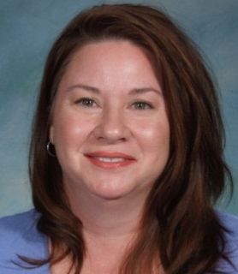
Pamela Tucker
by Taver Parker
Mrs. Tucker grew up in Wichita, KS. She came to KHS in 1984 and graduated from here. She thought it would be fun to come back. She has two children, 22 and 25, and both are in college. She’s been married for 26 years. She has taught for 10 years -- Head Start for 8 years and at Coolidge for 2 years. She became a teacher to help others. She also has one dog, one horse, and ten cats.
Welcome to KHS Mrs. Tucker!
Jr. 4-H news
by Bailey Hoeltzel
We elected new officers for the 4-H club. They are:
President-Taylor Parrish
Vice President-Bradie Grey
Secretary-Bradley Machia
Treasurer-Taylor Ellis
Reporter-Bailey Hoeltzel
Song Leader-Natalie Haggard
Recreation Leaders-Katy Brashears and Tyler Machia

We have been really busy this year; some of our activities have been: planning and participating in activities for the National 4-H Week, Achievement Banquet, Trick or Treat for Can Goods, selling cookie dough, and county and state fairs.
Dayla Anderson the Highest Salesperson Award for the county cookie dough fundraiser at the County Achievement Banquet. Bailey Hoeltzel won 1st year record book award, Outstanding first year record book award, top county collector award for the Ronald McDonald House, Green Clover Award, and medals for his swine and citizenship projects at the County Achievement Banquet.
Results for the county and state fairs:
Taylor Parrish-Champion Poland Barrow, Reserve Champion Poland Barrow, 2nd Light Barrow and Division, Reserve Division Champion Doe, 1st and 2nd. Champion Junior Swine and Goat Showmanship At Garfield County Fair; 4th, 5th and Champion Junior Goat Showmanship at the Oklahoma State Fair; 5th place Crossbred Barrow, 6th place Hampshire Barrow, Top 10 Junior Swine Showmanship and 8th and 10th place Does, Top 5 Junior Doe Showmanship at Tulsa State Fair; 6th and 7th in class with Crossbred at American Royal in Kansas City.
Logan Baker-Reserve Champion Spot Gilt and Reserve Champion Spot Barrow at Garfield County Fair and Champion Spot Gilt and 3rd in class Chester Gilt at Tulsa State Fair.
Bobbie Gray-Champion Duroc Barrow and Champion Yorkshire Barrow at Garfield County Fair and he participated in the Tulsa State Fair.
Bradie Gray-Reserve Champion Duroc Barrow and 1st in class Hampshire Barrow at Garfield County Fair and he participated in the Tulsa State Fair.
Taylor Ellis-1st in Class Crossbred Gilt at Garfield County Fair and placed 10th at Tulsa State Fair.
Mason Myers-Champion Berkshire Barrow at Garfield County Fair and he participated and the Tulsa State Fair.
Bailey Hoeltzel-Reserve Champion Poland Gilt, 1st place Insect Collection, 2nd place Fish Notebook at Garfield County Fair; 4th place Fish Notebook and 3rd place Insect Collection at Oklahoma State Fair and placed 6th in Poland Class in Tulsa State Fair
Hunter Minnick-3rd place at Garfield County Fair.
Dayla Anderson-Champion Hereford at Garfield County Fair and 4th place Hereford and 1st place Angus at Oklahoma State Fair.

We would like to thank our families and friends who helped make this such a great fall showing season. We would like to say a BIG THANK YOU to Mr. Bond for helping us with our show projects.
Some of our upcoming activities will be Thanksgiving Baskets, Ringing the Bells for Salvation Army, Smile Bags, Holiday Goodies Workshop and Oakwood Mall Day. The Jr 4-H club meets on the third Tuesday of the month in the common area after school.

Janel Powell
by Taver Parker
Mrs. Powell grew up in Bison, OK and went to college at NWOSU in 1985. She is now a special education teacher at KHS. She is in the very last room on the east side in the junior high hallway. She is married to Frank Powell and they have been married for 29 years. Mrs. Powell has two children: Barrett is 19 and a freshman at OSU and the other is Ryli, 14 and an 8th graders at Ringwood.
Mrs. Powell was a librarian at Ringwood. She has been teaching for 24 years and became a teacher so she could help young students. She has one dog, half Corgi and half Bassett, and her name is Penny.

Christmas Quiz
1. According to the Bible, how many wise men visited baby Jesus?
2. What was the new gift given on the 8th day of Christmas?
3. Who wrote “The Christmas Song” (aka “Chestnuts roasting on an open fire)? Hint: as a singer he was known as “Velvet Fog”
4. Which of Santa’s reindeer begins with the letter V?
5. What is German for “Merry Christmas”?
[see answers on page 10]
HOMECOMING PICS!
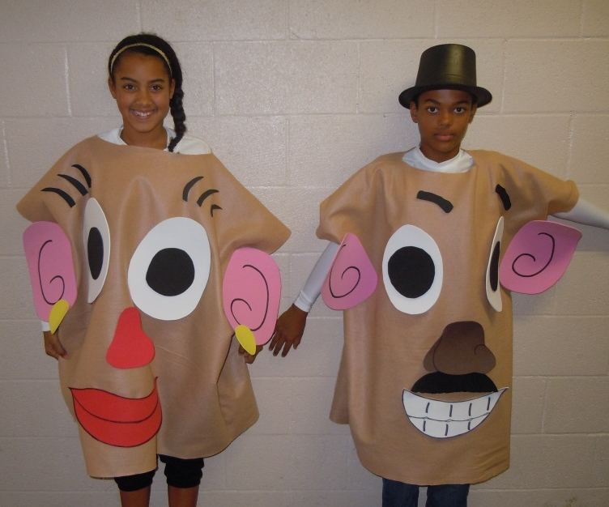
Jazzy Stubblefield and Elijah Norwood
aka Mr. and Mrs. Potato Head
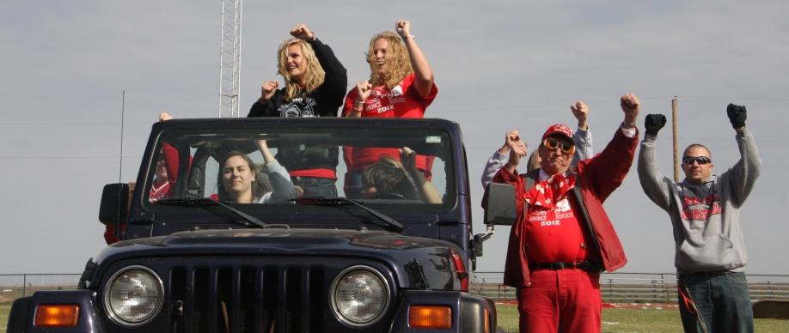
Teachers get into Homecoming spirit with “Call me, maybe.”
Uh, don’t call us, we’ll call you!
************************************************************
OTHER PHOTOS:
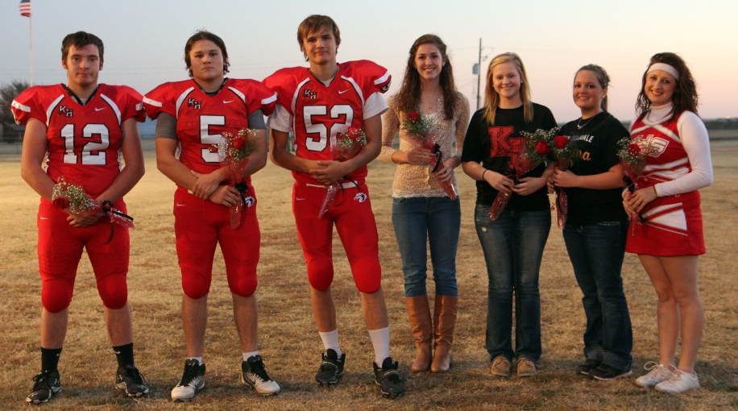
SENIOR NIGHT:
l to r: Tanner Sweetwood, Tanner Rogers, Aaron Butler, Christina Meyer,
Melissa Wallace, Allison Woodall, Morgan Stevens. Not pictured: Mike Austin

Jessica Britton “etches” her
school spirit into our minds.
***************************
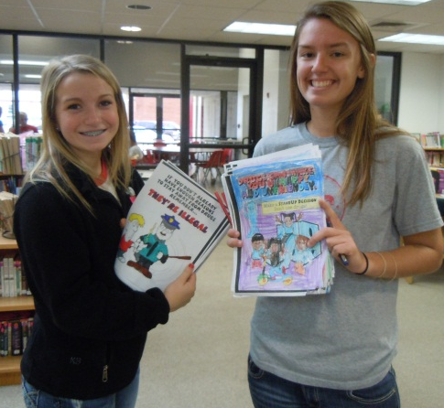
Karlee Bittle & Hannah Wuerflein display some of the students’ work for Red Ribbon Week.

Pond Creek-Hunter Invitational Basketball Tournament
Dec. 3 – 8, 2012

Girls vs DCLA 4:00 Tuesday
Boys vs PC-H 8:00 Tuesday

Support the
Lady Broncs
and Broncs!!!

Bronc Calendar 2012-2013
Dec. 3- 8 Pond Creek-Hunter Invitational Varsity Basketball Tournament
Dec. 8 KHS Junior High Invitational Academic Bowl Tournament @ Kremlin, 9:00 am – 1:00 pm
Dec. 10 Varsity BB vs Mulhall-Orlando @ Kremlin, 6:30 pm
Dec. 11 5th/6th Academic Team, District Tournament at Cherokee, 12:30 pm
Dec. 12 National Honor Society Blood Drive, 11:00 am - 3:00 pm, new gym lobby
Dec. 13 Elementary & Junior High BB at Garber, 4:30 pm
Dec. 14 Varsity BB vs DCLA at Lamont, 6:30 pm
Dec. 15 Cherokee Strip Conference Academic Tournament at Helena, 9 am
Dec. 15 Varsity BB vs Covington-Douglass @ Kremlin, 6:30 pm
Dec. 17 Christmas Program, 6:30 pm, new gym
Dec. 18 Varsity BB @ Drummond, 6:30 pm
Dec. 20 End of First Semester, Busses run at 11:00 am
Dec. 21 – Jan. 1 Christmas/New Year Holiday
Jan. 2 Teacher Workday, NO SCHOOL
Jan. 3 First Day of Second Semester
Jan. 3 HS Academic Team @ NOC-Tonkawa Invitational
Jan. 3 Elementary & Junior High BB at Cimarron, 4:30 pm
Jan. 5 5th/6th Academic Team Regional Tournament at Canton, 9:00 am
Jan. 5 Winter Formal
Jan. 7 Elementary & Junior High BB vs Medford, @ Kremlin, 4:30 pm
Jan. 7 BCS National Championship Football Game
Jan. 8 Varsity BB vs Lomega, @ Kremlin, 6:30 pm
Jan. 9 8th/9th Academic Team, District Tournament @ Aline-Cleo, time TBD
Jan. 10-12 Varsity BB Tournament @ Cherokee High School
Jan. 12 Varsity Academic Bowl, AREA Tournament @ Porter, 11:00 am
Jan. 14 Elementary & Junior High BB @ Drummond, 4:30 pm
Jan. 15 7th Academic Team, District Tournament, @ Cimarron, 1:00 pm
Jan. 15 Varsity BB @ Medford, 6:30 pm
Jan. 16 Elementary BB vs Covington-Douglass @ Kremlin, 12:30 pm
Jan. 17 Elementary & Junior High BB @ DCLA, 4:30 pm
Jan. 21 Elementary & Junior High BB @ Aline-Cleo, 4:30 pm
Jan. 22 Junior High and Varsity BB vs Pond Creek-Hunter, @ Kremlin, 4:00 pm
Red Ribbon Week
by Hannah Wuerflein
Every year, the National Honor Society sponsors Red Ribbon Week to raise awareness among the students about the dangers of drugs and alcohol and their abuse. Monday was Random Red Day. Students in jr and sr high school wore random clothes while elementary wore red. Students were given a variety of ribbons and stickers promoting Red Ribbon Week. Tuesday was Fight Against Drugs Day (students wore camo clothes), Wednesday was Team Up Against Drugs Day (students wore fav team gear), and Thursday was America Day (red,white, blue). Jr high and high school students received pencils. Students in grades Pre-K through sixth completed coloring or puzzle pages. From those who participated, papers were drawn at random and prizes awarded at a Red Ribbon Rally on Thursday, Oct. 25. Then all the pictures were hung on the media center/commons windows.
MIND GAMES
The KHS varsity academic team, Ricki Schroeder, Abby Courtney, Jacob Pekrul, and Jordan Presley, along with coach Roger Gossen, travelled to near OKC on Thursday, October 9, to tape the new tv game show called “Mind Games.” KHS competed against Enid High School in the 32 team tournament. Each Sunday night at 6:30 pm, on channel 52 or Suddenlink 16 (KSBI), two teams from around the state face off in the fun competition. TV personality Ed Murray is the moderator for the show and asks the questions. Sometime during the first period, there is an Oklahoma History question worth $250 for a correct answer. The winning team wins $300 and the right to come back for the next round and the losing teams wins $200.
In our game, broadcast on Sunday night, November 25, KHS gave Enid High a good run, but lost by 120 points, 490-370. KHS led 100-80 after the first period which was a series of 20 point toss up questions followed by a 10 point bonus question. The second period was the “flash” period, a series of True/False questions answered in a one-minute time frame. After that period, KHS led 190-170. In the third period, 40 point toss-ups with 20 point follow-up bonuses, Enid jumped out to a big lead and then KHS fought back to close the gap to the final score. Even though KHS lost the game, they won more money than Enid because KHS knew the OK History question and Enid didn’t know theirs (although KHS knew the answers to both).
Ricki led the Broncs with 160 points. Jordan had 40 points, Abby 20 and Jacob 20. They earned 40 points in bonus points and 90 in the Flash round. The team earned $450 for the academic team thanks to the Chickasaw Nation and Ward Petroleum, sponsors of the game.

KHS academic team coach names teams
Roger Gossen announces these teams for 2012-2013:
High School Varsity (OSSAA)
Seniors Ricki Schroeder (captain), Abby Courtney, Samantha Stoneberg; sophomores Jacob Pekrul and Hayden Bonine; freshmen Jordan Presley and Connor Snapp. Alternates are junior Trev Schoenhals, sophomore John Schrader, and freshman Elijah Voth.
8th/9th OJABA*
Freshmen Jordan Presley (captain), Connor Snapp, Elijah Voth, Billie Jo Gabriel; 8th graders Briley Craig and Corbin Lunday.
District at Aline-Cleo on January 9.
7th/8th OJABA*
8th graders: Briley Craig (captain), Corbin Lunday, Jordan Harris, Mikayla Horning; 7th graders Josh Reimer and Alice Keithly.
District at DCLA on January 23.
7th OJABA*
7th graders: Josh Reimer (captain), Alice Keithly, Ian Franklin, Cody Bower, Jazzy Stubblefield, Riley Jung.
District at Cimarron on January 15.
5th/6th OJABA*
6th graders: Natalie Haggard, Brett Russell, Bobbie Gray, Megan Carson; 5th graders: David Campbell, Josie Larsen, Sophie Fosmire, Magwire Lunday. (Captain not yet identified.)
District at Cherokee on December 11.

*OJABA: Oklahoma Junior Academic Bowl Association
KHS varsity academic team
Off to good start
The KHS academic team has competed in Skeltur Conference round robin games, winning six out of eight games. They lost to Drummond and lost to Pioneer (in sudden death), but beat Dover, Cimarron, Covington, Garber, Pond Creek, and Waukomis. The team was split into two teams for the KHS Invitational. The RED team went four and one, winning its pool but losing in the first round of the playoffs in sudden death to OBA. The WHITE team went three and two, losing only to the RED team in pool play and losing in the first round of playoffs to Edmond Santa Fe JV (the team that eventually finished second in the tournament).
In OSSAA playoffs, KHS split their district games, losing in a low scoring game to Dover 90-100 and then beating Morrison 190-180. In Regionals, KHS defeated Barnsdall 270-30, lost a tight game with eventual Regional champion Riverfield Country Day School 140-160, bounced back to defeat Woodland 220-40 and Morrison 260-160 to take third place and advance to the Area Tournament to be held at Porter, OK, on January 12.
KHS also ventured into NAQT (National Academic Quizbowl Tournament) competition by attending the Bulldog Invitational at Edmond Memorial on Nov. 17. KHS had a tough draw in the pool rounds, winning two and losing four. Three of the teams KHS played finished pool play seeded 1,2, and 4. KHS finished seeded 9th. They lost in the first round of playoffs to Norman (who went on to finish second in the overall tournament). Ricki Schroeder was 20th high scorer and Jordan Presley was 22nd high scorer out of 94 participants.
The Broncs will compete in the Cherokee Strip Conference Tournament on December 15 at Timberlake.

Home Culture Club
Christmas Party
Dec. 1

NHS active this semester
The KHS National Honor Society has sponsored the Red Ribbon Week and KHS Invitational Academic Bowl tournament this fall. Next up is the semi-annual Blood Drive scheduled for Wednesday, December 12, from 11:00 am until 3:00 pm. Call Roger Gossen at 874-2281, ext. 210 to schedule a time to donate but walk-ins are welcome.
NHS members will also purchase toys for the John 3:16 Mission Christmas store (in Tulsa) and NHS will host the second annual Junior High Academic Bowl tournament on December 8.
KHAEF Grants
by Kristi Hilburn
Leland Streck, Joyce Fales, Kristi Hilburn, and Beverly Voth delivered some nice gifts to Kremlin-Hillsdale teachers on Wednesday, November 7. They were awarding grants to KHS teachers from the K-H Academic Enrichment Foundation in the amount of $11,200! All twelve teachers that applied were awarded and the students of Kremlin Hillsdale School will be the big winners.
The teacher, the amount of the grant, and the subject of the grant for each awarded are as follows: Heather Russell, $810, “Typing to Learn” computer software; Heather Carson, $616, math manipulatives; Deanna Chesser, $995, dictionaries, thesauruses, and a cart; Chelsea Edington, $991, dictionaries, thesauruses, DVD, and a cart; Brady Bond, $849, SMART document camera; Kelsey Smith, $644, pulldown wall maps; Diane Highfill and Janel Powell, $1,502, Study Island programs; Roger Gossen, $987, TI-Inspire calculators for advanced math and science classes; Gina Pekrul, $976, iPads; Kaylene Toelle, $999, 25 student melodicas; David Campbell, $831, stereoscopic micro-scopes; Jamelyn Schultz, $1,000, Oklahoma Sequoyah Award books.
Half the money raised each year is added to a sustaining fund and the other half used directly for grants. The Foundation raises funds with several fund-raisers each year including a spring golf event and an ice cream social and auction in the fall when school starts.
God Bless the U.S.A.

Veterans Day Ceremony
The Pride of KHS band and its director, Mrs. Kaylene Toelle, put on another moving Veterans Day program for the KHS students, faculty, staff, and the K-H community. A skit featuring flashbacks to scenes in America’s past including Tuskegee airmen, women working in factories during WWII, the wives of the founding fathers, the flag-raising at Iwo Jima, was fun and informational. The veterans present were recognized and applauded. Thanks to the band and Mrs. Toelle for a job well done.
Scenes from the Veterans Day Program
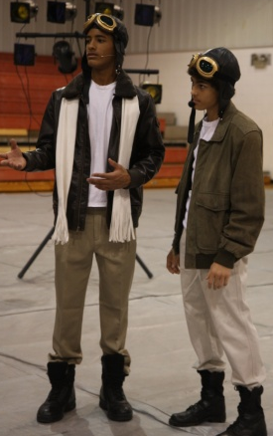
Ryan Voth Jadrien Stubblefield &
Isaiah Norwood
Tyler Jones, Justin Lippard, Connor Snapp

Answers to Christmas Quiz
1. The Bible does not say how many wise men there were. It does mention three gifts and tradition tells us that there were three: Caspar, Balthazar, and Melchior.
2. Eight maids a milking.
3. Mel Torme (who also recorded it, but the most famous recording was done by Nat King Cole.}
4. Vixen
5. Fröhliche Weinachten

Kremlin-Hillsdale Staff:
Superintendent Jim Patton
Administrative Secretary Virginia Craig
Elementary Principal/HS Social Studies
Boys Basketball Coach Brad Hawkins
Elementary Secretary Kristi Hilburn
Pre-Kindergarten/Cheer Sponsor Heather Carson
Aide Kelly Moffett
Kindergarten Gina Pekrul
Aide Lisa Long
First grade Sharon Riddle
Aide Vickie Odle
Second grade Jenny Meyer
Third grade Charlotte Lieser
Fourth grade Heather Russell
Fifth grade Pamela Tucker
Sixth grade/ 8th Math & English Deanna Chesser
Special Ed Janel Powell
Special Ed Diane Highfill
Band/Elem. PE Kaylene Toelle
Librarian/Yearbook Jamelyn Schultz
Secondary Principal/FB Coach Jeremy Brashears
Secondary Secretary Teresa Helm
Counselor / Careers Jenny Smithson
English HS & 7th Chelsea Edington
HS Social Studies/CC Coach Kasey McCoy
Agriculture/FFA Brady Bond
JH Social Studies/SB Coach Kelsey Smith
HS/JH Math/Computer/Girls BB Coach Tana Turney
FB Coach/ Social Studies Terry Fettke
Science David Campbell
Math/Academic Coach Roger Gossen
Speech pathologist Ronda Martin
Bus Supervisor / Driver Gail Messenger
Custodian Chuck Dickason
Custodian Laura Streck
Cafeteria Manager Diana Williams
Cafeteria Assistant Tracie Rhodes
Cafeteria Assistant Leslie Dobbs
Suburban Driver Christy Rundle
Bus Drivers Roger Gossen, Kasey McCoy,
Chuck Dickason

The Bronc will be published approximately several times per school year. If you have articles to be included, send them to Roger Gossen at Kremlin-Hillsdale School, P.O. Box 198, Kremlin, OK 73753. Or send an email message to gossenr@kremlin.k12.ok.us. The Bronc will be published online but for $5.00 you can receive a hardcopy. Contact Roger Gossen for more information.

Stuco Officers for 2012-2013

President Ricki Schroeder
V.P Haley Carson
Secretary Sam Stoneberg
Treasurer Jacob Pekrul
Reporter Katie Davis
Senior Reps
Sarah Stein / Lindsey Staley
Junior Reps
Chantz Tucker / Ciarra Creel
Sophomore Reps
Lakan Light / D.J. Toelle
Freshmen Reps
Billie Jo Gabriel / Jordan Presley
8th Grade Reps
Joe Keithly / Carly Salisbury / Brooklan Light
7th Grade Rep
Dakota Gabriel
Band Rep: Brenden Stokes
National Honor Society Rep:
Abby Courtney
Stuco Advisor: Mr. Kasey McCoy

NOTICE!
KREMLIN-HILLSDALE PUBLIC SCHOOLS
provides educational opportunities to handicapped students age 0 to 21.
These services are provided in accordance with Public Law 94-142, which requires an approved education for handicapped children 0-21.
Any person having knowledge of a handicapped child not identified or served, please contact:
Jim Patton
Kremlin-Hillsdale Schools
P.O. Box 198
Kremlin, OK 73753

