Basketball Homecoming
by Ty Zaloudek
The Homecoming coronation took place on Friday, February fourth, against the Cimarron Blazers. The Homecoming queen candidates were: Bailey Craig, Jessica Martin, Audrey McBride, and Kylin Wampler. The king candidates were: Austin Fox, Tanner Sweetwood, Ty Schoenhals, and Ty Zaloudek. The kindergarten escorts were Jacelyn Killen and Noah Maddox. After much anticipation, the Homecoming King and Queen claimed their thrones. The new Basketball King is Austin Fox, and Bailey Craig is Queen. The celebrations were coming to an end, and Austin sealed the night with a kiss.
Congratulations Austin and Bailey!
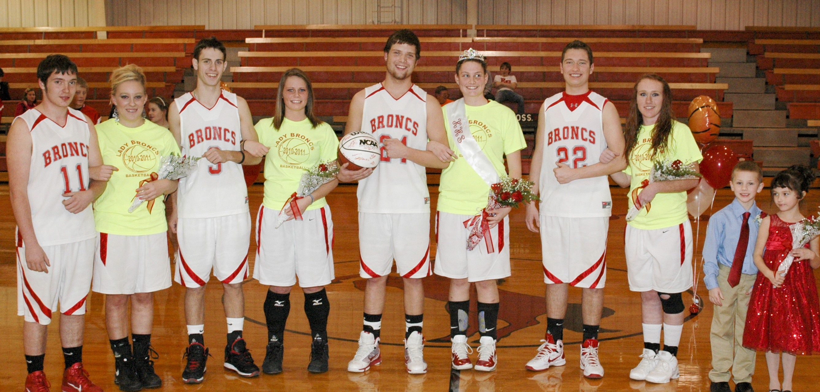
Tanner, Audrey, Ty Z, Jessica, King Austin, Queen Bailey, Ty S, Kylin, Noah, Jacelyn.
Dinner Theater comes to KHS
“Broadway Revue”
by Jennifer Pekrul
Attention all Kremlin-Hillsdale drama fans! Tickets are selling fast for this year’s spring musical “Broadway Revue”. Mrs. Rihn and Mrs. Toelle are working hard with the performers to get the show ready! There are two dinner shows at 6:30 pm on March 21 and 22 and one dessert show at 8:30 pm on March 22. At the dinner shows, you will be served chicken and potatoes O’Brien casserole, green beans, tossed salad and either angel food cake with strawberries or brownies ala mode. And for the dessert show, we will serve ice cream floats! Dinner show tickets are $12 (or a table of 8 for $80), and dessert show tickets are $7 (or a table of 8 for $40). Our new light system will be utilized in this show (thanks KHAEF!)
In other drama news, we recently attended Beauty and the Beast at the OKC Civic Center Music Hall. We also ate dinner at the Spaghetti Warehouse in Bricktown. It was a great evening. As Libby stated about the show, “On a scale of one to ten, it was twelve million!” We all agreed!
Trivia
Challenge
The KHS National Honor Society is ready to host its 22nd annual Trivia Challenge for teams of four adults (21+) who will fight for the title “Champions of Trivia”! People from all over northwest Oklahoma will travel to KHS on Monday, March 28, to compete. The fun will start at 6:30 pm.
Cost to enter a team is only $40, which works out to $10 per team member. Teams will play in pools and then advance to a single elimination tournament to determine a champion. Anywhere from 12 to 20 teams will participate.
All money raised goes to the NHS and KHS academic teams. Contact Roger Gossen by phone at 580-874-2281 or by email at gossenr@kremlin.k12.ok.us to enter a team or get more information.
Teams to State
Three KHS academic teams will travel to University of Oklahoma on consecutive weekends in April to compete in State Tournaments. See all the details on page 2! There is also a chance to show support of these teams by purchasing a t-shirt. Look for the order form in this issue.
Three J.H. academic teams to State!
Three academic teams from KHS will travel to Norman (OU) for State competitions in the Oklahoma Junior Academic Bowl Association (OJABA). The seventh grade team will go on April 2, the 7th/8th grade team will compete on April 9, and the 8th/9th grade team will be there on April 16. All three teams qualified in Regional tournaments held in February. Results of those tournaments follow on this page.
You can show support for these teams and help fund these trips by purchasing a t-shirt that lists the team members and says, “I support academic bowl.” and “Kremlin-Hillsdale ACADEMIC EXCELLENCE”. Look for the order form in this issue.
7th grade team – Regional Champs & Undefeated
This year’s seventh grade team went through district and regional competitions undefeated (6-0) and going to state on April 2nd. The core of this team was the team that won State and “Best of the Best” tournaments last year in 5th/6th grade level. Team members (and points scored in regionals) are: Captain Jordan Presley (200), Elijah Voth (190), Connor Snapp (160), Camden Roggow (50), Bobby Russell, Billie Jo Gabriel, Justin Lippard (10), and Cheyenne Roche. Roger Gossen is team coach.
At the regional tournament on Feb. 14 in Lahoma, KHS defeated Leedey 340-210, host Cimarron 310-260, and Cimarron again, 390-300.
7th/8th grade team – Also Regional Champs
KHS avenged a loss in district play to Cimarron by defeating the #1 seed twice in Regional play. KHS swept through Regionals undefeated and brought their season record to X-1. KHS beat DCLA (which finished fourth in Regionals) 310-180, then beat Cimarron in a come-from-behind victory 270-260. Next up came #3 seed Medford and the Broncs won 340-300. This put KHS in the driver’s seat and when the losers’ bracket settled, Cimarron was there to face the Broncs again. This time KHS dominated the match, smashing Cimarron 370-320 to claim the top spot in Regionals and a trip to State on April 9!
KHS team members (and points scored in Regionals) are: Captain Jacob Pekrul (300), Hayden Bonine (120), Jordan Presley (150), Elijah Voth (60), Connor Snapp (50), Olivia Holder (10), D.J. Toelle, and Zach Webber. Roger Gossen is team coach.
8th/9th grade team – Third place at Regional
The KHS 8th/9th grade that went winless in district play redeemed itself at Regionals by going 3-2 and qualifying for state with a third place finish. KHS, a #7 seed, lost to #2 seed Union City 160-240, but then won three in a row over Canton 180-150, Seiling 180-170, and Okeene 230-120 before being eliminated from further competition by top-seed Drummond 160-290. KHS will compete at State on April 16.
Team members (and points scored) are: Captain Trev Schoenhals (50), Hannah Wuerflein (30), Jacob Pekrul (230), Hayden Bonine (170), Karlee Bittle, Ryan Voth, Connor McCollough, and Chantz Tucker. Roger Gossen is team coach.

Counselor news
by Mrs. Murray
Seniors – Hopefully college applications have been filled out and ACT’s have been taken. Now is the time to fill out FAFSA. The FAFSA provides financial aid in several different ways, and is not just for those going to a 4 year college or university but also Technology Schools (Autry), Beauty Colleges, and 2 year colleges. Some University’s require you to fill out FAFSA before they will allow you to be eligible for their scholarships FAFSA is filled out online and can be found at FAFSA.gov or a link is available on the school website.
Freshmen – Junior: Now is the time to sign up for the June Act. The April 9 ACT deadline in March 4 and the June 11 ACT deadline is May 6.
Eighth – Tenth grade: Don’t forget to sign up for Oklahoma’s Promise. Sophomores, this is the last year you can qualify! A link can be found on the school website, kremlin.k12.ok.us.

Blast from the Past
News from 1999 issue of
THE BRONC
Katie Brainard (McCants), Rachel Wuerflein (Flavin), and Brandi Welker (Schiebber) swept the 1999 State Meat Judging contest in Stillwater at the OSU meats lab April 24.
This year’s Teacher of the Year is Mrs. Kaylene Toelle.
KHS 8th/9th grade academic bowl team wins the OJABA state tourn-ament in the small school division. They finished the season with a perfect 13-0 record.

Band Booster news
by Diane Fosmire
The Band Booster would like to thank everyone who has supported the sales of beautiful holiday poinsettias and valentine goodie bags. We would also like to remind you that “Bronc Band Bucks”, which are equivalent to cash, continues to be available for purchase at the front service desk of both Jumbo locations. When the band bucks are used to by your groceries, Jumbo foods generously donates 5% of the purchase price to our band. This is an easy way to support the band program year around. A big thank you goes to Sally McCollough who donated her time each month to the administration of this fantastic fundraising program.
As the fun of musical raising in support of our athletic teams in their performs has come and gone for another year and the band prepares for their serious spring contests, the Band Boosters wishes Mrs. Toelle and all her musicians well as they prepare to represent our school and community with their talent and hard work.
The Band Boosters are composed of parents of all band members. There are no fees to join in the fun of supporting our band students. If any parent would like to become more involved in the school projects than they need to contact Mrs. Toelle ,Diane Fosmire, Jenny Meyer, Teresa Helm, Heather Carson, Gina Pekrul, Kathy Wuerflein, Sally McCollough or any other band parents who would like to be interested in being a helper please call.

FCA news
by Eugene Brooks
FCA (Fellowship of Christian Athletes) has just recently started meeting regularly again -- junior high meets on Mondays at noon, and high school meets on Tuesdays at noon. Justin Jackson came and spoke to both groups on Feb. 15 about FCA summer camp. FCA had a GameDay on Sunday February 27, 2011 at an OU Women’s basketball game vs the number three ranked Baylor Bears; thirty KHS students attended. On February 22, FCA held a Super Sports & KHS Trivia night.
The FCA All State Recognition Banquet will be held Wednesday April 13, at Crossing Community Church in OKC. Former First Lady Laura Bush will be the keynote speaker. For more information, go on OKFCA.org or contact Roger Gossen at the school.
PTO news
by Samm Hoeltzel
Way to go KHS elementary students!! We had 92 students turn in their school mall booklets. This fundraiser so far has raised around $400. We will know the grand total in late April to early May. Great job students and parents! Mrs. Carson’s pre-K class brought the most booklets and Won the Popsicle party.
We are having a contest between the elementary classes. The class that bring the most box tops and labels for Education will get a pizza party right now Mrs. Riddle’s 1st grade class is in the lead with 314 while Mrs. Meyer’s 2nd grade class coming in a close 2nd with 292. We still need 3000 box tops to meet our ($600.00). We also need to collect labels for Education. These are used to purchase fun items for the students to use at recess.

FFA news
by Miranda Kolesar
Our FFA chapter has been a success so far. As of now we are participating in National FFA week. We kicked off the week on Sunday, February 20th with church at Kremlin, then continuing the rest of the week on Monday was Blue and Gold day and we also held an Aggie Olympics against Covington-Douglas FFA officers. Tuesday was official dress day. We also had guest speaker Amy Peel come speak to the 7th-12th grades. Wednesday is small group day; Thursday is dress like a farmer day; Friday is western day; Saturday is breakfast for farmers in Hillsdale at the community building and ending this busy week is church at Hillsdale.
County show was also held in the National FFA week and districts are the following weekend. Ty Zaulodek, Britani Taylor, Miranda Kolesar, Jessica Martin and Jeremy Maxwell got to speak on 103.1 KOFM radio station the Friday before FFA week. Our officer team and advisor are looking forward to what is in store for them before the year ends.

FFA Booster Club news
by Kim Zaloudek
FFA Boosters have been coming along great. The Zaloudeks will be providing a meal for the show team at the OYE show. We also voted to cover the difference for the electricity and rock for the drive at the AG barn.
STUCO news
by Haley Carson
Pennies for Patients is a fundraiser to help find the cure for Leukemia. This February, we will be bringing change to help support this fund. There will be a designated week to bring your change. All the students here at K-H will have a great time both competing and raising money for this fundraiser. You will be supporting all the patients with Leukemia. We will be preparing for Stuco president, vice president and treasurer elections in the month of April.

NHS news
by Danielle Stoneberg
The school year is almost over and lots of events are approaching. The annual Trivia Challenge is scheduled for March 28. The NHS and Academic Bowl members will be writing the questions so if you are in either of these organizations make sure your questions get to Mr. Gossen before spring break. The spring blood drive will be on April 4th from 2 pm to 6 pm in the New Gym lobby. We are working on setting up a day called “One Day Without Shoes”. This event will be in conjunction with Toms Shoes, a company that provides shoes for children in third world nations. More information and the official date will be announced as soon as it’s determined. The induction ceremony has been set for May 9th and possible inductees will be contacted within the next week or two.

Band Highlights
by C.J. Robino
- Libby Fosmire is going to State in vocal solo
- H.S. Band has District Ensembles on March 1st in Alva
- H.S. Band has District Concert Band contest on March 9th in Cushing
- March 3 several students are going to OSU to a workshop and will perform with the world renowned Dallas Brass
- J.H. &Elementary Bands are preparing for Tri-State

Mark Your Calendars
- April 27-30 Tri-State
- May 5 Spring Concert
- May 7 Band Awards Night

Bronc Boosters
by Miranda Kolesar
The booster club had a successful time with selling Bronc T-shirts. They will be holding an Athletic Banquet on May 6th. Watch future issues of THE BRONC for more information. Thanks to all who have joined Booster Club this year. It’s not too late to join and support the spring sports: baseball, slow pitch softball, and track. Contact Kim Zaloudek for more information.

Cheer Try-Outs!
by Haley Carson
Junior High and High School Cheer try-outs will be held on March 25th. Students in grades 6th-11th are encouraged to try-out. A mandatory try-out clinic will be held by Mrs. Carson on Wednesday and Thursday, March 23rd-24th.
Students trying out will need to be eligible in all classes. Students wishing to try-out will be required to attend both days of the clinic, must have an interview with Mrs. Carson, get teacher evaluations, and perform in front of judges.
If you want to try-out sign up in the High School office.

Blast from the Past
News from 1977 issue of THE BRONC
March Feature Story is a profile of the school board members. Jake Thesman is the senior board member having served 14 years… He drives a Ford pickup and a Ford LTD but not at the same time. Joe Forbes has served on the board for three years. He is an agricultural banker. Dale Hayes has been on the board for four years. His CP handle is Del-Fonz-O. The newest board member is Robert Dale Gray. “Tumblin’ Tumble Weeds” is his favorite song.
Article compiled and written by Janet Voth.
[Annual editor- Pam Voth (Schoenhals), Ass’t Ed. in Chief – Janet Voth (Streck), H.S. Ed. – Dian Simpson (Salisbury)]

S P O R T S

High school track news
by CJ Robino
The track team is practicing hard this year to get ready for our first meet. The team includes Junior CJ Robino, Sophomores: Christina Meyer, and Freshmen: Trev Schoenhals and Karlee Bittle. Our schedule is listed below:
March 26- Covington
March 31- Medford
April 9- Medford
April 14 – Ringwood 8-man
April 22- DCLA
April 23- Ringwood
April 26 Cherokee Strip Conference at Medford
Regionals- TBA
High school basketball
by Connor McCollough
High school basketball is now over, and the Broncs are on to baseball, so we have wrapped up the season. Although it wasn’t the highlight season we hoped for, by any means, we still fought hard in all our games. We got beat out of districts by Waukomis in a nail-bitter of a game. It was a tough loss, especially for our graduating seniors. This year we will lose three seniors from our line-up and hopefully will gain a lot from the underclassmen. We’re going to work hard so that we can come back next year strong, and make our old seniors proud.
Jr high baseball
by Brenden Stokes
The Junior High baseball team has been practicing for their first game. There are 12 members on the baseball team this year. The first game for Junior High will be on Tuesday March 29. It will be a home game and they will be playing Ringwood at 4:30.
Lady Broncs basketball
While KHS didn’t have the season they wanted, there was some late-season success, upsetting Covington and Cimarron on consecutive nights. Coach Monte Brotherson has a good nucleus returning for next year and some talented young ladies coming up.
Junior high track
by Trev Schoenhals
March 28 – Covington
April 7 – Ringwood
April 9 – Medford
April 12 – Chisholm
April 22 – DCLA
April 26 – Cherokee Strip Conference at Medford

Junior high slow pitch
by Haley Carson
This year’s slow pitch softball team consists of the following thirteen players:7th graders Billie Jo Gabriel, Rebecca Gannon, Siera Carter, Cheyenne Roache, Kalyn Nixon, Tesla Felber, Gabby Morris, Mary Mitchell, and Paige Ayres. 8th graders: Olivia Harder, Cherokee Minter, Cassy Albert, and Ashleigh Brewer. We hope you have a winning season. Good luck Lady Broncs!

High school slow pitch softball news
by Melissa Wallace
Our slow pitch softball girls this year are: seniors Bailey Craig, Jessica Martin, Kylin Wampler; junior Jennifer Pekrul; sophomores Melissa Wallace, Morgan Stevens, and freshmen Ryan Voth, Hannah Wuerflein, Haley Carson, Karlee Bittle, Olivia Felber, and Ciarra Creel. Our first games are against Covington-Douglas, Pond Creek Hunter, and Ringwood. All of them are away games and all start at 4 pm. We are all looking to a great year of softball and we would love to see everyone out there to support us.
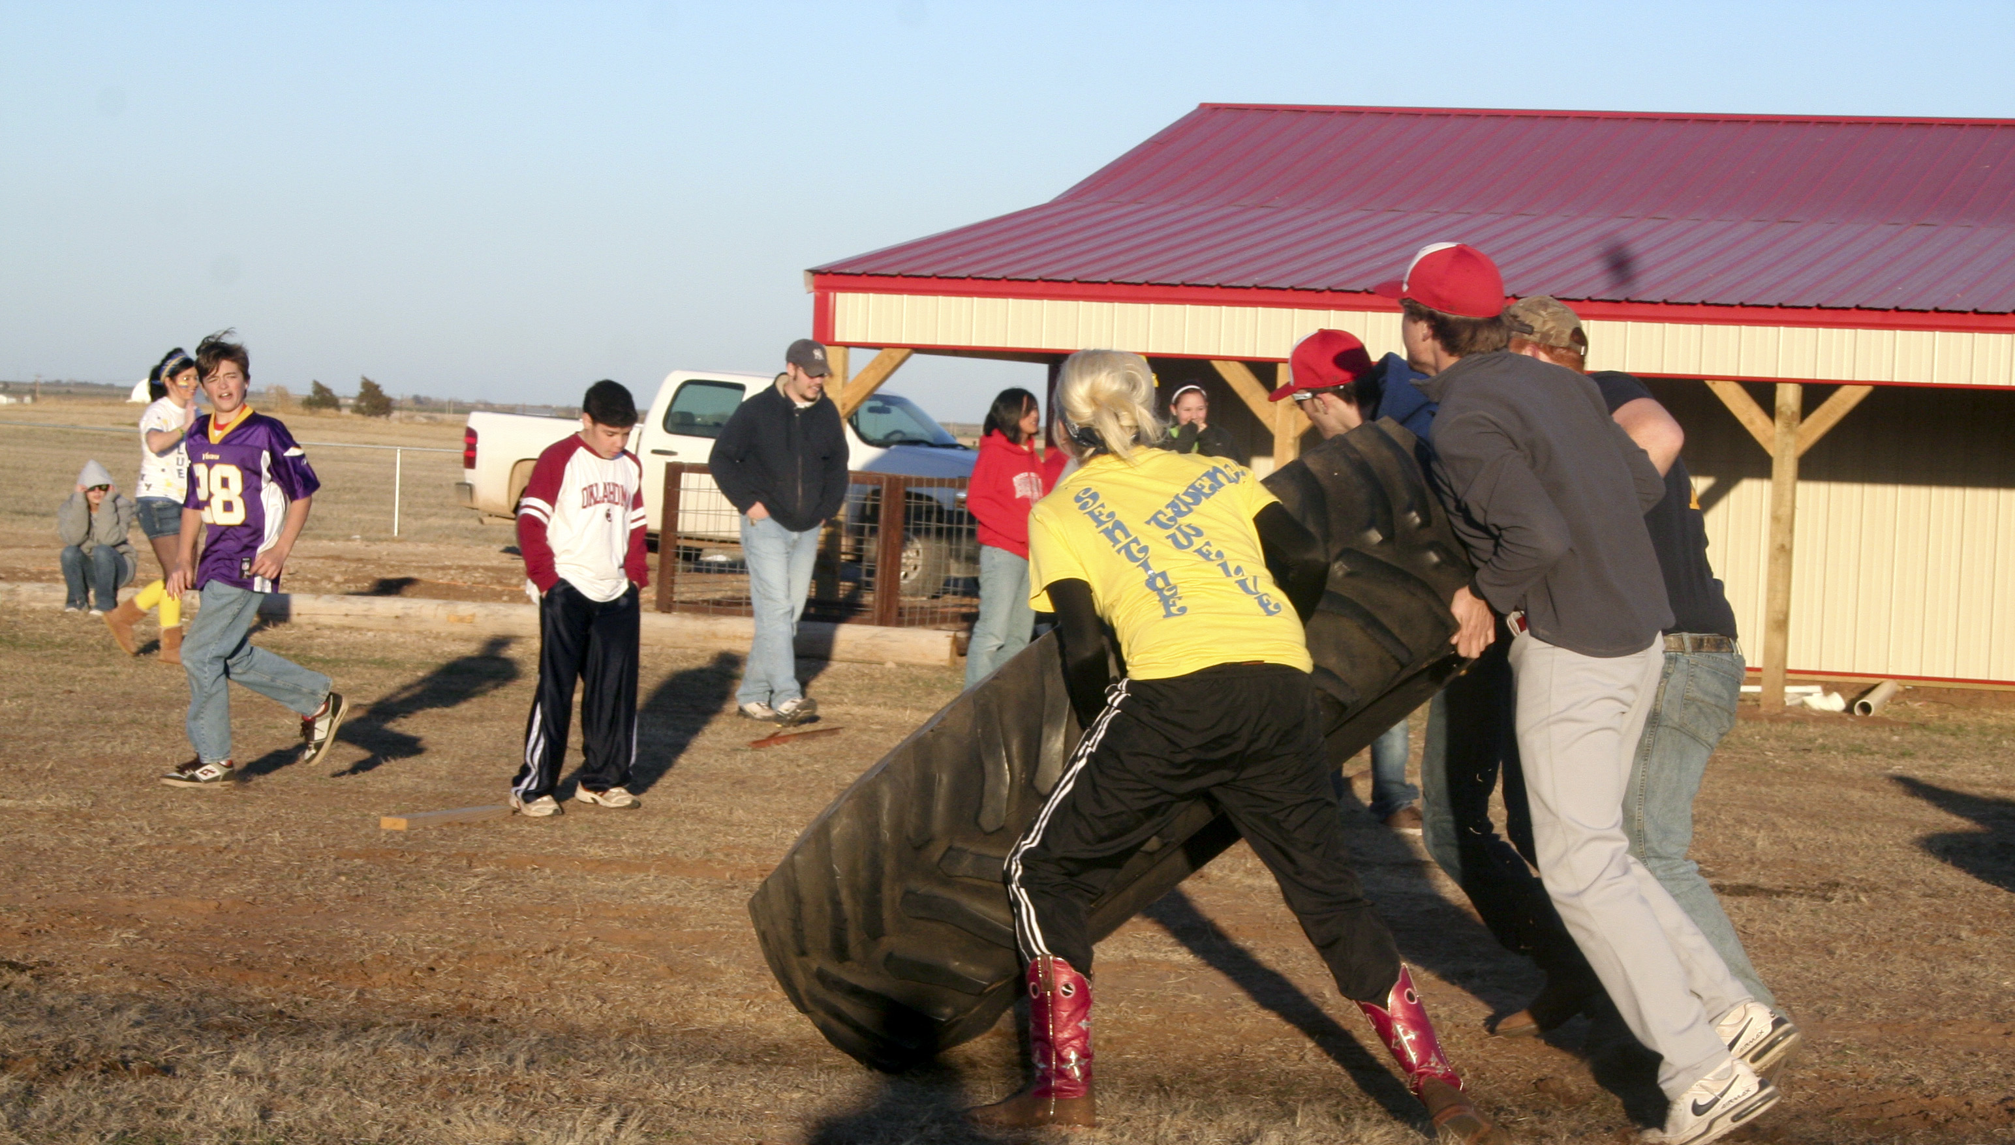
Ag Olympics: KHS vs Covington at KHS Ag Farm.

Kremlin Home Culture Club
by Avis Forbes
The Kremlin Home Culture met at Kremlin Church Jan 12, 2011 with Joyce Fales as hostess. Discussion was about the upcoming Achievement Day Jan 29, 2011at the OSU Extension Office. 2011 offices are Pres. Betty Sissom, Vice Pres. Avis Forbes, Sec. Joyce Fales and Tr. Sharon Riddle. The next meeting will be Feb.8.
The Feb.8, 2011 was cancelled due to snow and cold. A make-up meeting was held on Say. Feb. 12,at the Kremlin Church, with Betty Sissom serving as hostess. Following the Flag Salute, Club Creed and Devotion the business was conducted. Reports were read and new club books were giving to the members. The Spring Council is scheduled for April 12, 2011, which is the regular meeting date for the group. To allow members to attend the Spring Council our group will meet Sat, April 9, 2011, for a brunch at 10 a.m. at the home of Jennie Meyer.
Betty Sissom presented the lesson and a DVD on T’ai Chi Chen, an oriental movement series to help relaxation, balance, and circulation. Avis Forbes gave a Show N Tell about using wheat bran in cooking to help reduce fat intake.
Members drew names for 2011 Secret Pal and then played “Dirty Cupid”, where each member received a Valentine gift. Members attending where: Pres. Betty Sissom, Jennie Meyer, Stefanie Franklin, Virginia Craig, Sophia Thesman, Carolyn Ott, Joyce Fales, Nancy Ingraham, Beverly Buller and Avis Forbes. Next meeting is March, 2011 with Brandi Schieber as hostess and leader.

Kremlin UMW
by Avis Forbes
The 2011 UMW meeting was held at the Kremlin Methodist Church on January 5, 2011. The group completed Date Books for 2011. It was decided to spend the year making new Christmas items for the Church Christmas tress using felt and decoration with gold, glitter and modge pad. There is a wide variety of patterns and each will explain the meaning of the ornament. The project will be worked on at each monthly meeting. Joyce Fales was the hostess. The next meeting is on February 2. This meeting was canceled because of snow and cold. A short meeting was held, following church on Sunday, February 13, to plan the meal for the Lions Club, February meeting.
Blast from the Past
News from 1990 issue of THE BRONC
High school cheerleaders for the 1990-1991 school year include: Julie Haskins, Nichole Maddox, Shellina Mair, Heather Myers, Kennette Ronck, and Nikki Stubblefield.
KHS took Class B Sweepstakes at the NWOSU Curricular Contest on April 12.

4-H news
by Conner Snapp
The KHS 4-H Club has been very busy during the first two months of 2011. On January 29th several club members attended the OKC Barons Hockey Game, where they won an autographed hockey stick. The meat judging season has started. They will be competing in the NW district and state contest in April. Also the new trap shooting season will be starting up soon. Our meetings are every third Monday after school in the cafeteria.

KHS National Honor Society
Blood Drive
Monday, April 5, 2011
2:00 – 6:00 pm
Call 874-2281, ext. 210 to reserve time.
Walk-ins welcome!

25th Annual Chess Club Tournament
The KHS Chess Club will soon be forming for the 2011 tournament. Students in grades 7-12 that are interested in joining pay a $1 fee which pays for (1) club membership and (2) entry into the tournament. Last year’s winners were: 1st- Michael Schwahn, 2nd – Cordell Lloyd, 3rd- Tim Stein, and 4th – Bailey Craig. Since Michael and Cordell have graduated, Tim and Bailey will be the top seeds in a wide open contest. Roger Gossen is faculty sponsor and tournament director. Deadline to enter is March 9.
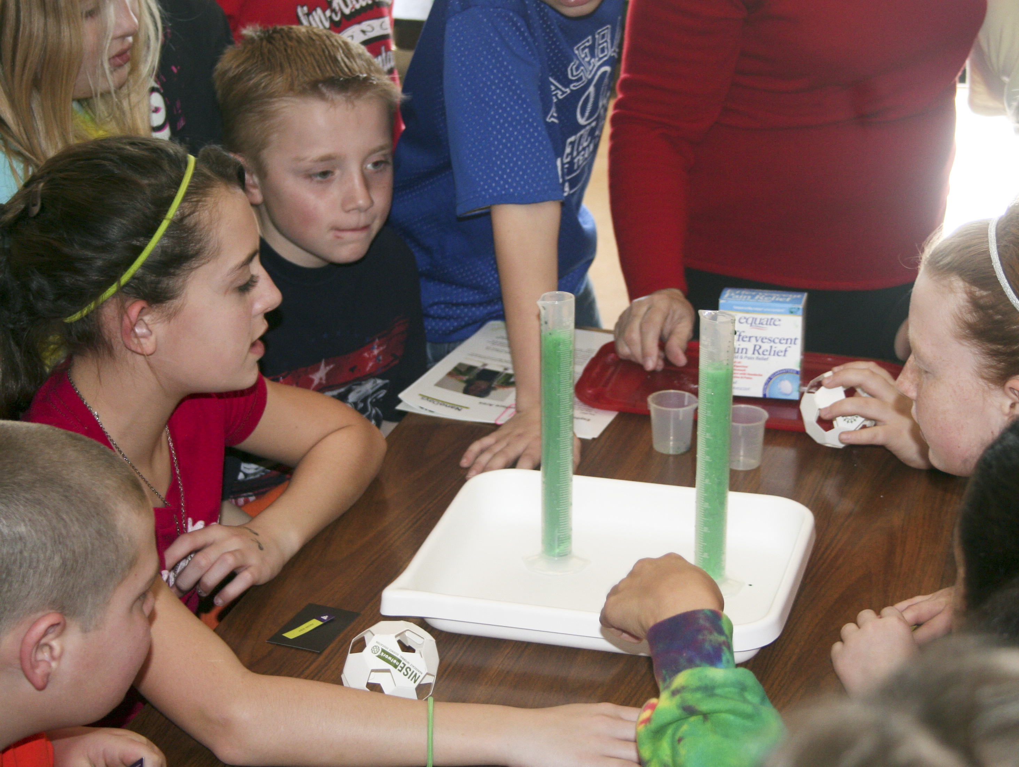
Fun at Leonardo’s in Science!

C L A S S N E W S

Seventh grade news
by Connor Snapp
For the seventh grade, it has been a great past few weeks, because the 7th grade academic team swept regionals after sweeping districts at Coyle. Regionals were at Cimarron, on February 14, which was a great Valentine’s Day present for the whole team. The members of the team are: Jordan Presley, Elijah Voth, Connor Snapp, Billie Jo Gabriel, Camden Roggow, Cheyenne Roche, Justin Lippard, and Bobby Russell. The team goes to state April 2nd, at OU. The 7/8th team also swept regionals at Kremlin, beating 1st seed Cimarron twice.
Tenth grade news
by Melissa Wallace
The tenth grade has had a pretty good year so far and is looking forward to the summer. The girls and boys basketball teams are now finished with basketball and we congratulate them on a good season. Now we are starting softball and baseball and everyone is excited. We got a long lost student back Mike Austin, we are all happy to have him back. A reminder to all the sophomores, class dues are due in April. So do not forget to pay your twenty dollars. We are looking forward to a great safe and fun rest of the year!

Eleventh grade news
by Gretchen Wuerflien
We are working towards all of our goals. We are also working on prom and we almost have everything planned! Many people are involved in sports, band and drama. The senior prophesies have been completed. We are all having fun and can not wait to be seniors next year!
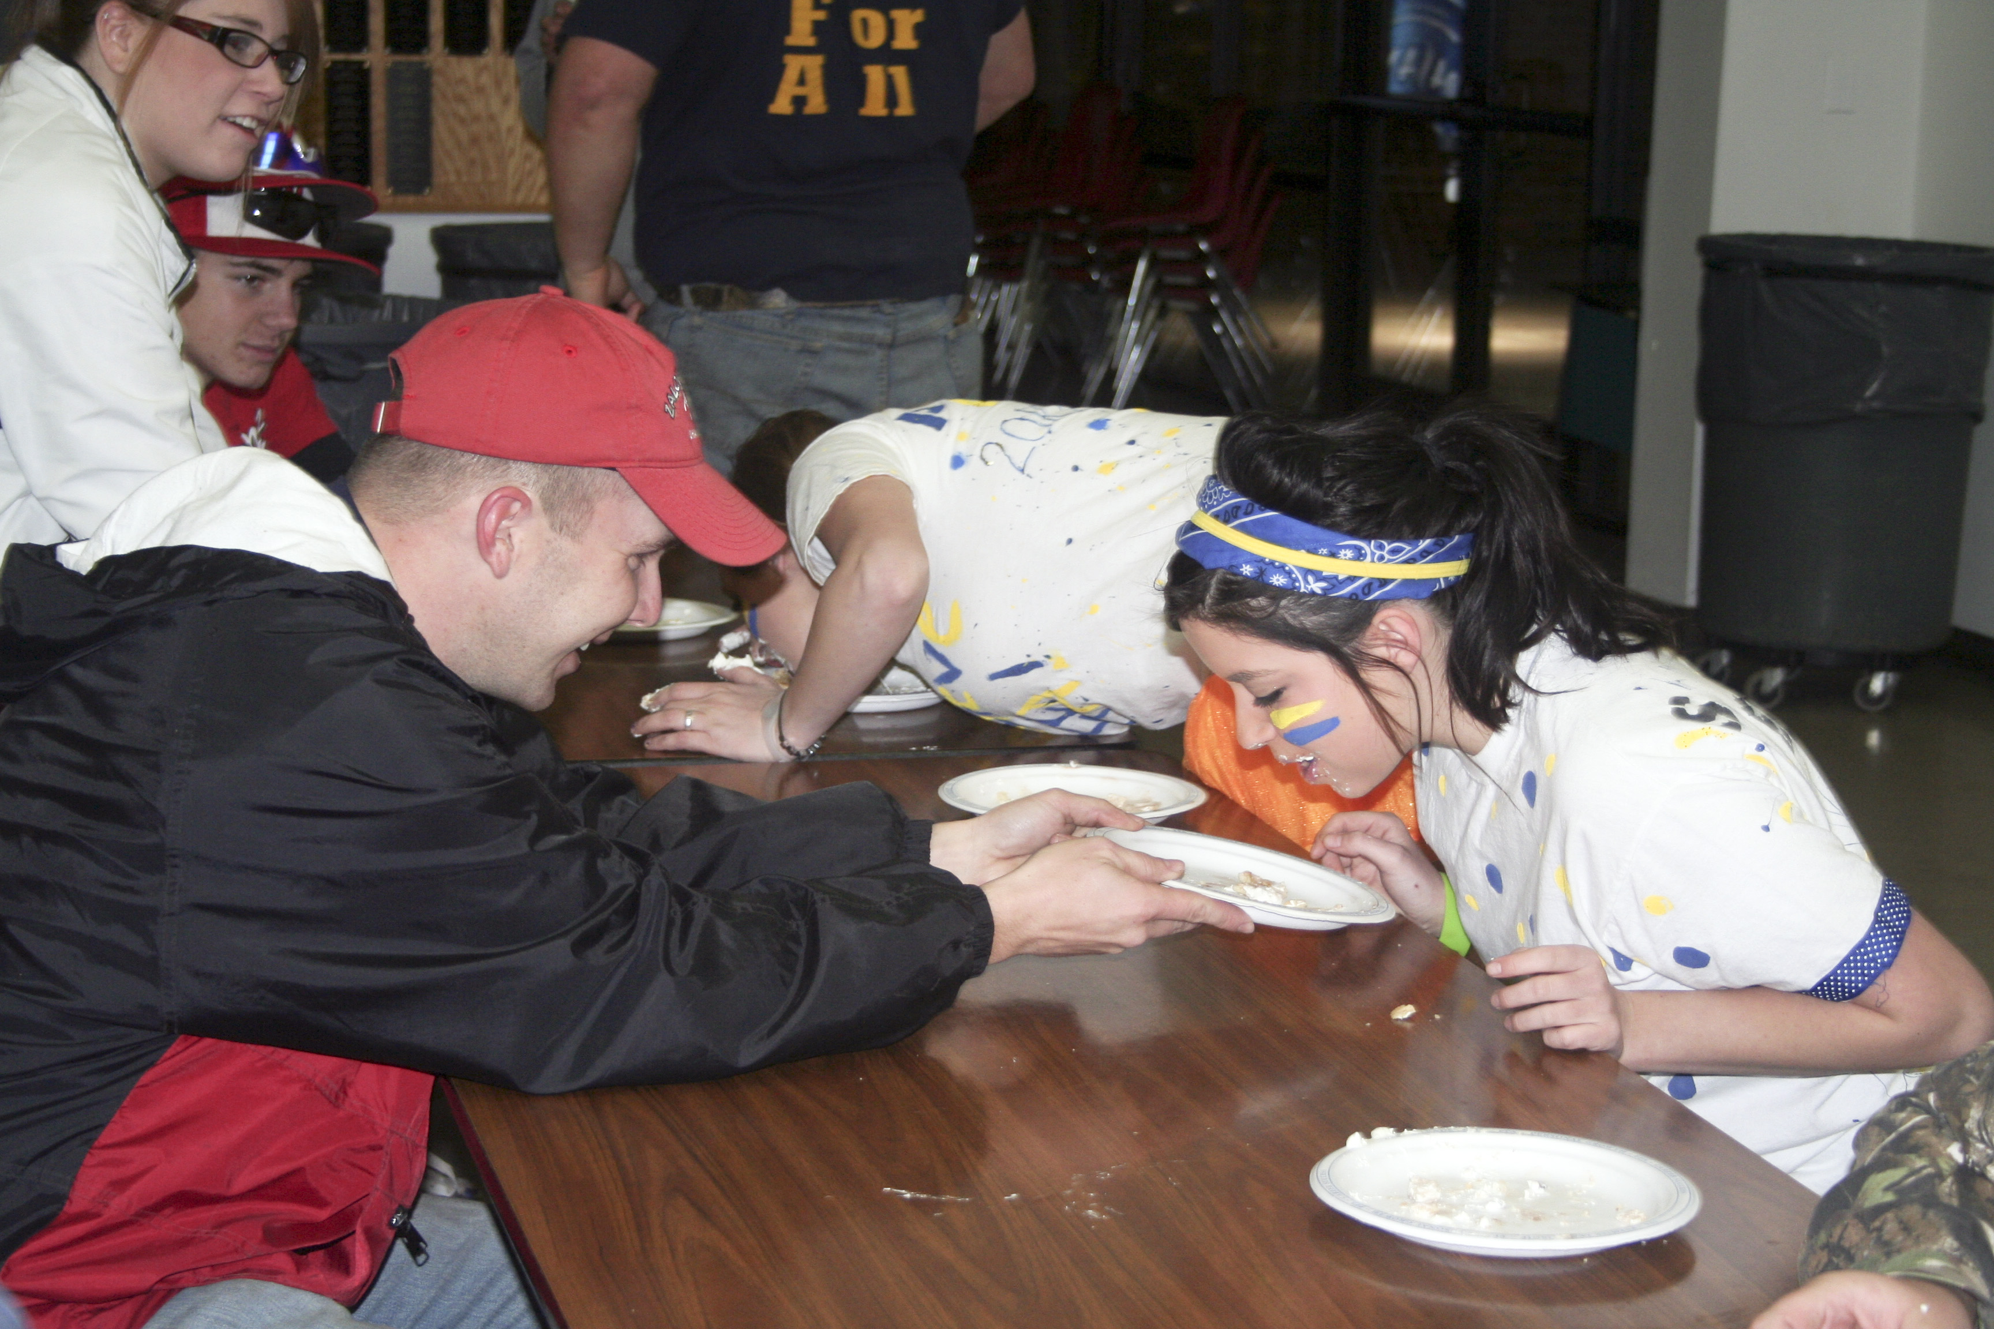
Mr. Smith & Britani Taylor – More fun at Ag Olympics!
Senior news
by Tim Stein
We’re rounding third and heading toward home plate now. In just nine more weeks until we walk across that stage with our diplomas. We are all tediously applying to school and preparing for life after high school. Not only that, but we’re looking to prom and after prom. Spring sports and activities are starting up-band, track, softball, and baseball, so everybody’s busy. Along with sports, the drama club is working at full speed for their Dinner Theatre productions, which will take place on March 21 and 22 ( contact Mrs. Rihn or Mrs. Toelle for more details). Other than that, not too much is happening. We’re all just looking forward to some warmer weather and being allowed to wear shorts again!
Kremlin elementary news
by Mr. McCoy & Ms. Hilburn
The Kremlin elementary school has had a fun-filled February, including 100th Day of school, an Electricity show and a Valentine’s Day party. February 3rd was the 100th day of School: celebrations included making a trail mix with 10 groups of 10 different things, measuring 100 hundred feet, and counting to 100. OG&E had an in-service to show the kids how electricity works. Elementary basketball recently finished a great season. On March 21st, 1st – 6th grade will go skating. February has been great . Thank you to everyone involved especially the parents.
WildHorse Gang news
by Chantz Tucker
The WildHorse Gang was established in 1992 by Gini Zaloudek. They meet one Tuesday of every month. Several events have happened this month. On January 30 David and Chloe Beth Campbell were guest ushers at the Oklahoma City Theater presentation “Always Patsy Cline” show. On February 5 Lewana Enwell concert Chantz Tucker, Tanner Rogers, Brenden Stokes, Jordan Presley, Rebekah Gannon ushered people to their seats at the symphony center. We also served at the Lions Club Valentines Day dinner. The Saurian Circus was on the 26th of February. Tickets were given to the WHG by John Dolum.

Bronc Calendar
by Alex Hicks [Home activities in bold type.]

March 4 HS Baseball vs Cov-Doug 4:00 pm
March 4 NO SCHOOL
March 3-5 HS Boys & Girls Basketball State at OKC
March 7 HS Baseball at Garber 4:30 pm
March 7 HS Softball at Pond Creek Hunter TBA
March 8 HS Softball at Ringwood TBA
Mar4ch 10 HS Softball at Drummond TBA
March 10 HS Baseball at Cimarron 4:00 pm
March 10 Parent-Teacher Conferences, 4:00 – 8:00 pm
March 11 HS Baseball at Cov-Doug 4:00 pm
March 11 Parent-Teacher Conferences, 8:00 am – 12 noon, NO SCHOOL
March 14 HS Baseball at Pond Creek 1:00 pm
March 14-18 Spring Break
March 21 JH Softball vs Ringwood, 4:30 pm
March 21 & 22 Spring Musical: Broadway Revue
March 22 HS Softball vs Garber
March 23-26 HS Baseball at Chisolm Trail TBA
March 24 JH Softball vs OBA, 4:30 pm
March 26 HS Track at Covington TBA
March 28 JH Track at Covington
March 28 Trivia Challenge 2011, 6:30 pm
March 28-31 HS Baseball Skeltur Conf at TBA TBA
March 29 JH Baseball vs Ringwood, 4:30 pm
March 30 Elementary Track at Covington
March 31 HS Track at Medford TBA
March 29-April 2 HS Softball Cimarron Tourn
April 1 JH Softball at OBA, 4:30 pm
April 1 JH Baseball vs PC—Hunter, 4:00 pm
April 2 OJABA 7th grade State Academic Bowl at OU
April 4 HS Baseball at Waukomis 4:00 pm
April 4 JH Baseball at Aline-Cleo, 4:30 pm
April 4 JH Softball vs Pioneer, 4:30 pm
April 5 HS Softball at Garber TBA
April 5 HS Baseball at Medford 4:30 pm
April 5 JH Softball at Ringwood, 4:30 pm
April 5 Redlands Interscholastic Contest in El Reno
April 6 Elementary Track at Chisholm
April 7 JH Track at Ringwood
April 7 JH Softball at Pioneer, 4:30 pm
April 8 JH Baseball at Pond Creek-Hunter, 4:00 pm
April 8-9 HS Softball Waukomis Tourn
April 9 OJABA 7th/8th grades State Academic Bowl at OU
April 9 HS Track at Medford TBA
April 9 JH Track at Medford
April 11 HS Baseball at OBA 4:00 pm
April 11 HS Softball at Cimarron TBA
April 11-12 Pittsburg State University Math Relays
April 12 JH Track at Chisholm
April 12 JH Baseball vs Aline-Cleo, 4:30 pm
April 12 HS Softball at Cov-Doug TBA
April 12 HS Baseball vs OBA 4:00 pm
April 14 JH Softball at Cimarron, 4:30 pm
April 14 HS Track at Ringwood 8-Man TBA
April 15 HS Softball atPond Creek Hunter TBA
April 15 JH Track at DCLA
April 16 HS Baseball vs Garber 1:00
April 16 OJABA 8th/9th grades State Academic Bowl at OU
April 16 KHS Junior-Senior PROM
Staff of THE BRONC:
Computer I Class: Eugene Brooks, Haley Carson, Ciarra Creel, Kody Faulkenberry, Olivia Felber, Devin Helm, Tim Mardis, Connor McCollough, Cassady Koehn, Lee Olmstead, Trev Schoenhals, Kendra Sellers, Shelby Smith, Freddy Stephens, Brendan Stokes, Chantz Tucker
Computer II Morning Class: Lexus Billingsley, Libby Fosmire, Ty Schoenhals, Ty Zaloudek.
Computer II Afternoon Class: R.J. Drago, Alex Hicks, Miranda Kolesar, Tanner Rogers, Mandy Schroeder, Morgan Stevens, Tanner Sweetwood, Melissa Wallace, Allison Woodall
Computer III Class: Trevor Buck, Jessica Cambron, Bryce Gannon, C.J. Robino
KHS BRONC Sponsor: Roger Gossen
The next edition of THE BRONC will be issued around the middle of April and the senior edition at the end of school in May. Turn in any news to Roger Gossen at P.O. Box 198, Kremlin, OK, 73753 or email it to gossenr@kremlin.k12.ok.us

High school academic team competes in Arkansas
Ninth place finish!
Roger Gossen took six KHS academic team members to Ft. Smith, AR, to a Regional tournament sponsored by Questions Unlimited on Saturday, January 22. There were nineteen teams in the high school varsity division. KHS finished just out of the playoffs, tying for ninth with a 3 - 3 record. They started out with a loss to the team that ultimately won the whole tournament, losing 80-280 to Little Rock Parkview A. KHS defeated Parkview B 200-135 in the next round, but lost to another top team in the tournament, Ft. Smith Southside, 90-290. After lunch, KHS played a 7A school from Rogers, AR, and beat them 150-130 and followed that up with a victory over Waldron 210-140. The final game of the day was against OK powerhouse Claremore (winner of three of last four state championships and current #1 seed in 6A State Tournament). KHS led Claremore at the half, but the Zebras roared to life in the second half and beat us 235-120.
KHS was well-represented by the team. Captain Mandy Schroeder led the Broncs in scoring with 200 points, followed by Tim Stein (140 pts), Gretchen Wuerflein (20), Ricki Schroeder (20), Libby Fosmire, and Sam Stoneberg. Roger Gossen is team coach.
The team stayed overnight in Ft. Smith on the Friday night before the contest and stopped in Tulsa on the way home Saturday night where they spent some time at Woodlands Hills Mall and they enjoyed a meal at Agave Mexican Restaurant before heading home.
KHS is looking forward to next year and welcoming the successful younger players coming up into high school. We hope to return to prominence in northwest Oklahoma and get back to the Area and State tournaments in 2012!

KHAEF
by Mike Riddle
The Kremlin-Hillsdale Academic Enrichment Foundation is again hosting its tenth annual golf tournament. Look on the website for the announcement and opportunity to print out the entry form. It will be held on Saturday, April 9, 2011, with a shotgun start at 1:00 pm. Registration, putting & chipping contests, and a BBQ lunch will all begin at 11:30 am. Cost is $65 per person. There are cash prizes for the winners in two flights plus special awards for ugliest hat, Payne Stewart look-alike, most balls lost, longest drive, and closest to the pin. Contact Mike Riddle at 580-747-1150 for more info.
Yearbook
Order Form
The high school yearbook staff is selling yearbooks and you can order yours today! Look on the KHS website and print out an order form shown there.
Lions Club 2011 “Citizen of the Year”
Roger Gossen
The Kremlin Lions Club has announced its latest “Citizen of the Year” to be KHS teacher Roger Gossen. The announcement was made at the annual Valentines Day dinner held this year at St. Matthews Episcopal Church. Gossen was nominated by Larry Johnson, retiring KHS board of education member. Gossen was selected based on his involvement in school, community, and church activities. He has served as a positive role model for students and adults alike for the past 28 years he has taught in Kremlin. Congratulations, Mr. Gossen.
Gossen has been married to Jodi (Thesman) for 37 ½ years and they have three adult children. They attend Enid Mennonite Brethren Church.

Support the KHS Academic Teams!
Buy a T-Shirt.

[Front Side of T-shirt will be something like this:]
Kremlin-Hillsdale
Academic
Excellence

[Back Side of T-shirt will be something like this:]
I Support
Academic Bowl

7th Grade 7th/8th Grade 8th/9th Grade
Jordan Presley Jacob Pekrul Trev Schoenhals
Elijah Voth Hayden Bonine Hannah Wuerflein
Connor Snapp Olivia Holder Karlee Bittle
Billie Jo Gabriel D.J. Toelle Connor McCollough
Justin Lippard Zach Webber Ryan Voth
Cheyenne Roche Jordan Presley Chantz Tucker
Camden Roggow Connor Snapp Jacob Pekrul
Bobby Russell Elijah Voth Hayden Bonine
Coach Roger Gossen
Take State!

****************************ORDER FORM*************************
All shirts are short-sleeved, gray with red printing, Gildan 100% Cotton 6.1 Oz. shirts.
Cost: All Youth sizes: $9 Adults Sizes S – XL: $10 2XL – 5XL: $12
Indicate number of each size: ___YXS ___YS ___YM ___YL ___YXL
___AS ___AM ___AL ___AXL ___A2XL ___A3XL ___A4XL ___A5XL
Total Youth ordered: _____ x$9 = $_______
Total Adult S-XL ordered: _____ x $10 = $_______
Total Adult 2XL-5XL ordered: _____ x $12 = $_______
TOTAL Amount of Order: $________
Make checks payable to Kremlin Hillsdale School and note Academic Team Shirts.
Payment must accompany order. Deadline for first round of orders is Friday, March 11. Turn in this order form and money to either elementary or high school offices. T-shirts delivered after spring break.
[T-shirts made by “4Tees Screen Printing” – Tyler and Tanya Ellis]

