Formatting a paper in Microsoft Word

Font: Times New Roman 12pt (Set these under the “Home” Tab)
Double Space: Entire paper (Under the “paragraph” section of the “home” tab) 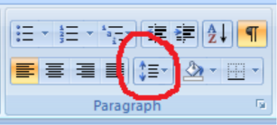
Page Numbers: (under “insert” tab)
Header: Last name it typed right before the page number (No punctuation between Header and page number)
Top left: Student Name
Teacher’s Name
Class
Date (Number space month space Year) ex: 12 December 2013
Title: Centered without punctuation (highlight in gray with mouse and click 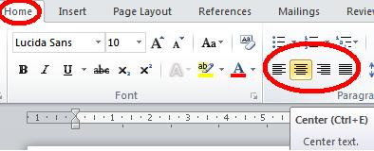)
(Do not change the font of the title)
-After the title is centered, go back to “align left”. 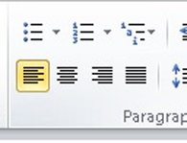
Indent paragraphs:

After the end of a sentence type two spaces

Example on Back

