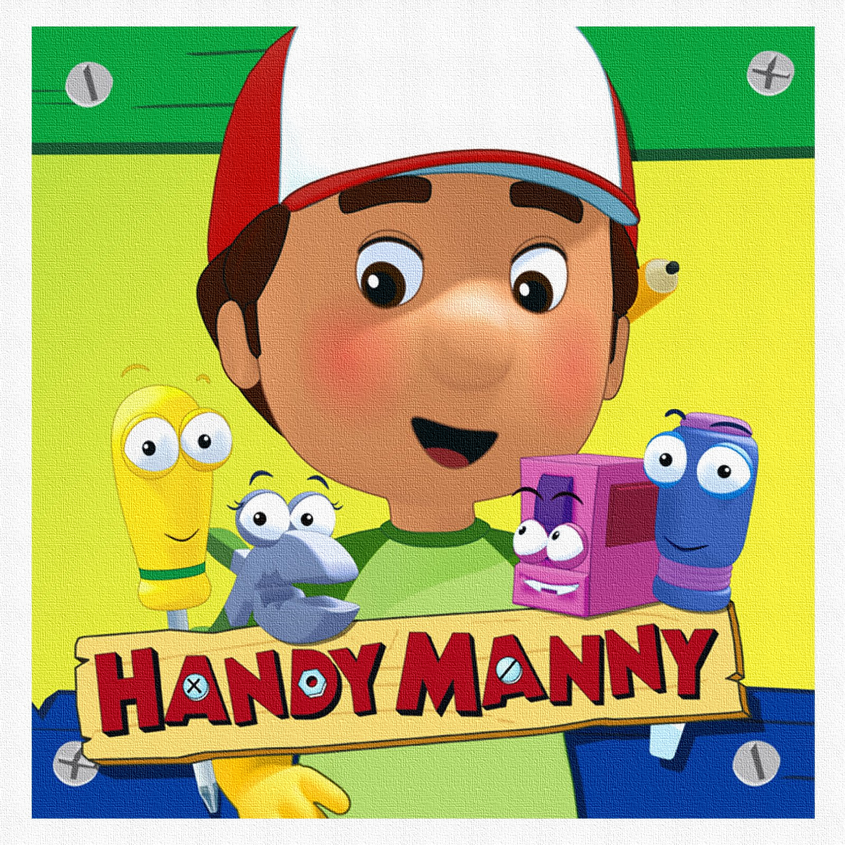
Physical Education Schedule 2017-2018
Middleton  Moore | A | B | C
8:05-8:55  Fifth | Marshall  Carmichael | Plexico  C.Casselman | Howard  Blakely
9:05-9:55  First | Gunter  Cribb  Owens | J. Casselman  Mears  Dunn | Wheeler  Marshall
10:05-10:55  Third | Nesmith  Grant | Lambert  Livingston | A.Alford  Miller
11:05-11:55  Fourth | Gasque  Berry | Cheely  T.Casselman | Morris  Wiler
11:55-12:20
LUNCH
12:25 –1:15  Second | Camp  Gamble | Wright  Ford | Nease  McCants
1:25-2:15  Kindergarten | Turner  Cannon | Watford  Steedly | J.Alford  Harrigan

