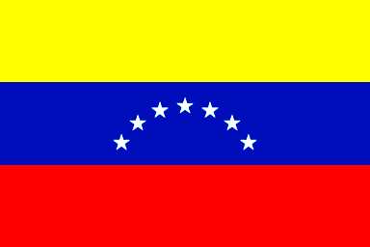

GEORGETOWN HIGH SCHOOL

Project: “Exchanging Information through Foreign Language Communications”

Class: Spanish I, II, III Date: Monday 27th, 2017
Time: 8:00 to 3:05 Teacher: Mrs. Silva

Dear Parent.
My students of Spanish I, II, III will be participating in a project named “Exchanging Information through Foreign Language Communications” where they will be able to speak Spanish with Venezuelan students from the English Language Teaching Institute. They will be talking about several topics about Venezuela and U.S.A in order to practice Spanish, following the SC Standards for Foreign Languages:
If you want to grant permission for your child to participate in Skype activity class, sign the form below
I do grant permission for _____________________________________
(Please print the full name of Student.)
to be included in Skype activity.
Parent’s/Legal Guardian’s Signature: ________________________

Thanks for your support.

Mrs. Maria Elena Silva

