6th Grade GT Midterm Review Passages
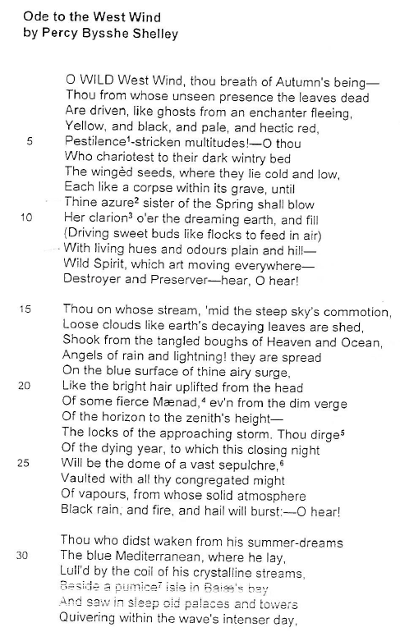
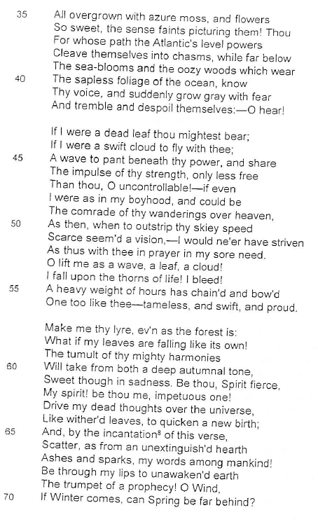
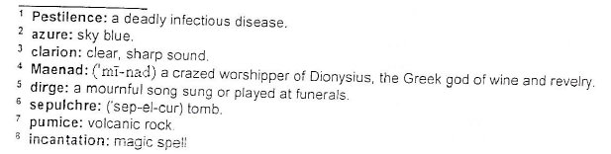
*Ode *Simile *Context Clues *Metaphor *Theme
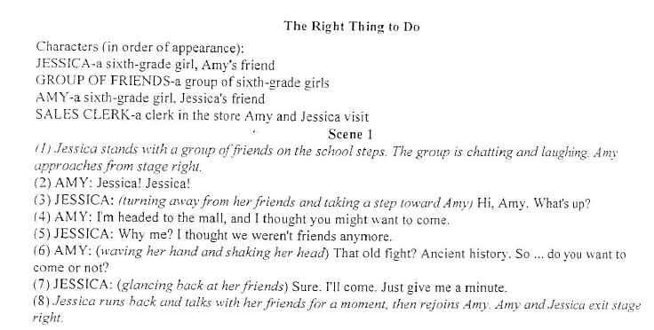
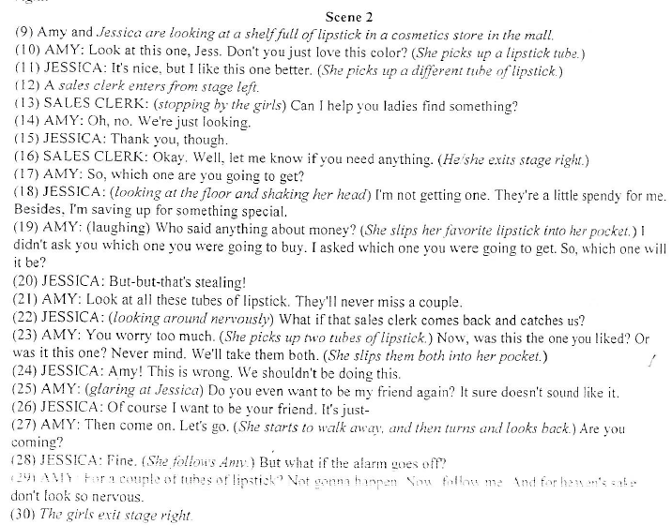
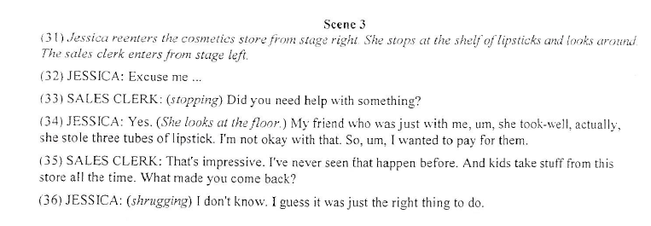
*Denouement/Resolution
*Theme
*Summarize
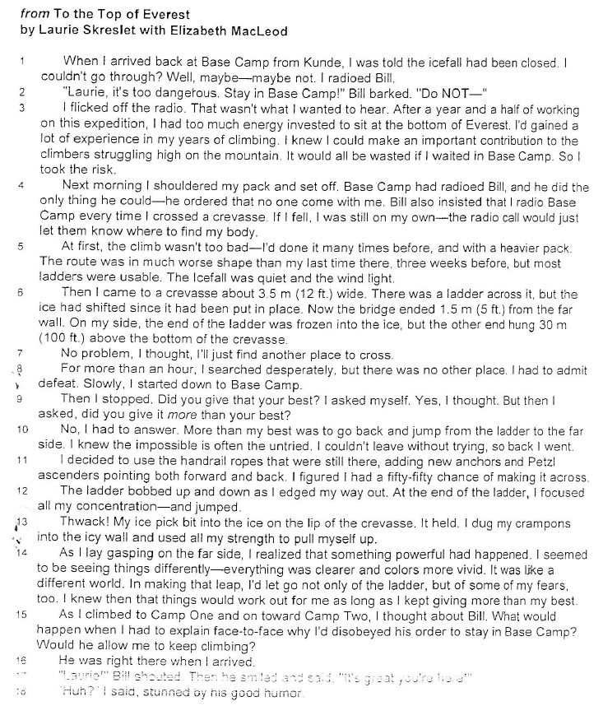
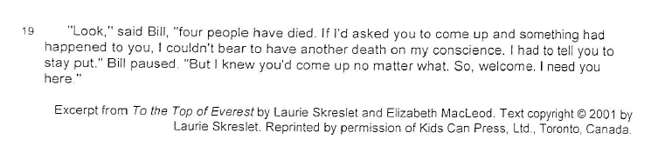
*Theme
*Drawing Conclusions
*Purpose of punctuation (dashes, commas, parentheses)
*Memoir
*Predict
*Text Structure
*Details
*Central Idea
*Writing Style
*Precise Language
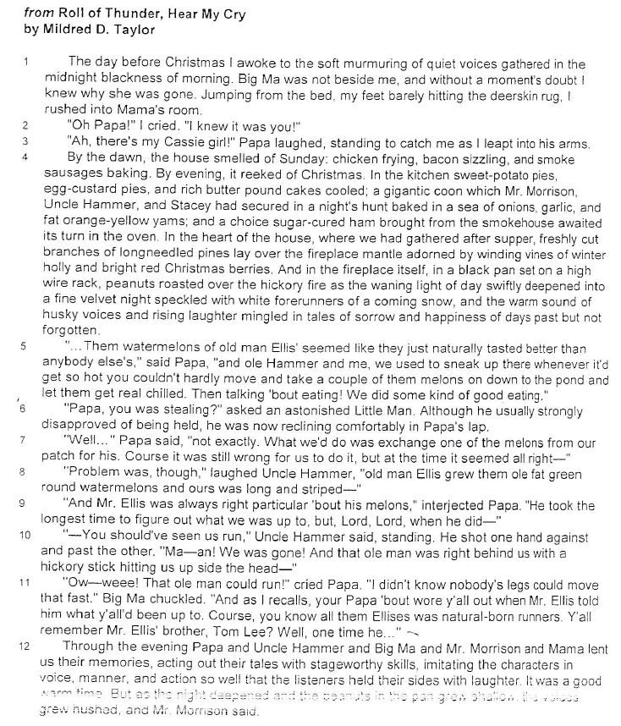
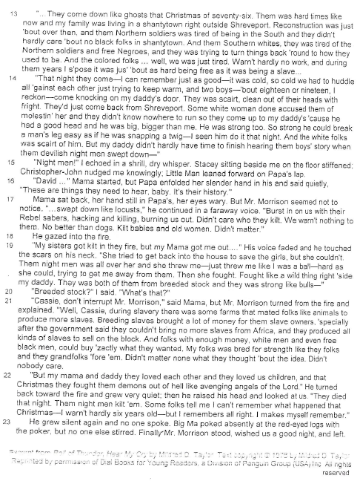
*Setting
*Excerpt
*Point of View
*Characters
*Theme
*Central Idea
*Historical Fiction

