6th Grade Midterm Review Passages
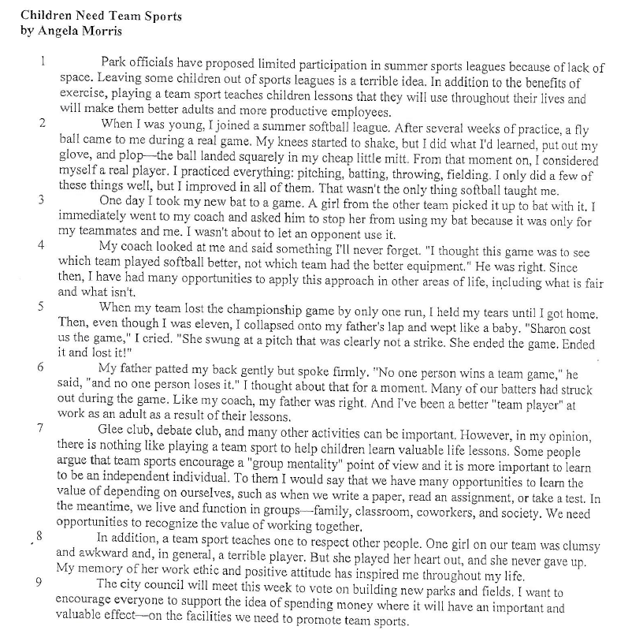

*Author’s Purpose
*Anecdote
*Main Idea
*Supporting Details
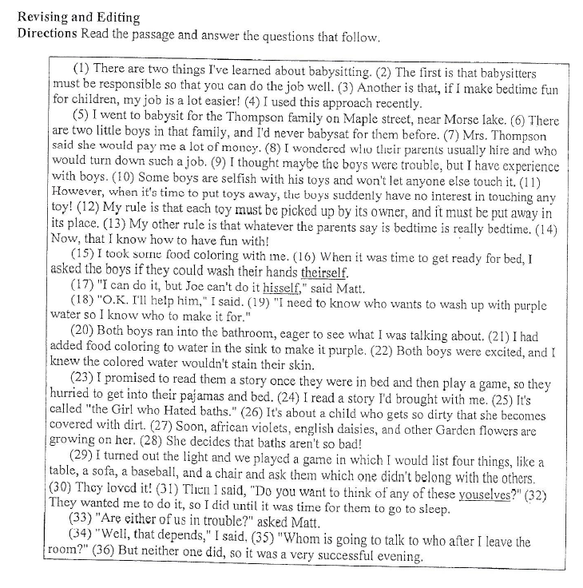
*Sentence revision
*Correct pronoun usage

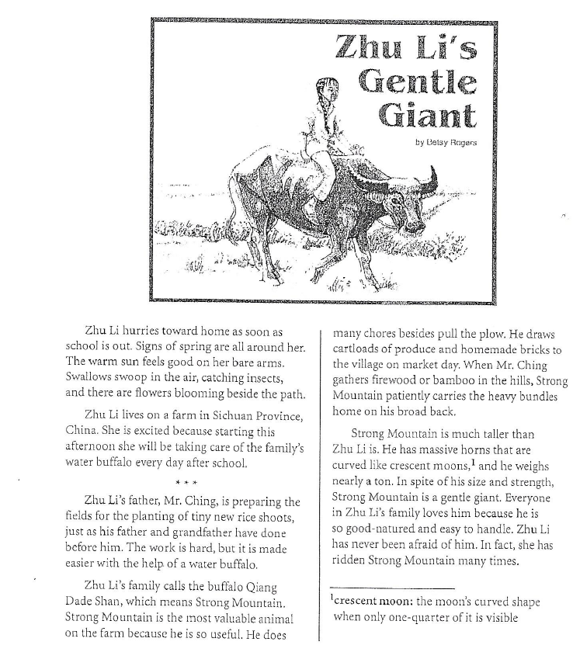
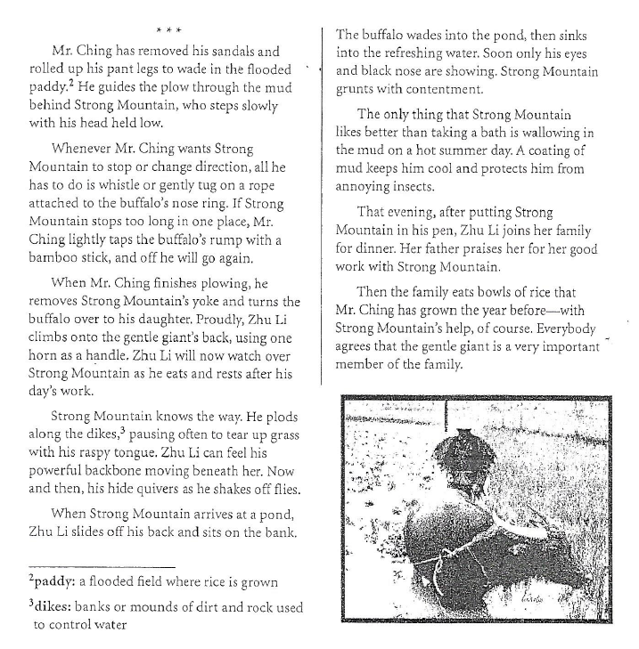

*Making Inferences
*Drawing Conclusions

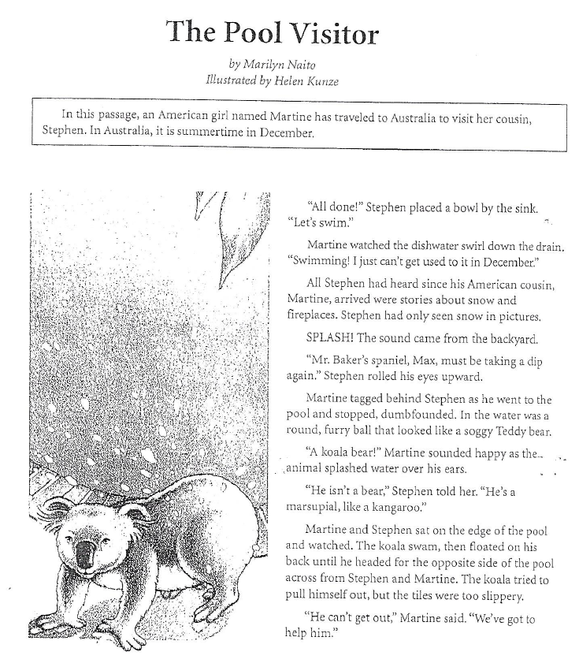

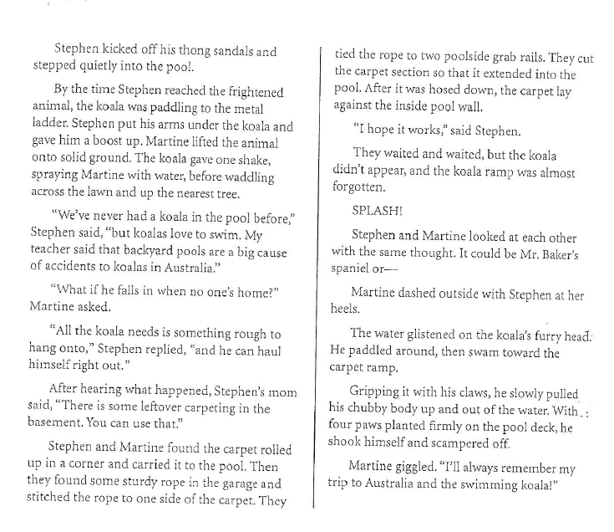
*Setting
*Drawing Conclusions
*Realistic Fiction

