SC Social Studies Standards
8-1: The student will demonstrate an understanding of the settlement of South Carolina and the United States by Native Americans, Europeans, and Africans.
8-2: The student will demonstrate an understanding of the American Revolution—the beginnings of the new American nation and South Carolina’s part in the development of that nation.
8-3: The student will demonstrate an understanding of the American Civil War—its causes and effects and the major events that occurred during that time.

Student Name _____________________________________________________________________________
Parent Signature ___________________________________________________________________________
SC History Midterm Study Guide
Date: Thursday - January 18, 2018 Test Make-Up: 40 Multiple Choice Questions
8-1: Native Americans/European Exploration
- What is the name of the group of Native Americans that lived in South Carolina?
- Why were Native Americans able to create more permanent settlements?
- Why did the relationships between Native Americans and Europeans settlers breakdown?
- Describe the characteristics of the New England, Middle, and Southern colonies (social, political, economic)
- Complete this chart on European settlements in South Carolina.
Name of Settlement | Country | Location | Result
San Miguel de Gualdape
Charlesfort
San Felipe
Charles Town

- What is a headright?
- Describe the Gullah culture.
- Describe the Stono Rebellion? What was its result?
- Describe the difference in population in South Carolina between Africans and whites.
- Describe the Regulator Movement. What ended it?
- Why were the British colonists upset with the Lords Proprietors? What type of colony did they become? Describe it.

- What is indigo? Who was responsible for bringing it to South Carolina?
- What major European powers fought in the French & Indian War? What was the outcome of that war?
- What factors led in the Cherokee War in SC?
- What group gave British colonists the knowledge to cultivate Carolina Gold?
- Define mercantilism.

8-2: American Revolution
- Describe the following British taxation policies:

  - Stamp act
  - Tea act
  - Townshend Act

- What was South Carolina’s response to the Stamp Act?
- What were the Sons of Liberty? Who was their leader in Charleston?

- Explain the political cartoon below.
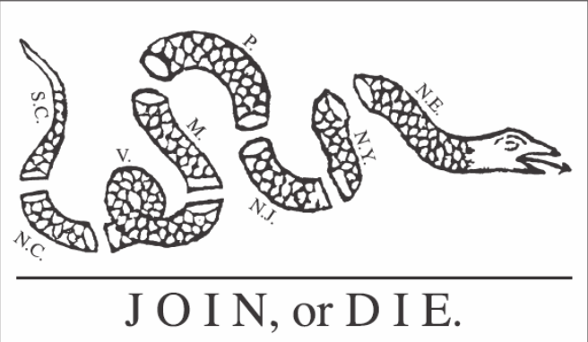

- Explain the difference between Tories/Loyalists and Patriots.
- What led some Patriots to become Partisan fighters in SC? Describe their fighting style. Identify the 3 major Partisan fighters in SC and provide their animal nicknames.
- Complete the Battles of the American Revolution chart below.
Battle | Date | Winner | Significance
Sullivan’s Island/Ft. Moultrie
Invasion of Charleston
Camden
Kings Mountain
Cowpens
Eutaw Springs

- Identify the roles and perspectives of the following groups: women, African Americans, and Native Americans
8-3: New Government & Constitution
- Describe the state’s economic situation after the American Revolution.
- Why did the capital city move from Charleston to Columbia in 1785?
- Describe the Articles of Confederation. What were the problems with this document?
- What did we use to replace the Articles of Confederation/
- Describe the following Constitutional Compromises?

  - Virginia Plan
  - New Jersey Plan
  - Great Compromise

- Explain the 3/5ths Compromise.
- Compare and Contrast Federalists and Anti-Federalists and their responses to the following:

  - National bank
  - XYZ Affair
  - War of 1812

