SC Social Studies Standards
8-1: The student will demonstrate an understanding of the settlement of South Carolina and the United States by Native Americans, Europeans, and Africans.
8-2: The student will demonstrate an understanding of the American Revolution—the beginnings of the new American nation and South Carolina’s part in the development of that nation.
8-3: The student will demonstrate an understanding of the American Civil War—its causes and effects and the major events that occurred during that time.

SC History Midterm Study Guide
8-1 (Chap. 2, 3, 4, 5, 6, 7, 9)
- What is the name of the group of Native Americans that lived in South Carolina? Eastern Woodland
- Why were Native Americans able to create more permanent settlements? No longer hunter-gathers, but started to practice with agriculture
- Why did the relationships between Native Americans and Europeans settlers breakdown? Disputes over land, trading, and clash of cultures
- Describe the characteristics of the New England, Middle, and Southern colonies (see attachment)
- Complete this chart on European settlements in South Carolina.
Name of Settlement | Country | Location of Settlement | Result
San Miguel de Gualdape | Spain | Winyah Bay | Leader Dies, lack of supplies (Failed)
Charlesfort | France | Parris Island | Lack of Leadership (Failed)
Santa Felipe | Spain | Parris Island | Native American Attacks (Failed)
Charlestown | England/Great Britain | Charlestowne | Succeeded

- What is a headright? Grant of land given to settlers of the English colonies- more people brought to the new world the more land
- Describe the Gullah culture. Common language of the sea islands of SC which uses English and African dialects (Chapter 6)
- Describe the Stono Rebellion? What was its result?The Largest slave rebellion of colonial America. Between 60 and 100 blacks led by Jemmy attempted a revolt outside of Charleston to escape to Spanish Florida. They were capture d, hung and as a result slave codes were passed. (Chapter 6)
- Describe the difference in population in South Carolina between Africans and whites.By 1820 African Americans held a majority of the total population in the state due to the high level of slave labor.(Chapter 6)
- Describe the Regulator Movement. What ended it? Group of Back Country settlers who protested the lack of protection from the colonial government. They organized to protect themselves against theft and murder. (Chapter9)
- Why were the British colonists upset with the Lords Proprietors? What type of colony did they become? Describe it.The Lords Proprietors did not offer any protection from Native American attacks, Spanish, pirate threat and slave revolts. The colony changed to a Royal Colony.
- What is indigo? Who was responsible for bringing it to South Carolina?A blue dye which became very profitable, Eliza Lucas Pinckney (Chapter 6)
- What were the major European powers in the French and Indian War? French and Indians vs. British and Colonists What was the outcome of this war? Great Britain won and gained control of most of North America; colonists were taxed to pay war debt
- What factors led to the Cherokee War? Broken treaties between the colonists and the Cherokee Indians
- What group gave British colonists the knowledge to cultivate rice? West African slaves
- Define mercantilism. An economic policy in which a nation exports more than it imports for the benefit of the Mother Country

8-2 American Revolution
- Describe the following
  - Stamp Act: British tax on all printed material
  - Tea Act: required colonists to purchase tea from the British East India Company
  - Townshend Act: a tax on secondary goods (tea, lead, paper, glass, paint, etc…)
- What was South Carolina’s response to the Stamp Act? Protested by tar and feathering tax collectors and hanging effigies
- What were the Sons of Liberty? Who was their leader in Charleston? American Patriots who protested against British policies (taxes)
- Explain the political cartoon below. Colonies cannot survive unless they unite

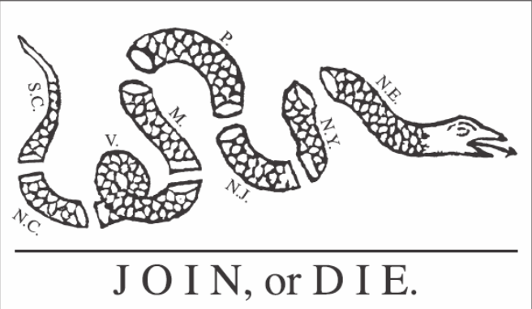

- Explain the differences between Tories/Loyalists and Patriots. Tories/Loyalists sided with Great Britain during the Revolutionary war, while Patriots wanted independence from Great Britain
- What led some Patriots to become Partisan fighters in SC? Harsh treatment from the British troops towards South Carolinians (not honoring parole, houses burned, brutal attacks, etc…) Describe their fighting style. Guerrilla Warfare- hit and run tactics Identify the 3 major Partisan fighters in SC and provide their animal nicknames. - Francis Marion (Swamp Fox), Thomas Sumter (Gamecock), Andrew Pickens (Wizard Owl)
- Complete the Battles of the American Revolution chart below.
Battle | Winner | Significance
Sullivans Island/Ft. Moultrie | Patriots | Palmetto log aided in Patriot victory; Palmetto tree added to the state flag
Invasion of Charleston | British | Beginning of British control in SC; naval blockade in Charleston Harbor
Camden | British | Britain almost controls all of SC
Kings Mountain | Patriots | Turning point of war; loyalists vs. patriots fought
Cowpens | Patriots | British left the state and showed the cooperation between the militia and regular Continental Army
Eutaw Springs | No Clear winner | One of the bloodiest battles of the Revolution; one of the last battles in SC

- Identify the roles and perspectives of the following groups: Women, African Americans, and Native Americans
- women: managed plantations, present in camps to serve food, act as nurses, became spies; some supported Loyalists;
- African Americans: most served as slaves; some joined the Partisan bands (1/3); no military role because of fear of rebellion;
- Native Americans: most supported the British; few supported the colonists; Cherokees supported the British and attacked the settlers.
8-3 New Government & Constitution
- Describe the state’s economic situat9ion after the American Revolution. SC had more debt than any other state in the country; both the Upcountry and Low country were economically affected after the war
- Why did the capital city move from Charleston to Columbia in 1785? In order to settle the political dispute between the Back Country and Low Country
- Describe the Articles of Confederation. First attempt at government for the United States What were the problems with this document? Central government was too weak
- What did we use to replace the Articles of Confederation? The Constitution
- Describe the following Constitutional compromises.
  - Virginia Plan: created a bicameral legislature with representation based on population
  - New Jersey Plan: representation in Congress would be equal
  - Great compromise: combined the New Jersey and Virginia Plans, creating a bicameral legislature with representation in one house based on population and the other house would be equal
- Explain the 3/5ths Compromise. In determining representation, Southern states were allowed to count slaves as 3/5ths of a person
- Compare and contrast the Federalists and Anti-Federalists and their responses to the following: (See attachment)
  - National Bank
  - XYZ Affair
  - War of 1812

